Authour: S275931

Documentation for the Task Management System, EULA and User Manual

Task Management System Documentation

Task Management System Documentation

Table of Contents

Introduction 2

End User License Agreement 3

Terms of Use 4

System Requirements 5

Docker Deployment (Windows): 5

Docker Deployment (macOS): 6

Docker Deployment (Linux): 6

Render.com deployment (online): 7

Building and deploying from source code (Windows): 7

Building and deploying from source code (macOS): 7

Building and deploying from source code (Linux): 8

Installation 8

Setup Render.com Deployment 11

Installation and Setup using Docker Deployment 13

Installation and Setup Using Source Code 21

Prerequisites 22

Downloading from the GitHub repository 22

Open the PyCharm Project 23

Setting up the PyCharm environment (Windows) 26

Setting up the PyCharm Environment (Linux) 33

Setting up the PyCharm environment (macOS) 37

Setting up the Flask Configuration 42

Run the Task Management System from PyCharm 45

Setting up and pushing to Git repository (Version Control) 47

Modifying Source code, Adding and Testing New Features 54

Suggested Modifications 55

Unit Testing the Task Management System Source Code 57

Deploy online using Render.com or other webhosting service using a Continuous Integration / Continuous Deployment (CI/CD) Pipeline. 60

Deploy using Docker or other containerisation platforms. 70

Using the Task Management System 76

First Time Setup 76

Logging out 79

Logging In 80

Create Account 81

Manage Projects 83

Create a New Project 83

View Projects 84

Update a Project – Administrators and Root User Only 86

Delete a Project – Administrators and Root User Only 87

Manage Tasks 89

Create a New Task 89

View Tasks 90

Update Tasks – Administrators and Root User Only 91

Delete Tasks – Administrators and Root users only. 93

Managing Your Account 94

View Your Account Details 94

Changing your Account Details 95

Changing your Username 97

Changing your Password 98

Deleting your Account 100

Managing Users and Administrative Tasks – Administrators and Root User Only 102

View the List of Users as a Table (Administrators and Root User Only) 103

Change User Account Type (Administrators and Root Users Only) 104

Delete a User (Administrators and Root Users Only). 106

Blocking a User (Administrators and Root Users Only) 107

Unblocking a User (Administrators and Root Users Only) 109

Changing Another User’s Password (Administrators and Root Users Only) 111

Factory Resetting the Task Management System (Administrators and Root Users Only) 113

Task Management System on Mobile Devices. 115

Security Features 129

References 130

# Introduction

The Task Management System is a Python-based web application that manages tasks and projects for an organization to help the organisation keep track of tasks and their associated projects. Features include a database that contains three tables (one with a list of tasks, another with a list of projects and thirdly with a list of users), user roles (Administrator, Root User, Standard User), Create, Read, Update and Delete functionality for tasks, projects, and users. Administrators have full control of the Task Management system (Add, Update, View and Delete tasks and projects, manage other users (change account type and password, view details of all users, delete users, block, and unblock users), factory reset the Task Management System, and manage their own account. Standard users are restricted therefore can only add and view tasks and projects, view and manage their own account. Standard users cannot update or delete tasks and projects, view and manage other users or factory reset the Task Management system. For security, authentication is required for all users and all accounts are password protected. The passwords are encrypted and stored as hashes in the database in the event the application or database gets hacked, randomly generated session IDs authenticate each session, Passwords are required to have minimum length of 10 characters and must contain at least one uppercase letter, one lowercase letter, one number, one special character and must not be a common password. The Task Management System is cross-platform and can run as a container on a computer `or server running Windows, Mac OS or Linux with Docker installed, hosted online as a web service on hosting sites such as Render.com linked to a GitHub repository (It could also be hosted on other web hosting platforms that are compatible with Python 3.12, Flask and Gunicorn). You can also deploy the Task Management System directly from its source code by cloning its Git repository, run app.py in a suitable Python IDE such as PyCharm and have the Python 3.12 interpreter installed on your computer, then deploy on a containerisation platform of your choice such as Docker (others may require the Dockerfile to be replaced with their own containerisation file) or on a web hosting platform such as Render.com.

# End User License Agreement

IMPORTANT – YOU MUST AGREE TO THE TASK MANAGEMENT SYSTEM’S GNU AGPLv3 LICENSE BEFORE YOU CAN USE THIS PRODUCT IN ANY WAY.

The full license agreement is available in a separate document. The Task Management System is open source with the copyleft GNU Affero General Public License.

You must comply with the following permissions, conditions and limitations when using, managing, downloading, installing, setting up, distributing, deploying, or modifying the Task Management System as stated in the table below in accordance with the open-source GNU Affero General Public License Agreement. Failure to comply can result in legal action under U.K. law, international law, and local laws of your country where you are using this software.

The GNU Affero General Public License Agreement is available here: <https://www.gnu.org/licenses/agpl-3.0.en.html>

Alternative links to license agreement: <https://github.com/AlexanderJohnRobertson/task-management-system/wiki/Task-Management-System-GNU-AGPLv3-License-Agreement> <https://github.com/AlexanderJohnRobertson/task-management-system-clean-install/wiki/Task-Management-System-(Clean-Install)-Documentation>

|  |  |  |
| --- | --- | --- |
| Permissions | Conditions | Limitations |
| Commercial Use is Authorised | You Must Disclose the Original Source | Liability – We cannot be held liable for any damage or data loss caused by modifications. |
| Distribution is Authorised | You Must Include License and Copyright Notice | Warranty – Modified code is not covered by warranty. |
| Modification is Authorised | Network use is Distribution |  |
| Patent Use is Authorised | You Must Use the Same License |  |
| Private Use is Authorised | You Must State Changes (Choose an open source license, 2007) |  |

# Terms of Use

IMPORTANT – YOU MUST AGREE TO THE TERMS OF USE BEFORE YOU CAN USE THE TASK MANAGEMENT SYSTEM IN ANY WAY.

1. You must accept the license agreement (see above).
2. You must comply with the license agreement and must not violate it or else you could face legal action under U.K. law, international law, and local laws in the country you are using this software.
3. You must not violate the terms of use or else you could face legal action under U.K. law, international law, and local laws in the country you are using this software.
4. You must not use the Task Management System for illegal purposes or to support criminal activity.
5. You must not modify and redistribute the Task Management System by inserting malicious code in any language into the source code to turn it into malware. This includes but not limited to:
   1. Viruses
   2. Trojans
   3. Worms
   4. Adware and Malvertising
   5. Spyware
   6. Ransomware
   7. Rootkits
   8. Browser Hijackers
   9. Potentially Unwanted Programs
   10. Cryptominers
   11. Keyloggers
   12. Password Stealers
   13. Hack tools.
   14. Browser Hijackers
   15. Links to third party malware websites, scam websites and spam websites
   16. Spambots, Bots and Botnets
   17. Exploits
   18. Backdoors
   19. Logic Bombs
   20. (Distributed) Denial of Service Attack
   21. Fileless Malware
6. You must comply the relevant laws and regulations of the country(s) you are using the Task Management System in and not break them. Failure to comply can result in civil and criminal prosecution. These include:
   1. Data Protection Act and General Data Protection Regulations
   2. Computer Misuse Act
   3. Communications Act and Malicious Communications Act
   4. Telecommunications Act.
7. You must not use the Task Management System or modify it in a way to facilitate cybercrimes. This includes but is not limited to:
   1. Malware (see above for examples)
   2. Break the laws listed above.
   3. Hacking
   4. Spying and espionage
   5. Identity Theft
   6. Any type of fraud
   7. Phishing
   8. Spam
   9. Scams
8. You must not redistribute this software with a proprietary license and sell it for money and pretend it’s your own or with any other type of license. The license must stay the same.
9. As the software is currently free, you must not sell it for any amount of money.

# System Requirements

## Docker Deployment (Windows):

* Computer must meet the system requirements to run Docker and a compatible web browser.
* 64 Bit Windows 10 Home, Professional, Enterprise or Education 21H2 (build 19044) or later or Windows 11 Home, Professional, Enterprise or Education version 22H2 or later (Docker, Inc., 2024).
* Docker Desktop and compatible web browser installed.
* Windows Subsystem for Linux (WSL) 2 feature enabled with a Linux operating system installed (Available from the Microsoft Store) or Hyper-V and Windows Containers features enabled (Docker, Inc., 2024).
* Professional and Enterprise editions of Windows are required to run Windows containers (Docker, Inc., 2024).
* 64-bit processor (CPU) with Second Level Address Translation (SLAT) (Docker, Inc., 2024) (Extended Page Table (EPT) in Intel processors, Rapid Virtualisation Indexing (RVI) in AMD processors) (Gibb, 2011).
* 4GB system RAM (Docker, Inc., 2024) (More may be required if application is scaled).
* Hardware Virtualisation enabled in computer BIOS (Docker, Inc., 2024).
* Internet connection.
* Tested web browsers include Mozilla Firefox, Microsoft Edge, Google Chrome, and Safari but should run on other web browsers too.
* 152 MB disk space for Task Management System container (may increase if database is large)
* 100 GB disk space for Docker as Docker can take up large amounts of disk space (Kinda Code, 2022).
* Mozilla Firefox System Requirements: 1GHz processor (CPU), 2GB RAM, 500 MB disk space (Mozilla, 2024).
* Microsoft Edge is bundled with Windows 10 and 11 (Microsoft, 2024).
* Google Chrome System Requirements: Windows 10 or 11, Intel Pentium 4 processor (CPU) or AMD equivalent (Google, 2024).

## Docker Deployment (macOS):

* Docker is compatible with most recent versions of macOS (Docker, Inc., 2024).
* Docker is compatible with Apple Silicon chips (CPUs) such as M1, M1 Pro, M1 Max, M1 Ultra, M2, M2 Pro, M2 Max, M2 Ultra, M3, M3 Pro, M3 Max and future Apple Silicon processors (Docker, Inc., 2024).
* Docker is compatible with most recent Intel CPUs in Macs with Intel chips (Docker, Inc., 2024).
* 4 GB RAM (Docker, Inc., 2024) (more RAM may be required if scaled)
* 100 GB disk space for Docker as Docker can take up large amounts of disk space (Kinda Code, 2022).
* 152 MB disk space for Task Management System container (may increase if database is large)
* Internet Connection.
* Tested web browsers include Mozilla Firefox, Microsoft Edge, Google Chrome, and Safari but should run on other web browsers too.
* Mozilla Firefox System Requirements: macOS 10.15 or later (Catalina), Intel or Apple Silicon processor (CPU), 512 MB RAM, 200 MB disk space (Mozilla, 2024).
* Google Chrome System Requirements: macOS Catalina 10.15 and up (Google, 2024).
* Safari System Requirements: Safari is bundled with macOS (Apple, 2024).

## Docker Deployment (Linux):

* Supported Linux Distributions: Ubuntu, Debian, Fedora (Docker, Inc., 2024).
* 64-bit kernel and processor (CPU) for virtualisation (Docker, Inc., 2024).
* KVM virtualization support (Docker, Inc., 2024).
* QEMU 5.2 or later (Docker, Inc., 2024).
* systemd init system (Docker, Inc., 2024).
* Gnome, KDE, or MATE Desktop environment (Docker, Inc., 2024).
* 4 GB RAM (Docker, Inc., 2024) (more RAM may be required if application is scaled).
* Configuring ID mapping in user namespaces enabled (Docker, Inc., 2024).
* Initialize pass recommended for credentials management (Docker, Inc., 2024).
* 100 GB disk space for Docker as Docker can take up large amounts of disk space (Kinda Code, 2022).
* 152 MB disk space for Task Management System container (may increase if database is large)
* Internet Connection.
* Tested web browsers include Mozilla Firefox, Microsoft Edge, Google Chrome, and Safari but should run on other web browsers too.
* Mozilla Firefox System Requirements: Following libraries and packages must be installed: glibc 2.17 or higher, GTK+ 3.14 or higher, libglib 2.42 or higher, libstdc++ 4.8.1 or higher, X.Org 1.0 or higher (1.7 or higher is recommended), DBus 1.0 or higher, NetworkManager 0.7 or higher, PulseAudio. Mozilla Firefox is bundled with some Linux distributions (Mozilla, 2024).
* Google Chrome System Requirements: 64-bit Ubuntu 18.04+, Debian 10+, openSUSE 15.2+, or Fedora Linux 32+, SSE3 capable Intel Pentium 4 or later processor (CPU) or AMD equivalent (Google, 2024).

## Render.com deployment (online):

* Any device with compatible browser, operating system, and internet connection.
* Examples of devices include workstations, desktop and laptop computers running Windows, Linux, macOS or ChromeOS, Smartphones running Android and iOS, Tablets and iPads running Android, iOS and iPadOS, Macs running macOS, Chromebooks running ChromeOS, Raspberry Pi etc.
* Tested browsers include Mozilla Firefox, Microsoft Edge, Safari, and Google Chrome. Task Management System should be accessible on other browsers too.

## Building and deploying from source code (Windows):

* Internet connection to clone git repository.
* Software: Windows 10 1809 or later or Windows 11, Python 3.12 Interpreter, Python IDE (PyCharm Recommended), Git (to commit to your own git repository (required for Render.com deployments), Docker (for containerisation deployments), GitHub Desktop SQLite Studio. You could try other Python IDEs, containerisation platforms and git clients but may require modifications to the code, Dockerfile etc. and may result in compatibility issues as they have not been tested.
* PyCharm System Requirements (Jetbrains, 2024):
  + 4 GB RAM (8 GB RAM recommended).
  + Any modern processor (CPU) – Multi-core CPU recommended.
  + 3.5 GB Disk Space (5 GB Disk Space on Solid State Drive (SSD) recommended).
  + 1024x768 screen resolution (1920x1080 or higher recommended).
* Docker System Requirements: See above.
* Web Browser System Requirements: See above.
* GitHub Desktop and Git System Requirements: Windows 10 64-bit or Windows 11 (GitHub, 2024).
* GitHub account (GitHub, 2024).
* Docker Hub account (Docker, Inc., 2024).
* Render.com account (Render.com, 2023).
* JetBrains account (Jetbrains, n.d.).
* PyCharm must have Flask and Gunicorn installed using PIP Install.

## Building and deploying from source code (macOS):

* Internet connection to clone git repository and deployment.
* Software: macOS 12.0 (Monterey) or later, Python 3.12 Interpreter, Python IDE (PyCharm Recommended), Git (to commit to your own git repository (required for Render.com deployments), Docker (for containerisation deployments), GitHub Desktop SQLite Studio. You could try other Python IDEs, containerisation platforms and git clients but may require modifications to the code, Dockerfile etc. and may result in compatibility issues as they have not been tested.
* PyCharm System Requirements:
  + 4 GB RAM (8 GB RAM recommended).
  + Any modern processor (CPU) – Multi-core CPU recommended.
  + 3.5 GB Disk Space (5 GB Disk Space on Solid State Drive (SSD) recommended).
  + 1024x768 screen resolution (1920x1080 or higher recommended).
* Docker System Requirements: See above.
* Web Browser System Requirements: See above.
* GitHub Desktop and Git System Requirements: macOS 10.13 (High Sierra) or later.
* GitHub account.
* Docker Hub account.
* Render.com account.
* JetBrains account.
* PyCharm must have Flask and Gunicorn installed using PIP Install.

## Building and deploying from source code (Linux):

* Internet connection to clone git repository and deployment.
* Software Any Linux distribution that supports KDE or Gnome DE (e.g. Ubuntu, Debian, RHEL etc.), Linux Distribution must include GLIBC 2.27 or later, Python 3.12 Interpreter, Python IDE (PyCharm Recommended), Git (to commit to your own git repository (required for Render.com deployments), Docker (for containerisation deployments), GitHub Desktop, SQLite Studio. You could try other Python IDEs, containerisation platforms and git clients but may require modifications to the code, Dockerfile etc. and may result in compatibility issues as they have not been tested.
* PyCharm System Requirements:
  + 4 GB RAM (8 GB RAM recommended).
  + Any modern processor (CPU) – Multi-core CPU recommended.
  + 3.5 GB Disk Space (5 GB Disk Space on Solid State Drive (SSD) recommended).
  + 1024x768 screen resolution (1920x1080 or higher recommended).
* Docker System Requirements: See above.
* Web Browser System Requirements: See above.
* GitHub Desktop is not supported on Linux. Git is supported.
* GitHub account.
* Docker Hub account.
* Render.com account.
* JetBrains account.
* PyCharm must have Flask and Gunicorn installed using PIP Install.

# Installation

This section provides Installation instructions for the Task Management System.

Before installing the Task Management System, the prerequisite software must be installed first:

* For Docker installation and setup instructions, visit the official Docker website:
  + Install Docker on Windows: <https://docs.docker.com/desktop/install/windows-install/>
  + Install Docker on macOS: <https://docs.docker.com/desktop/install/mac-install/>
  + Install Docker on Linux: <https://docs.docker.com/desktop/install/linux-install/> , <https://docs.docker.com/desktop/install/debian/> , <https://docs.docker.com/desktop/install/fedora/> , <https://docs.docker.com/desktop/install/ubuntu/> , <https://docs.docker.com/desktop/install/archlinux/> .
  + Full Docker Documentation: <https://docs.docker.com/manuals/>
  + Download Docker: <https://www.docker.com/products/docker-desktop/>
* For PyCharm installation and setup, visit the official JetBrains PyCharm website:
  + Installation Guide: <https://www.jetbrains.com/help/pycharm/installation-guide.html>
  + Full PyCharm Documentation: <https://www.jetbrains.com/help/pycharm/getting-started.html>
* Use PIP to install Flask and Gunicorn if they have not already been installed.
* For Flask install and setup instructions and documentation, visit the official Flask website: <https://flask.palletsprojects.com/en/3.0.x/>
* For Gunicorn install and setup instructions and documentation, visit the official Gunicorn website: <https://docs.gunicorn.org/en/stable/>
* For Python 3.12 interpreter installation and setup instructions and documentation, visit the official Python website:
  + Python 3.12 documentation: <https://docs.python.org/3/index.html>
  + Python Installation Instructions: <https://python.land/installing-python>
  + Python Wiki: <https://wiki.python.org/moin/>
  + Python 3.12 download links: <https://www.python.org/downloads/release/python-3120/> and <https://www.python.org/downloads/>
  + Python Tutorials: <https://www.learnpython.org/>
* For Git download, installation and setup instructions and documentation, visit the official Git website:
  + Git documentation and setup instructions: <https://git-scm.com/doc>
  + Git download link: <https://git-scm.com/downloads>
* For GitHub Desktop installation and setup instructions and documentation, visit the official GitHub Desktop website:
  + GitHub Desktop download link: <https://desktop.github.com/>
  + GitHub Desktop documentation: <https://docs.github.com/en/desktop>
* For GitHub Documentation and instruction manuals, visit the official GitHub website:
  + Documentation and manuals: <https://docs.github.com/en>
  + GitHub website: <https://github.com/>
* For Render.com instructions, manuals and documentation visit the Render.com official website:
  + Documentation: [Docs + Quickstarts | Render Docs](https://docs.render.com/)
  + Render.com: <https://render.com/>
* For SQLite Studio and SQLite Download and documentation please visit the official SQLite Studio and SQLite websites:
  + SQLite Studio download: <https://sqlitestudio.pl/>
  + SQLite Documentation: <https://www.sqlite.org/docs.html>
  + SQLite Tutorials: <https://www.sqlitetutorial.net/>
* For the HTML documentation and manuals, please visit the official HTML website: <https://html.spec.whatwg.org/>
* For the CSS documentation and manuals, visit the official CSS website: <https://www.w3.org/TR/CSS/#css>
* For CSS tutorials, visit <https://www.w3schools.com/Css/>
* For the JavaScript documentation, manuals, and tutorials, visit the official JavaScript website and tutorial websites:
  + Official websites: <https://www.javascript.com/> and <https://ecma-international.org/publications-and-standards/standards/ecma-262/>
  + Documentation: <https://devdocs.io/javascript/>
  + JavaScript Tutorials: <https://www.w3schools.com/js/DEFAULT.asp>
* For Mozilla Firefox Download and documentation, visit the official Mozilla Firefox website:
  + Documentation: <https://developer.mozilla.org/en-US/docs/Mozilla/Firefox> and <https://support.mozilla.org/en-US/products/firefox/get-started>
  + Download: <https://www.mozilla.org/en-GB/firefox/new/>
* For Google Chrome download and documentation, visit the official Google Chrome website:
  + Documentation: <https://developer.chrome.com/docs/>
  + Help Manual: <https://support.google.com/chrome/?hl=en#topic=7439538>
  + Download: <https://www.google.co.uk/chrome/>
* For Microsoft Edge Documentation and download, visit the Microsoft Edge official webpage:
  + Documentation: <https://learn.microsoft.com/en-us/microsoft-edge/>
  + Help: <https://support.microsoft.com/en-us/microsoft-edge>
  + Download: <https://www.microsoft.com/en-us/edge/download?form=MA13FJ>
* For Safari Download and Documentation, visit the official Safari Website:
  + Documentation: <https://developer.apple.com/documentation/safari-release-notes>
  + Support: <https://support.apple.com/safari>
  + Download: <https://support.apple.com/downloads/safari>
* For the Windows Subsystem for Linux documentation, visit the WSL official website:
  + Documentation: <https://learn.microsoft.com/en-us/windows/wsl/>
* For the Hyper-V manuals, visit the official Microsoft Website:
  + Windows 10: <https://learn.microsoft.com/en-us/virtualization/hyper-v-on-windows/>
  + Windows 11: <https://techcommunity.microsoft.com/t5/educator-developer-blog/step-by-step-enabling-hyper-v-for-use-on-windows-11/ba-p/3745905>
* For download, manuals, and documentation on Windows, visit the official Microsoft Windows website:
  + Documentation: <https://learn.microsoft.com/en-us/windows/>
  + Windows 11: <https://support.microsoft.com/en-us/windows/meet-windows-11-the-basics-a7519756-6807-41e4-be66-ed3b2c0abe0d>
  + Windows 11 Support: <https://support.microsoft.com/en-us/meetwindows11>
  + Windows 11 Download: <https://www.microsoft.com/en-gb/software-download/windows11/>
  + Windows 10: <https://support.microsoft.com/en-us/microsoft-edge/quick-start-guides-for-windows-10-surface-book-and-microsoft-edge-4e603411-16ad-73f7-0923-5aa3d327bb59>
  + Windows 10 Download: <https://www.microsoft.com/en-gb/software-download/windows10>
* For macOS documentation and manuals, please visit the official Apple macOS website:
  + User Guide: <https://support.apple.com/en-gb/guide/mac-help/welcome/mac>
  + Manuals: <https://support.apple.com/manuals/macos>
  + Download (Requires a Mac): <https://support.apple.com/en-us/102662>
* For Linux documentations and downloads, visit the official pages of the Linux distributions:
  + Linux Kernel Documentation: <https://www.kernel.org/doc/html/latest/>
  + Ubuntu documentation: <https://docs.ubuntu.com/>
  + Ubuntu Download: <https://ubuntu.com/download>
  + Debian Documentation: <https://www.debian.org/doc/>
  + Debian Download: <https://www.debian.org/distrib/>
  + Fedora Documentation: <https://docs.fedoraproject.org/en-US/docs/>
  + Fedora Download: <https://www.fedoraproject.org/en/workstation/download> and <https://docs.fedoraproject.org/en-US/fedora/latest/fedora-downloads-info/>
  + Arch Linux Documentation: <https://wiki.archlinux.org/> and <https://wiki.archlinux.org/title/Installation_guide>
  + Arch Linux Download: <https://archlinux.org/download/>

# Setup Render.com Deployment

To set up the Render.com deployment, you just need a device that connects to the internet and a recent version of a web browser installed.

The clean installation of the Task Management System is available on Render.com here: <https://task-management-system-clean-install.onrender.com/setup> .

__________________________________________________________________________________

Another version of the Task Management System with example data, users, tasks, and projects is available here: <https://task-management-system-hnmb.onrender.com/>

The username for the Root user is Root and the password is TaskManagement123#

The username for an administrator is barneyPurpleDinosaur and the password is BabyBop123#

The username for a standard user is Birmingham888 and the password is SouthSide123@

Login Credentials for Task Management System With Example Data

|  |  |  |
| --- | --- | --- |
| User Role | Username | Password |
| Root User | Root | TaskManagement123# |
| Administrator | barneyPurpleDinosaur | BabyBop123# |
| Standard | Birmingham888 | SouthSide123@ |

__________________________________________________________________________________

When you click the first link, you will be redirected to the setup page.

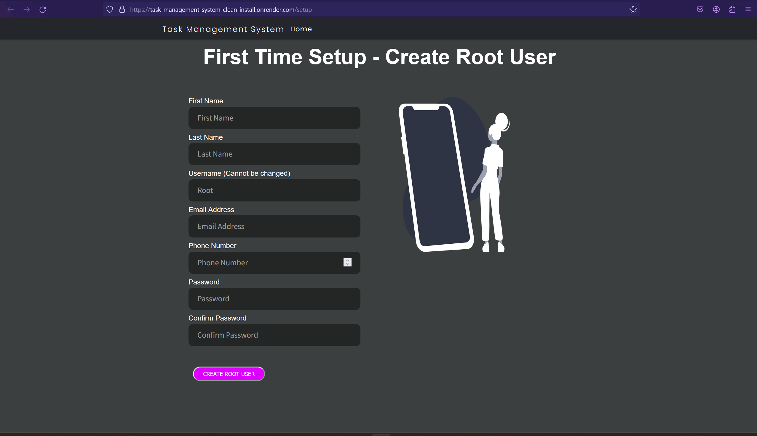

Figure 1 - Task Management System Setup Page

Fill in the fields in the form then click the *Create Root User* button. The Root username cannot be changed. The password must be a minimum length of 10 characters, have at least one capital letter, one lowercase letter, one number and one special character (ASCII characters only). The password must not be a common password. See the screenshot below for an example.

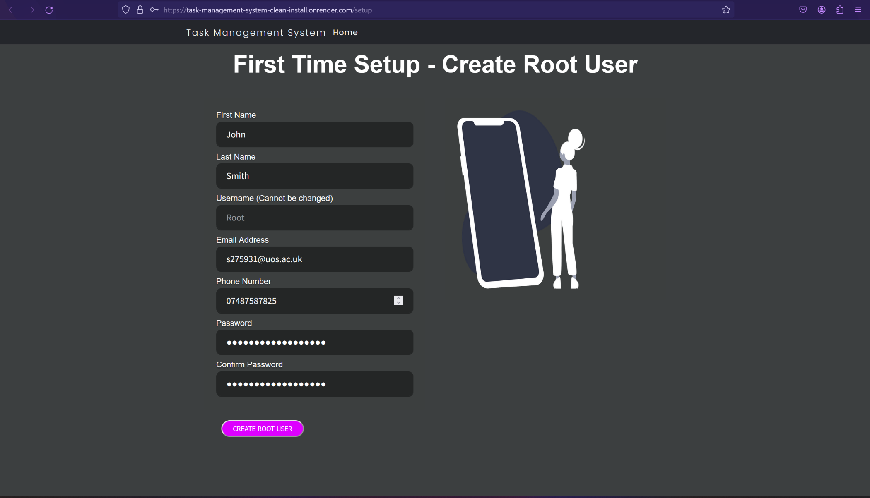

Figure 2 - Task Management System Setup Form Example

The Root user will then be redirected to the Home page and will be logged in to the Task Management System. The root user will automatically receive an email with their password sent to the email address entered in the setup form.

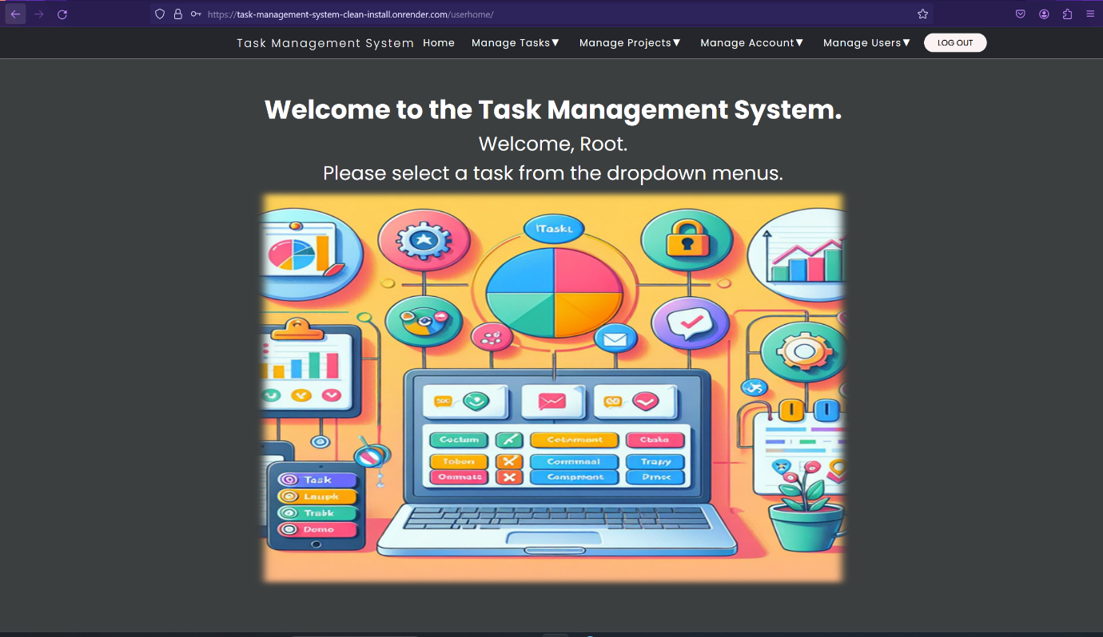

Figure 3 - Task Management System Home Page when logged in.

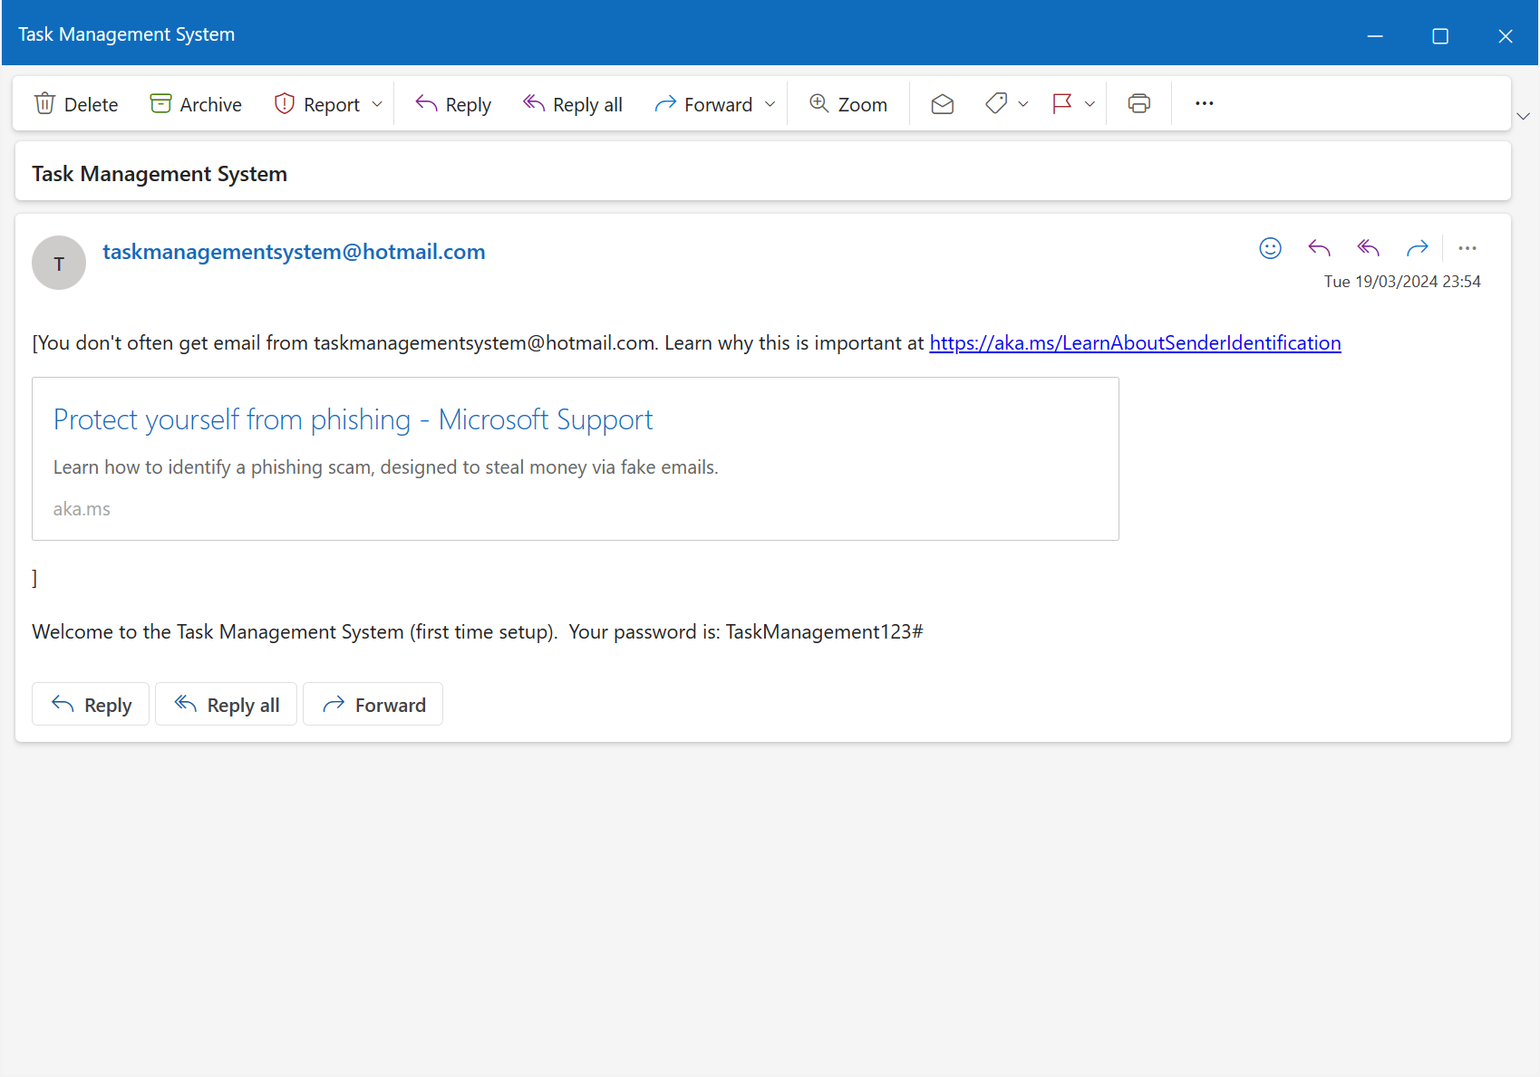

Figure 4 - Automatic email containing the Root User's password.

The Task Management System is now ready for use.

# Installation and Setup using Docker Deployment

These are instructions on how to install and set up the Task Management System as a Docker deployment.

1. Docker MUST be installed prior to installation and setup of the Task Management System and your computer must meet the system requirements to run Docker. For instructions, refer to the Docker documentation (<https://docs.docker.com/manuals/>) and download Docker here: <https://www.docker.com/products/docker-desktop/> .
2. Go to Docker hub to copy the pull command. For clean installation: <https://hub.docker.com/r/alexjrobertson/taskmanagementsystemcleaninstall> , for Task Management System with example data, users, tasks and projects: <https://hub.docker.com/r/alexjrobertson/taskmanagementsystem> .
3. Copy the following Docker pull command: *docker pull alexjrobertson/taskmanagementsystemcleaninstall* into the computer terminal, Command Prompt or PowerShell for download for a clean installation of the Task Management System container. Copy the following Docker pull command: *docker pull alexjrobertson/taskmanagementsystem* into the computer terminal, Command Prompt or PowerShell for the Task Management System Container with example data, users, tasks, and projects. When using Docker on Linux, you may be required to type ‘sudo’ before entering the Docker commands or else you may get a ‘permission denied’ or ‘access denied’ error. You may also be prompted to enter your computer password (must be an administrator, root or superuser password) into the Linux terminal. This applies to all Docker commands when using Linux.
4. Enter the following Docker command to run the container: *docker container run -d -p 5000:5000 alexjrobertson/taskmanagementsystemcleaninstall:latest* for the clean installation and *docker container run -d -p 5000:5000 alexjrobertson/taskmanagementsystem:latest* for the Task Management System with example data, users, tasks, and projects. The port number in red can be changed to suit the specific need of the host running the Task Management System. This is especially important if you have multiple containers running or multiple applications using localhost as two applications or containers cannot share the same port.

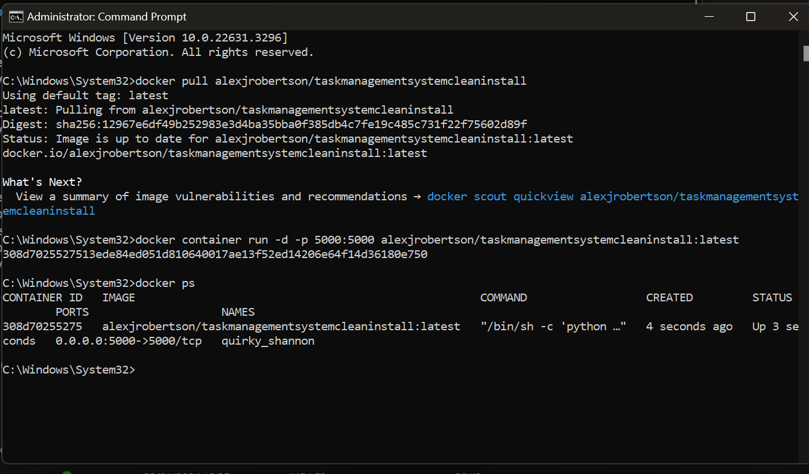

Figure 5 - Example of downloading and running the Task Management System container using Docker commands in the Command Prompt.

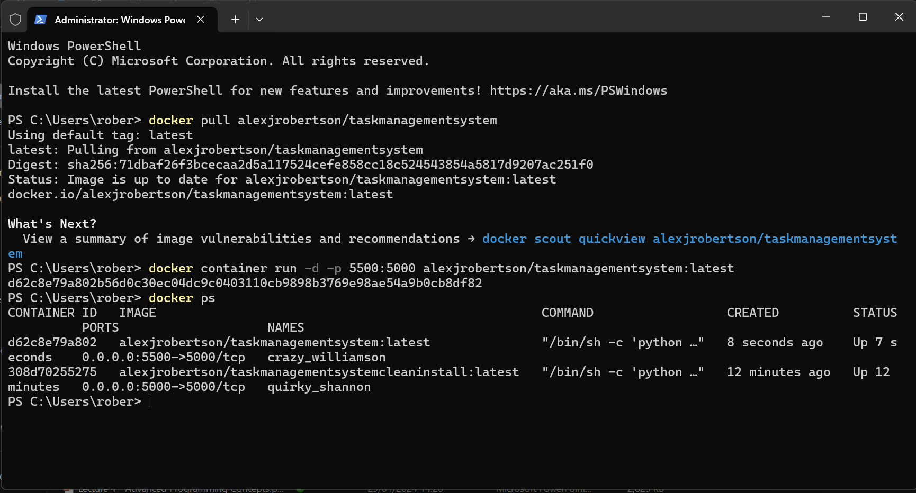

Figure 6 - Example of downloading the Task Management System image and running the Task Management System container using Docker commands in the terminal (Windows PowerShell)

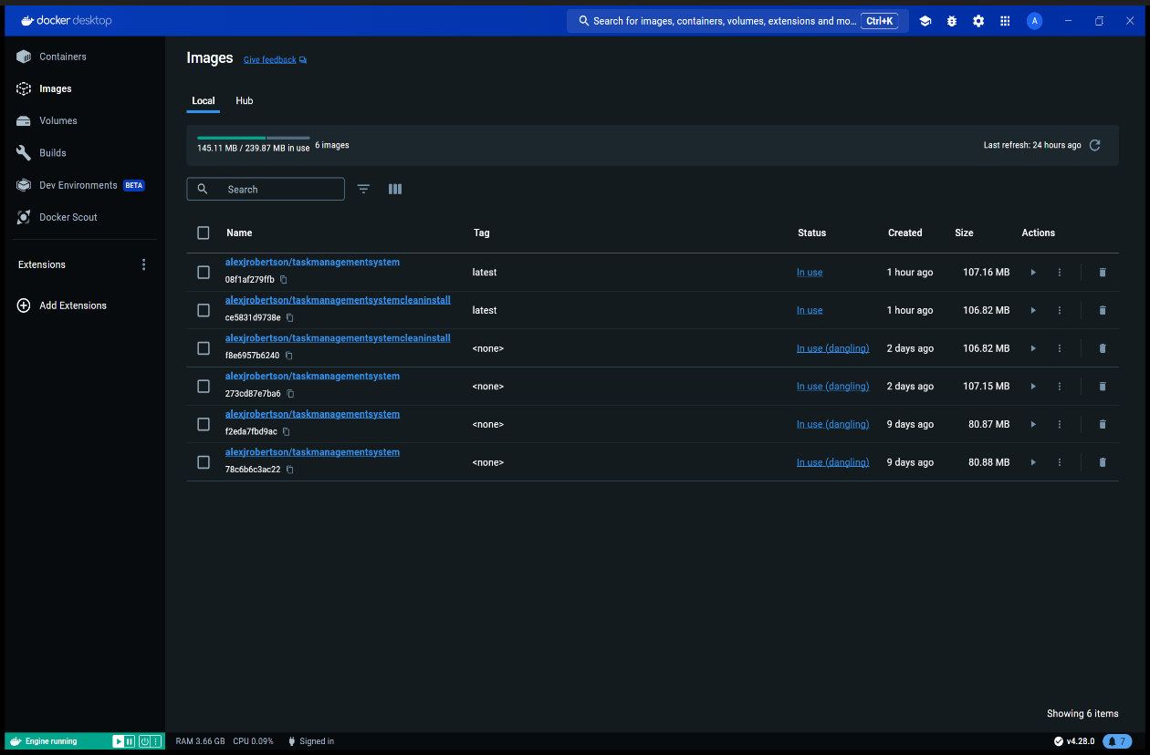

Figure 7 - Task Management System images visible on Docker Desktop.

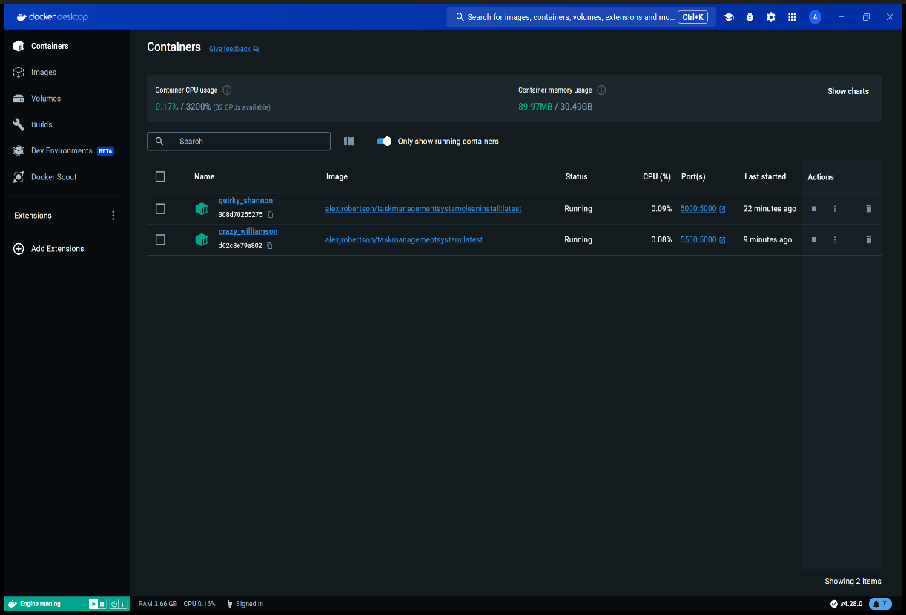

Figure 8 - Running Task Management System containers visible on Docker Desktop.

1. You can also run the Task Management System containers by clicking the play ▶ buttons beneath the Actions page below the Actions tab on the Images page. Then open Optional Settings in the popup menu that appears and assign a port to the container and then click Run. See the screenshot below for an example.

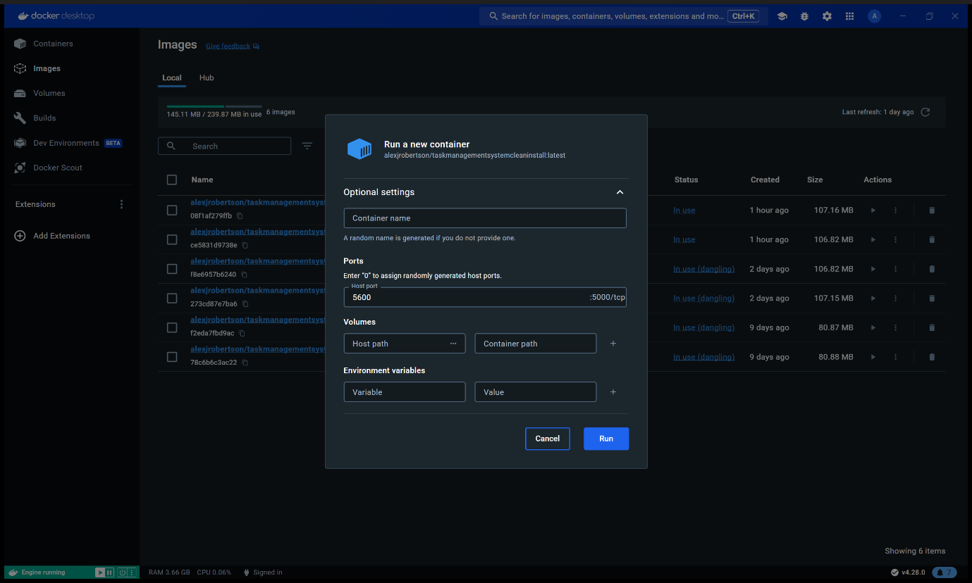

Figure 9 - Running the Taks Management System container from Docker Desktop GUI. Make sure to assign a port number.

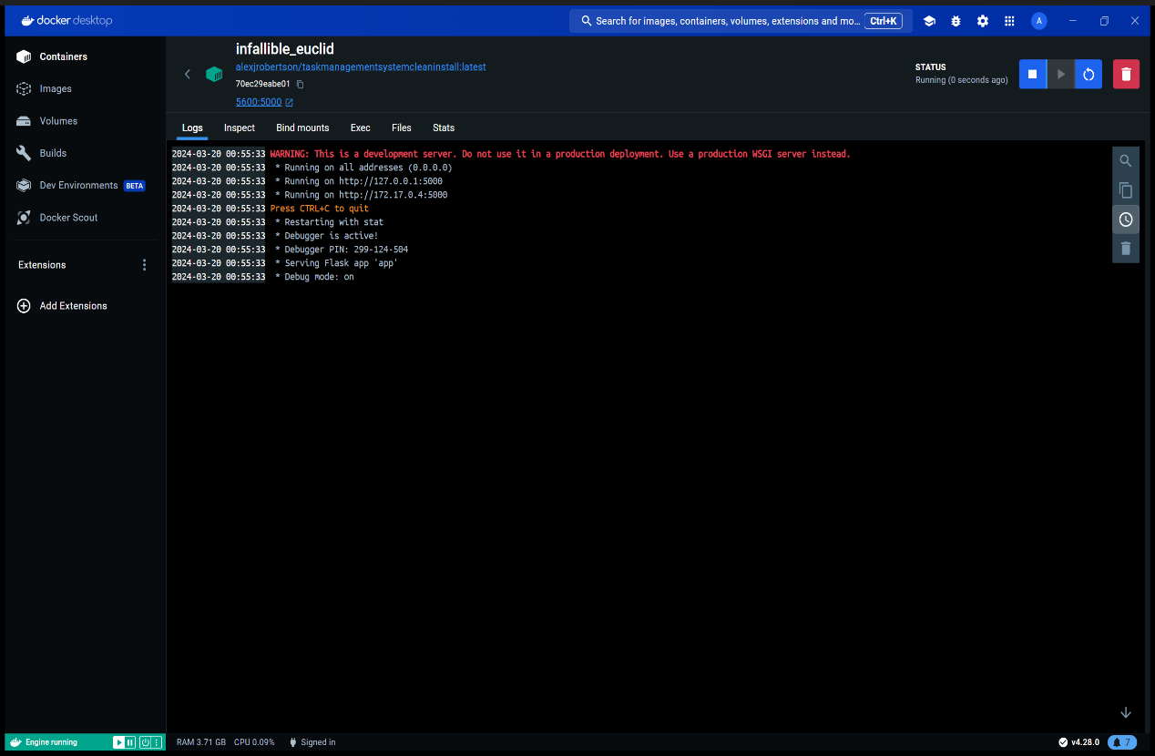

Figure 10 - Docker Desktop after running the Task Management System container.

1. Type localhost:<port number> e.g. localhost:5000 or localhost:5500 into the web browser address bar and press enter. The port you enter must be the same as the one you entered in the *docker container run* command. The Task Management System Setup page or Landing page (Home / index.html) will appear.

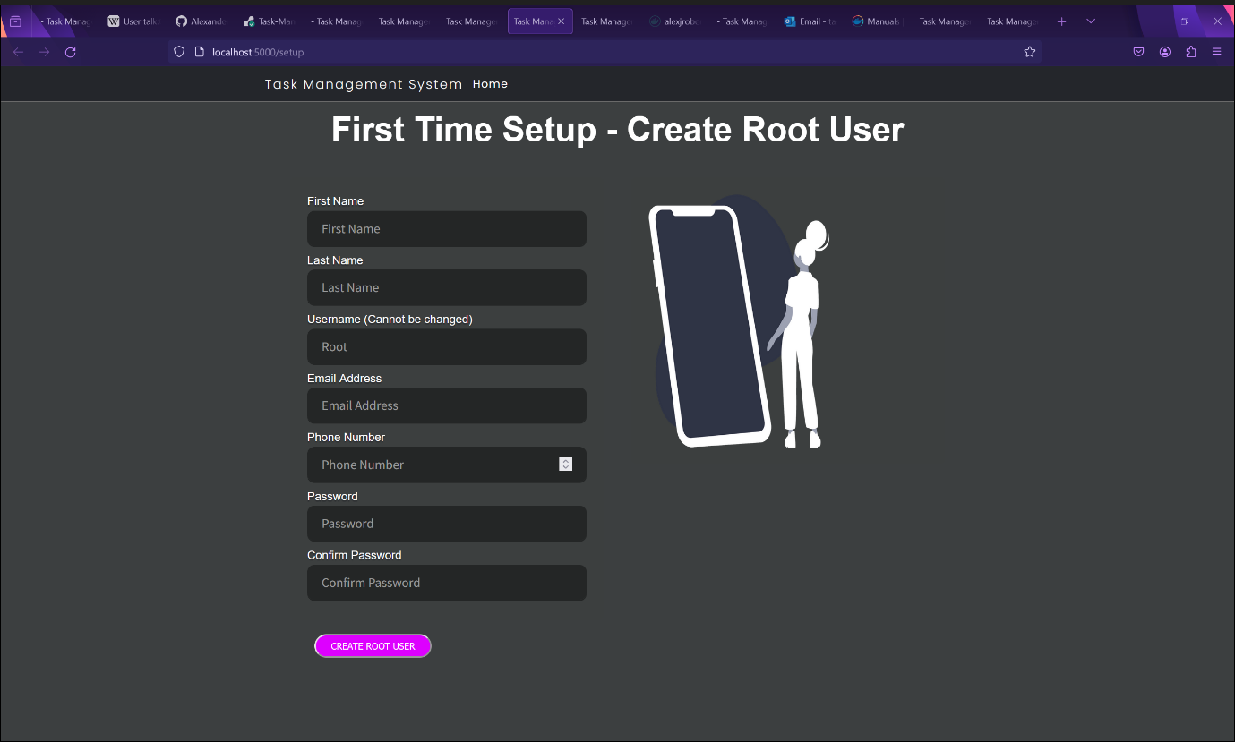

Figure 11 - The Task Management System Setup page is loaded when you enter localhost:<container port number> e.g. localhost:5000 into the address bar in your web browser.

1. Fill in the fields in the form then click the *Create Root User* button. The Root username cannot be changed. The password must be a minimum length of 10 characters, have at least one capital letter, one lowercase letter, one number and one special character (ASCII characters only). The password must not be a common password. See the screenshot below for an example.

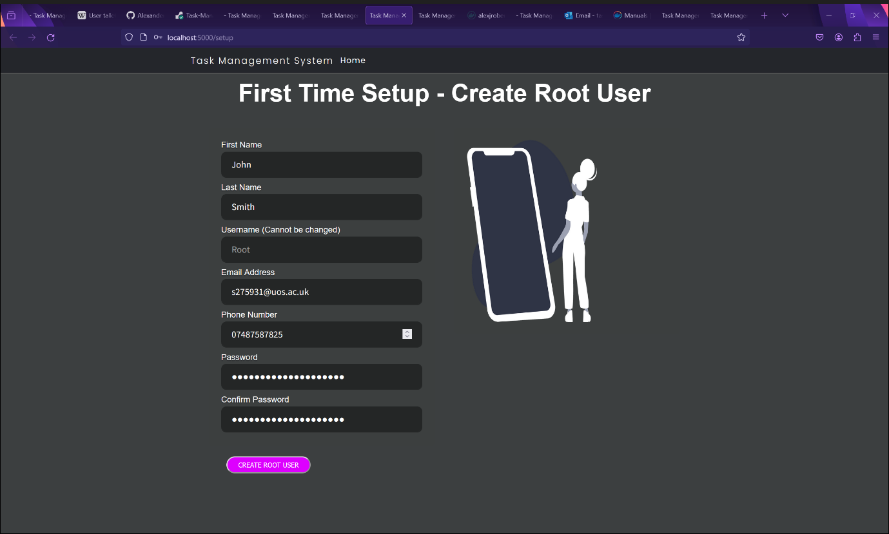

1. You will be redirected to the homepage and be logged in.

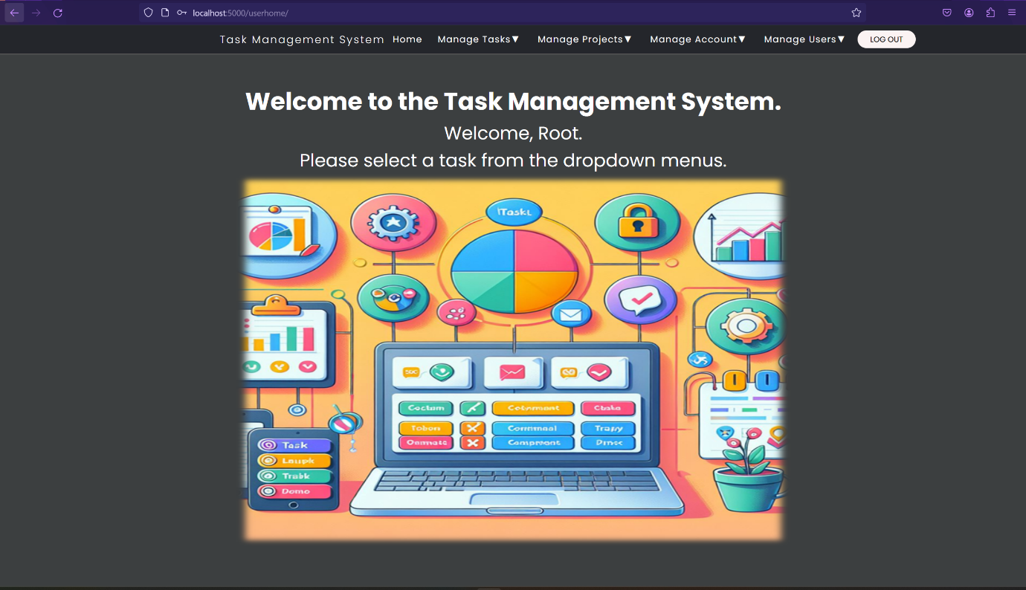

Figure 12 - The Root User is redirected to the home page and logged in after setup.

1. You will receive an automatic email with your password.

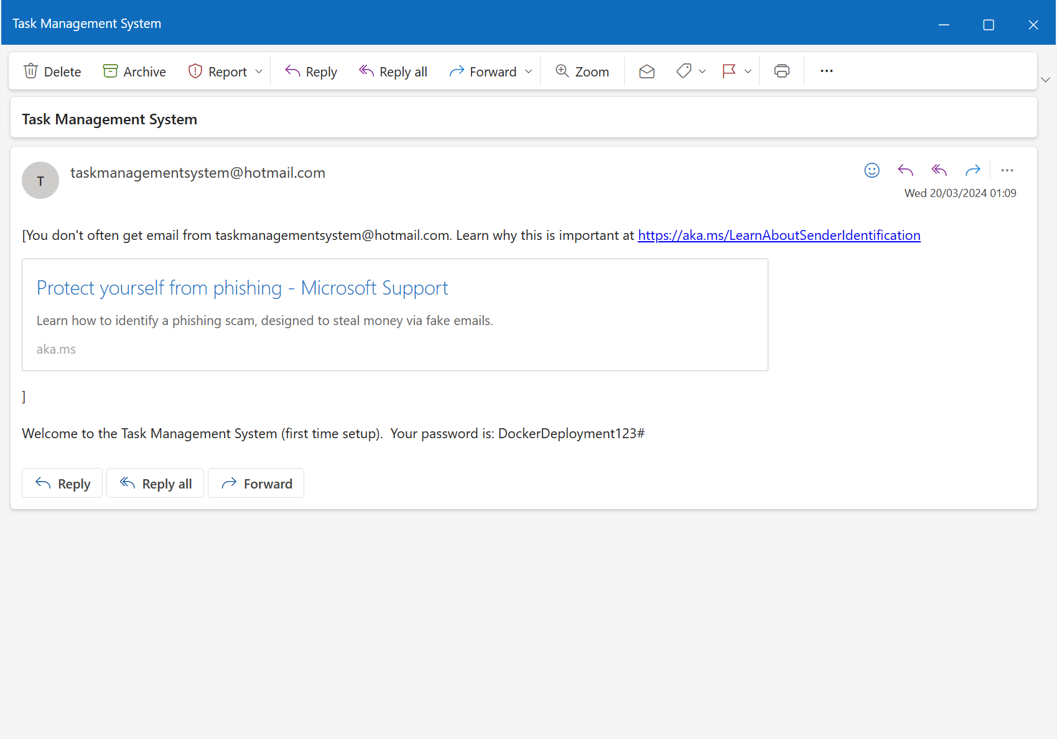

Figure 13 - Email containing Root User's password.

1. The Task Management System is ready to use.
2. For the Task Management System with example data, users, tasks, and projects:
   1. The username for the Root user is Root and the password is TaskManagement123#
   2. The username for an administrator is barneyPurpleDinosaur and the password is BabyBop123#
   3. The username for a standard user is Birmingham888 and the password is SouthSide123@
3. To stop the Task Management System Docker containers, Click the Stop ◼ buttons below the Actions tab on the Containers page on Docker Desktop or type docker *stop <container_id>* where *<container_id>* is the ID number or name of the container. See the two screenshots below for an example.

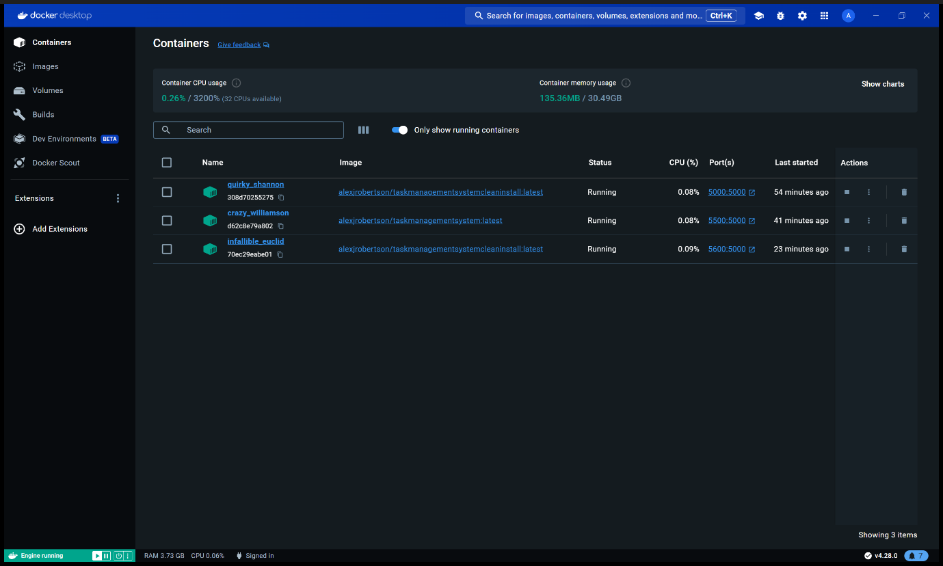

Figure 14 - Stopping Task Management System containers in Docker Desktop.

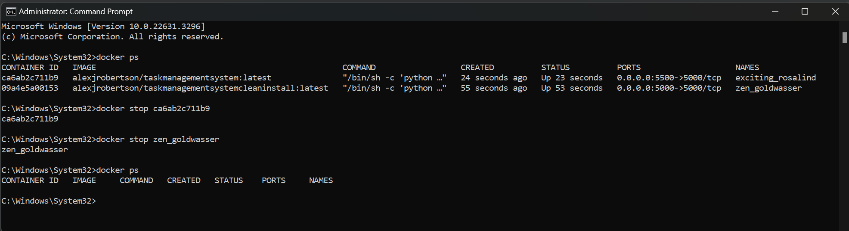

Figure 15 - Using docker stop commands using the Command Prompt / PowerShell / Terminal

# Installation and Setup Using Source Code

Instructions to download the Task Management System source code from GitHub repository and build and deploy the application from scratch. Using this method, you can modify the source code to suit your organisation’s needs such as modifying, adding, or removing features, changing the architecture, password requirements, database design, automatic email messages and domain, user interface design or experiment with new features. You can also choose a deployment platform of your own choice however this may require you to make modifications to the source code and files.

**WARNING: ONLY MODIFY THE SOURCE CODE IF YOU HAVE EXPERIENCE WITH AND UNDERSTAND PYTHON 3, SQL, SQLITE, HTML, CSS, JAVASCRIPT, FLASK, DOCKER AND DOCKERFILES, GUNICORN AND GIT. EDITING THESE FILES WITHOUT THE RIGHT KNOWHOW MAY DAMAGE THE TASK MANAGEMENT SYSTEM, RENDERING THE APPLICATION INOPERABLE AND/OR CORRUPT THE DATABASE RESULTING IN PERMANENT DATA LOSS! ALWAYS BACK UP THE ORIGIONAL APPLICATION AND USE VERSION CONTROL ON YOUR OWN GIT REPOSITORY IN CASE THE APPLICATION GETS DAMAGED. THE SOFTWARE AUTHOUR CANNOT BE HELD RESPONSIBLE FOR DAMAGE CAUSED BY A THIRD PARTY MODIFYING THE SOURCE CODE.**

## Prerequisites

To modify, build and deploy the Task Management System from scratch, you will need the following software installed on your computer:

* Windows 10, Windows 11, macOS 12.0 (Monterey) or a supported distribution of Linux (Ubuntu, Debian, RHEL etc.)
* Windows Subsystem for Linux (WSL) or Hyper-V features enabled if using Windows and a compatible version of Linux installed in WSL (see above)
* PyCharm IDE
* Python 3.12 interpreter
* SQLite Studio
* Git
* Docker
* Compatible web browser (Firefox, Google Chrome, Microsoft Edge, Safari etc.)

## Downloading from the GitHub repository

Firstly, you will need to download the Task Management System from the GitHub repository by cloning the repository using the git clone command in the Terminal / PowerShell / Command Prompt.

Link to GitHub repository for clean install: <https://github.com/AlexanderJohnRobertson/task-management-system-clean-install.git>

Link to GitHub repository for Task Management System with example data, users, tasks and projects: <https://github.com/AlexanderJohnRobertson/task-management-system.git> (The username for the Root user is Root and the password is TaskManagement123# ,

The username for an administrator is barneyPurpleDinosaur and the password is BabyBop123# ,

The username for a standard user is Birmingham888 and the password is SouthSide123@ ).

Enter the following git command into the computer Terminal / PowerShell / Command Prompt to clone and download the Task Management System as a clean install: *git clone* [*https://github.com/AlexanderJohnRobertson/task-management-system-clean-install.git*](https://github.com/AlexanderJohnRobertson/task-management-system-clean-install.git%20)

Enter the following git command into the computer Terminal / PowerShell / Command Prompt to clone and download the Task Management System with example data, users, tasks and projects: *git clone* [*https://github.com/AlexanderJohnRobertson/task-management-system.git*](https://github.com/AlexanderJohnRobertson/task-management-system.git)

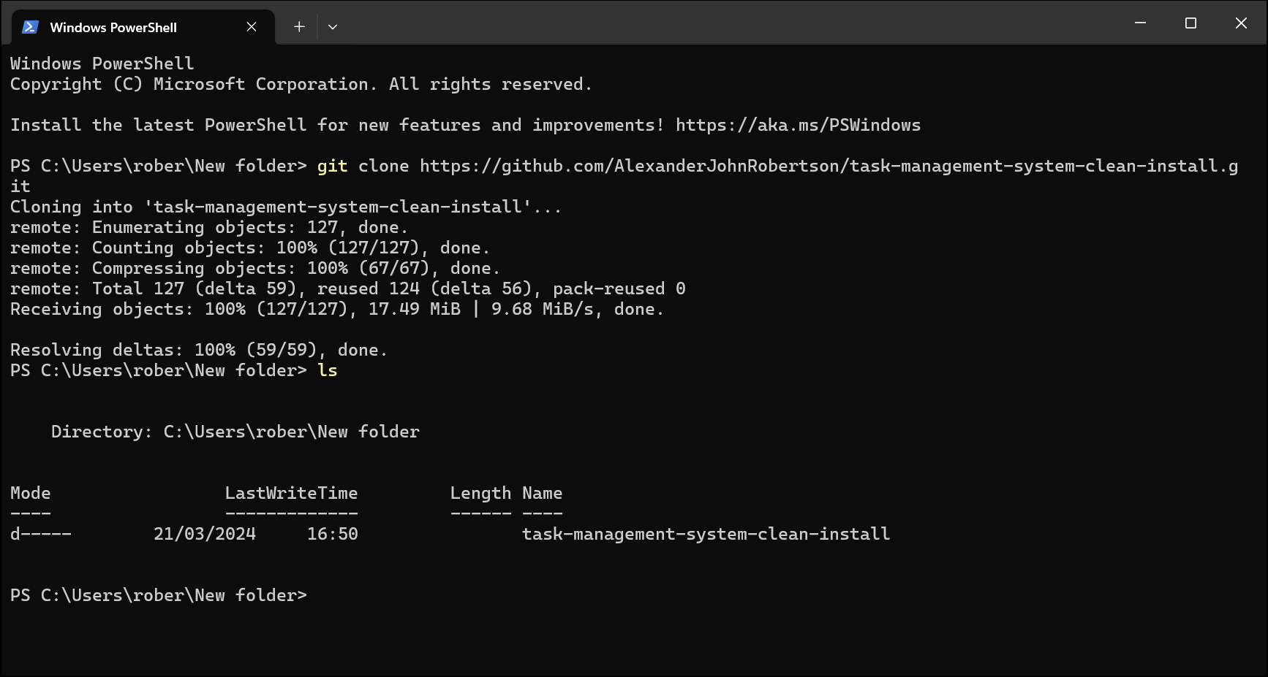

Figure 16 - Screenshot of cloning the Task Management System Clean Install Git repository.

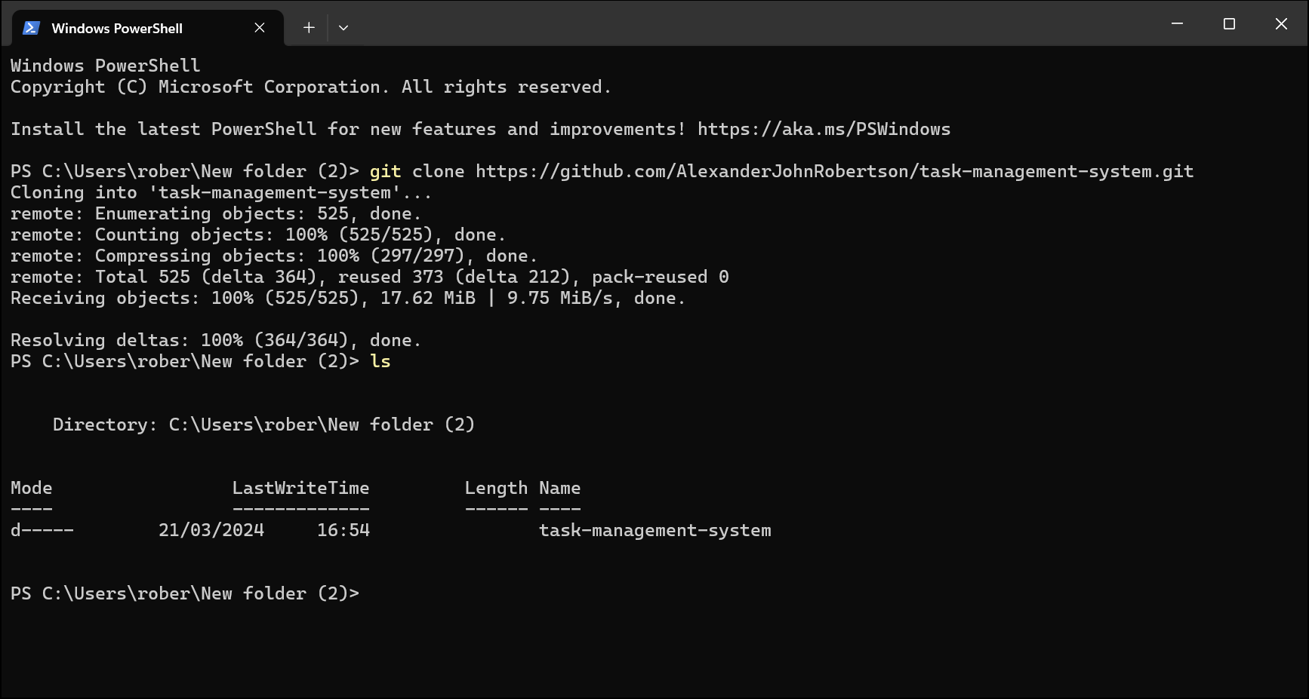

Figure 17 - Screenshot of cloning the Task Management System with example data, users, tasks, and projects from the git repository.

## Open the PyCharm Project

1. Open PyCharm.
2. On the Welcome to PyCharm screen, select ‘Open’.

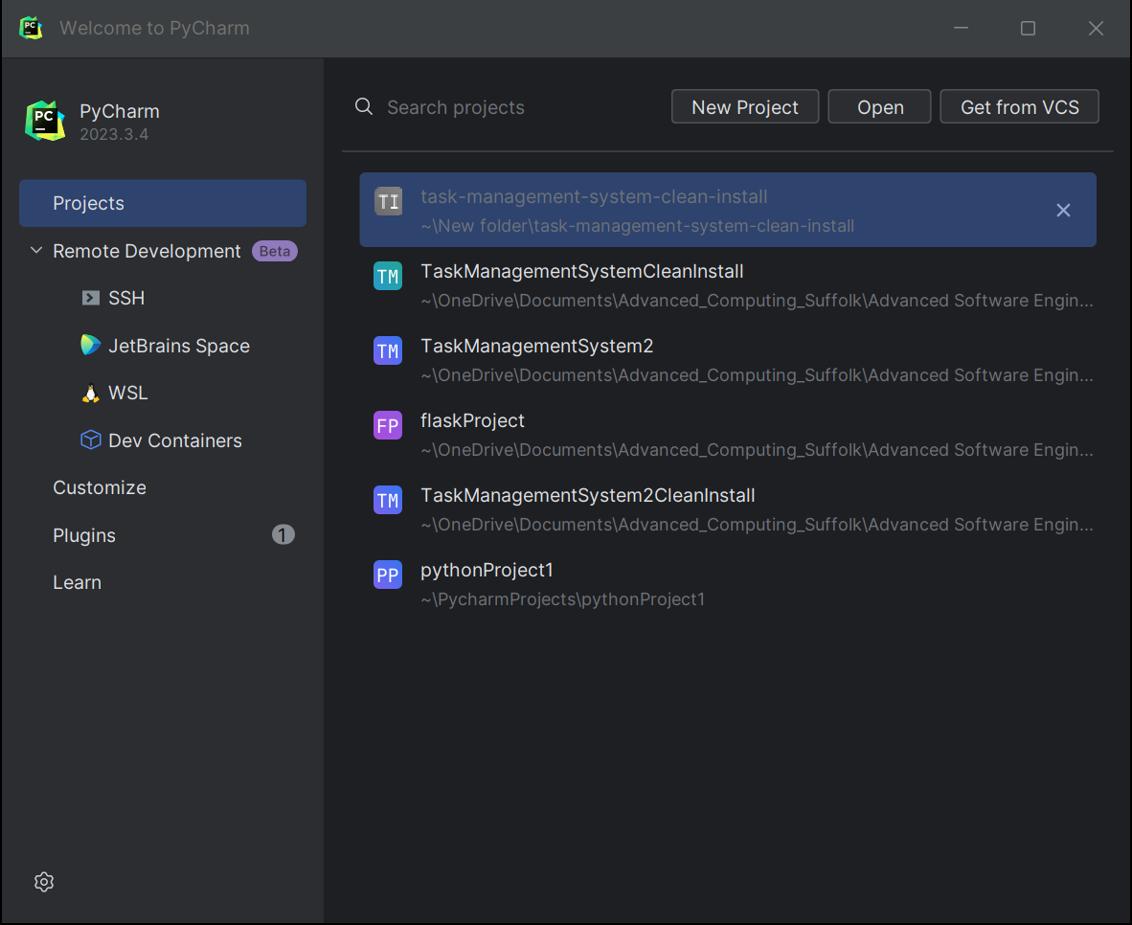

Figure 18 - PyCharm Welcome Screen

1. Navigate to the location of the cloned Git repository and select the “task-management-system-clean-install” or “task-management-system” folder then click “OK”.

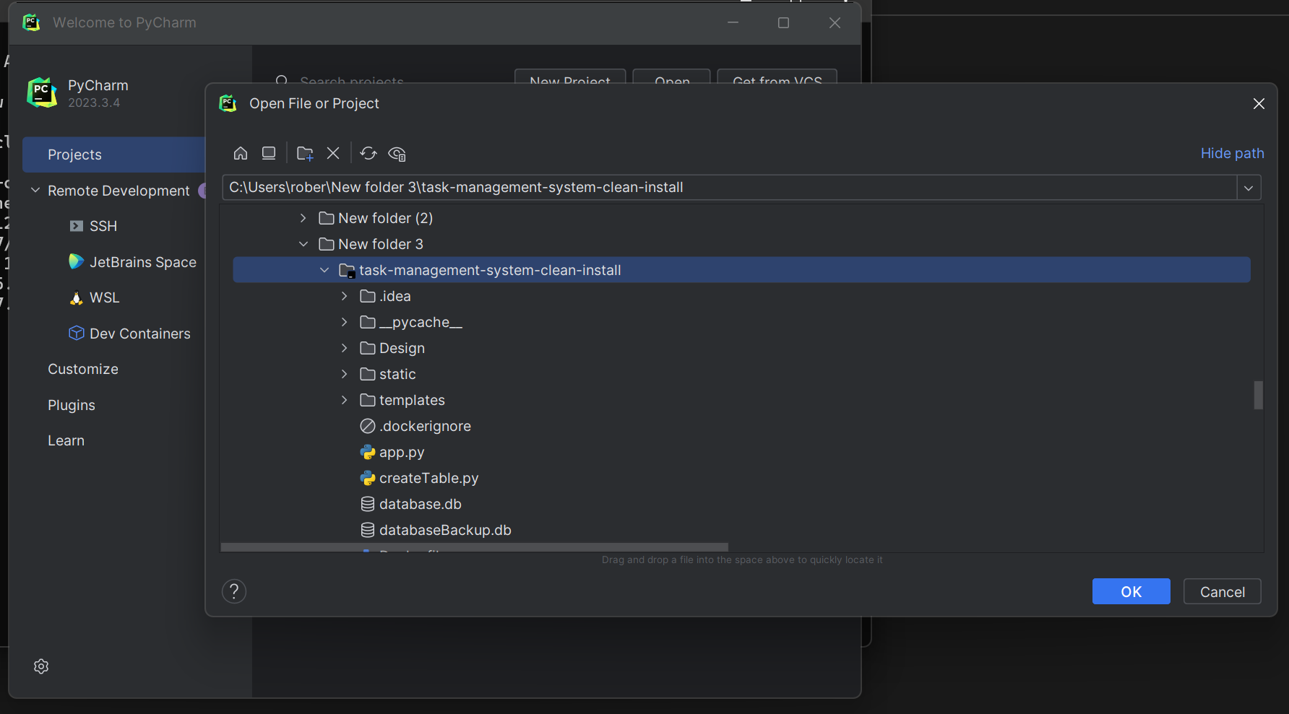

Figure 19 - PyCharm file browser.

1. Click “Trust Project”.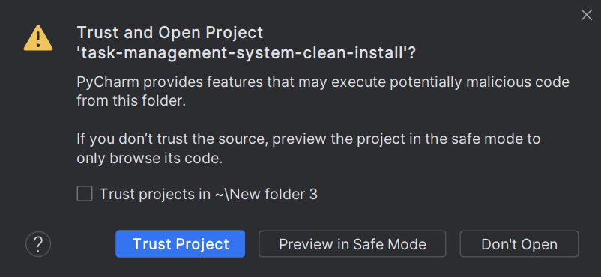

Figure 20 - Select "Trust Project”.

1. Wait for PyCharm to load the project and then click on “app.py” – the main Python file in the Task Management System.

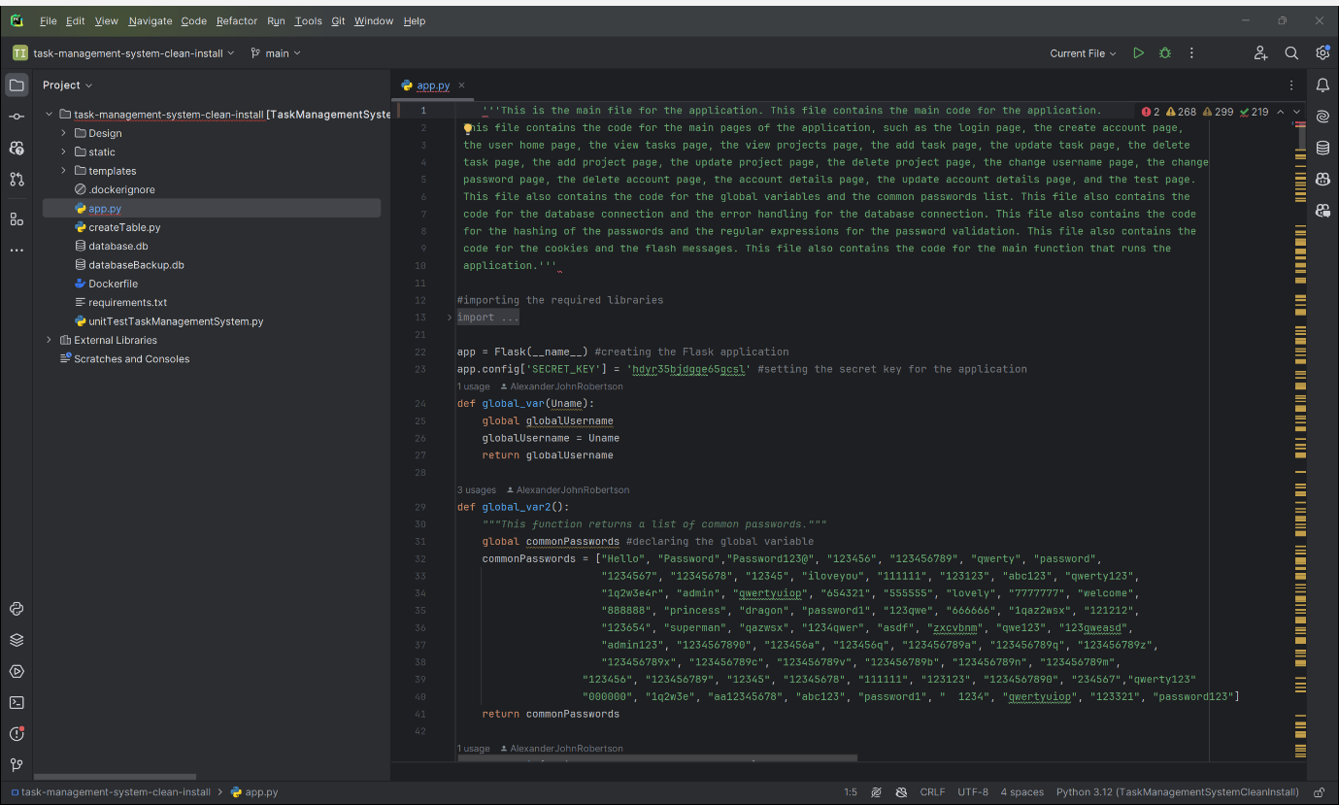

Figure 21 - PyCharm should look like this once it is loaded and app.py is opened.

## Setting up the PyCharm environment (Windows)

1. Delete the. venv folder and select “Delete” to confirm.

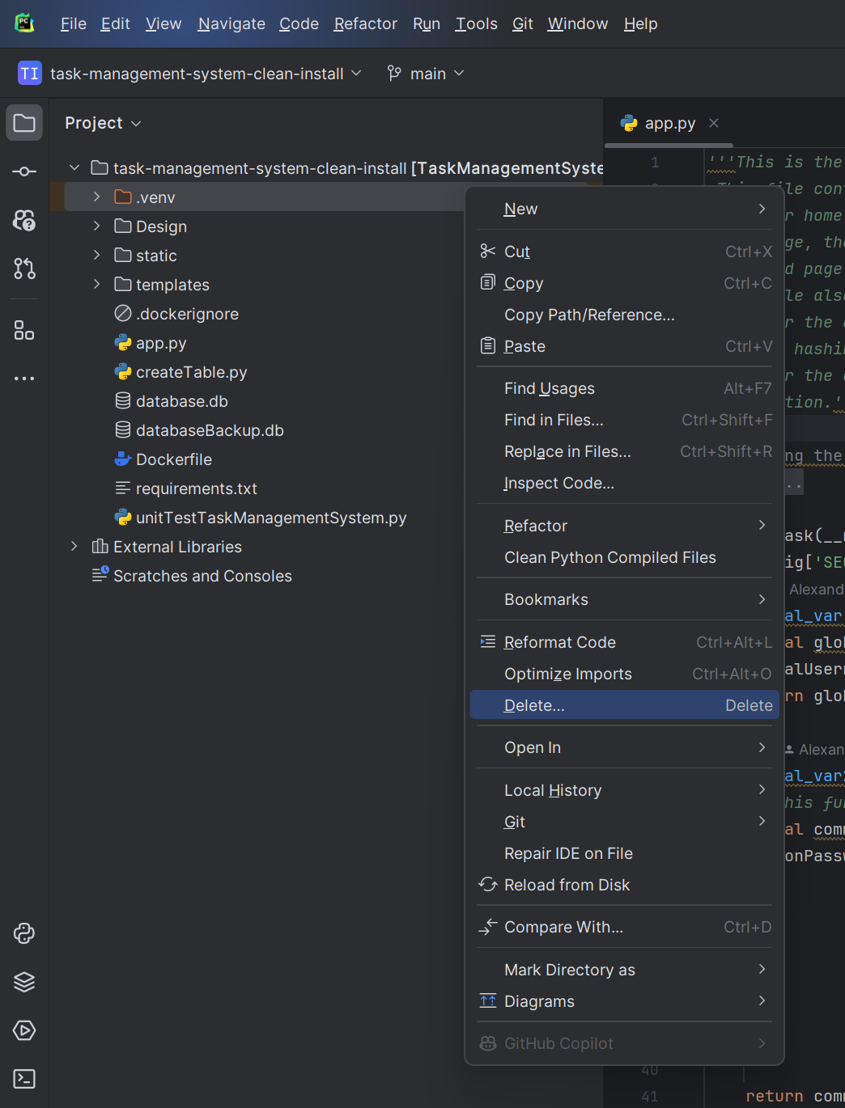

Figure 22 - Deleting the. venv or venv folder

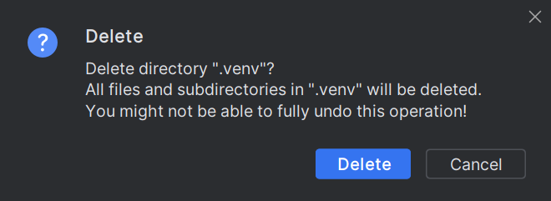

Figure 23 - Click Delete

1. Set up a new Python interpreter for the project.
   1. Select the Settings (⚙️icon in the top right corner of PyCharm IDE) then click “⚙️Settings…” in the menu.

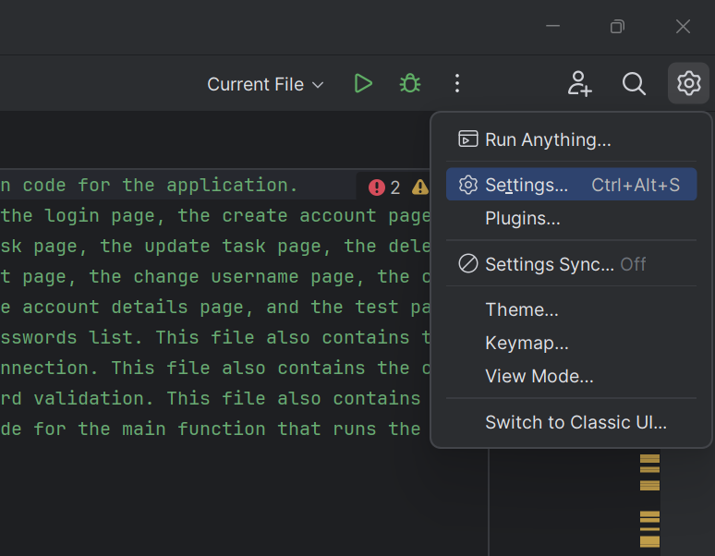

Figure 24 - Selecting the Settings drop down menu.

* 1. In the settings menu select “Project: task-management-system” or “Project: task-management-system-clean-install” > “Python Interpreter”.
  2. Select “Add Interpreter” next to “Python Interpreter” and then “Add Local Interpreter…” on the drop-down menu.
  3. Select “No Interpreter” from the drop-down menu.

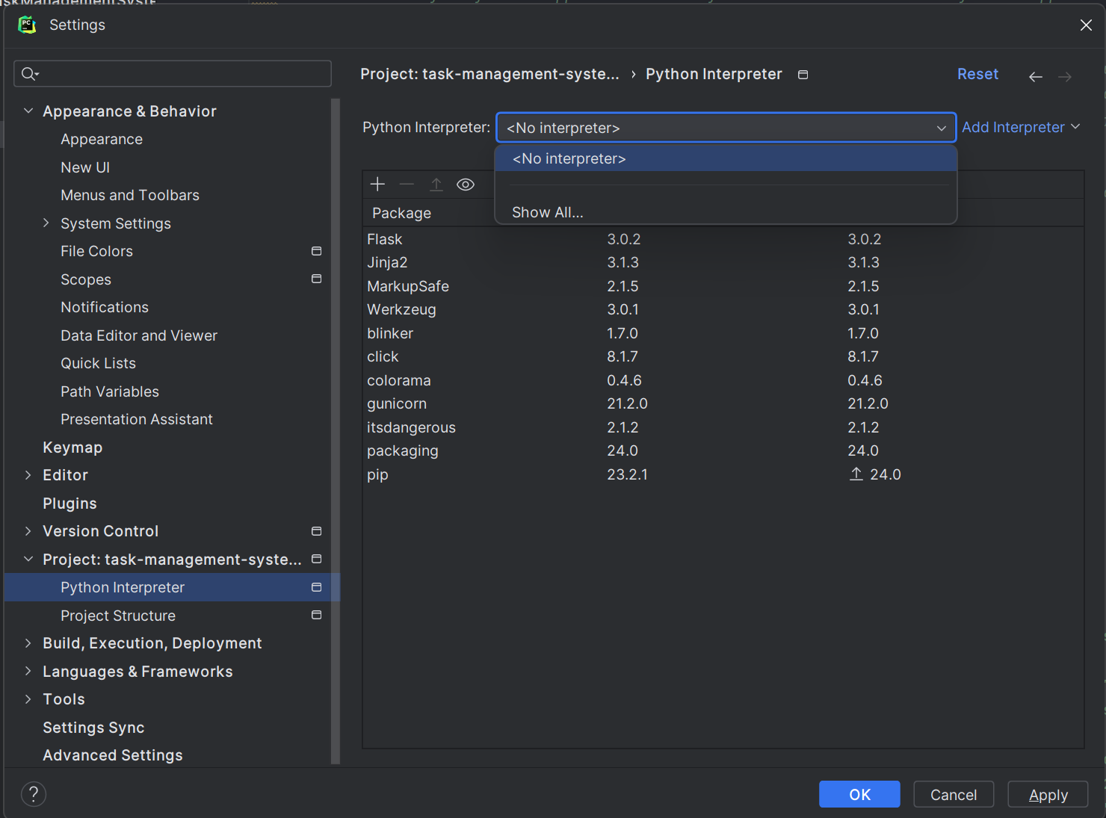

Figure 25 - Setting up the Python Interpreter.

* 1. Then select "Add Local Interpreter” from the “Add Interpreter” drop-down menu.

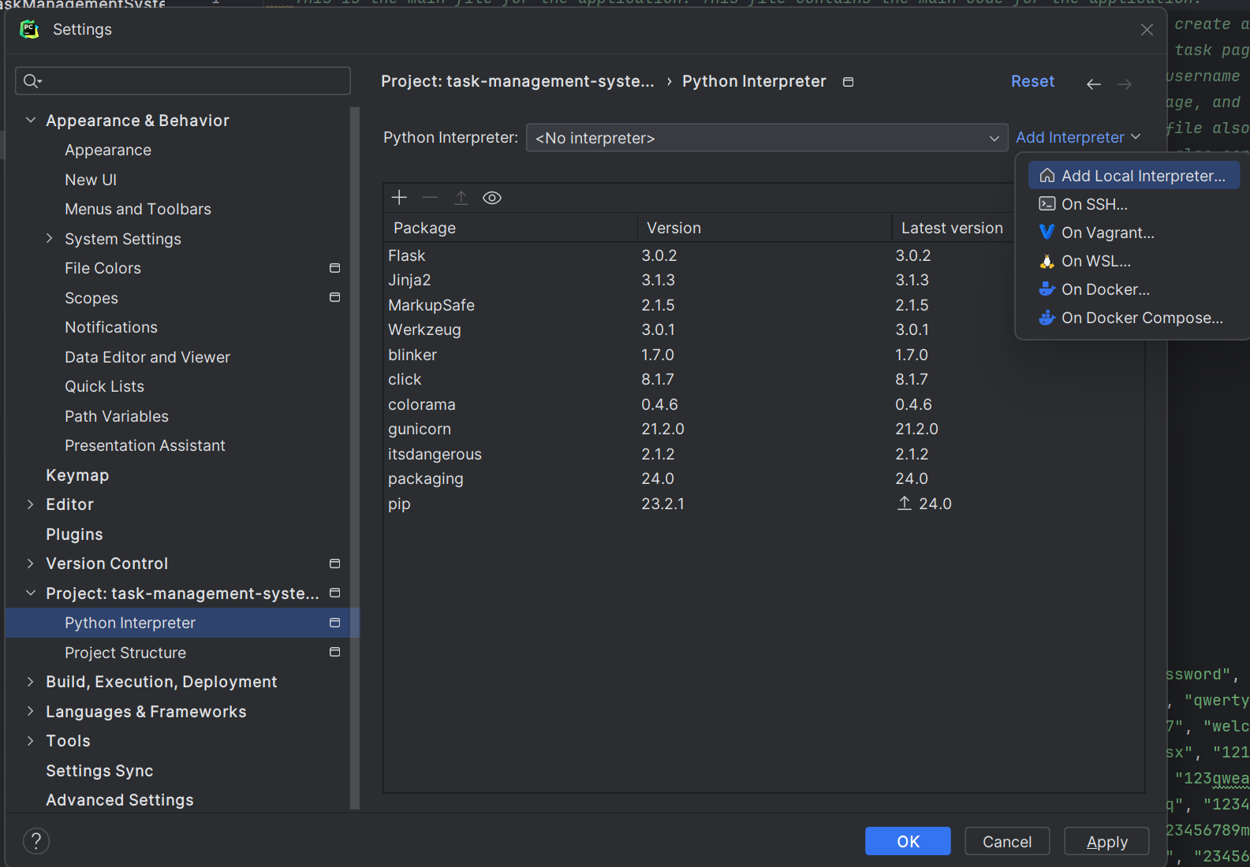

Figure 26 - Setting up the Python Interpreter.

* 1. Select “Environment: New” radio button and PyCharm will automatically create a new. venv directory for the Python Virtual Environment. Make sure the Base Interpreter is set to the location path of the Python3.12 interpreter installed on the computer. Then click “OK”.

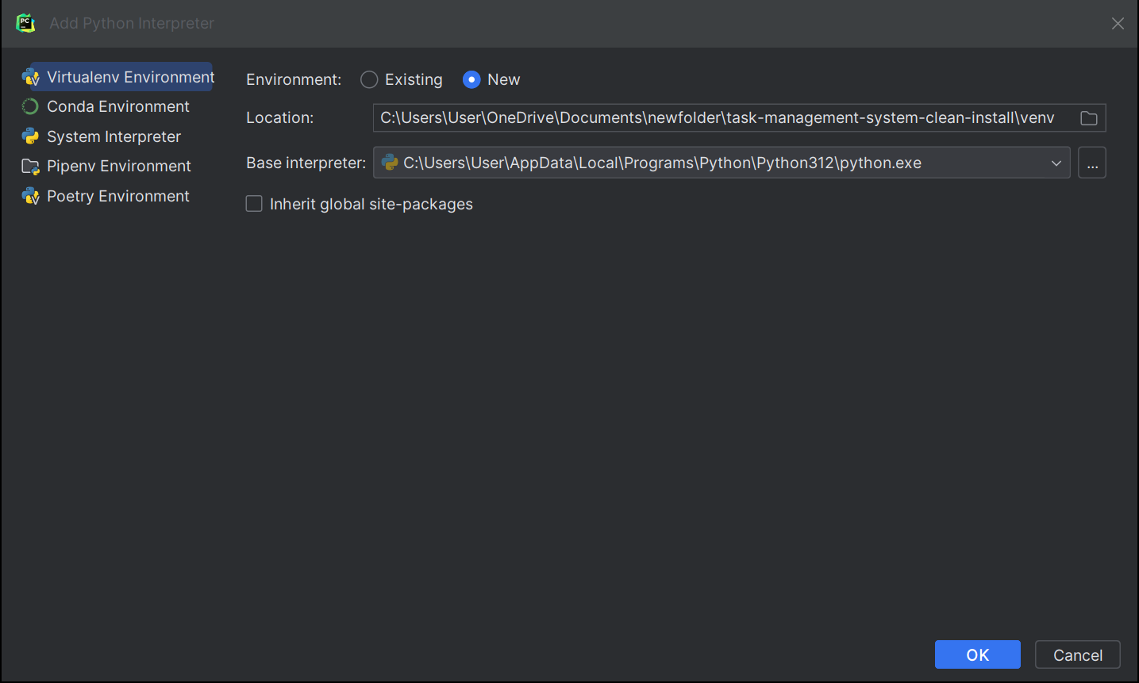

Figure 27 - Select New Environment option, Location: Path to virtual environment (auto generated), Base Interpreter: Path to Python 3.12 installation.

* 1. Wait for the virtual environment to be created then click OK again.
  2. Click the link to use the Python Interpreter you have created in the new. venv directory.

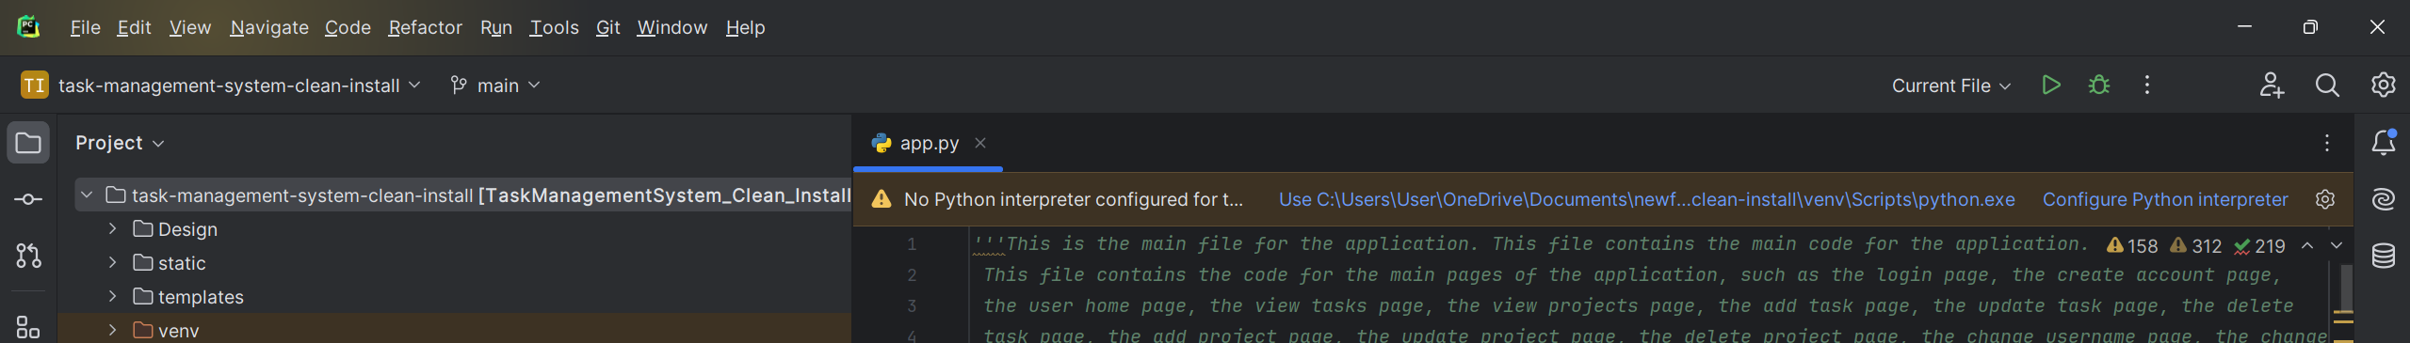

Figure 28 - Click the link to use the Python Interpreter you have created in the new. venv directory.

1. Set up Flask configuration.
   1. Select “Current File” then “Edit Configurations…”

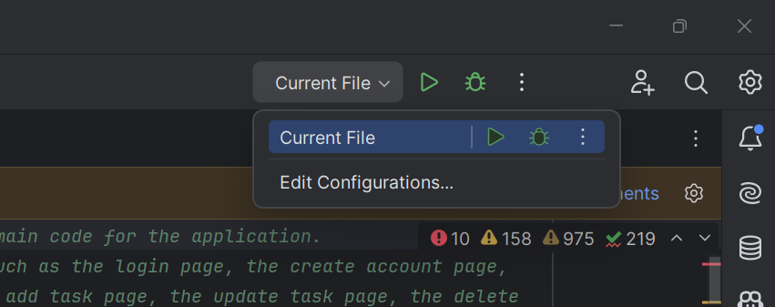

Figure 29 - Select Edit Configurations...

* 1. Click “Add new run configuration…” and select “Flask Server” from the drop-down menu.

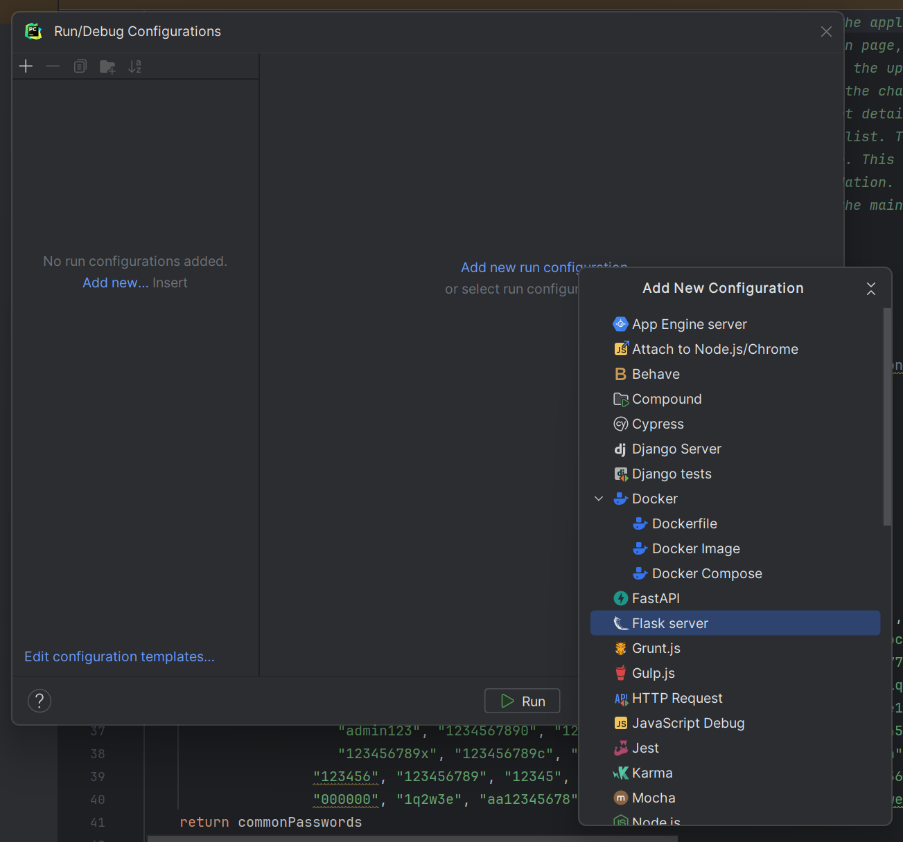

Figure 30 - Select "Add new run configuration" then "Flask server".

* 1. Set the target to “App.py”, Set “FLASK_ENV:” to “development” and enable “FLASK_DEBUG”. Make sure the Python interpreter is selected in “Python Interpreter”. Then click “OK”.

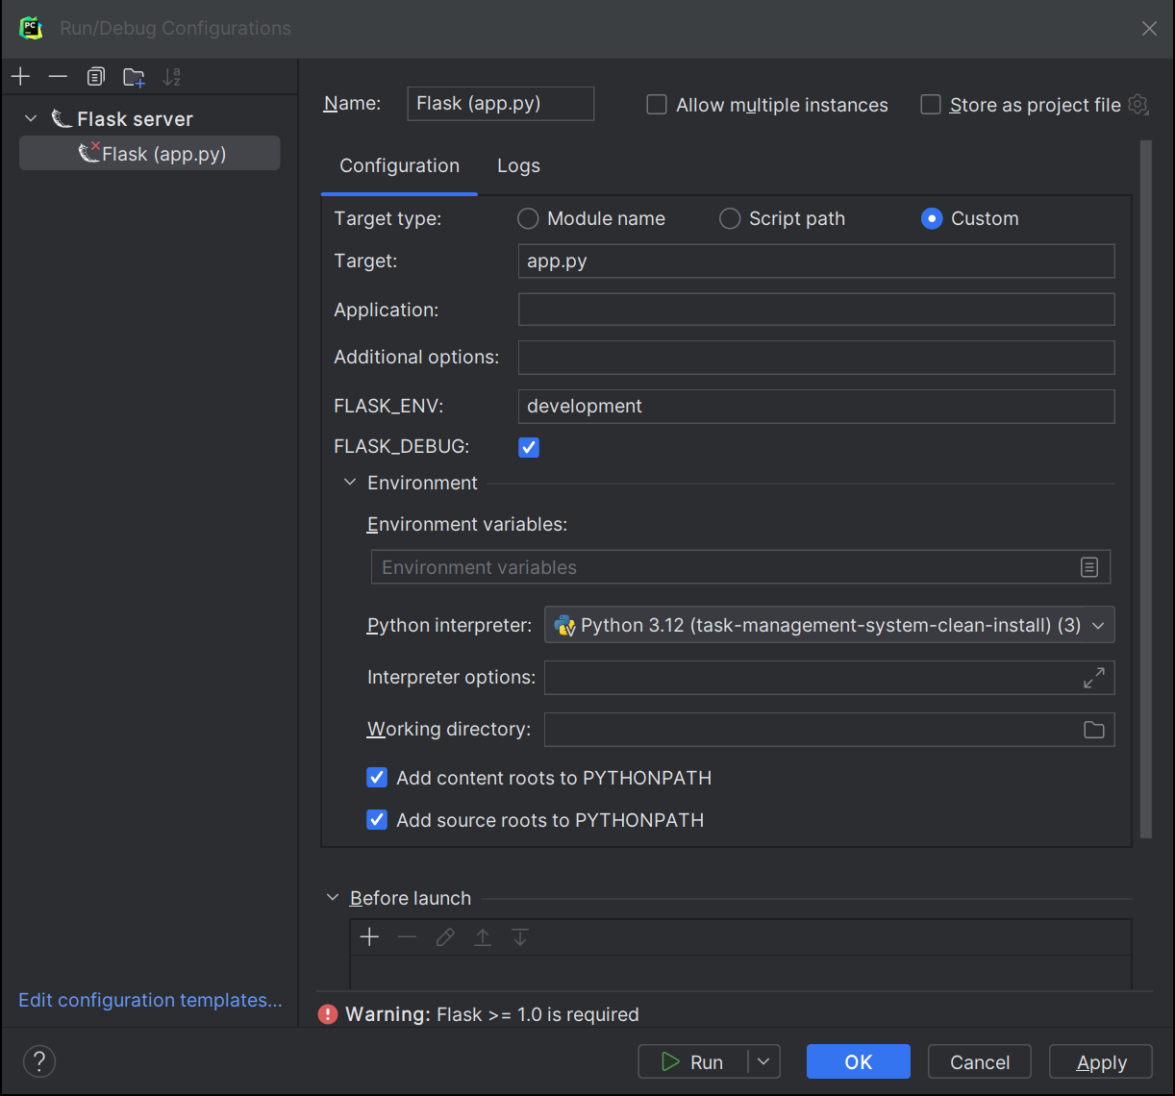

Figure 31 - Set Target to "app.py", FLASK_ENV: to "development", enable FLASK_DEBUG:, set Python Interpreter to Python 3.12 (task-management-system(-clean-install). Click OK.

* 1. Install any missing requirements if you get a message that they ae missing by clicking “Install requirements”.



Figure 32 - Install requirements if prompted to do so.

* 1. If you had to install any missing requirements, make sure both requirements are selected and click “Install”. Wait for requirements to install.

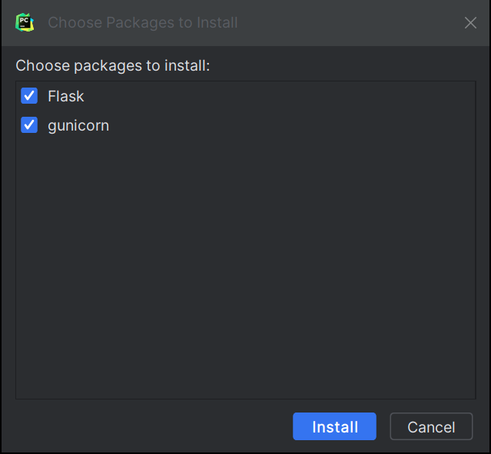

Figure 33 - Make sure "Flask" and "Gunicorn" are selected then click "Install".

x

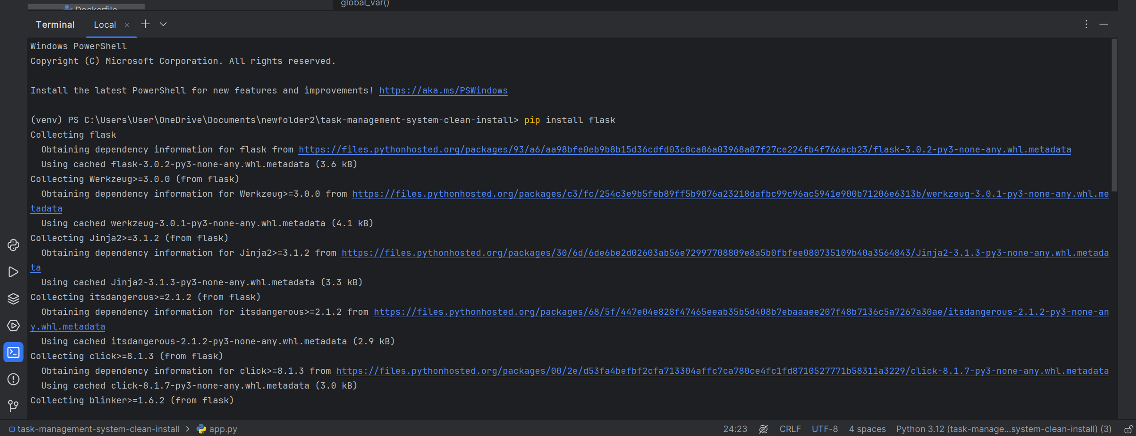

Figure 34 - "pip install flask" in PyCharm console.

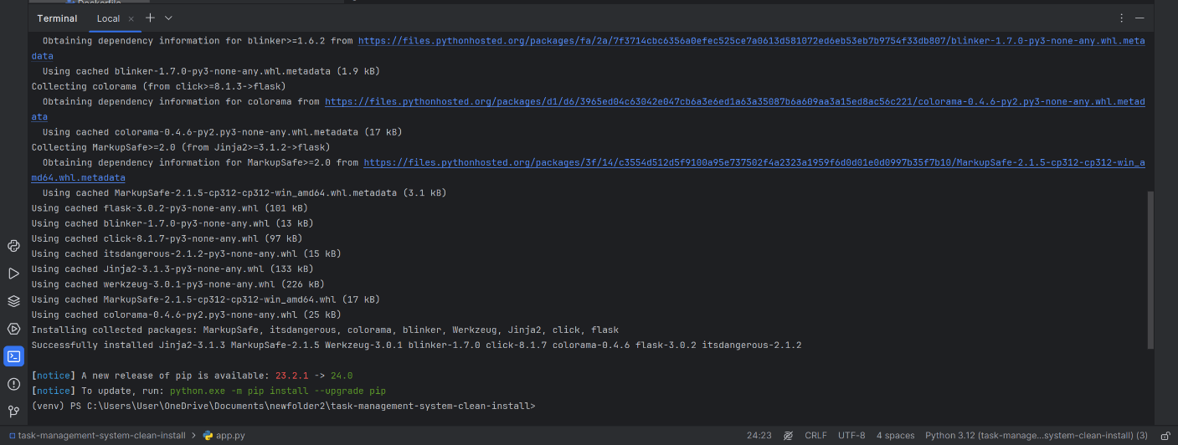

Figure 35 - "pip install flask" in PyCharm console.

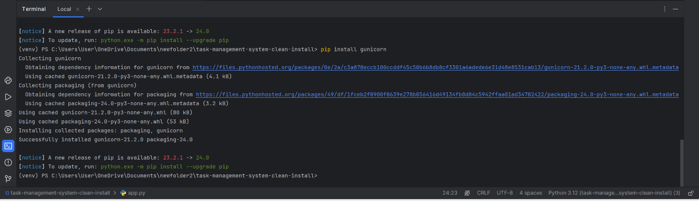

Figure 36 - "pip install gunicorn" in PyCharm console.

## Setting up the PyCharm Environment (Linux)

1. Delete the venv directory and confirm deletion.

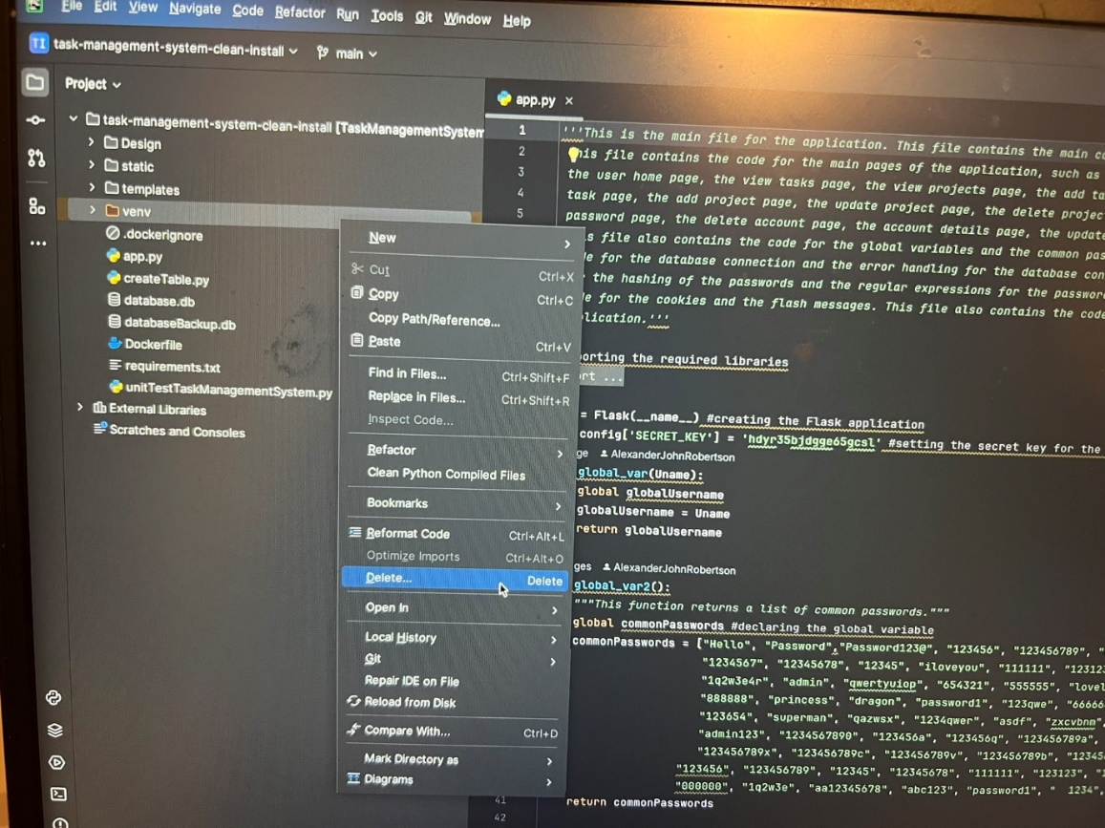

Figure 37 - Deleting the. venv or venv folder

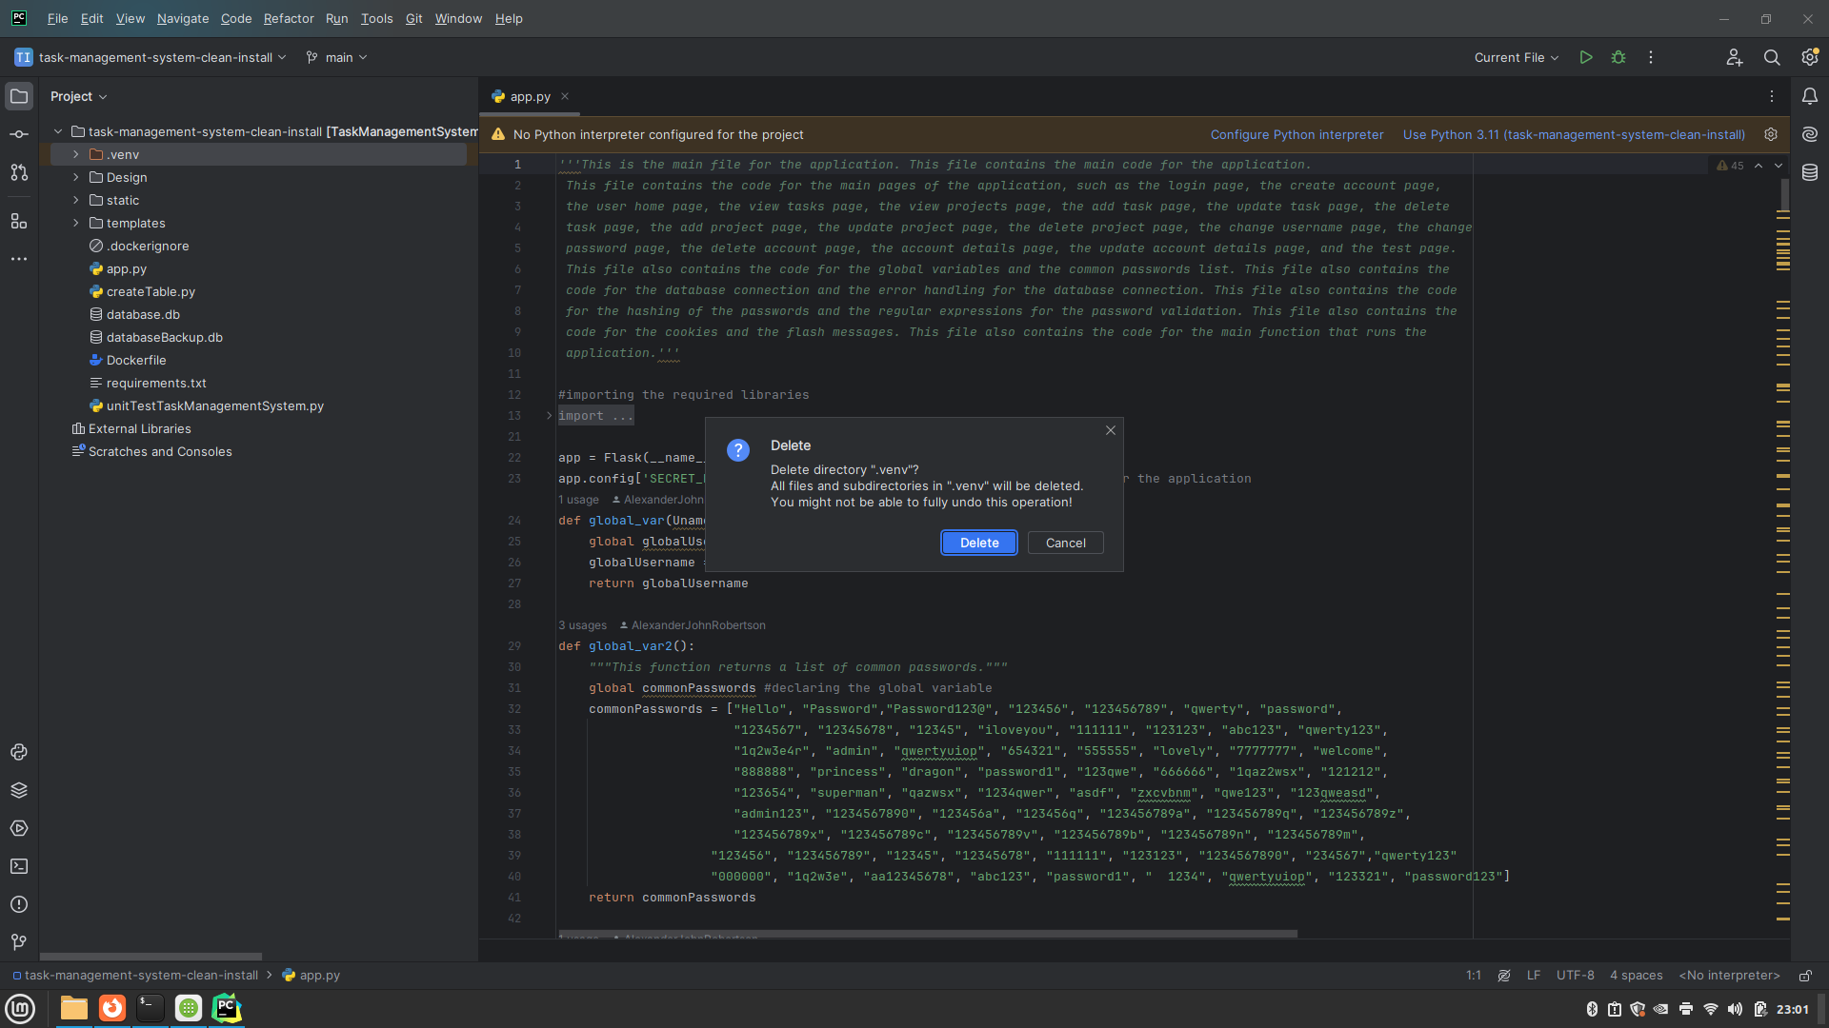

Figure 38 - Click Delete

1. Select the Python Interpreter (Method 1)
   1. Click link to “Configure Python Interpreter” then “Add New Interpreter” then “Add Local Interpreter”.

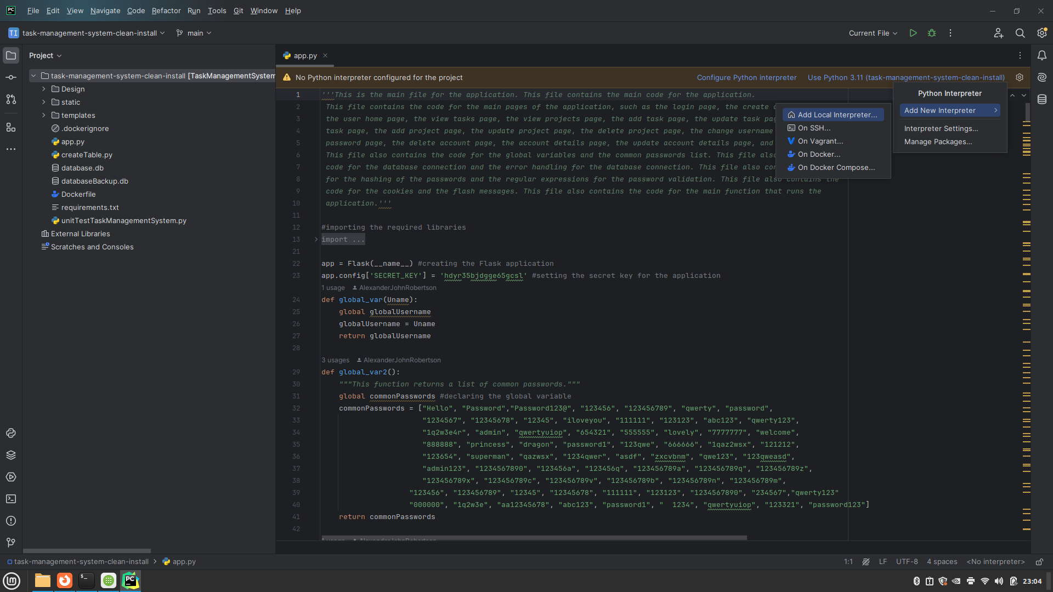

Figure 39 - Select "Configure Python Interpreter" > "Add New Interpreter" > "Add Local Interpreter...".

* 1. Select ”New” for Environment, PyCharm will automatically select the task-management-system or task-management-system-clean-install directory and create a new. venv folder containing the Python virtual environment. Make sure that the location of the Base Interpreter is the location where the Python 3.12 is installed on your computer. Then click “OK”.

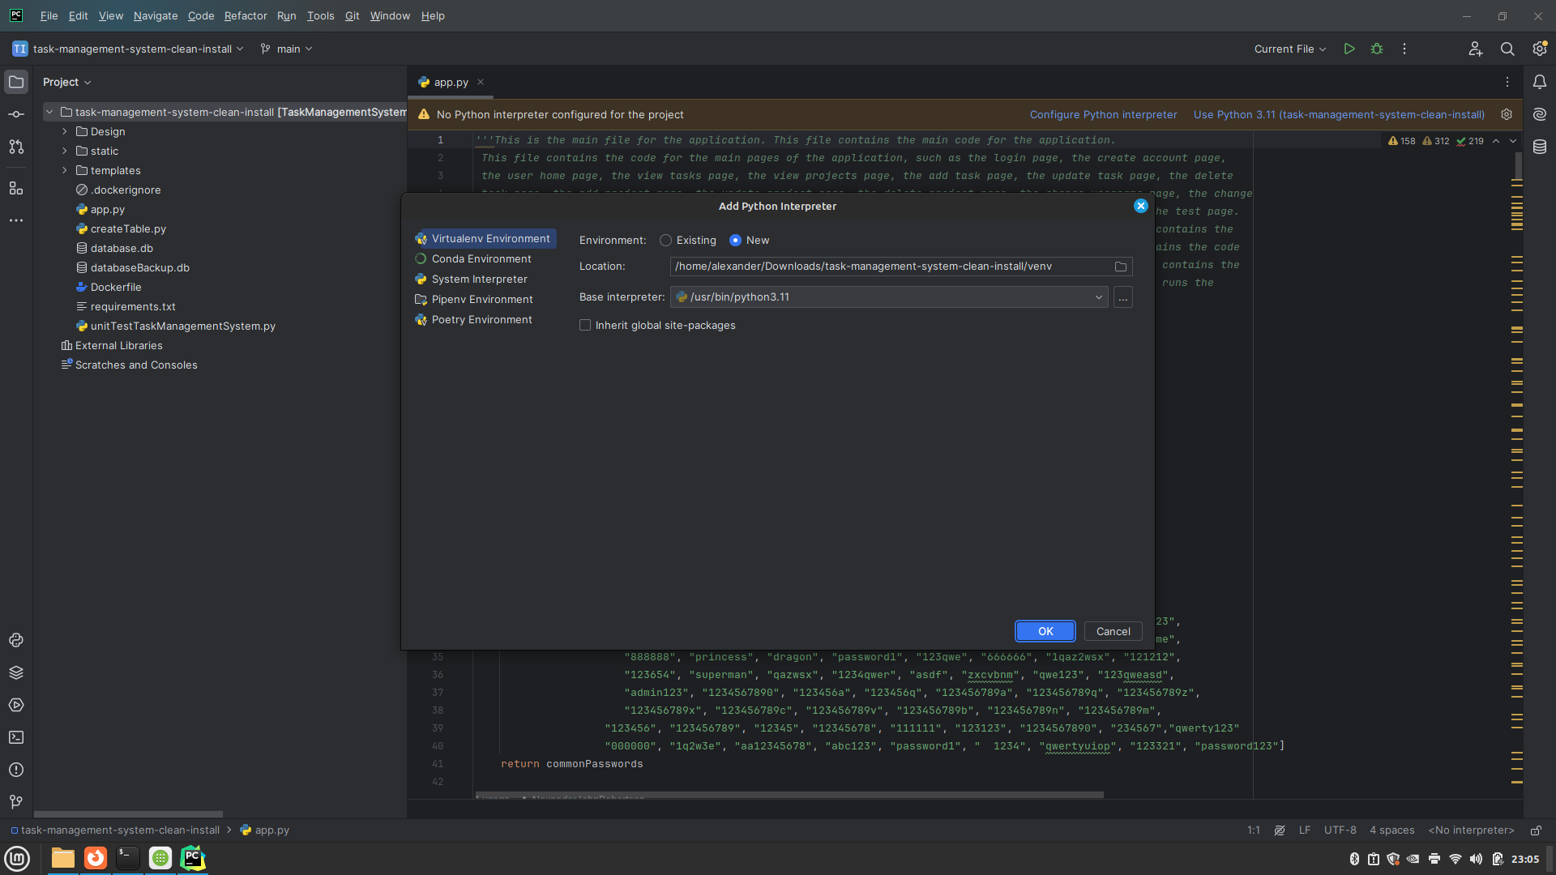

Figure 40 - Adding a Python Interpreter.

* 1. Click on the link to “Install Requirements” when it appears. If this doesn’t appear, enter the PIP commands *pip install flask* and *pip install gunicorn* into the PyCharm Terminal and wait for the modules to install as an alternative method.

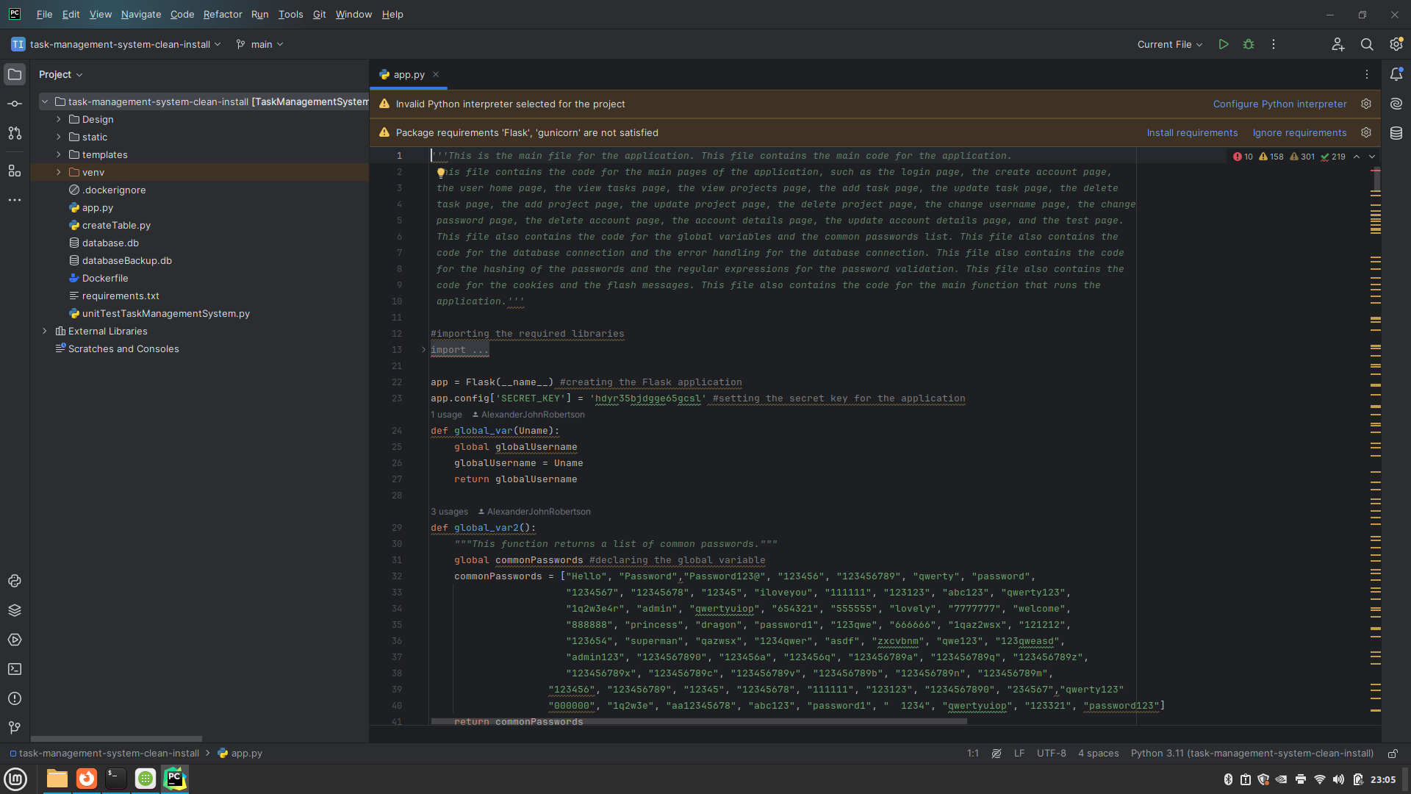

Figure 41 - Select "Install requirements".

* 1. Make sure ”Flask” and ”Gunicorn” checkboxes are selected then click ”Install”.

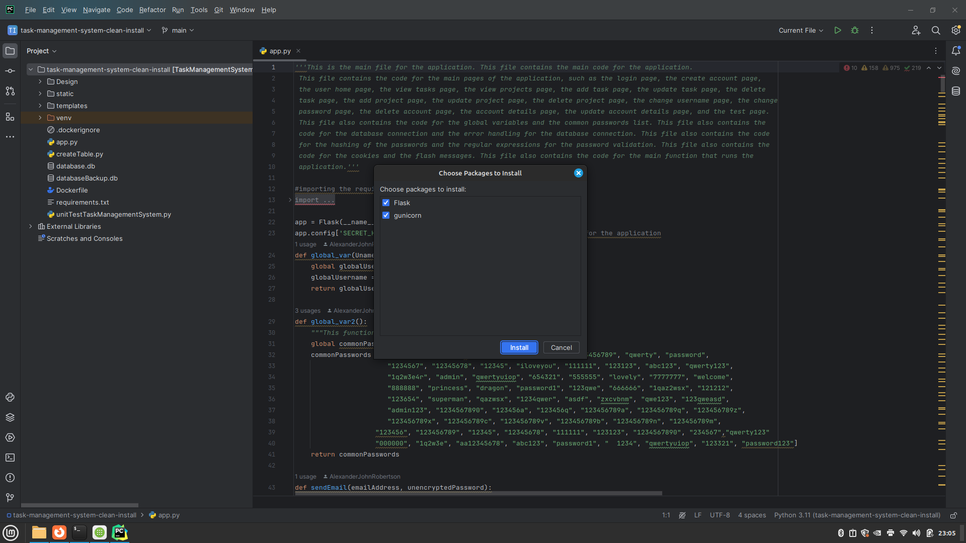

Figure 42 - Make sure "Flask" and "Gunicorn" are selected then click "Install".

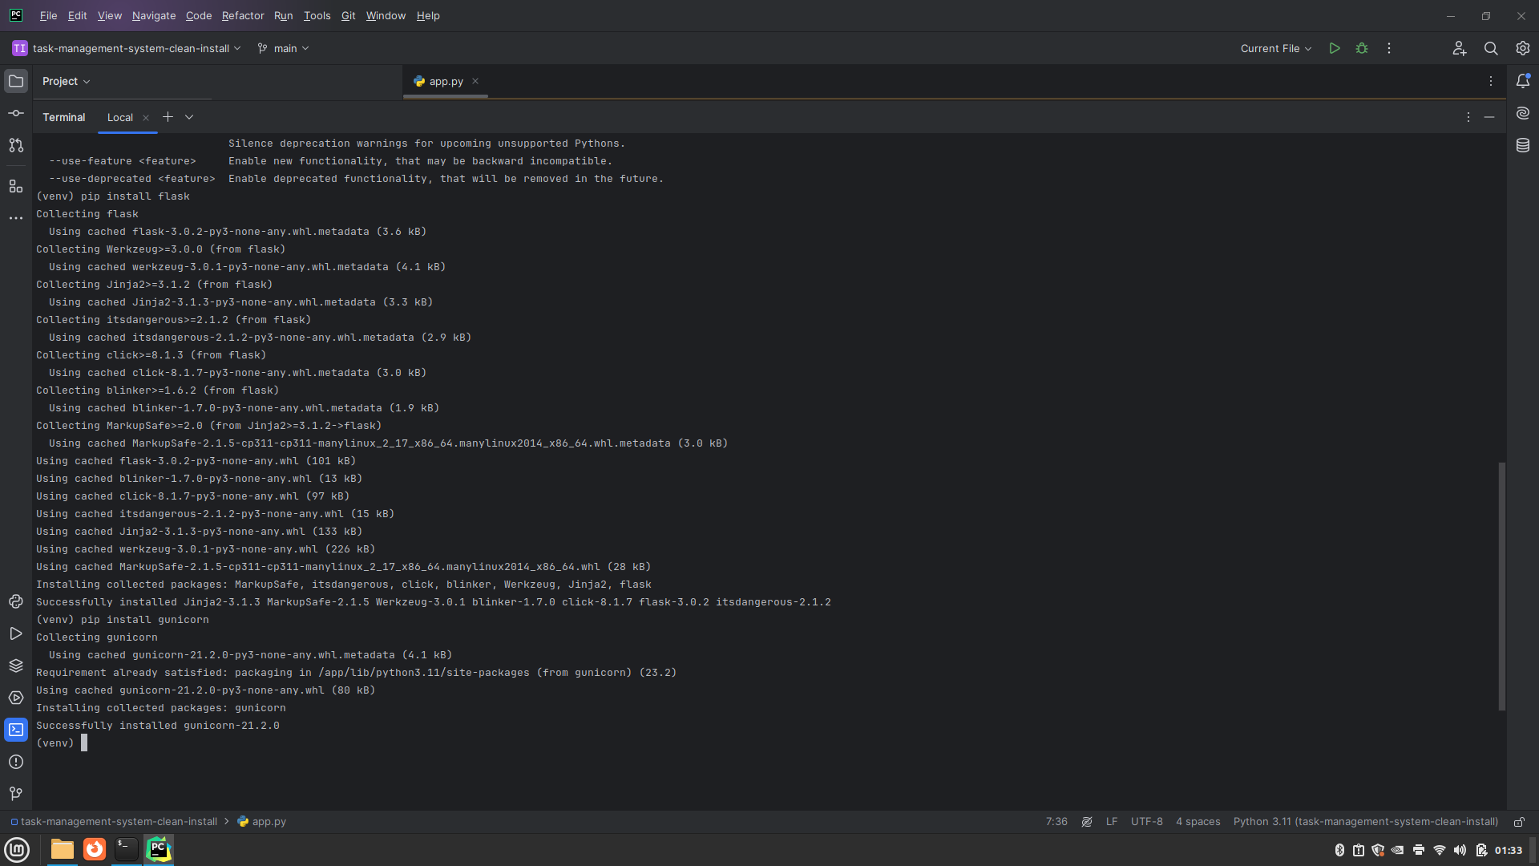

Figure 43 - enter "pip install flask" then "pip install gunicorn" into the PyCharm terminal.

1. Select the Python Interpreter (Method 2)
2. After deleting the venv folder, a link to “Create a virtual environment using requirements.txt” will appear. Click this link.

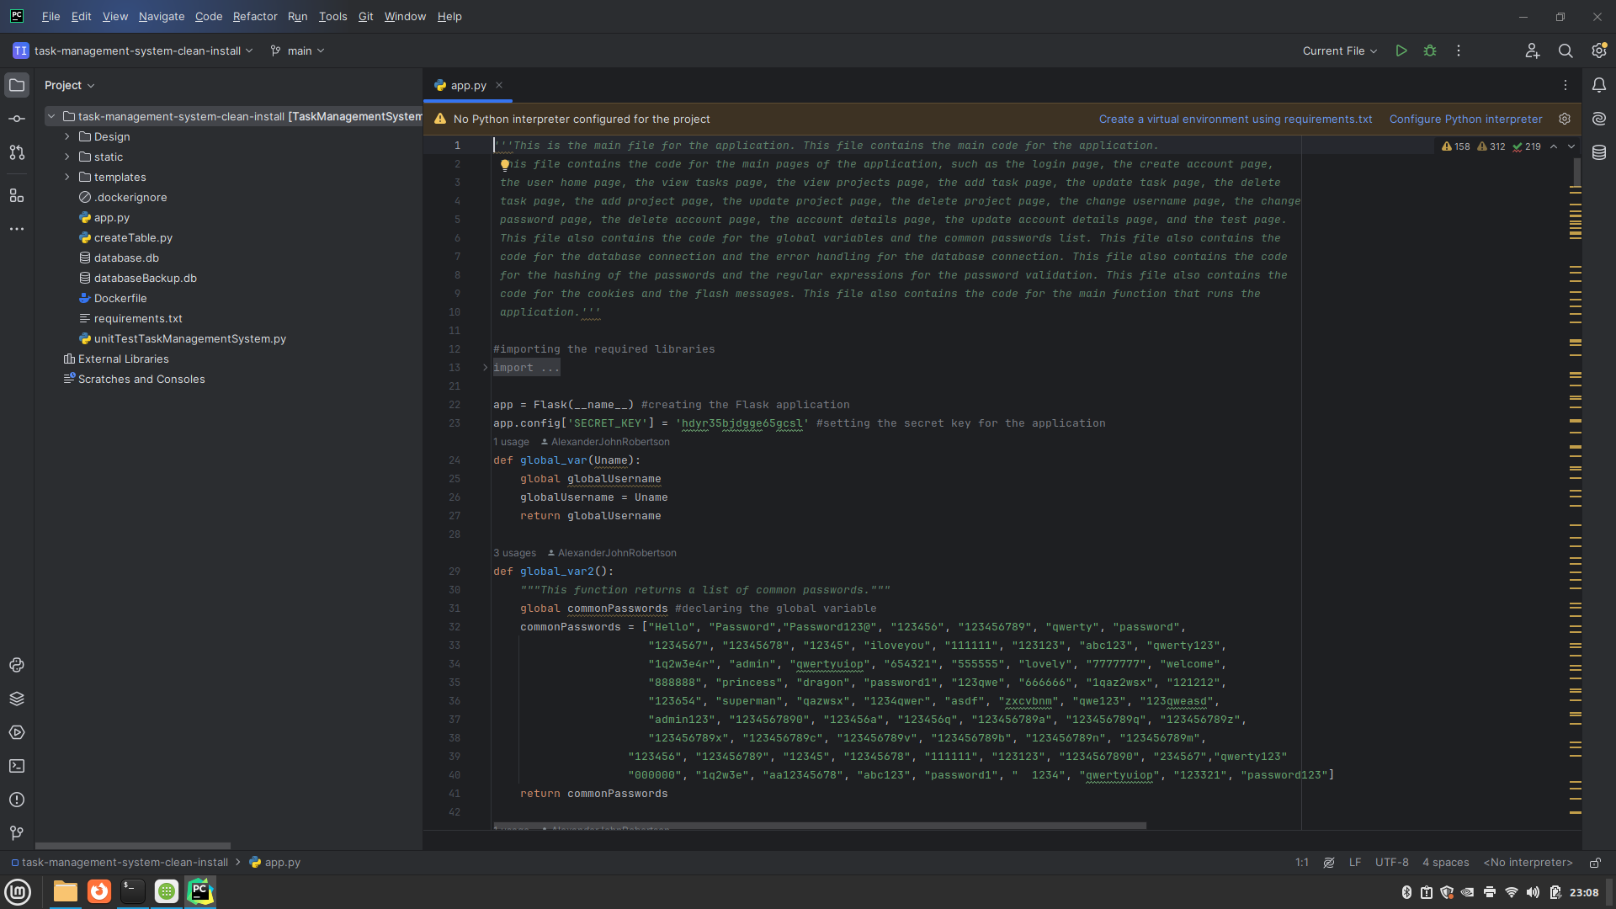

Figure 44 - Click "Create a virtual environment using requirements.txt.

1. The Location, Base Interpreter and Dependencies should automatically be set up in the Creating Virtual Environment popup window. Make sure the location is set to the path of the task-management-system/venv or task-management-system-clean-install/venv, the Base Interpreter path is set to the location of the Python 3.12 interpreter install location on your computer and the Dependencies path is set to task-management-system/requirements.txt or task-management-system-clean-install/requirements.txt. Then click ”OK”, Wait for PyCharm to create the virtual environment and install the dependencies and requirements.

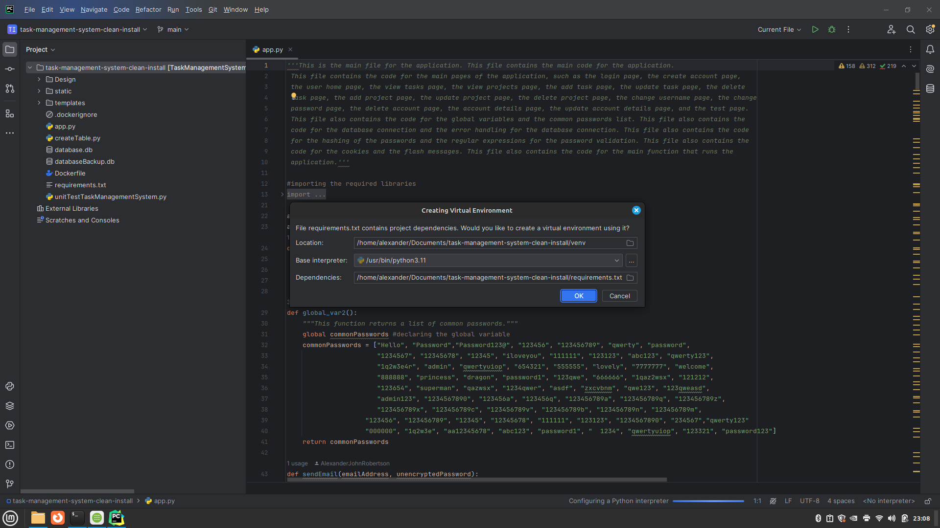

Figure 45 - Location is automatically chosen as the Task Management System's source code root directory. Set the Base interpreter as the location of the Python 3.12 install location and set dependencies to the location of "requirements.txt" in Task Management System’s root directory. This should be done automatically. Click “OK”.

## Setting up the PyCharm environment (macOS)

1. Delete the venv directory then confirm the delete by clicking “OK”.

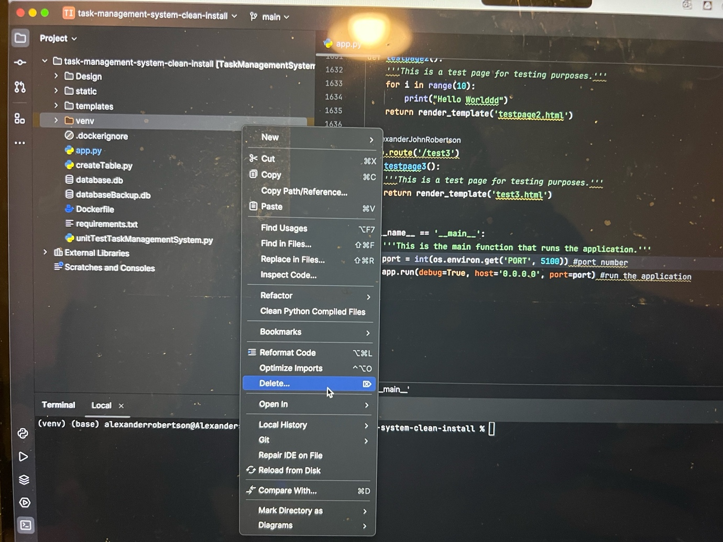

Figure 46 - Deleting the .venv or venv folder.

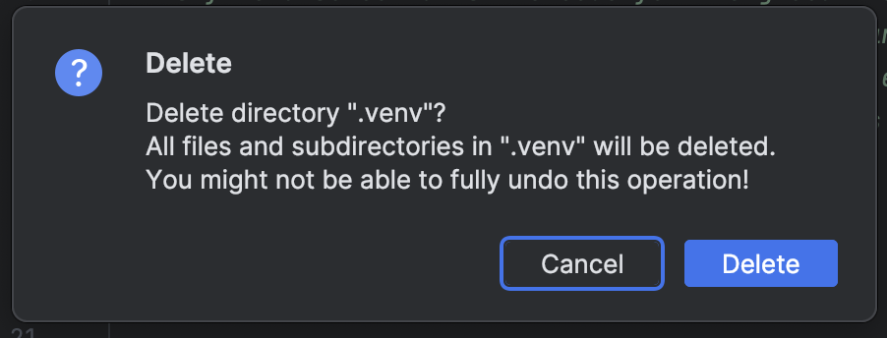

Figure 47 - Click Delete

1. Method 1:
   1. select “Configure Python Interpreter” > “Add New Interpreter” > “Add Local Interpreter”.

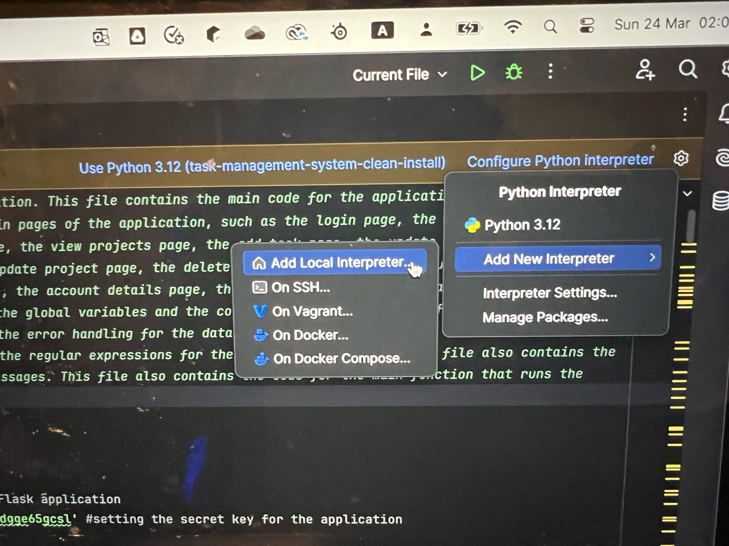

Figure 48 - Select "Configure Python Interpreter" > "Add New Interpreter" > "Add Local Interpreter...".

* 1. Select Environment as “New” (This should be automatically selected). The environment location path will be automatically set to the location of the task-management-system/venv or task-management-system-clean-install/venv directory and The Base Interpreter path should be to the location where Python 3.12 is installed on your Mac. Then click “OK”. Wait for PyCharm to create the virtual environment.

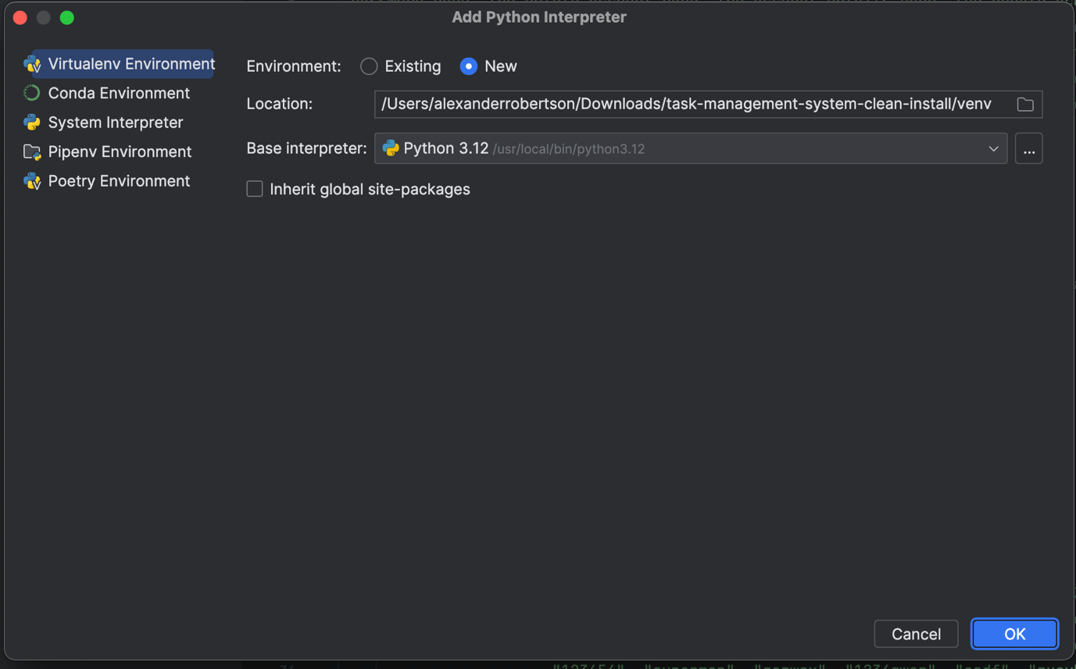

Figure 49 - Adding a Python Interpreter.

* 1. Select “Use Python 3.12 (task-management-system-clean-install)” or “Use Python 3.12 (task-management-system)”.

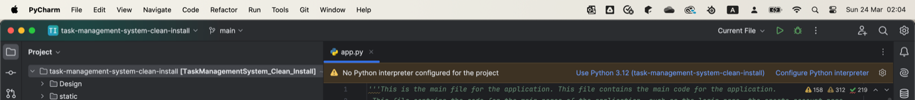

Figure 50 - Select "Use Python 3.12 (task-management-system-clean-install" or "Use Python 3.12 (task-management-system)".

* 1. Select “Install requirements”

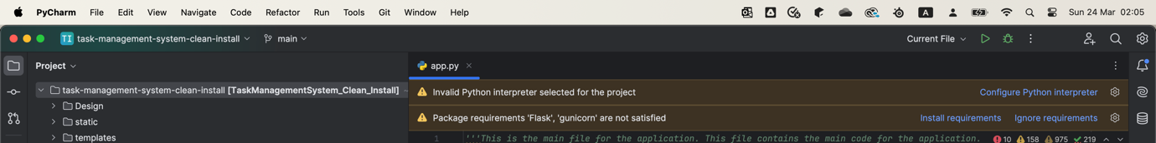

Figure 51 - Select "Install requirements".

* 1. Make sure “Flask” and “Gunicorn” checkboxes are both selected then click “Install Requirements”.

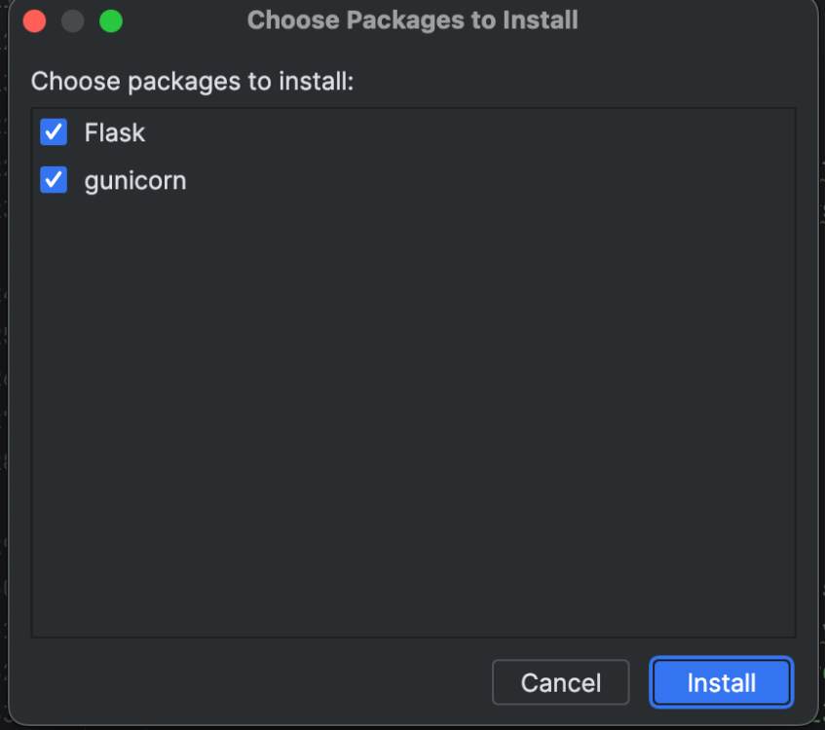

Figure 52 - Make sure "Flask" and "Gunicorn" are selected then click "Install".

* 1. Wait for requirements to install.
  2. Alternatively, instead of clicking “Install Requirements” you can enter “pip install flask” and “pip install gunicorn” into the PyCharm terminal.

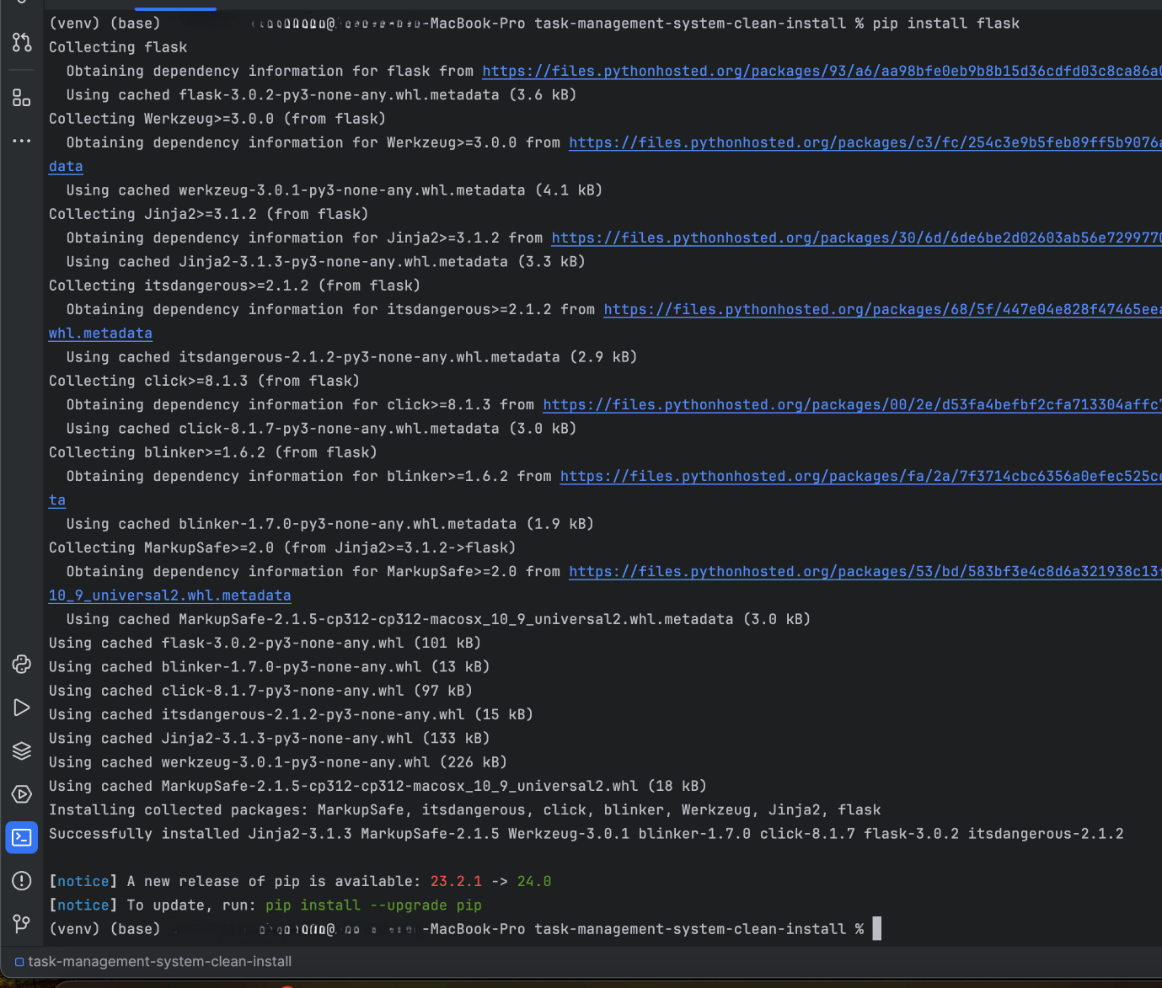

Figure 53- "pip install flask" in PyCharm console.

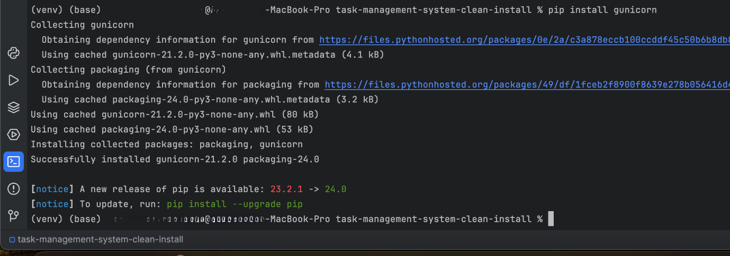

Figure 54 – “pip install gunicorn" into the PyCharm terminal.

1. Method 2:
   1. Wait for “No Python interpreter configured for this project” error to appear above the code. Then click “Use <path/to/task-management-system-clean-install/.venv/Scripts/python.exe>” or “Use <path/to/task-management-system/.venv/Scripts/python.exe>”

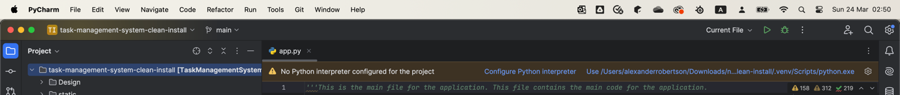

Figure 55 - Select "Use <path/to/task-management-system-clean-install/.venv/scripts/python.exe>" or "Use <path/to/task-management-system/.venv/Scripts/python.exe>".

* 1. Then click “Create a virtual environment using requirements.txt”.



Figure 56 - - Click "Create a virtual environment using requirements.txt.

* 1. The Location, Base interpreter and Dependencies paths are automatically generated. The Location should be” </Path/to/task-management-system-clean-install/venv> or </Path/to/task-management-system/venv>, the Base interpreter should be the path to the location where the Python 3.12 interpreter is installed on your Mac and Dependencies should be </Path/to/task-management-system-clean-install/requirements.txt> or </Path/to/task-management-system/requirements.txt>. then click “OK” and wait for PyCharm to create the virtual environment.

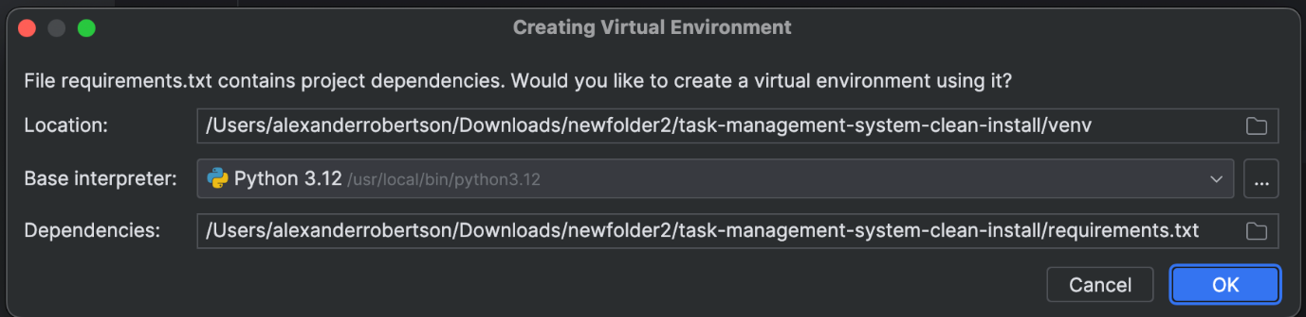

Figure 57 - Location is automatically chosen as the Task Management System's source code root directory. Set the Base interpreter as the location of the Python 3.12 install location and set dependencies to the location of "requirements.txt" in Task Management.

## Setting up the Flask Configuration

1. Select “Current File” then “Edit Configurations…”



Figure 58 - Select Edit Configurations...

1. Click “Add new run configuration…” and select “Flask Server” from the drop-down menu.



Figure 59 - Select "Add new run configuration" then "Flask server".

1. Set the target to “App.py”, Set “FLASK_ENV:” to “development” and enable “FLASK_DEBUG”. Make sure the Python interpreter is selected in “Python Interpreter”. Then click “OK”.



Figure 60 - Set Target to "app.py", FLASK_ENV: to "development", enable FLASK_DEBUG:, set Python Interpreter to Python 3.12 (task-management-system(-clean-install). Click OK.

1. Install any missing requirements if you get a message that they ae missing by clicking “Install requirements”.



Figure 61 - Install requirements if prompted to do so.

1. If you had to install any missing requirements, make sure both requirements are selected and click “Install”. Wait for requirements to install.

**

Figure 62 - Make sure "Flask" and "Gunicorn" are selected then click "Install".

1. If the prompt to install the requirements does not appear in the PyCharm IDE, use the PyCharm terminal to install Flask and Gunicorn by entering the following commands: *pip install flask* and then *pip install gunicorn.* Wait for the pip installations to complete.



Figure 63 - "pip install flask" in PyCharm console.



Figure 64 - "pip install flask" in PyCharm console.



v

Figure 65 - "pip install gunicorn" in PyCharm console.

## Run the Task Management System from PyCharm

1. Run the application by clicking the play ▷ button (Run ‘Flask (app.py)’ Shift+F10 on Linux and Windows, ^R on macOS).

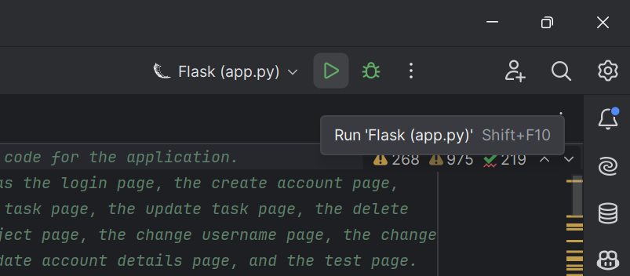

Figure 66 - Click the Run button (resembles a green play button).

1. Click the blue link (http://<ip-address>) in the Python console.

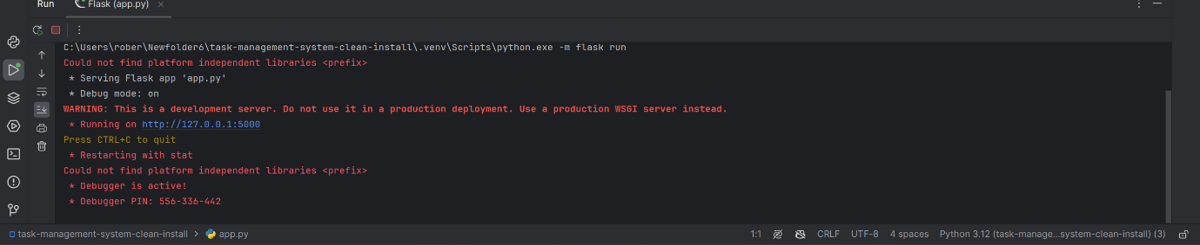

Figure 67 - Task Management system is available at the blue link.

1. The Task Management System is now available in your web browser.

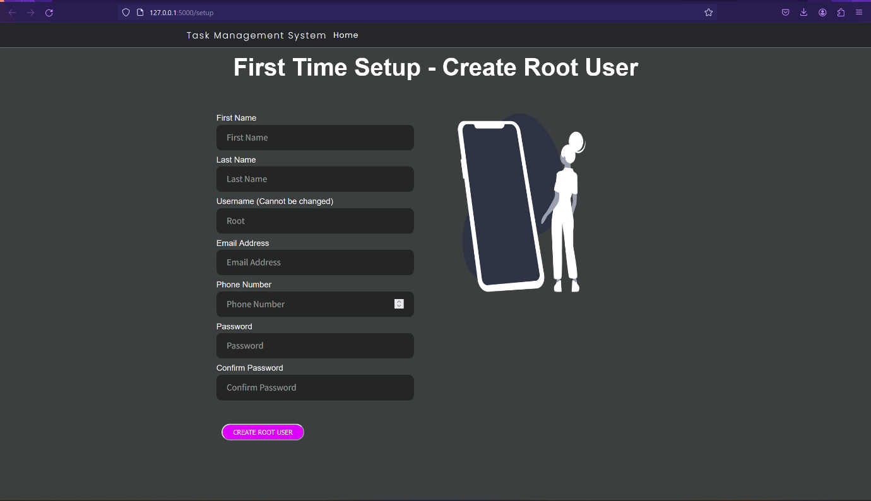

Figure 67 - Task Management System Setup page.

1. Troubleshooting tip: If you get an “Address already in use” error, this means the port is already in use by another application or process.

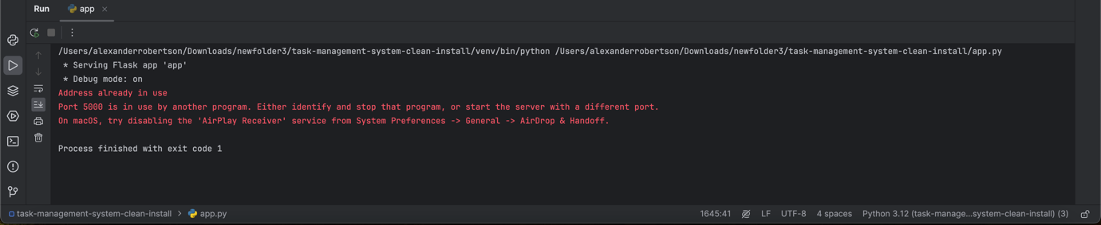

Figure 68 - Error if the port is already in use.

To fix this, change the port number in the app.py code below the *if __name__ == '__main__':* function, Line 1645 (may be different if you have modified the code) *port = int(os.environ.get('PORT', 5000)) #port number* for example to *port = int(os.environ.get('PORT', 5100)) #port number.*

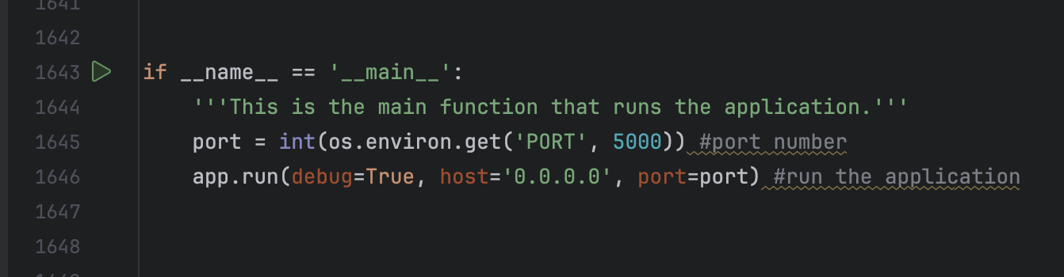

Figure 69 - Old port number 5000

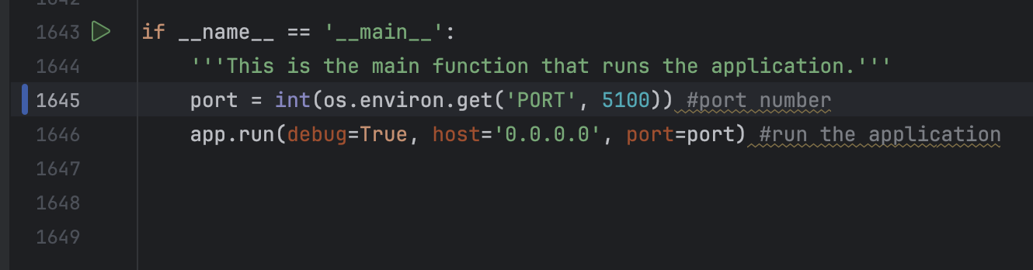

Figure 70 - New port number 5100.

## Setting up and pushing to Git repository (Version Control)

1. Make sure hidden files are visible on your computer’s file browser.
   1. Windows:
      1. Select the … icon in File Explorer.

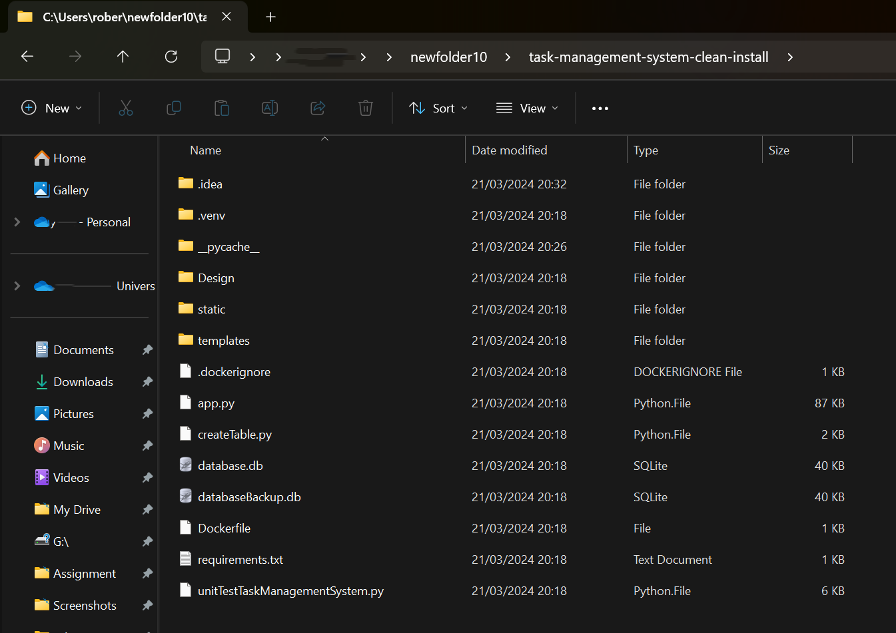

Figure 71 - ... icon for menu

* + 1. Select “⚙️Options” from the drop-down menu.

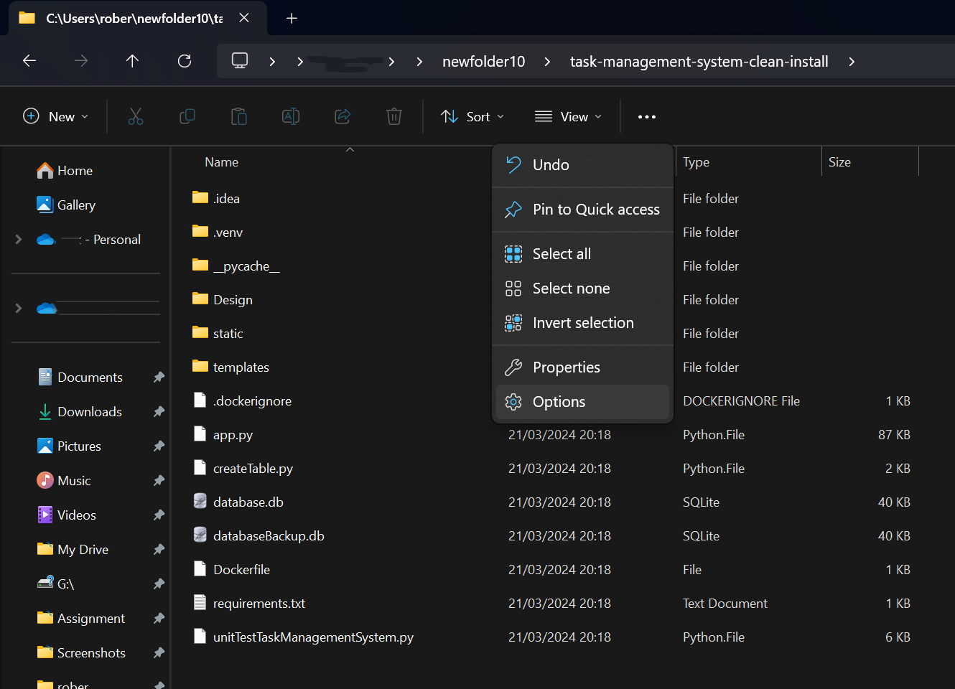

Figure 72 - File Explorer dropdown menu.

* + 1. Select "View” then “Show hidden files, folders and drives” radio button and then click “OK”.

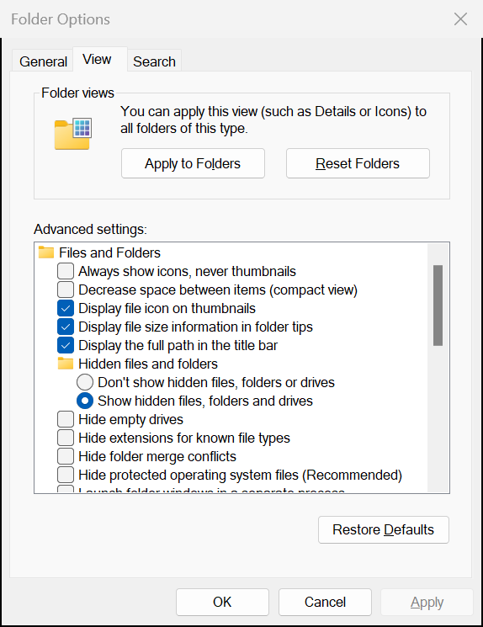

Figure 73 - Folder Options - Select "Show hidden files, folders and drives".

* + 1. The .git folder will now be visible.

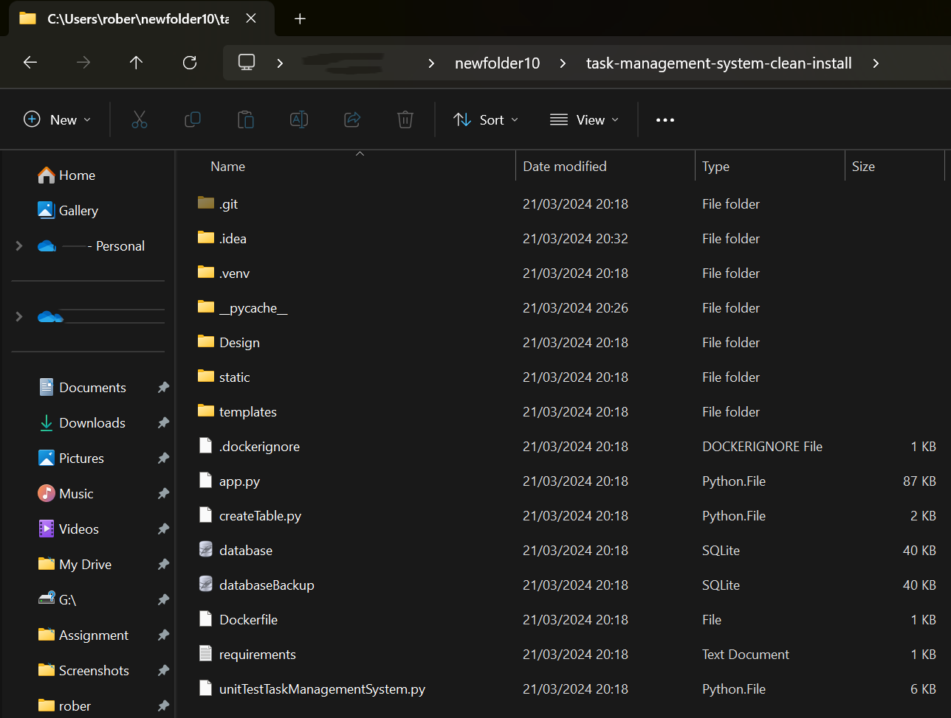

Figure 74 - .git folder in task-management-system (clean-install) directory.

* 1. macOS:
     1. Navigate to the task-management-system or task-management-system-clean-install directory in Finder.
     2. Press ‘Command’ + ‘Shift’ + . (Full Stop key).
     3. The .git folder will be visible.
  2. Linux:
     1. Enter the command “ls -a” into the Terminal in the task-management-system or task-management-system-clean-install directory and .git will be visible.
     2. Press ‘Ctrl+H’ in File Manager to view hidden files and folders that will make the .git folder visible.

1. Delete the existing .git folder.

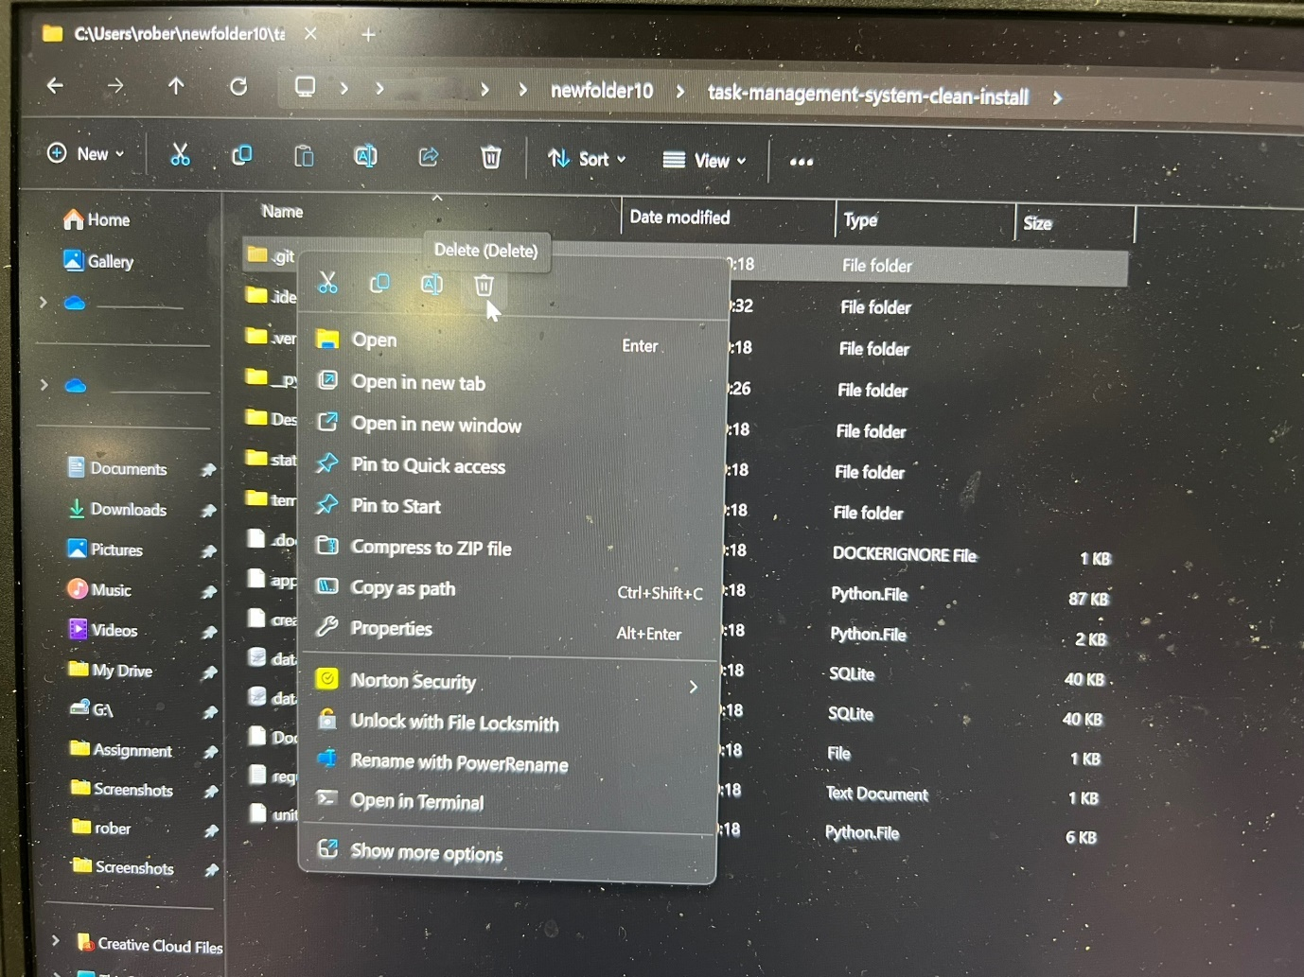

Figure 75 - Deleting the .git folder.

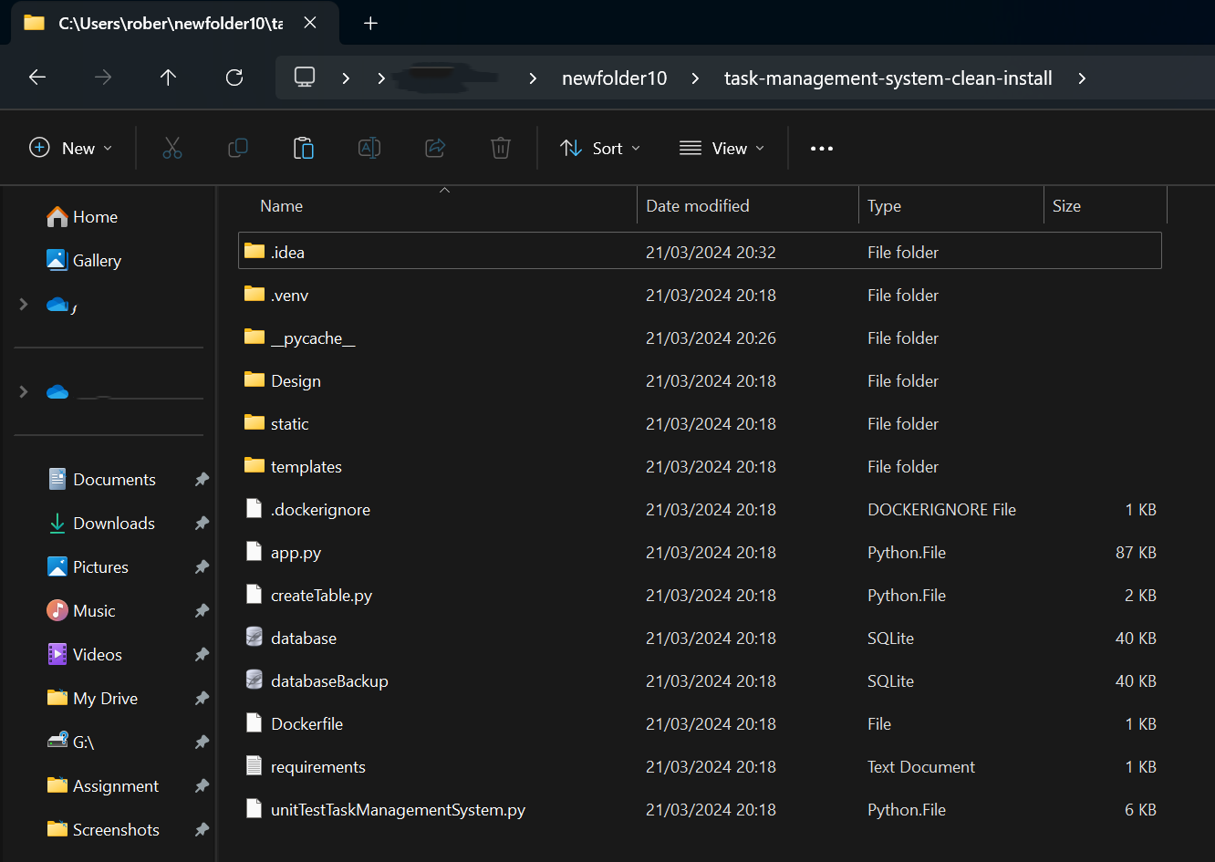

Figure 76 - .git folder deleted.

1. Create a GitHub account if you haven’t already got one. You can also choose to host your Git repository elsewhere such as on GitLab, Amazon AWS CodeCommit, Bitbucket, Microsoft Azure DevOps, SourceForge etc. GitHub will be used for demonstration purposes.
2. Create a git repository on GitHub.com (or other Git version control platform)
   1. On your GitHub Dashboard, click “New” next to “Top Repositories”.

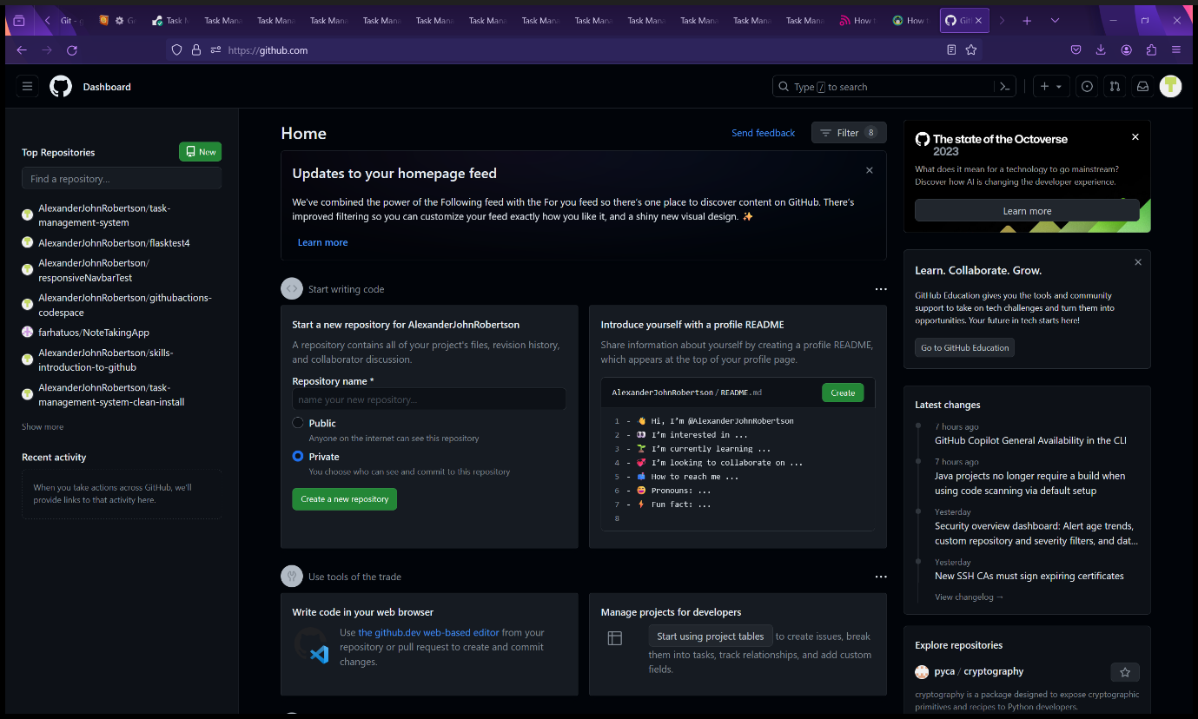

Figure 77 - The GitHub dashboard

* 1. Choose a name for your GitHub repository, add a description (optional), choose if you want to make your repository public or private, choose license (optional) and then click “Create Repository”.

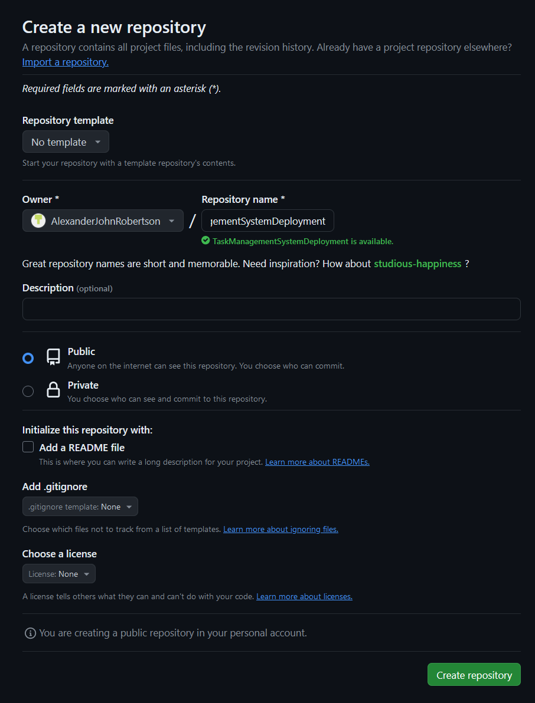

Figure 78 - Creating a new repository.

* 1. Your GitHub repository will now be created.

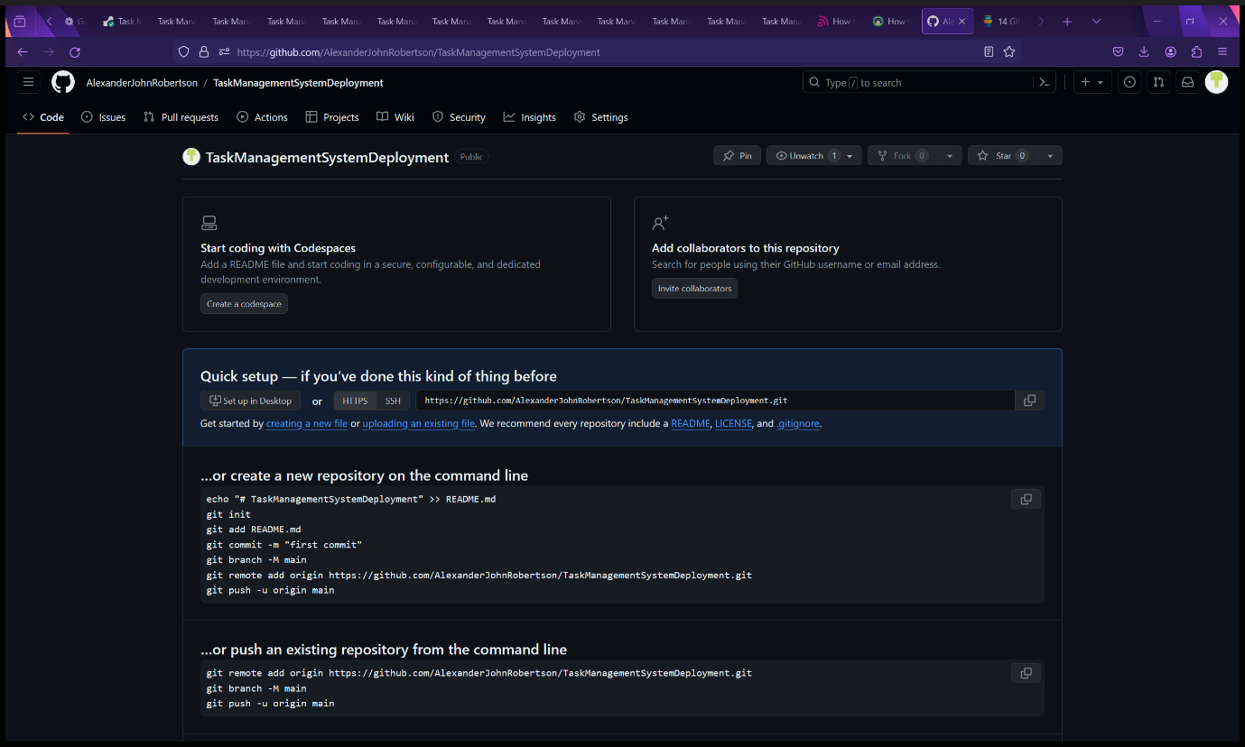

Figure 79 - New GitHub repository with Git command instructions.

1. Make sure the current working directory matches the location of the Task Management System source code you have downloaded by entering the command “pwd” into the PyCharm terminal.

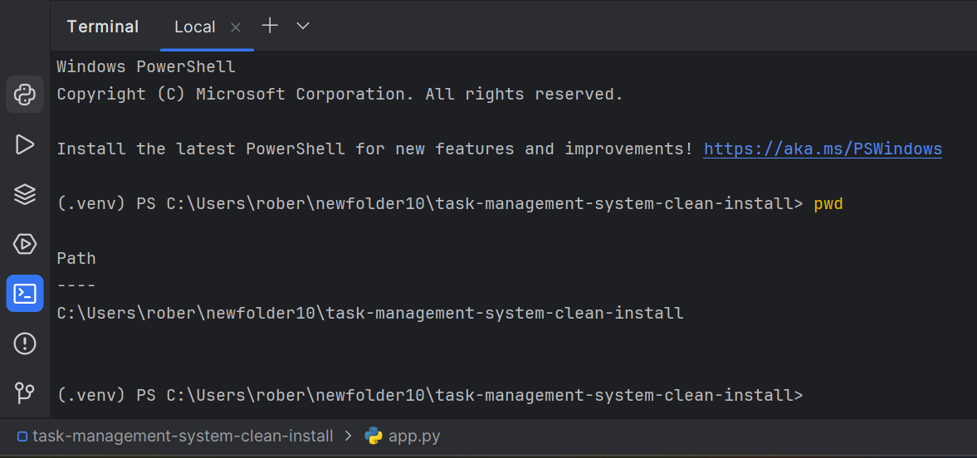

Figure 80 - Making sure you are in the correct working directory.

1. Set up the local Git repository in PyCharm by entering the following Git commands into the PyCharm terminal in the following order:
   1. *git init*
   2. *git add .*
   3. *git commit -m “first commit”*
   4. *git branch -M main*
   5. *git remote add origin https://github.com/<GitHub-username>/<git-repository-name>.git*
   6. *git push -u origin main*

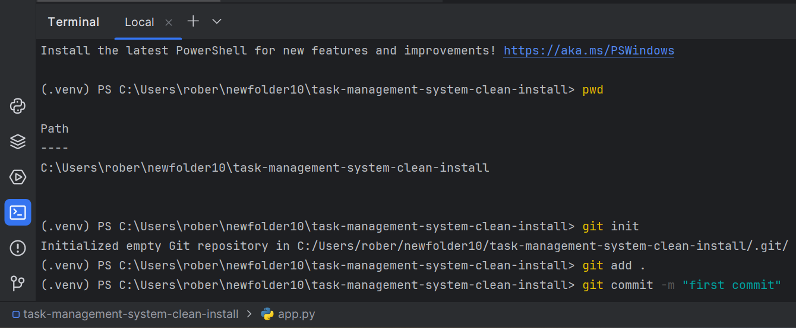

Figure 81 - Setting up the Git repository in PyCharm console.

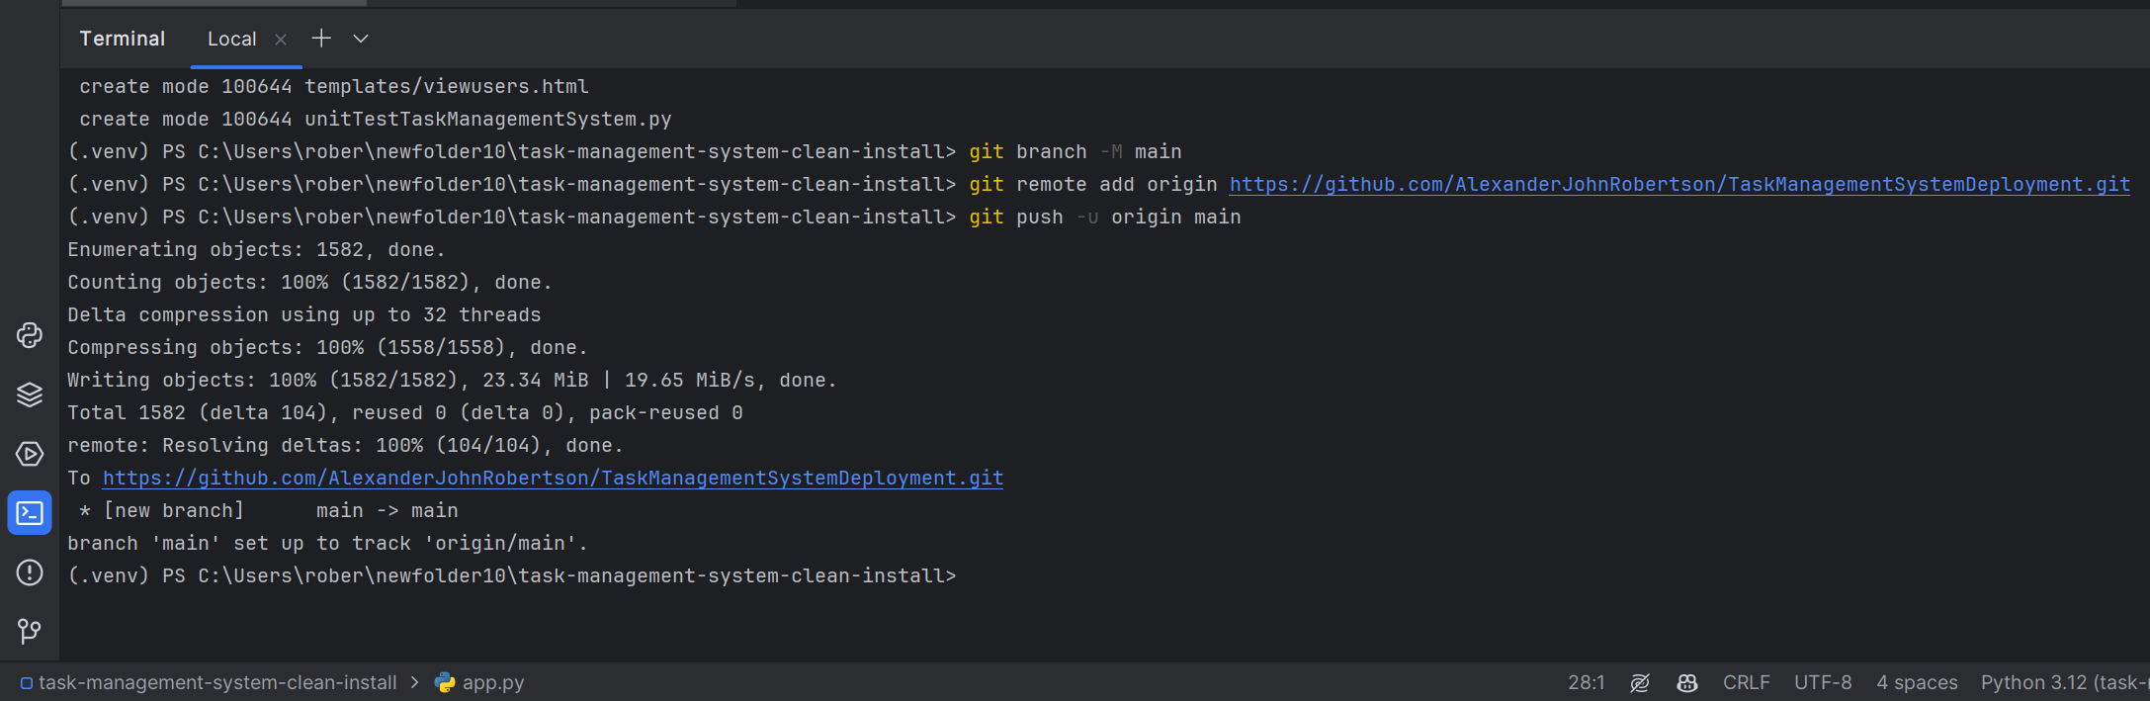

Figure 82 - Setting up the Git repository in PyCharm console.

1. Refresh the GitHub repository page on github.com to view the contents that you have pushed to your repository.

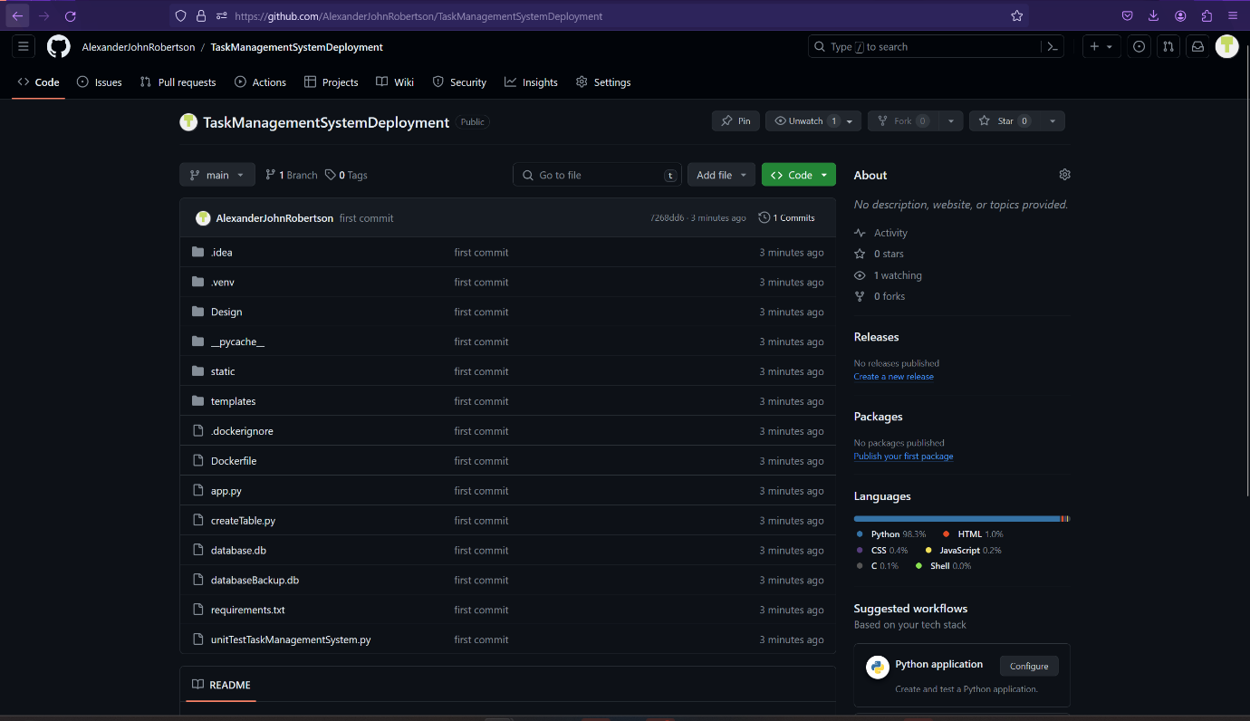

Figure 83 - Newly created Gir Repository with source code and program files.

1. Your Git repository is now ready to use.
2. For future commits to your Git repository, you only need to enter the three following Git commands into the PyCharm terminal each time:
   1. git add .
   2. git commit -m “<your message here>”
   3. git push origin main

## Modifying Source code, Adding and Testing New Features

**WARNING: ONLY MODIFY THE SOURCE CODE IF YOU HAVE EXPERIENCE WITH AND UNDERSTAND PYTHON 3, SQL, SQLITE, HTML, CSS, JAVASCRIPT, FLASK, DOCKER AND DOCKERFILES, GUNICORN AND GIT. EDITING THESE FILES WITHOUT THE RIGHT KNOWHOW MAY DAMAGE THE TASK MANAGEMENT SYSTEM, RENDERING THE APPLICATION INOPERABLE AND/OR CORRUPT THE DATABASE RESULTING IN PERMANENT DATA LOSS! ALWAYS BACK UP THE ORIGIONAL APPLICATION AND USE VERSION CONTROL ON YOUR OWN GIT REPOSITORY IN CASE THE APPLICATION GETS DAMAGED. THE SOFTWARE AUTHOUR CANNOT BE HELD RESPONSIBLE FOR DAMAGE CAUSED BY A THIRD PARTY MODIFYING THE SOURCE CODE.**

### Suggested Modifications

#### Editing the List of Common Password to be Banned

You can change the list of common passwords in the commonPasswords global variable.

Open app.py in PyCharm edit the global variable on lines 29-41, save the edit, run the application to test it, if it works, you can commit to your git repository or Docker repository for deployment.

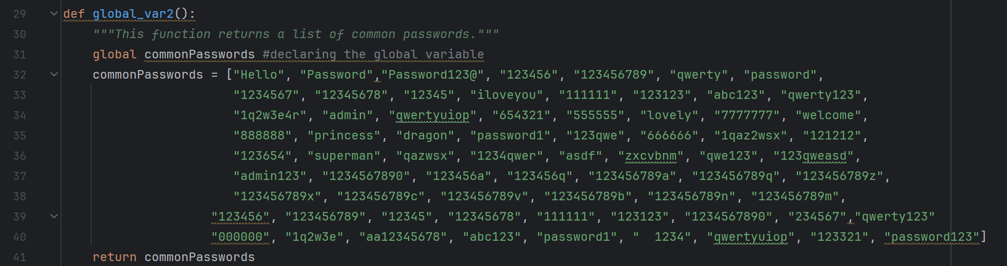

Figure 84 - List of banned common passwords.

#### Changing the Email Content

You can change the email domain, email address, email password and email content for the automated emails that are sent during setup and when an administrator resets a user password.

Open app.py in PyCharm edit the sendEmail function on lines 43-53 for the email that is sent when an administrator resets a user’s password and the setupEmail function on lines 55-65. You can change save the edit, run the application to test it, if it works, you can commit to your git repository or Docker repository for deployment.

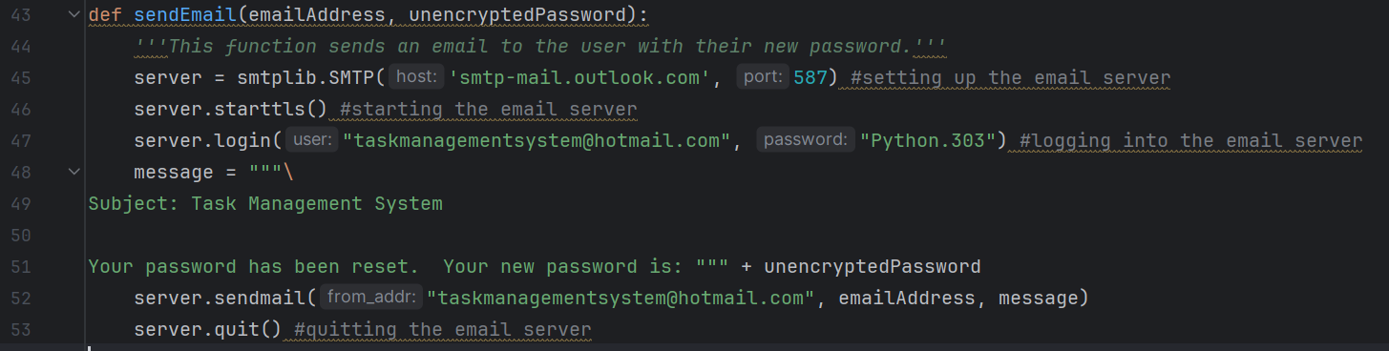

Figure 85 - Email that is automatically sent to the user when an administrator resets another user's password.

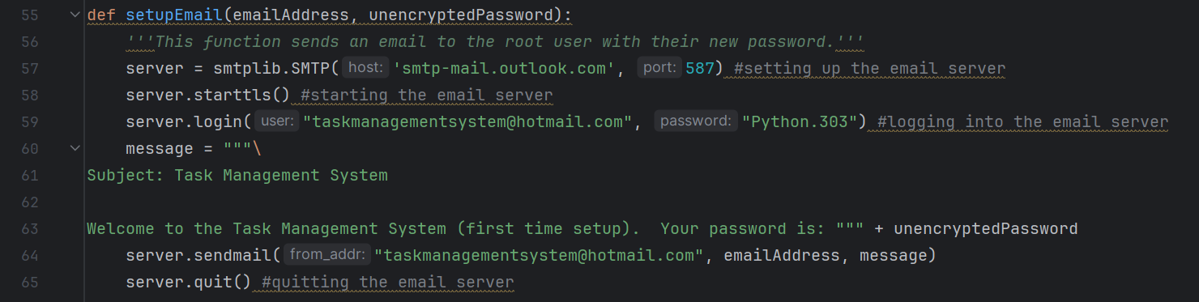

Figure 86 - Email that is automatically sent to the Root User when they set up the Task Management System.

#### Testing Experimental Features

You can test new features in the Task Management System’s source code. Add functionality (Backend code) to experimental features in the three test page functions (testpage (line 1626), testpage2 (line 1631) and testpage3 (line 1637)) in app.py. Every function has a Flask route() decorator above it to specify the paths for the test page URLs.

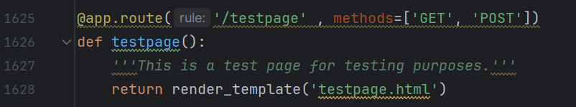

Figure 87 - Flask route() decorators with test page functions. Python and SQLite code for the test pages goes in these functions.

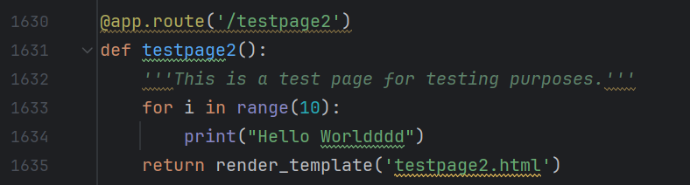

Figure 88 - Flask route() decorators with test page functions. Python and SQLite code for the test pages goes in these functions.

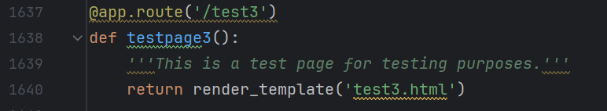

Figure 89 - Flask route() decorators with test page functions. Python and SQLite code for the test pages goes in these functions.

The frontend HTML files for the webpages and forms are in the templates folder.

You can test new features on testpage.html, testpage2.html and test3.html. You can also test new user interface designs here. If you wish to test new changes to the CSS files for the UI, you should create a test CSS file, link it to the test page and test CSS style changes to the UI in the test copies of the CSS files to prevent unwanted changes and damage to the main files.

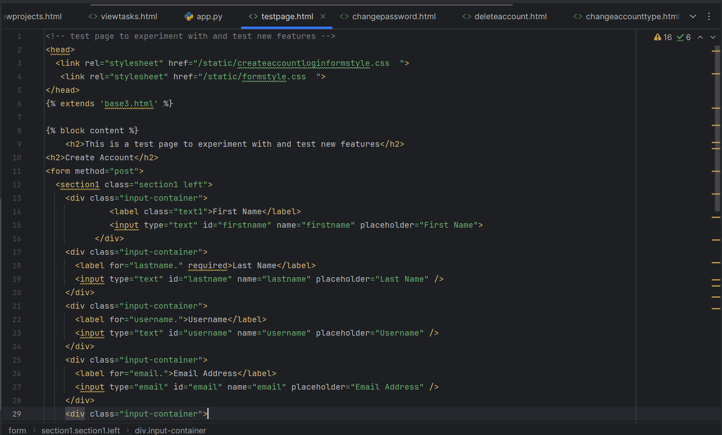

Figure 90 - HTML code on test page.

Once satisfied with feature tests and UI tests, you can integrate the changes into the main application features.

## Unit Testing the Task Management System Source Code

1. Open unitTestTaskManagementSystem.py in PyCharm.

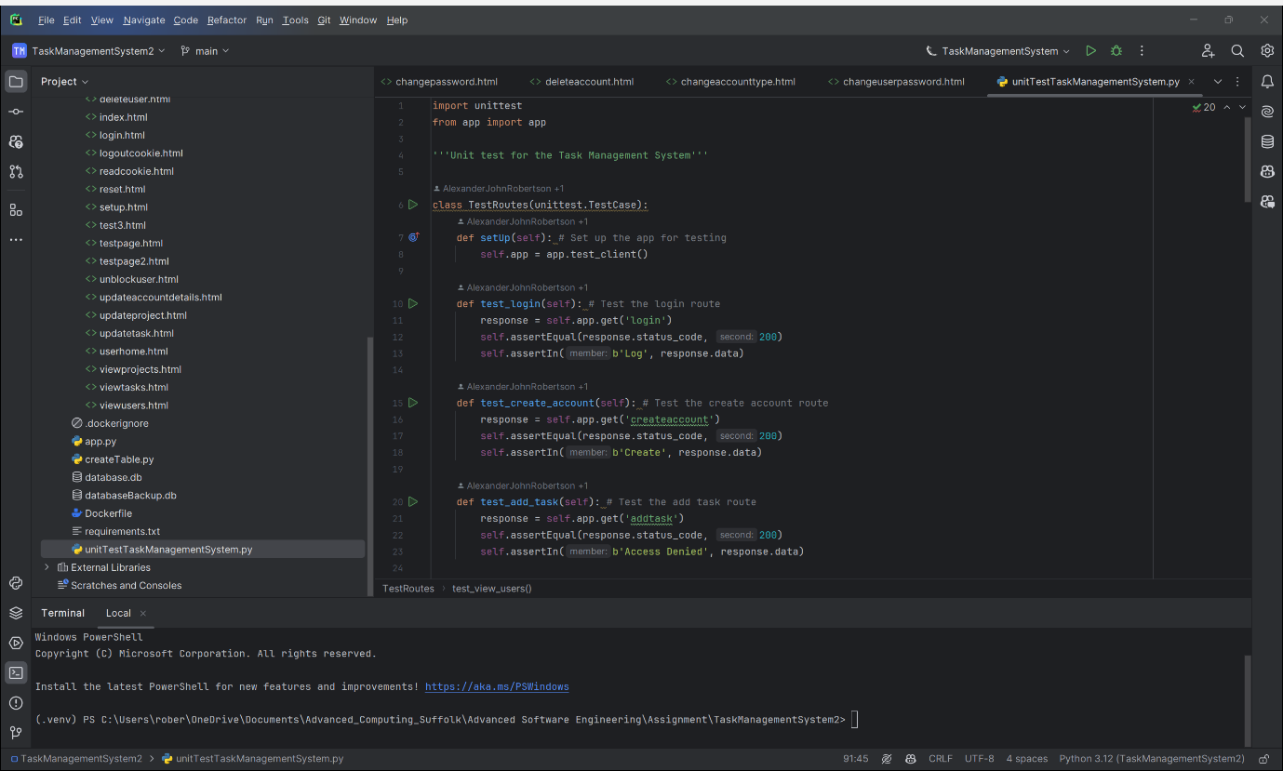

Figure 91 - unitTestTaskManagemntSystem.py open in PyCharm for unit testing the Task Management System.

1. Change “TaskManagementSystem” or “TaskManagementSystem_Clean_Install” to “Current File”.

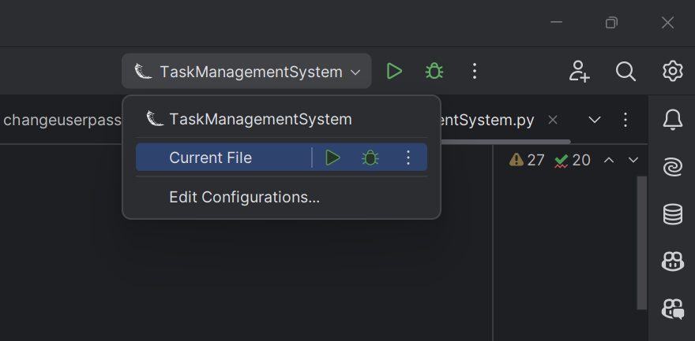

Figure 92 - Select "Current File" instead of "Task Management System".

1. Run the current file.

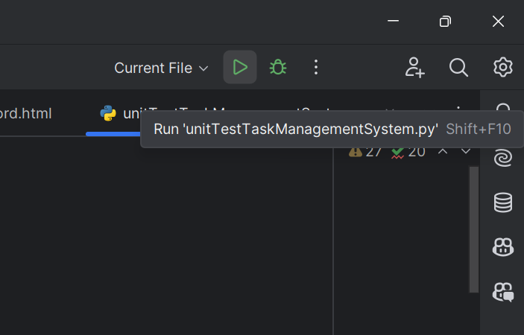

Figure 93 - Click the Run button.

1. If the Taks Management System passes all the unit tests, then you will receive a message saying “OK” in the Python console.

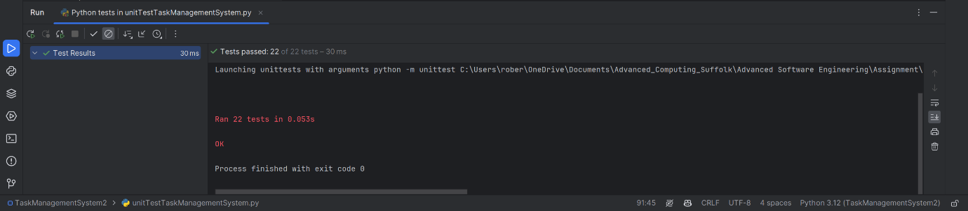

Figure 94 - Passed all elements of the Unit Testing.

1. If the Task Management System fails one or more of the unit tests, you will receive an error message in the Python console saying “Failure”, “<Error Message>, “FAILED”. A Test Results tree will appear next to the Python console that navigates to the unit test that failed.

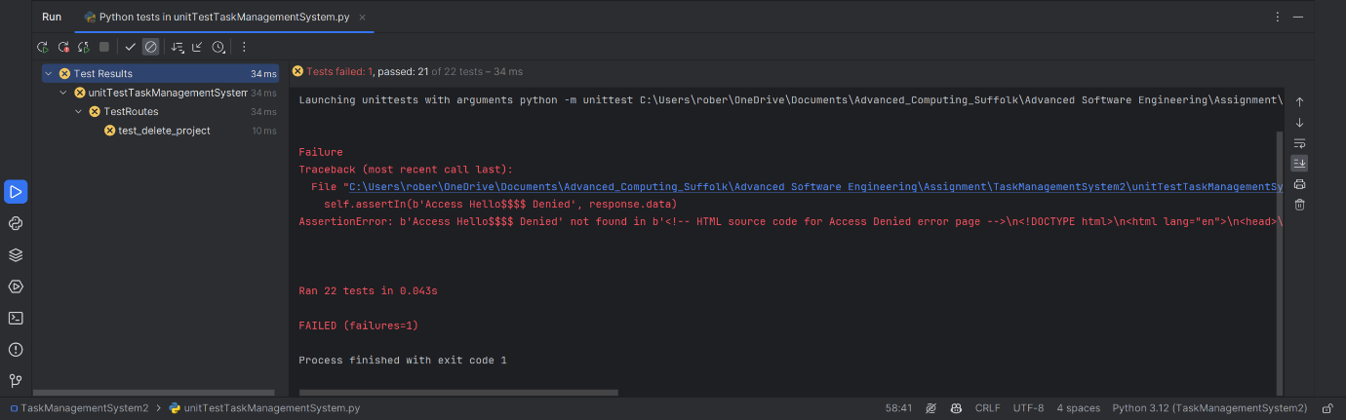

Figure 95 Failed the Unit Testing as the Task Management System has failed one or more unit test elements.

1. Fix the code that is causing the unit test to fail.
2. Re-Run the unit tests.
3. Add new unit tests to the TestRoutes class below the setup function to unit test new features.

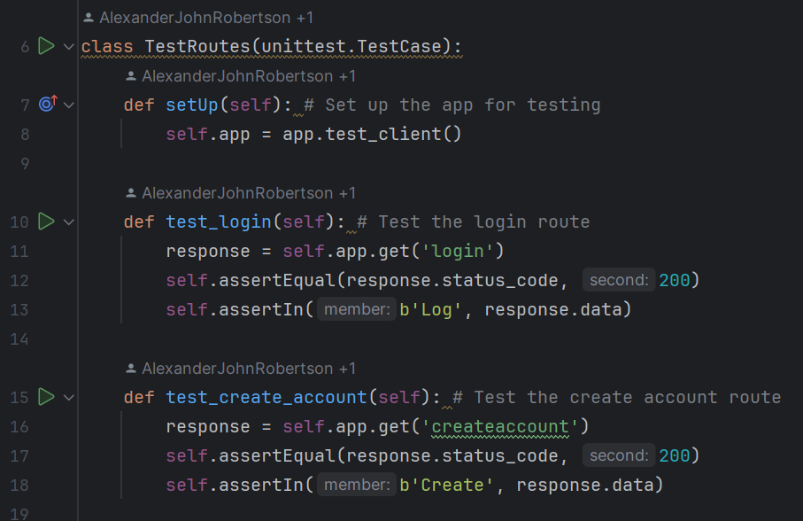

Figure 96 - Snippet of the Unit Testing source code.

## Deploy online using Render.com or other webhosting service using a Continuous Integration / Continuous Deployment (CI/CD) Pipeline.

This section is for deploying the Task Management System online using a webhosting service using a Continuous Integration / Continuous Deployment (CI/CD) Pipeline. Render.com will be used in the given instructions however other platforms could also be used.

1. Go to Render.com: <https://render.com/>
2. Create a Reender.com account if you don’t already have one or sign in to your existing account.
3. Go to your Render.com Dashboard.

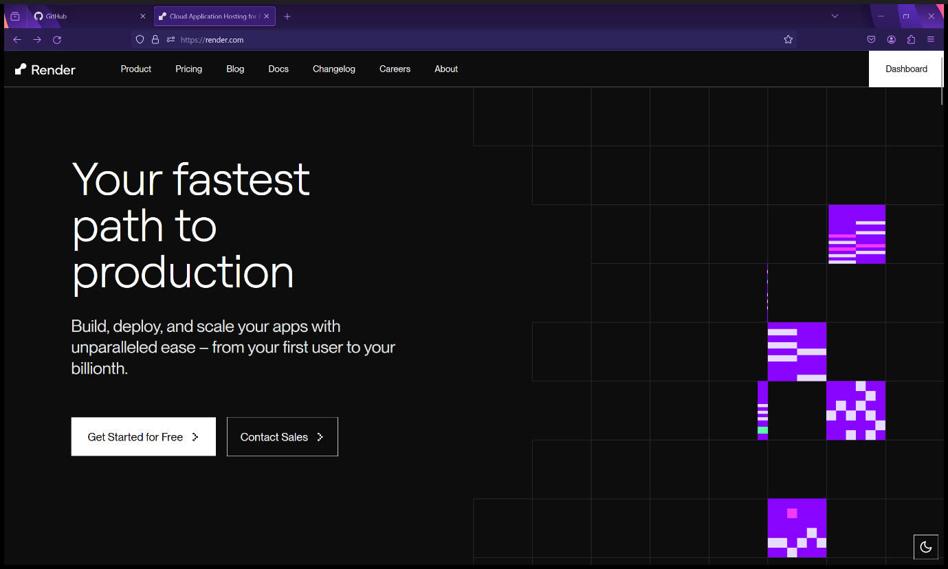

Figure 97 - Render.com homepage. Select “Dashboard”.

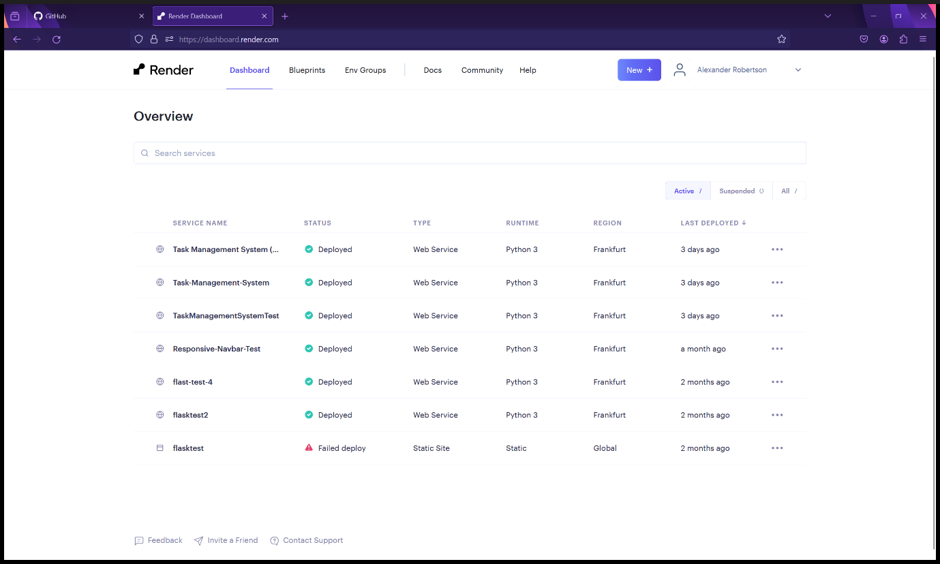

Figure 98 - Render.com Dashboard

1. Select “New” then “Web Service”.

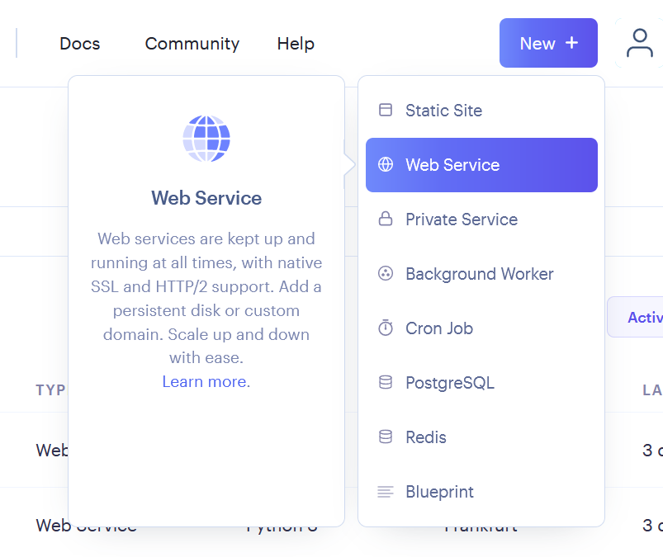

Figure 99 - Select "New Service" from the "New+" dropdown menu.

1. Select "Build and deploy from a Git repository” and then click “Next”.

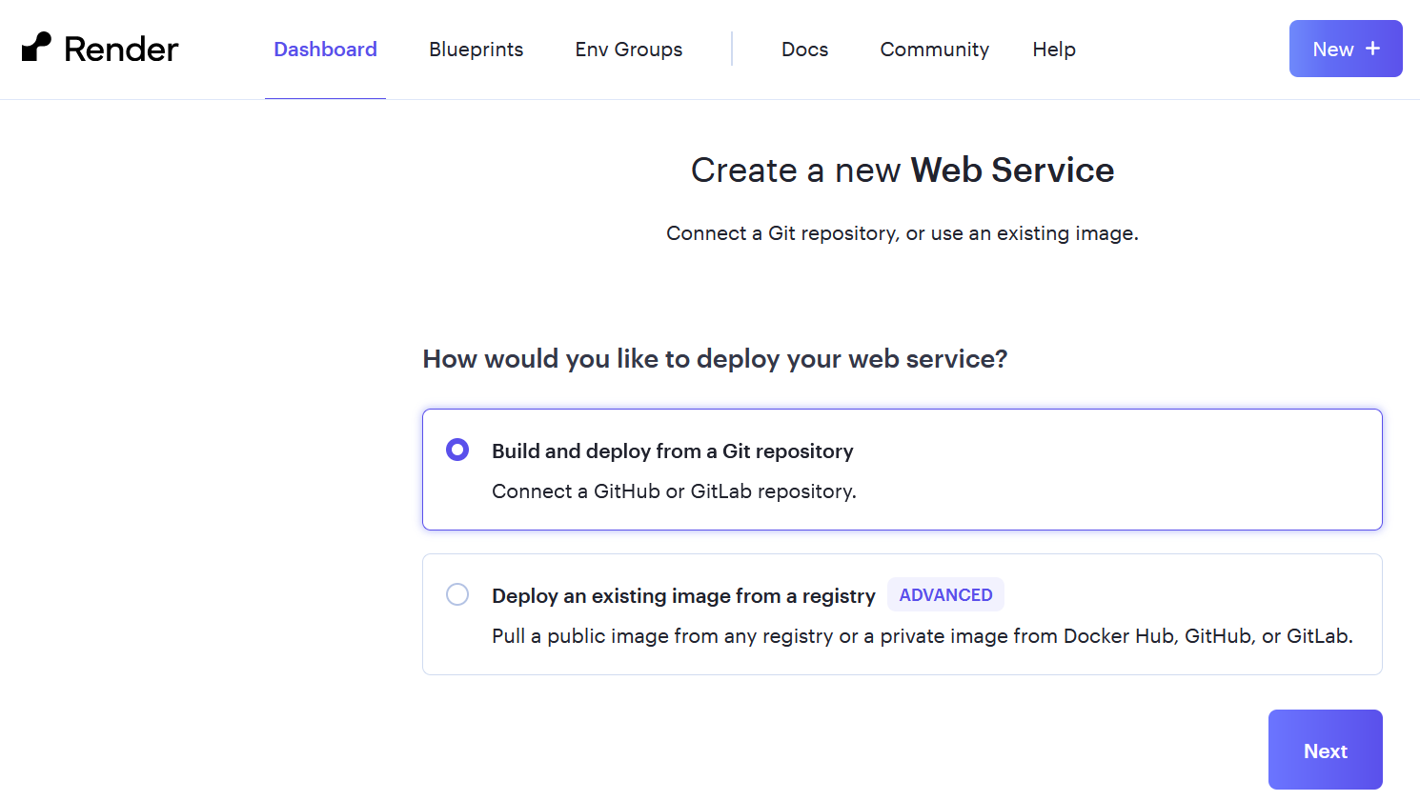

Figure 100 - Select "Build and deploy from a Git repository" then click "Next".

1. Connect the Git repository that you created in the previous steps for Setting up and pushing to a Git repository. Choose the repository from the list then click “Connect”.

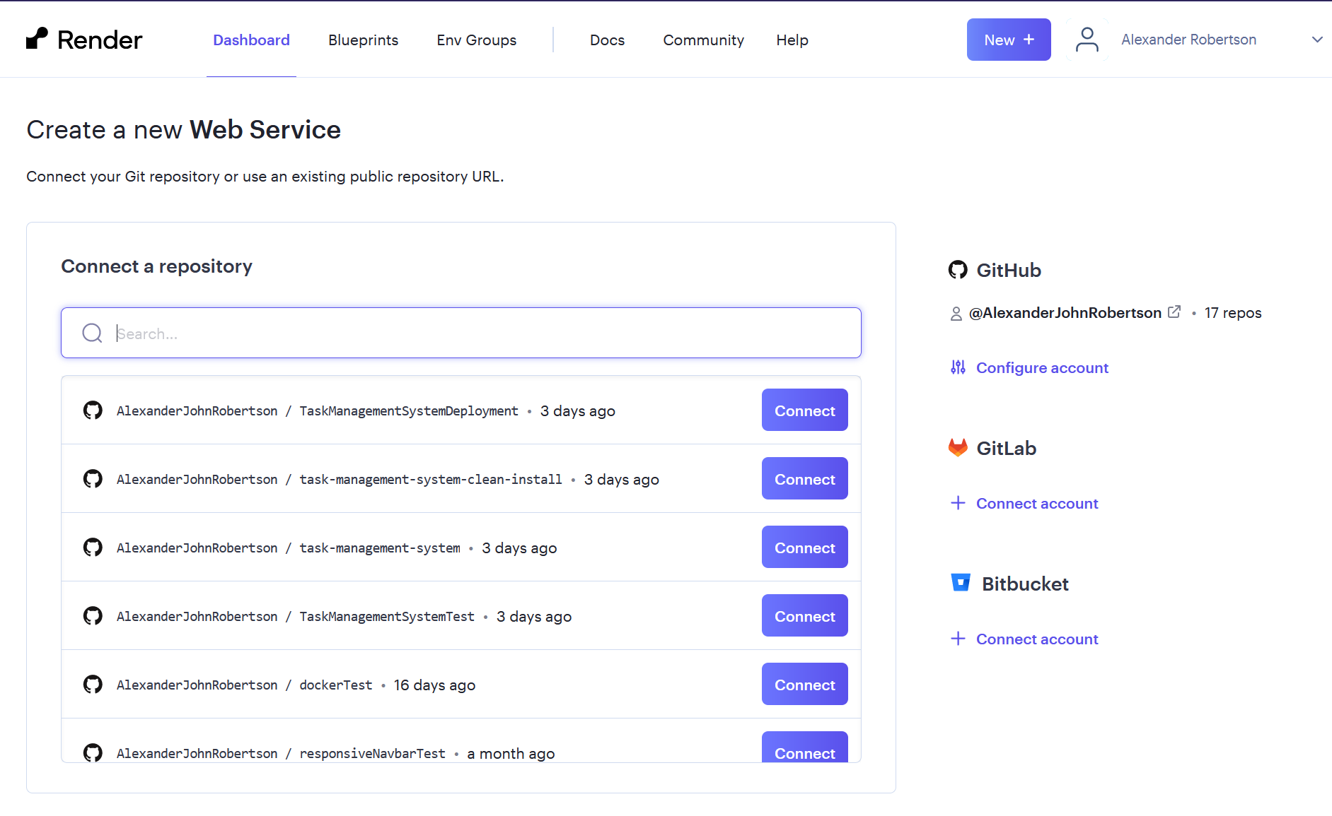

Figure 101 - Select the GitHub repository you created in the previous section.

1. Set the Name to an appropriate name for the Task Management System deployment, the Region, Branch of your Git repository, Set the Runtime to “Python 3”. Make sure the Build Command is set to “*pip install -r requirements.txt*” and the Start Command is set to "*gunicorn app:app*”.

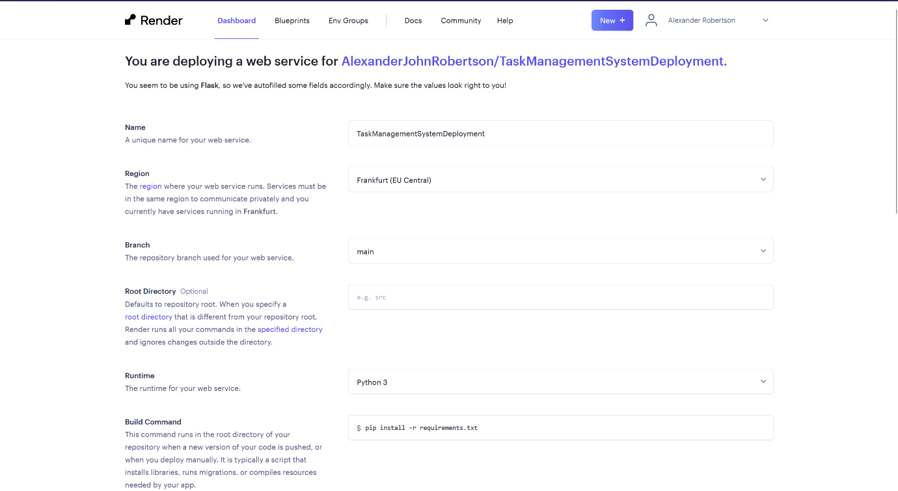



Figure 102 - Render.com web service settings.

1. Set the Instance Type to a subscription dependent on your organisation's needs.

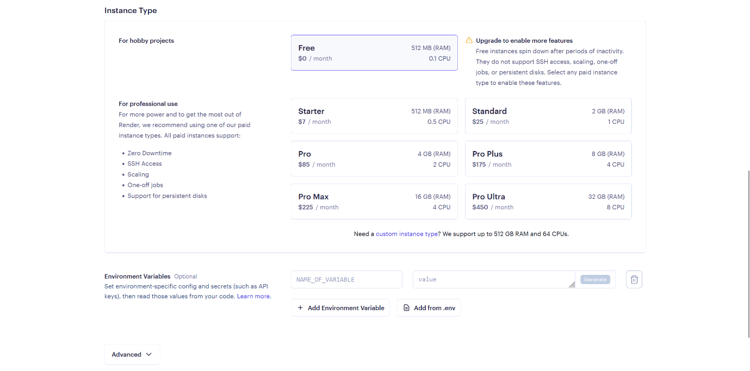

Figure 103 - Render.com subscriptions.

1. Click “Create Web Service”.

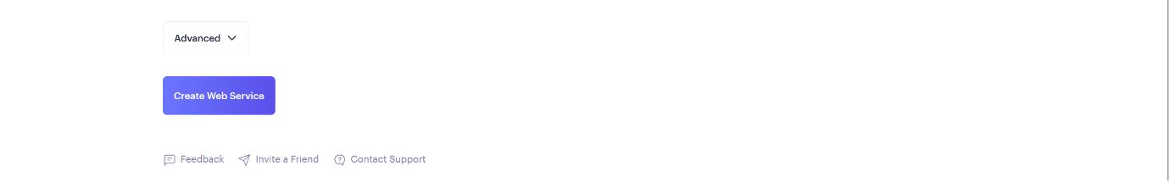

Figure 104 - Create Web Service

1. Wait for Render.com to build and deploy the Task Management Web Service

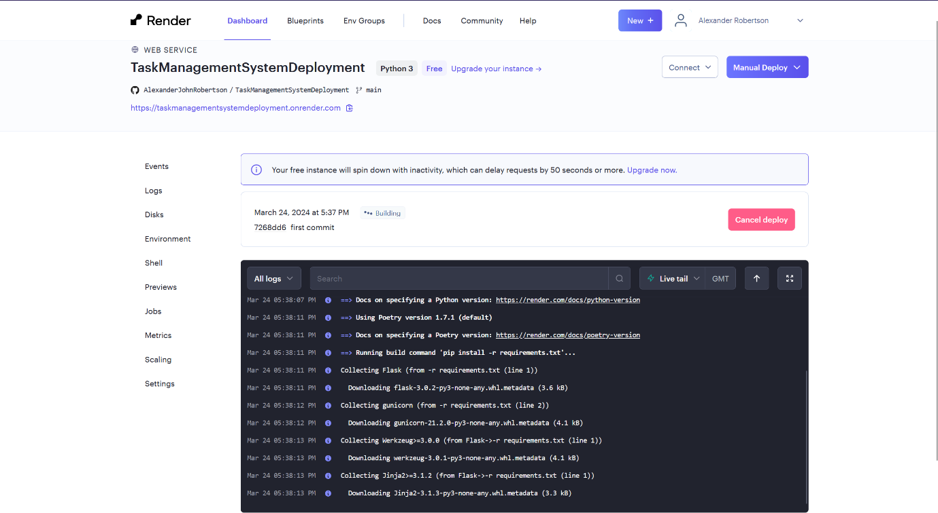

Figure 105 - Render.com build progress.

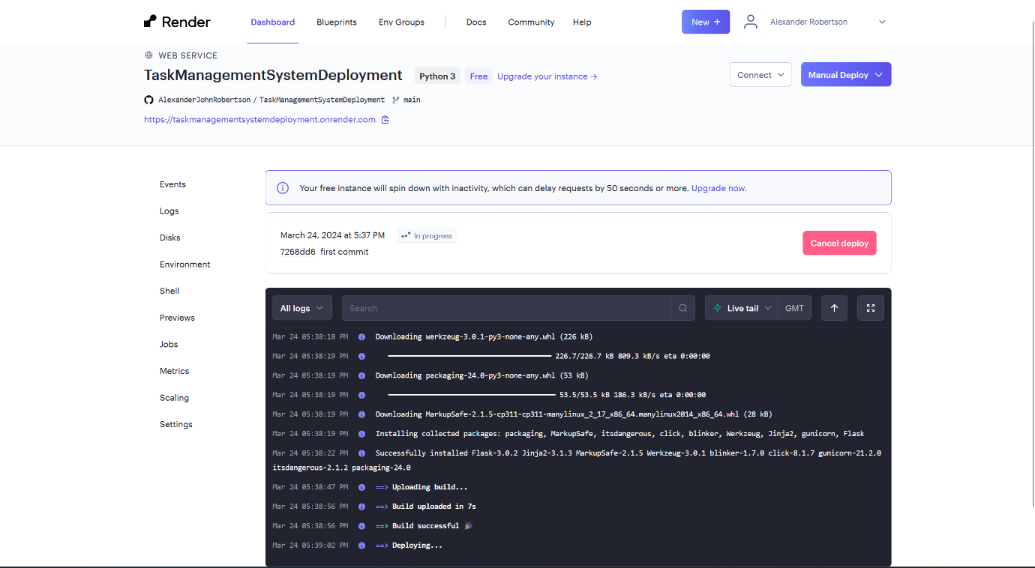

Figure 106 - Render.com deployment progress.

1. The Task Management Web Service deployment is now live. Click the link to view the web service.

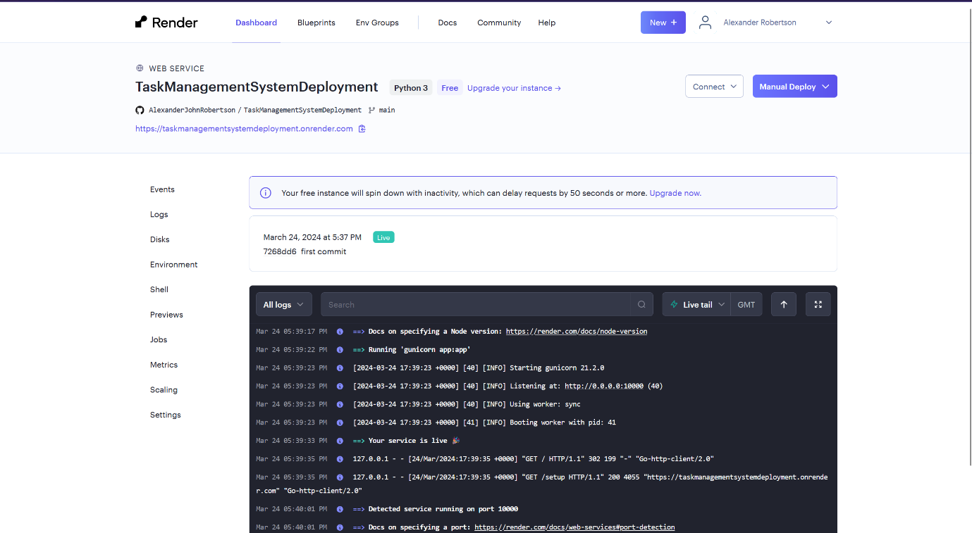

Figure 107 - Build and deploy now complete. Task Management System web service is now live at the given URL.

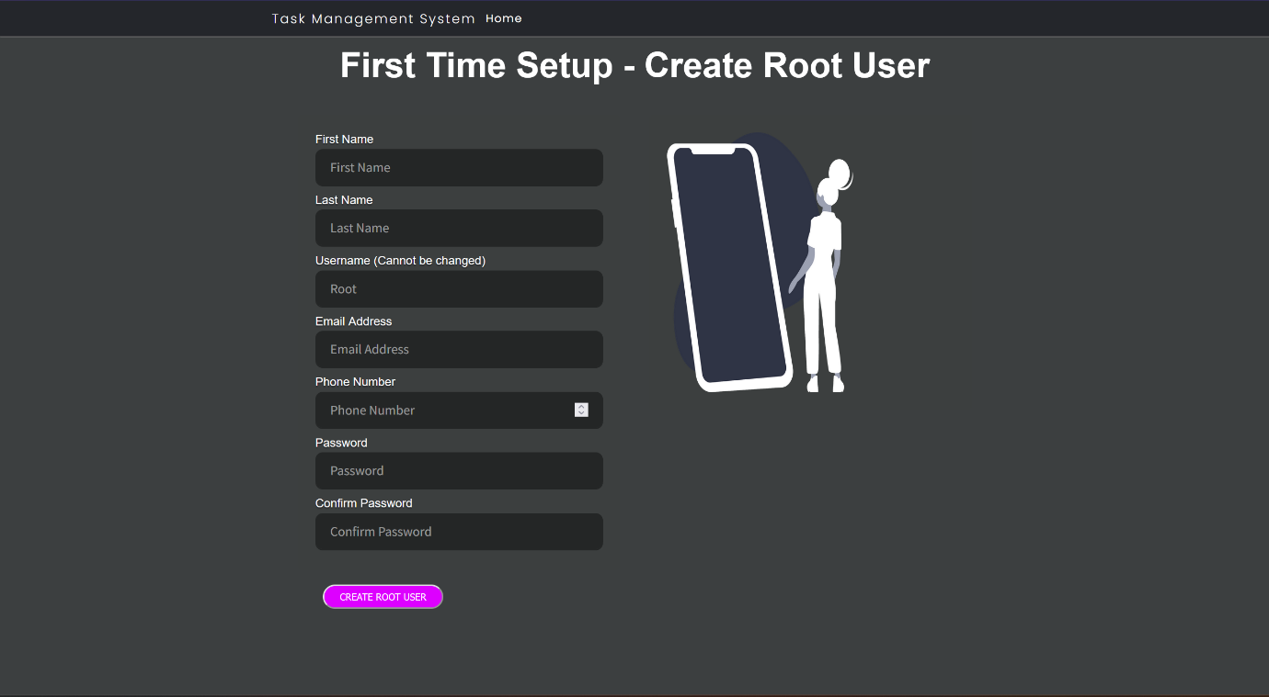

Figure 108 - Task Management System Setup page on Render.com.

1. The Task Management System Web Service is now ready to set up and use.
2. You have now created a Continuous Integration / Continuous Deployment (CI/CD) Pipeline with PyCharm (Code and test (e.g. unit testing)) 🡪 Git 🡪 GitHub 🡪 Render.com (Build, Deploy and Release) 🡪 Task Management System as the process is automated as soon as you push to the Git repository from the PyCharm terminal, the Task Management System is deployed on Render.com. Render.com automatically detects new commits and pushes to the Git repository and will then automatically rebuild and redeploy the application.

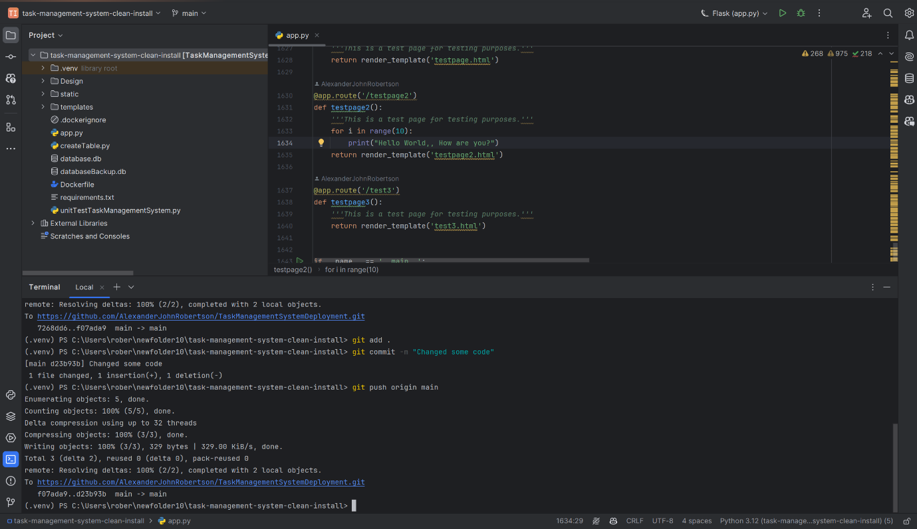

Figure 109 - Committing and pushing new changes to the Git repository.

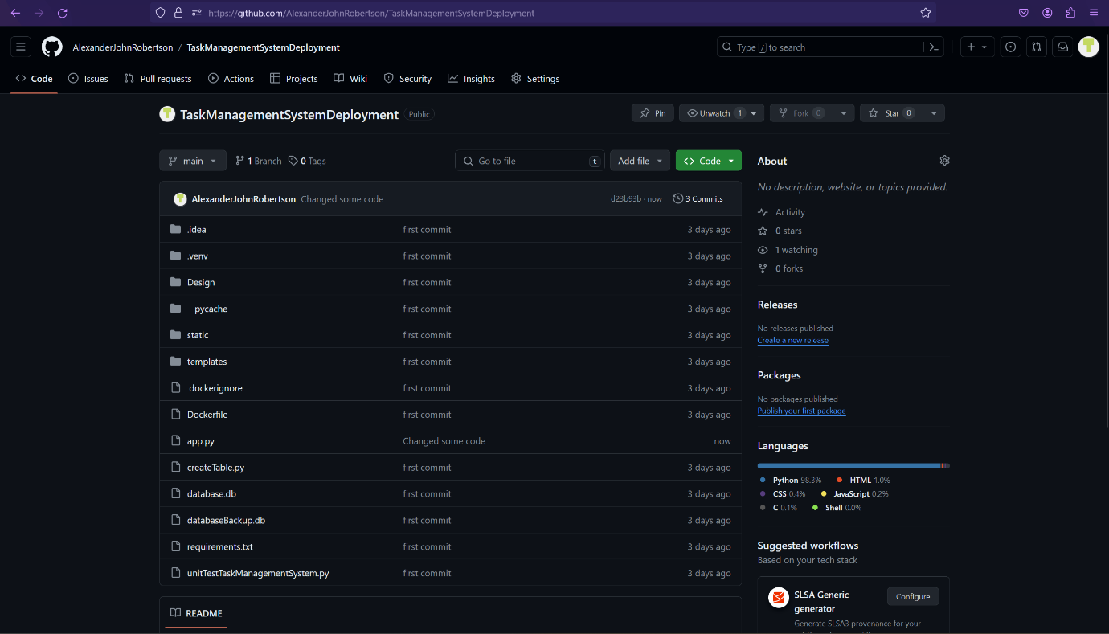

Figure 110- New changes committed to Git repository.

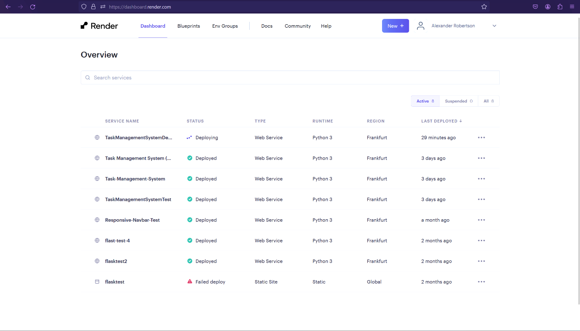

Figure 111 - Task Management System web service redeploying shown on Dashboard.

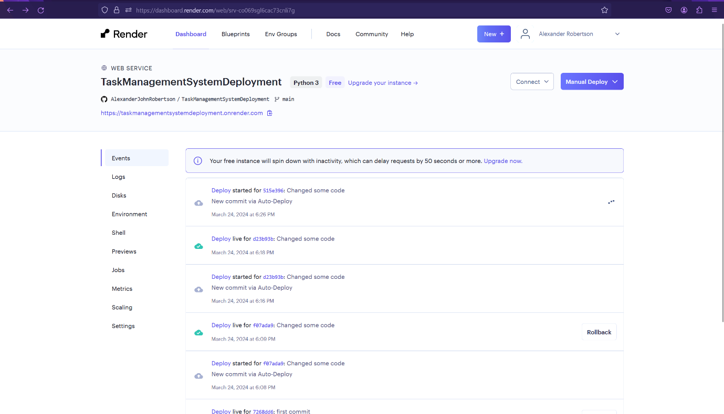

Figure 112 - Task Management System redeployment showing in web service "Events" tab.

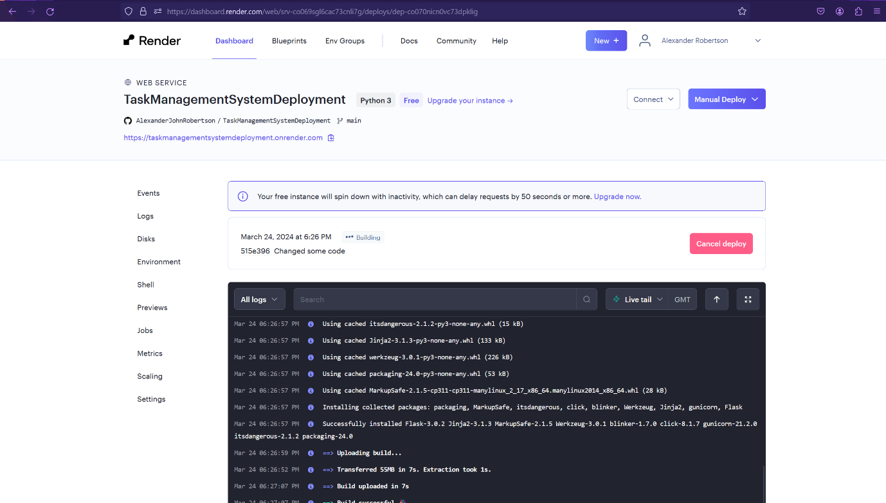

Figure 113 - Task Management System web service rebuilding as GitHub and Render.com has set up a CI/CD pipeline.

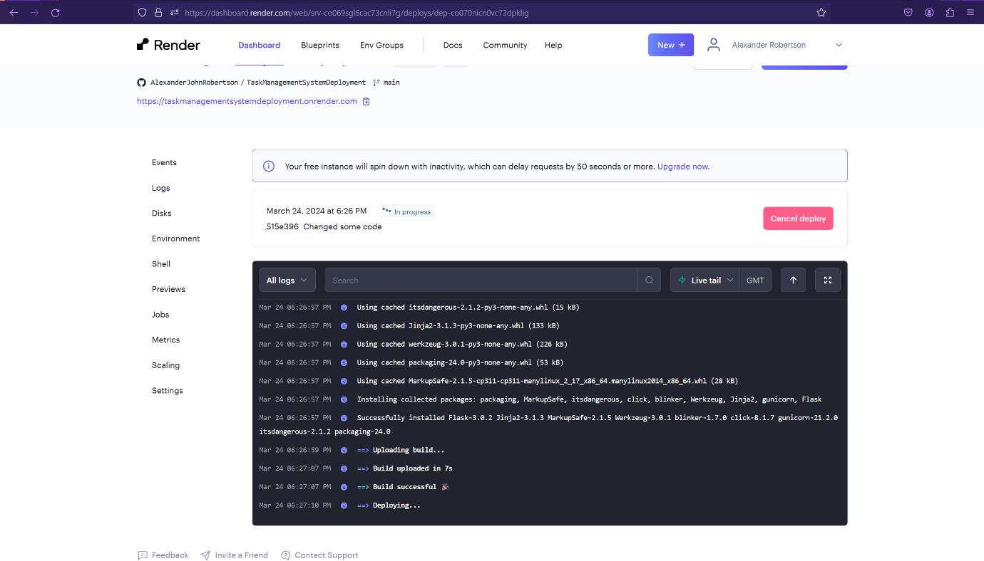

Figure 114 - Task Management System web service redeploying as GitHub and Render.com has set up a CI/CD pipeline.

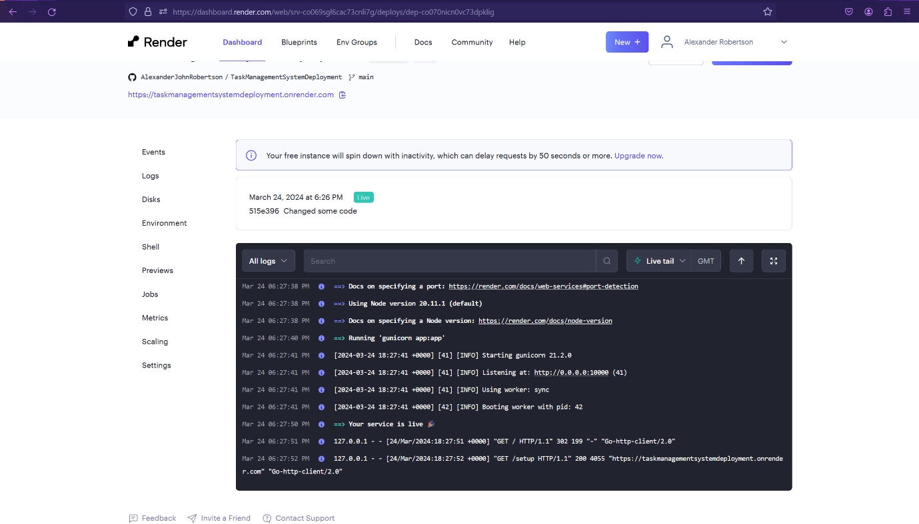

Figure 115 - Task Management System has been successfully redeployed and is now live.

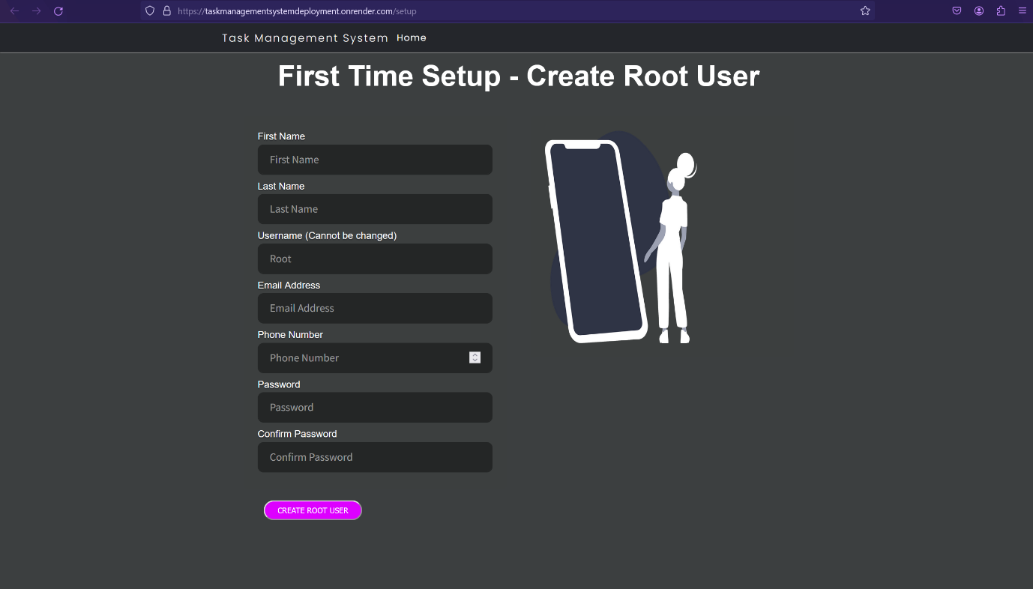

Figure 116 - Task Management System redeployed on Render.com.

## Deploy using Docker or other containerisation platforms.

1. Open the folder containing the source code for the Task Management System.

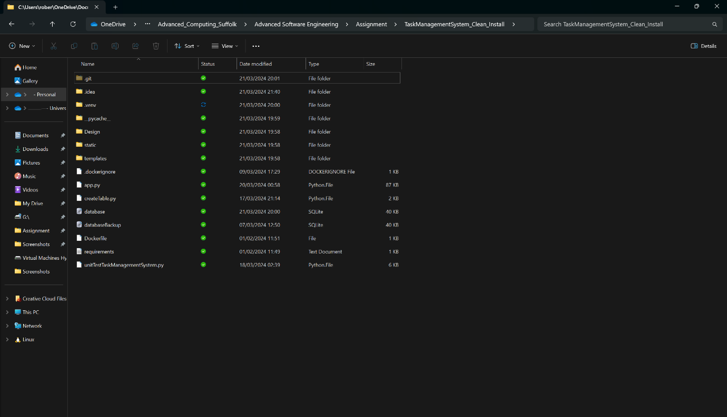

Figure 117 - Directory containing the Task Management System program files.

1. Open the folder containing the Task Management System in the Terminal, PowerShell, or Command Prompt. Alternatively navigate to the folder from within the terminal if your operating system’s file browser doesn’t support this feature.

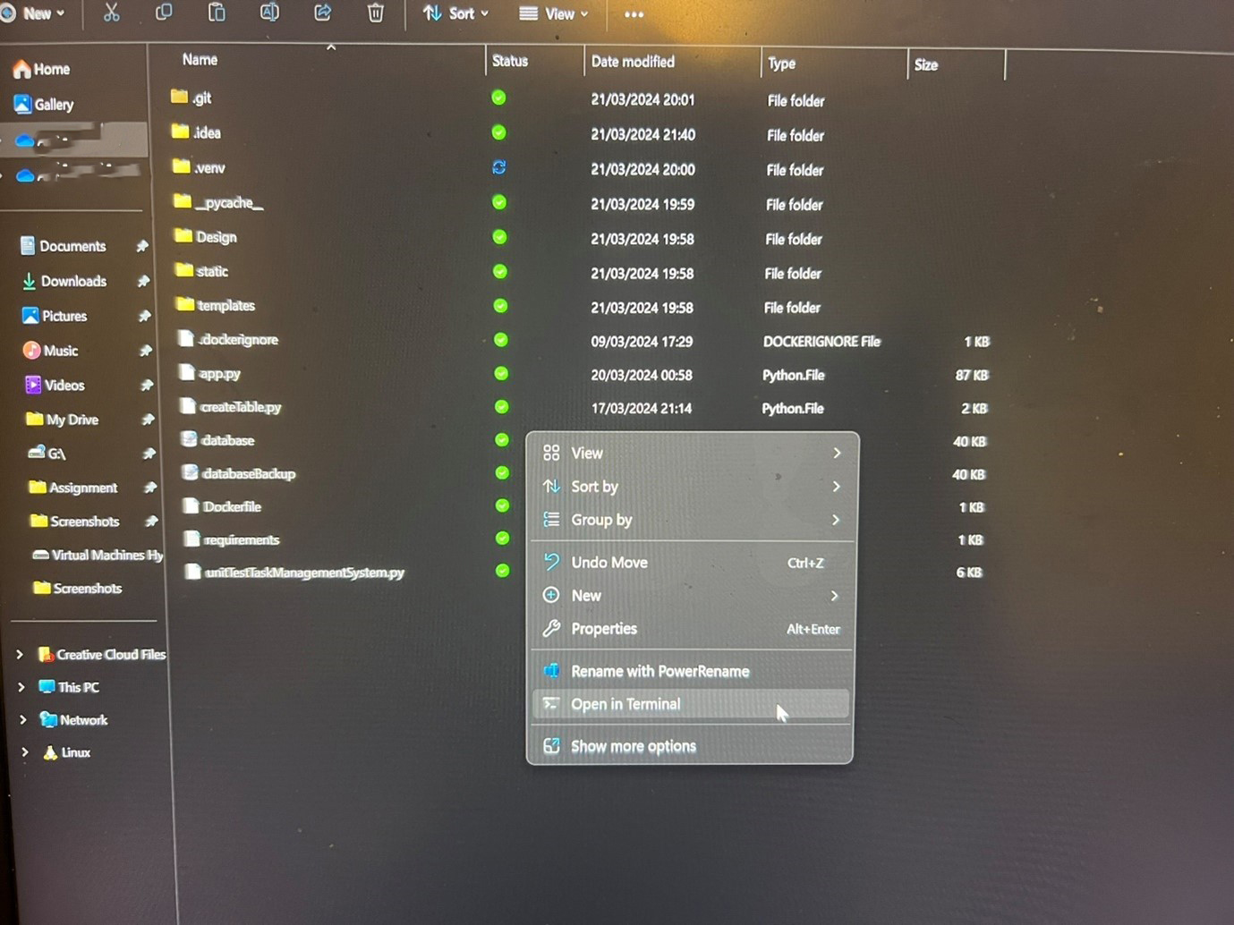

Figure 118 - Opening the Terminal in the Task Management System directory.

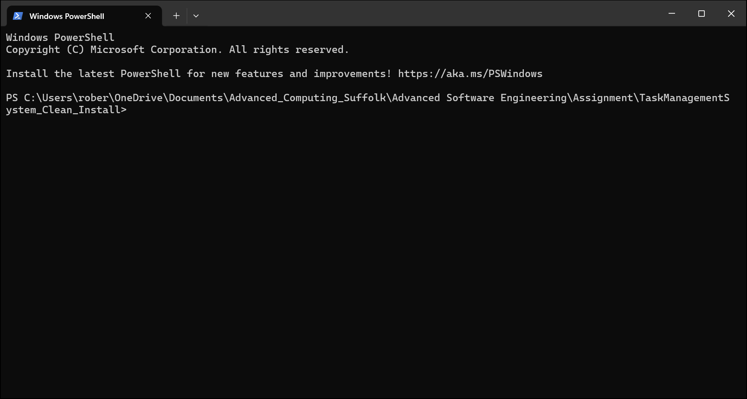

Figure 119 - The Terminal open in the Task Management System directory.

1. Build the Docker image by entering the command “*docker build -t <your-docker-username>/taskmanagementsystemcleaninstall:latest .*” or *docker build -t <your-docker-username>/taskmanagementsystem:latest .*”.
2. Run the Docker container by entering the command “*docker container run -d -p 5000:5000 <your-docker-username>/taskmanagementsystemcleaninstall:latest*” or “*docker container run -d -p 5000:5000 <your-docker-username>/taskmanagementsystemcleaninstall:latest*”.
3. Use the command “*docker ps*” to verify that the container is running.

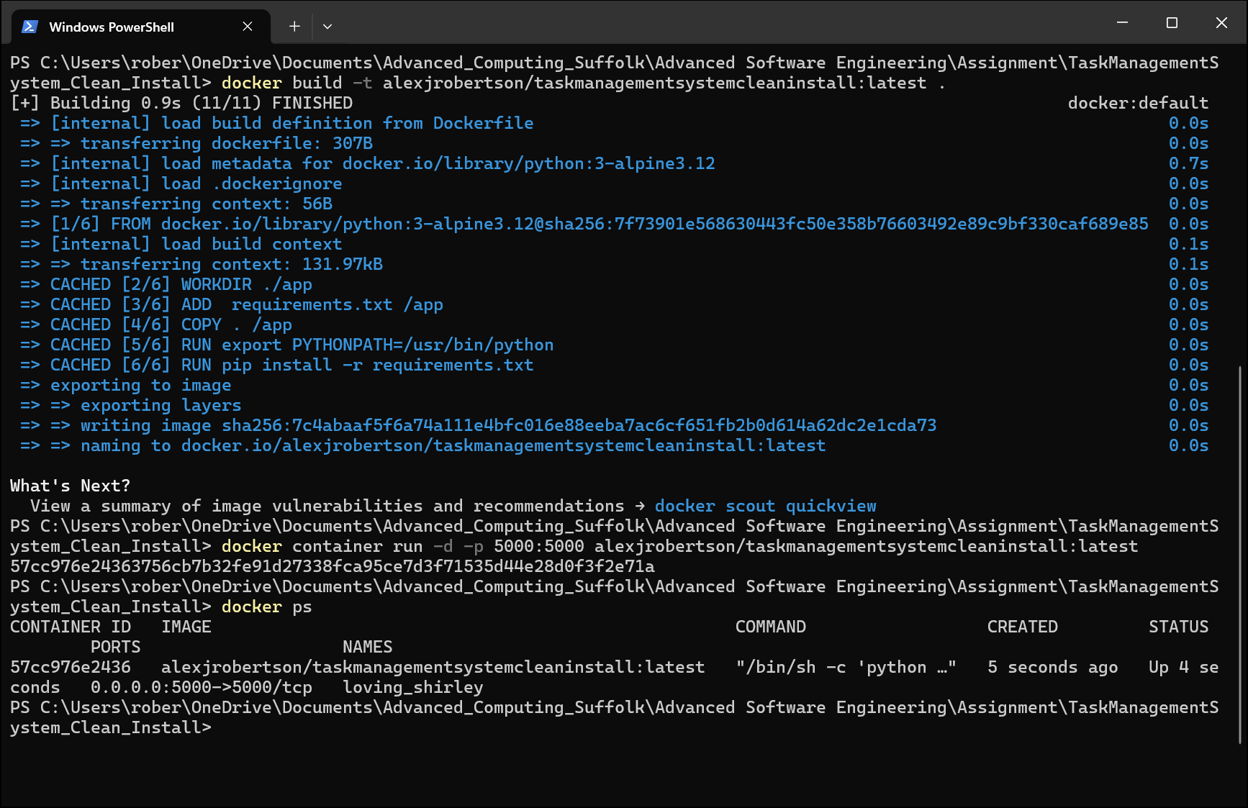

Figure 120 - Running the docker build and docker run commands to build the Docker Image and run the Docker Container.

1. View the running container(s) in the Containers tab in Docker Desktop.

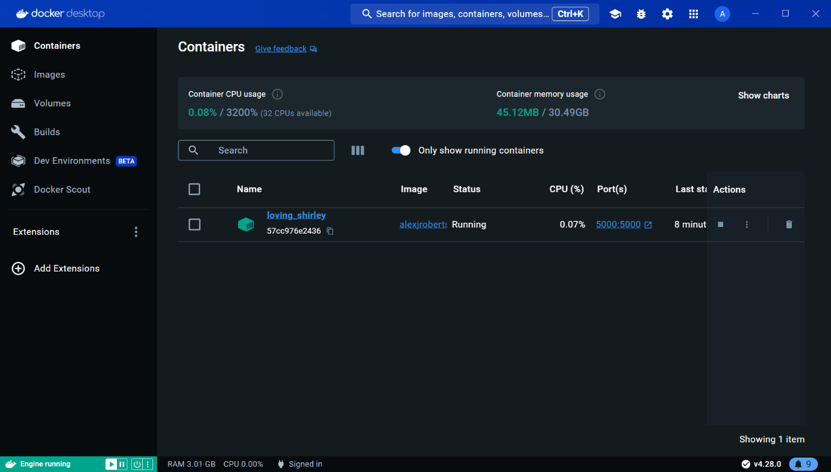

Figure 121 - Task Management System Container running on Docker Desktop.

1. Click on the Port(s) to view the running Task Management System container in your web browser.



Figure 122 - Select the Port(s) to access the Task Management System running in your browser.

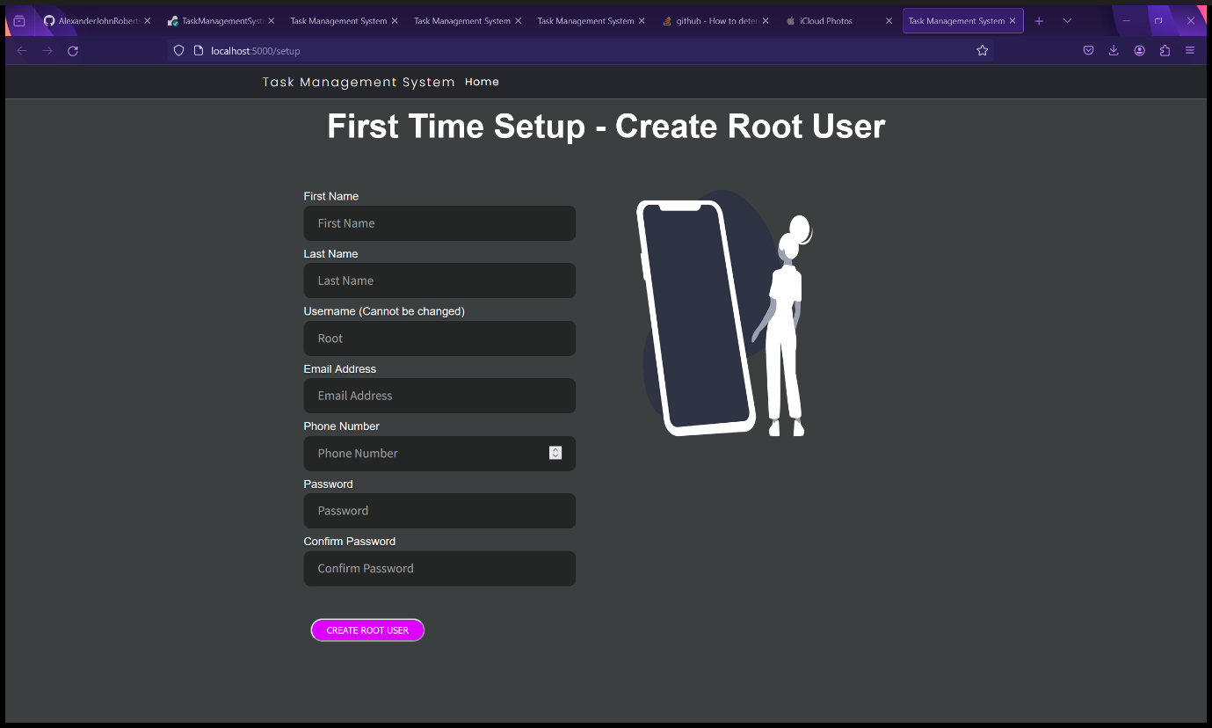

Figure 123 - Task Management System running in a Docker container.

1. View the images on the Images tab in Docker Desktop.

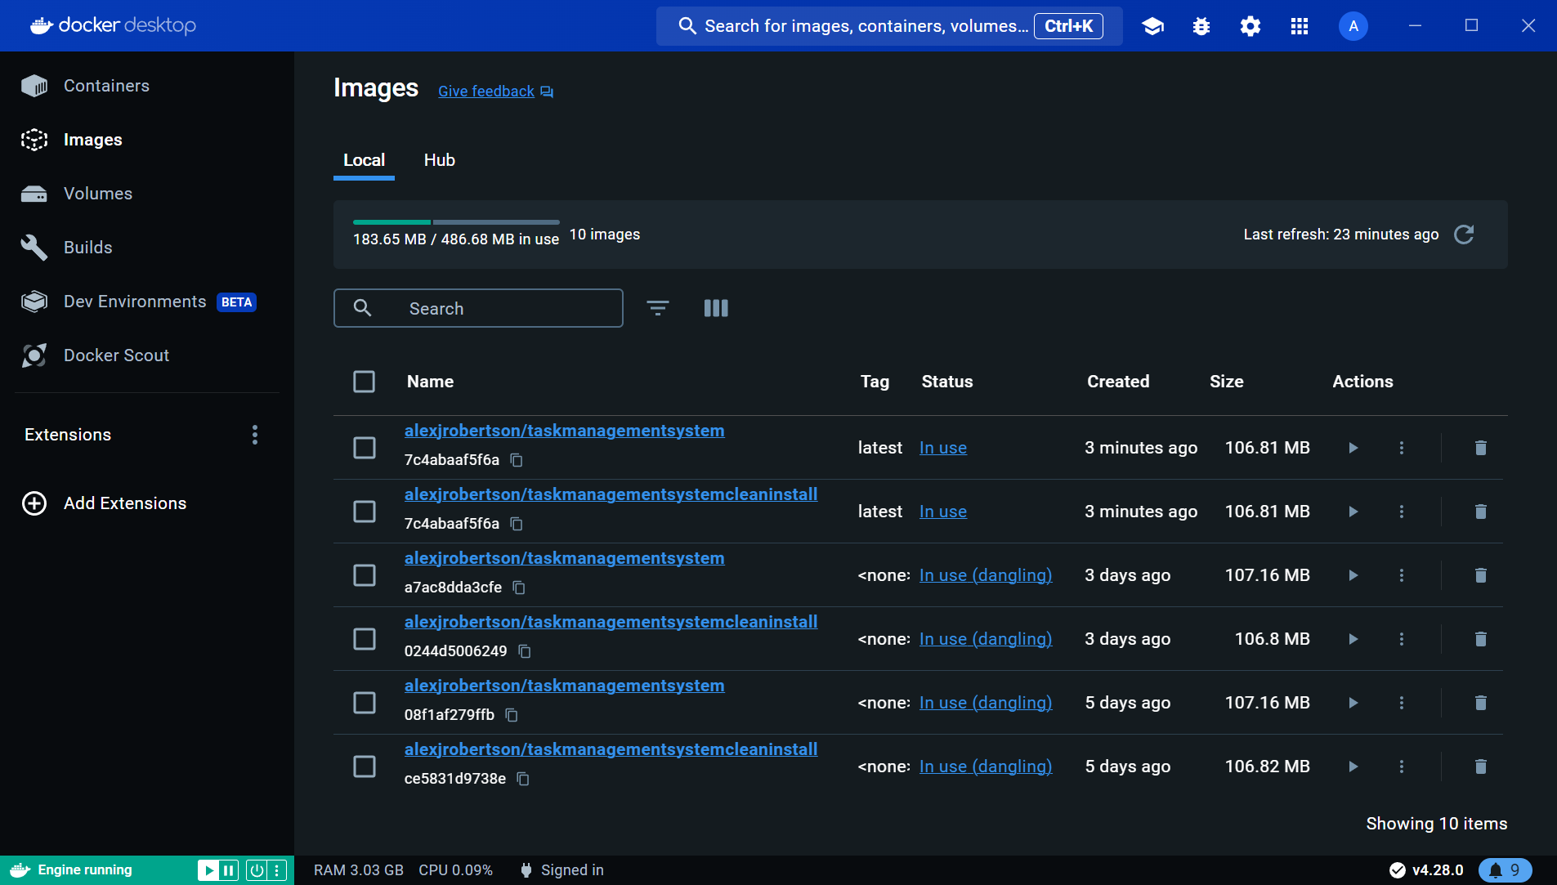

Figure 124 - List of Docker Images.

1. Push the image to Docker Hub.

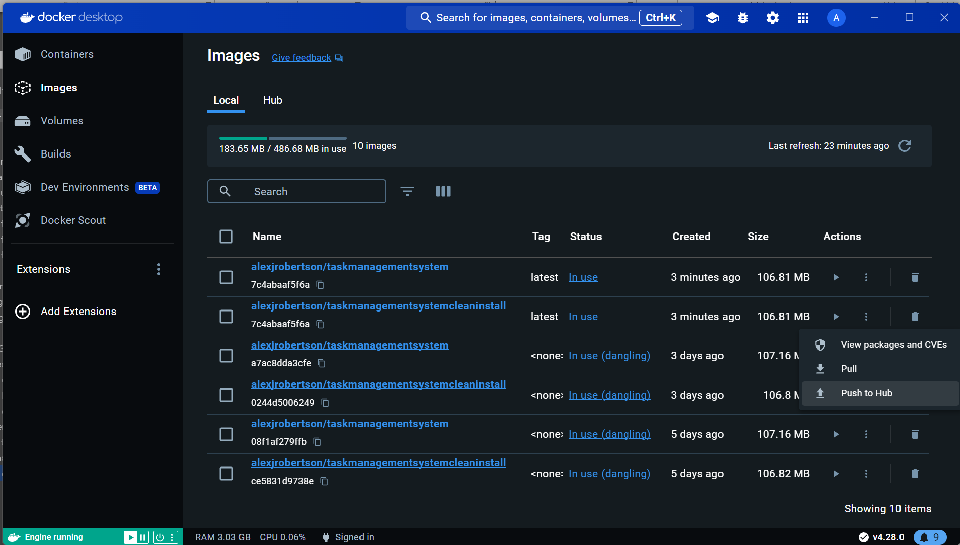

Figure 125 - Pushing the Docker Images to Docker Hub.

1. View the image in Docker Hub.

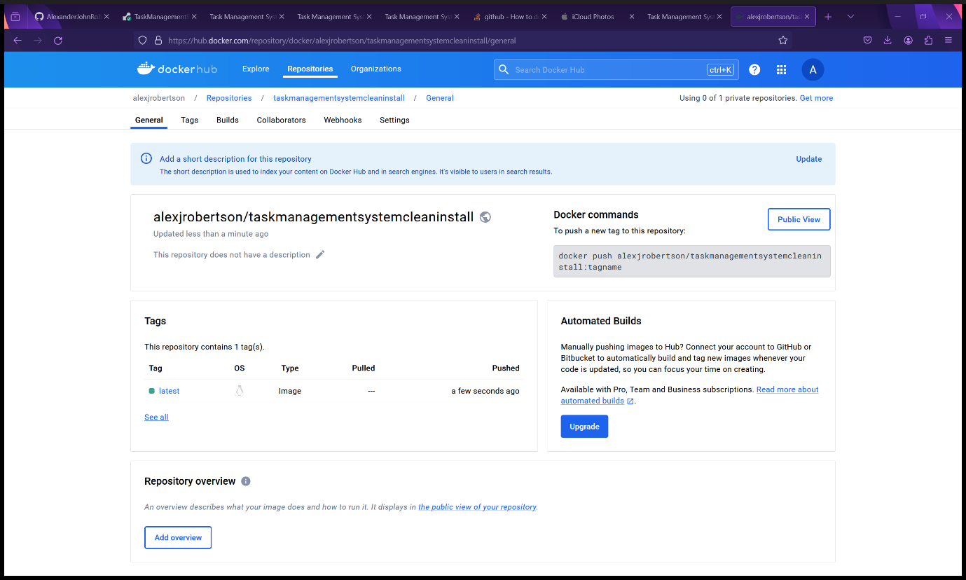

Figure 126 - Task Management System on Docker Hub.

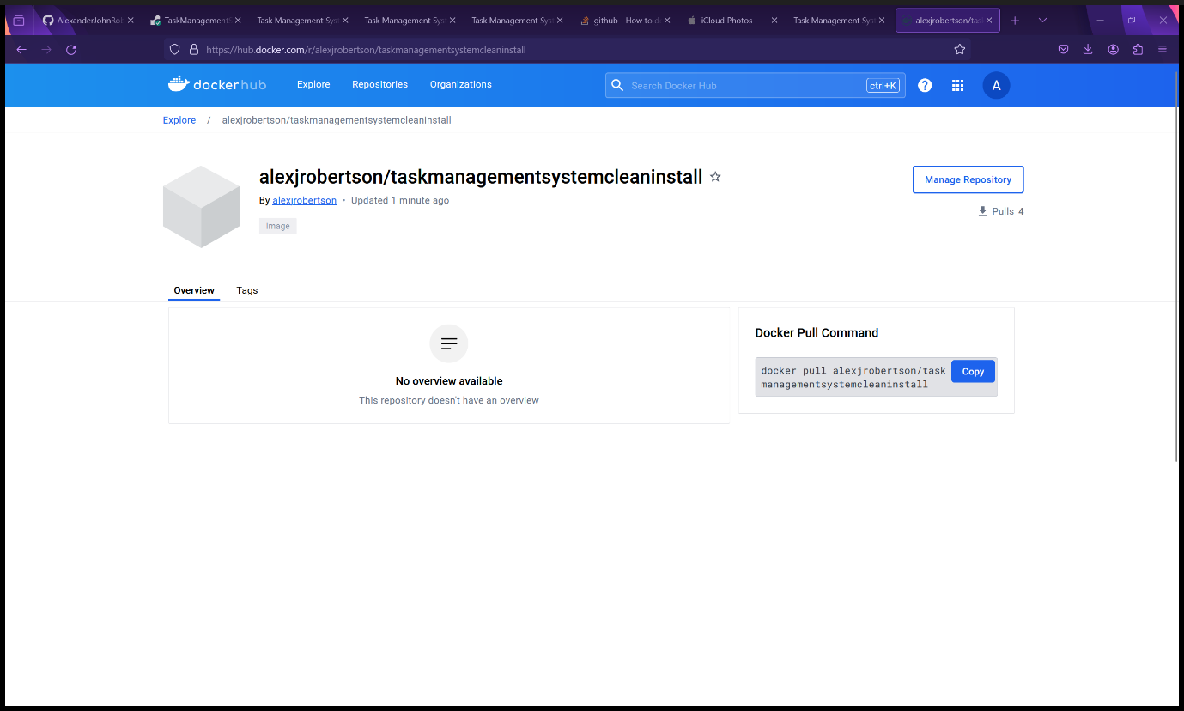

Figure 127 - Public view of the Docker Image on Docker Hub.

1. Troubleshooting tips:
   1. Make sure there is one space and a full stop (.) at the end of the Docker build command or else the build will fail.
   2. If the build fails and you encounter an error message in the terminal (*ERROR: failed to solve: error from sender: context canceled*) when entering the docker build command, consider closing PyCharm and re-run the docker build command. Use the computer terminal instead of the PyCharm terminal. There is a bug that sometimes causes PyCharm to interfere with Docker.

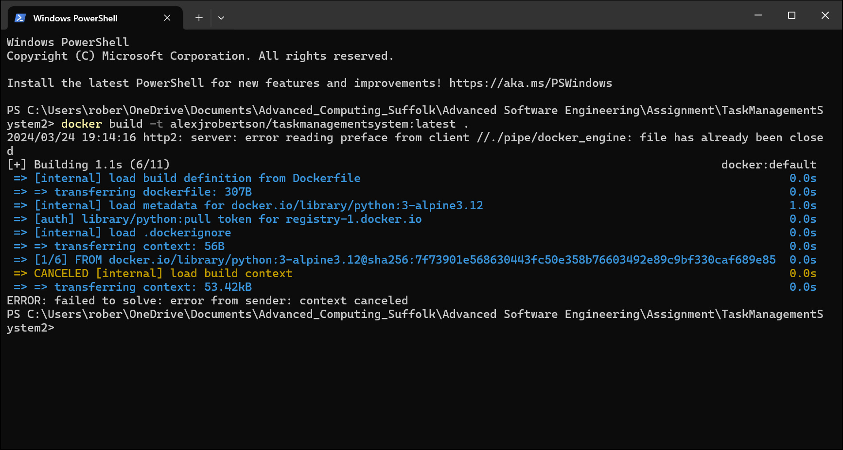

Figure 128 - Error that occurs if you try to build the Docker images while PyCharm is still running.

* 1. If you receive an error message that the port is already in use when you enter the docker container run command, then change the port number (in red) before the colon and re-run the docker container run command. E.g. change “*docker container run -d -p 5000:5000 <your-docker-username>/taskmanagementsystemcleaninstall:latest*” to “*docker container run -d -p 5100:5000 <your-docker-username>/taskmanagementsystemcleaninstall:latest*”.

# Using the Task Management System

## First Time Setup

1. On the deployment platform of choice such as Render.com or Docker, open the link to the Task Management System (See Installation instructions above for details).

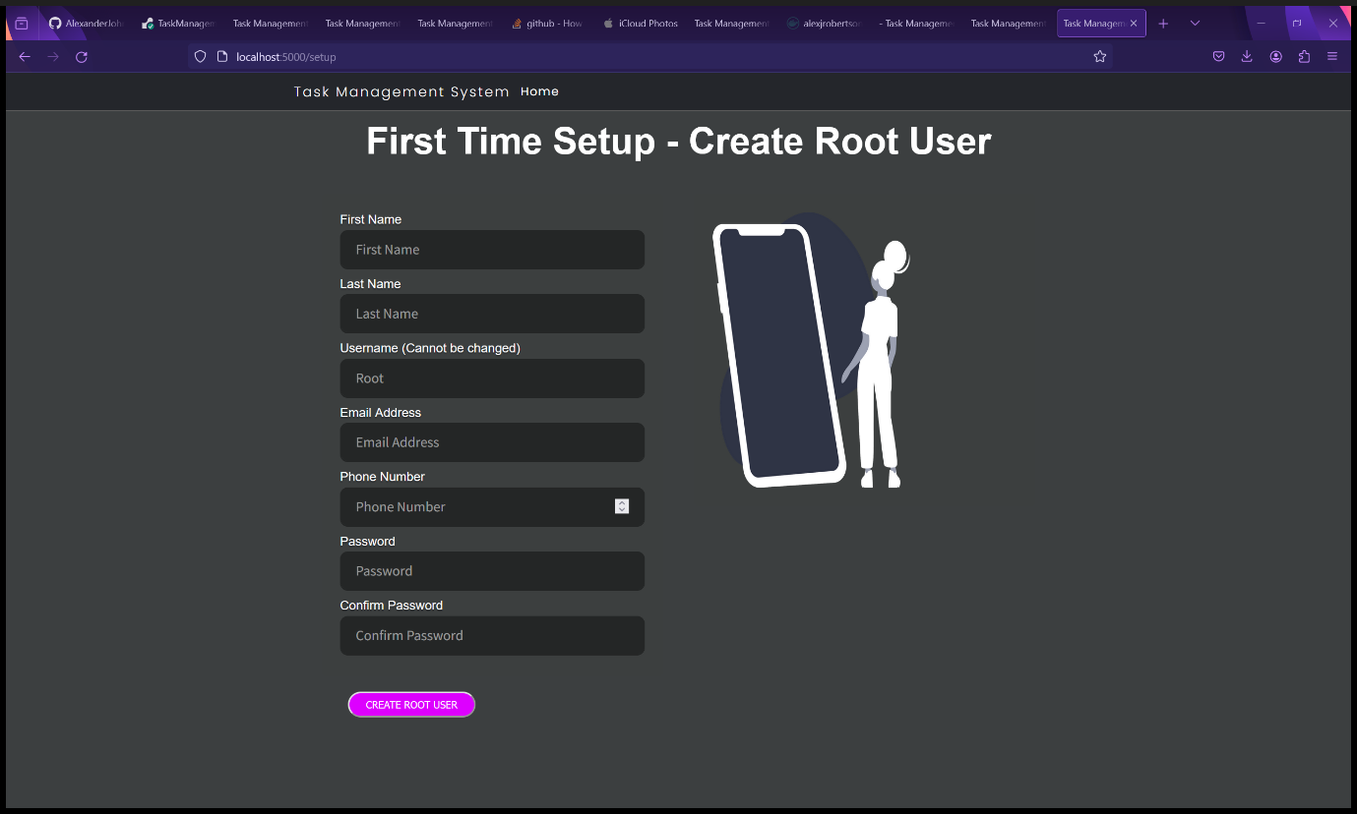

Figure 129 - Task Management System Setup page.

1. Fill in the First Time Setup form to create a Root user. Please note that the username is “Root” and cannot be changed for this user. All fields must be filled in with valid information. The password must be at least 10 characters long, have at least one uppercase letter, one lowercase letter, one number and one special character. The special character(s) must be an ASCII character due to technical limitations with the emailing function. Then click “Create Root User”. The password must be a common password.

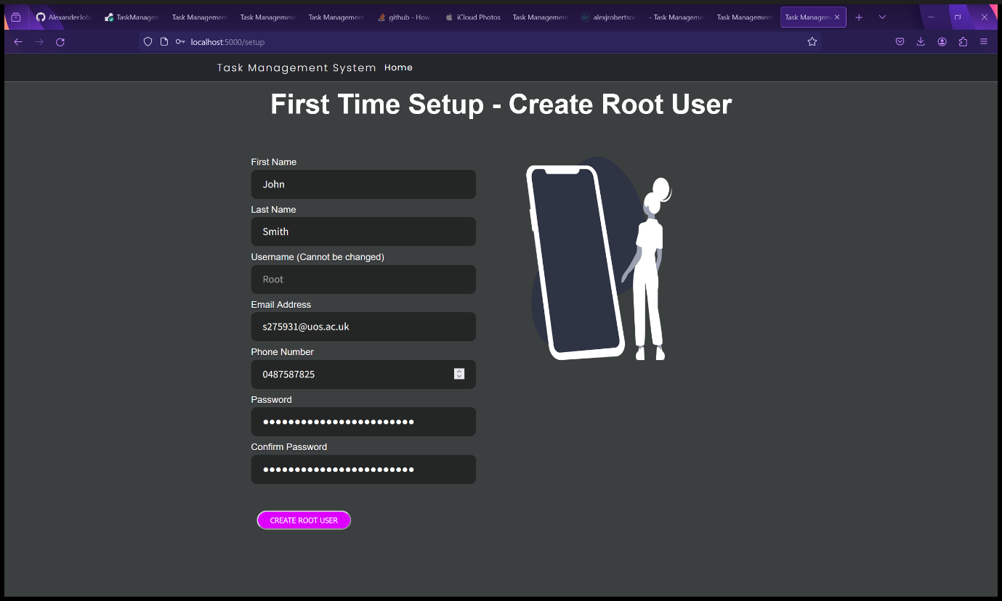

Figure 130 - Task Management System Setup page.

1. You will be redirected to the User home page and receive an email with the password you entered.

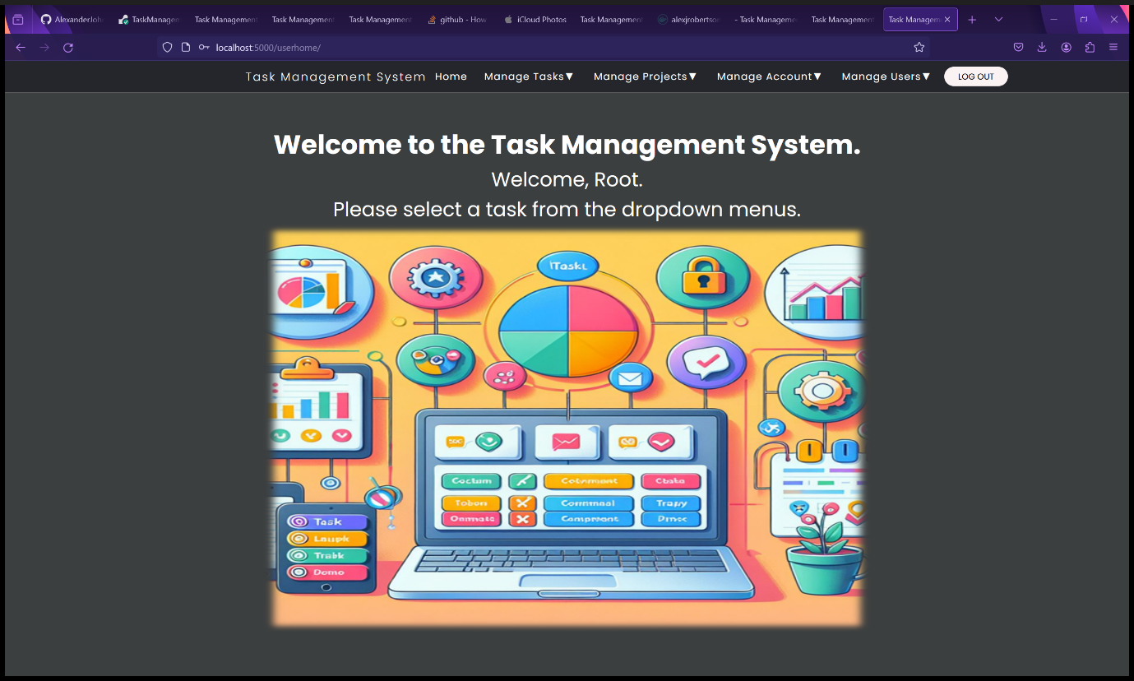

Figure 131 - User Home Page

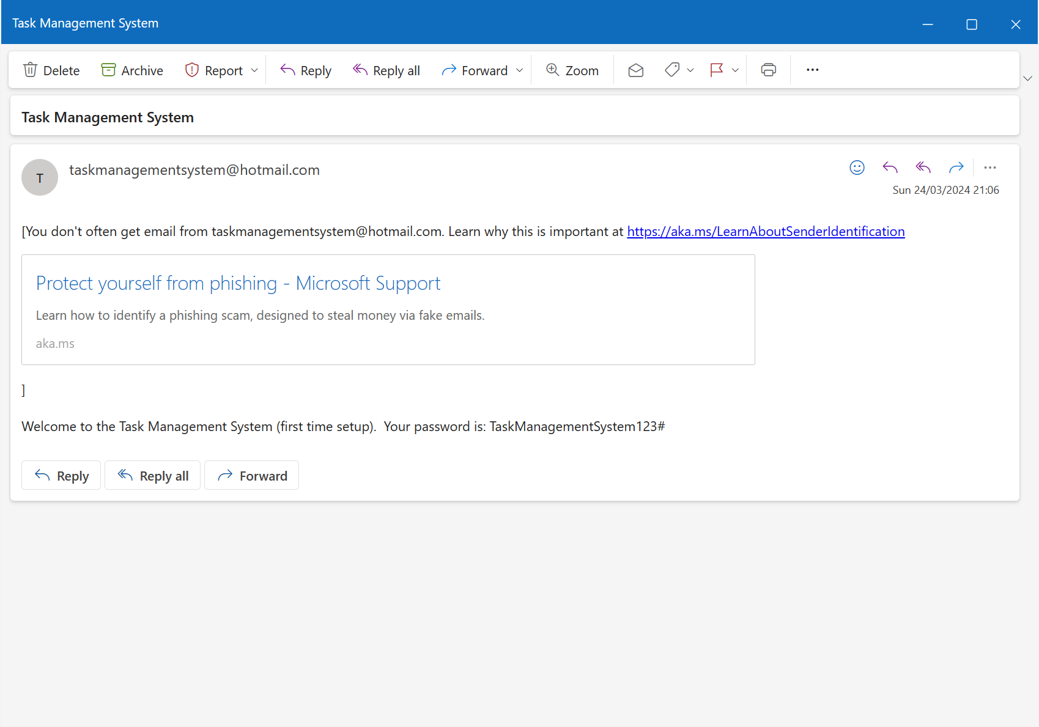

Figure 132 - Automatic email sent to Root User upon setup.

1. The Task Management System is now ready for use.

## Logging out

To log out, simply click the “Log Out" button in the top right corner of the navbar. You will be redirected to the Task Management System landing page.



Figure 133 - User Home Page while logged in.

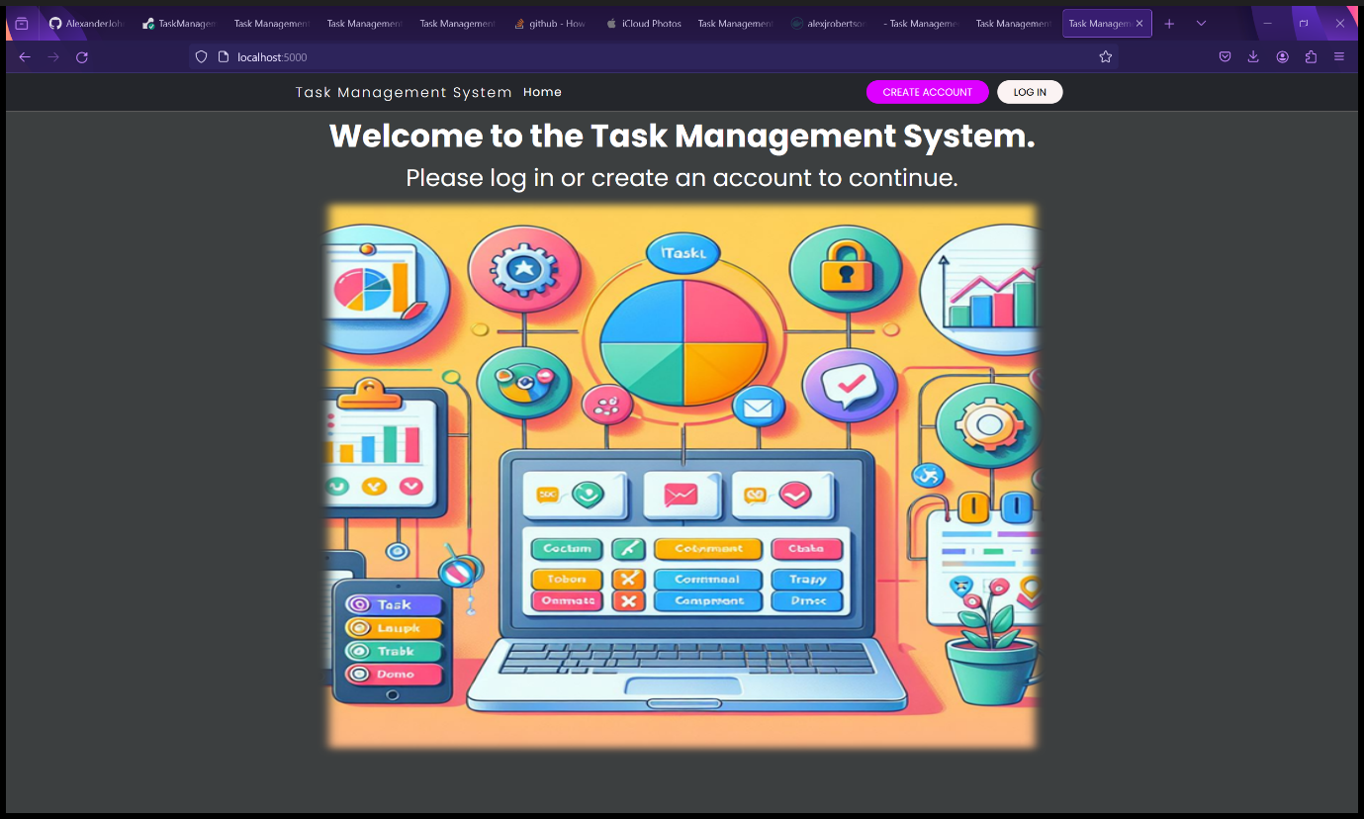

Figure 134 - Landing page after being logged out.

## Logging In

1. Click the “Log In” button in the navbar in the top right corner.



Figure 135 - Landing Page

1. Enter your username and password and click “Log In”. WARNING: If you enter the wrong password three or more times in a row, your account will be automatically blocked for security reasons. You will need to contact an administrator or Root user to unblock your account.

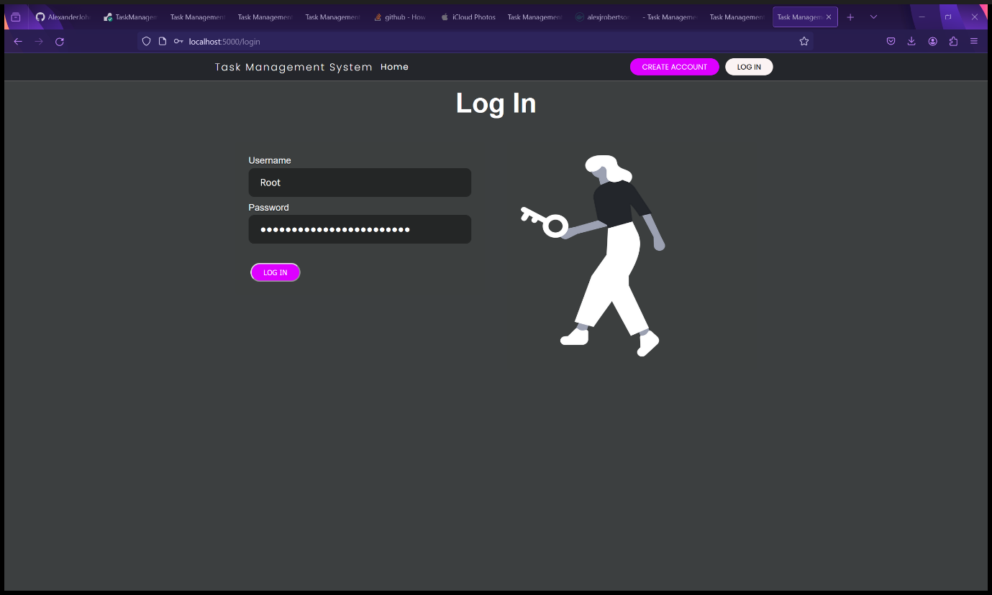

Figure 136 - Log In form.

1. You will be redirected to the User home page.

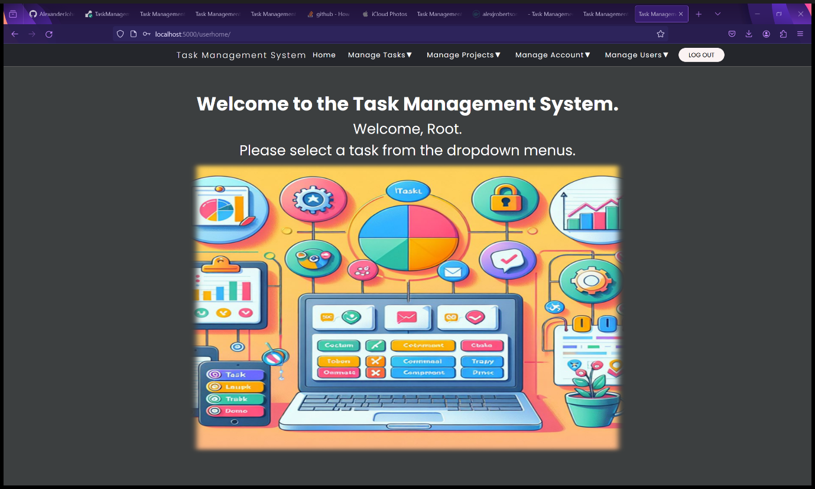

Figure 137 - User Homepage after logging in.

1. You are now able to use the Task Management System.

## Create Account

1. Click the “Create Account” button in the navbar in the top right corner.



Figure 138 - Landing Page

1. Fill in the Create Account form with your details then click the “Create Account” button. Please note that the password must be at least 10 characters long, have at least one uppercase letter, one lowercase letter, one number and one special character and must not be a common password. Non-ASCII characters such as UTF and Unicode characters are allowed as an email is not automatically sent in this case.

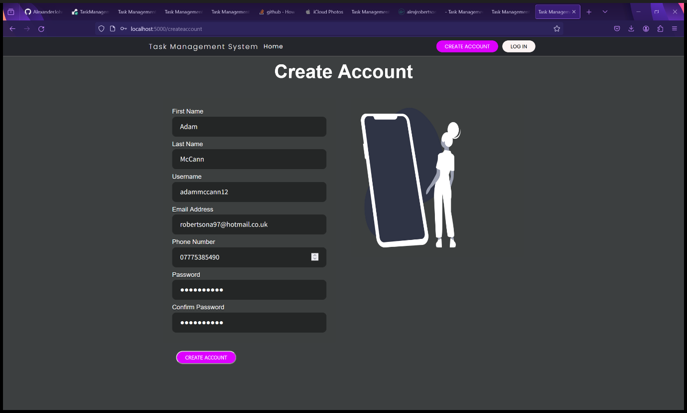

Figure 139 - Account Creation Form.

1. The user is redirected to their user home page and are now ready to use the Task Management System. Please note that new user accounts are created as a standard user by default for security purposes therefore there are restrictions on standard accounts. A standard account can add and view tasks, add and view projects, view and change their own account details except for their account type and block status. An administrator account and the Root user both have full control over the Task Management System and therefore can add, view, update and delete tasks, add, view, update and delete projects, manage other users, and view other user details and perform administrative tasks. Administrators and the Root user can change the account type of other users, block and unblock users and factory reset the Task Management System.

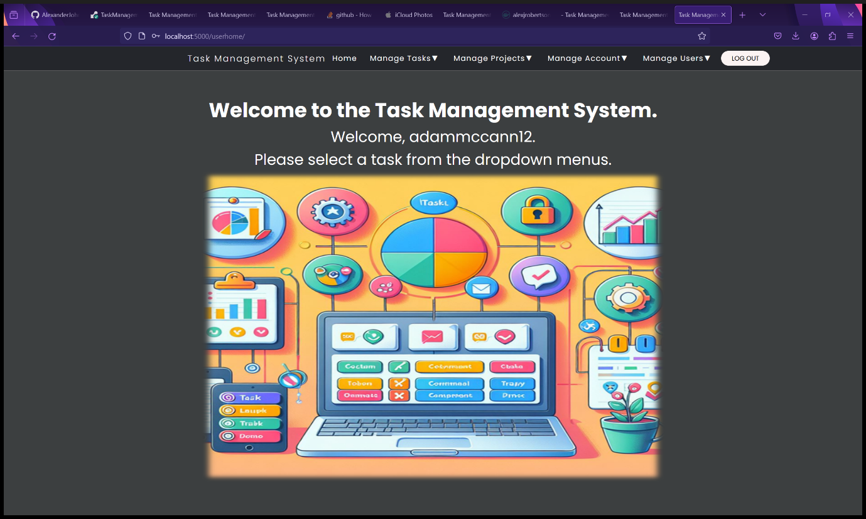

Figure 140 - User Home Page after Account Creation.

1. The Task Management System is ready for use.

## Manage Projects

### Create a New Project

1. Select “Create Project” from the “Manage Projects” dropdown menu.

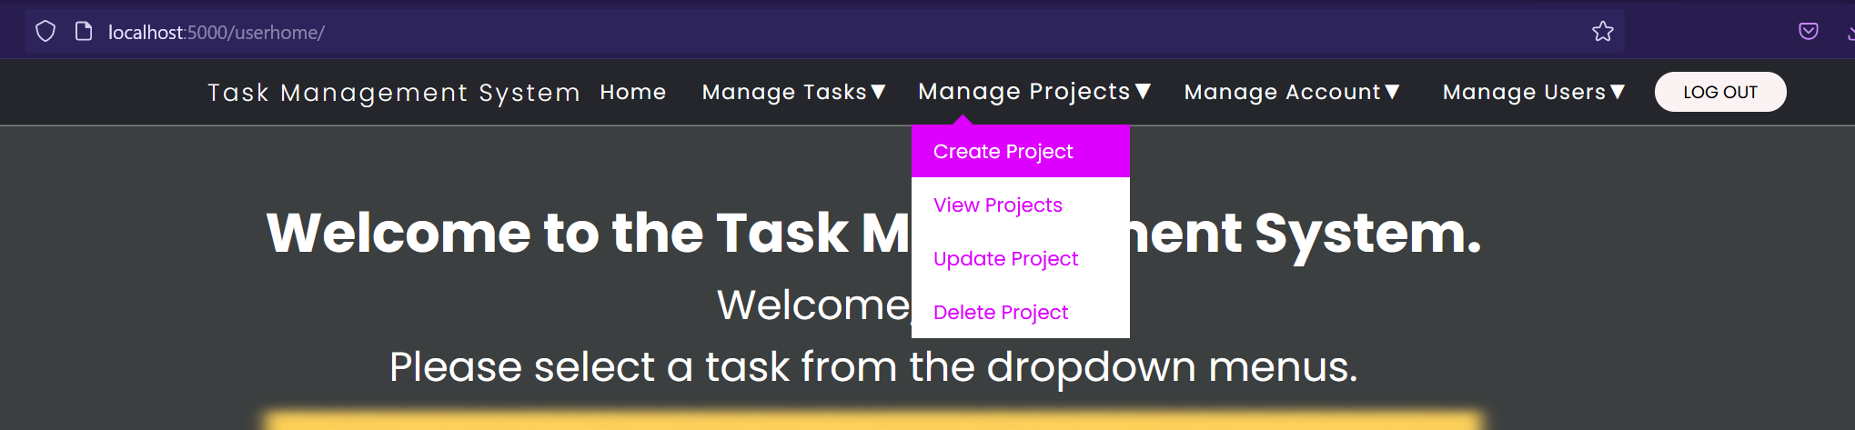

Figure 141 - Select "Create Project" from "Manage Projects" dropdown menu.

1. You will be redirected to the Add New Project form.
2. Fill in the details of the new project in the Add New Project form. All fields are mandatory.
   1. The Project ID must be a whole number. All project IDs must be unique.
   2. The Title is the project title. Any character is accepted. Foreign languages are supported.
   3. The Description text field contains the project description. Any Unicode character is supported and foreign languages and writing systems are supported.
   4. The Assigned Tasks field is where you enter a list of tasks separated by a comma. Unicode characters, foreign languages and writing systems are supported.
3. Click the “Add Project” button.

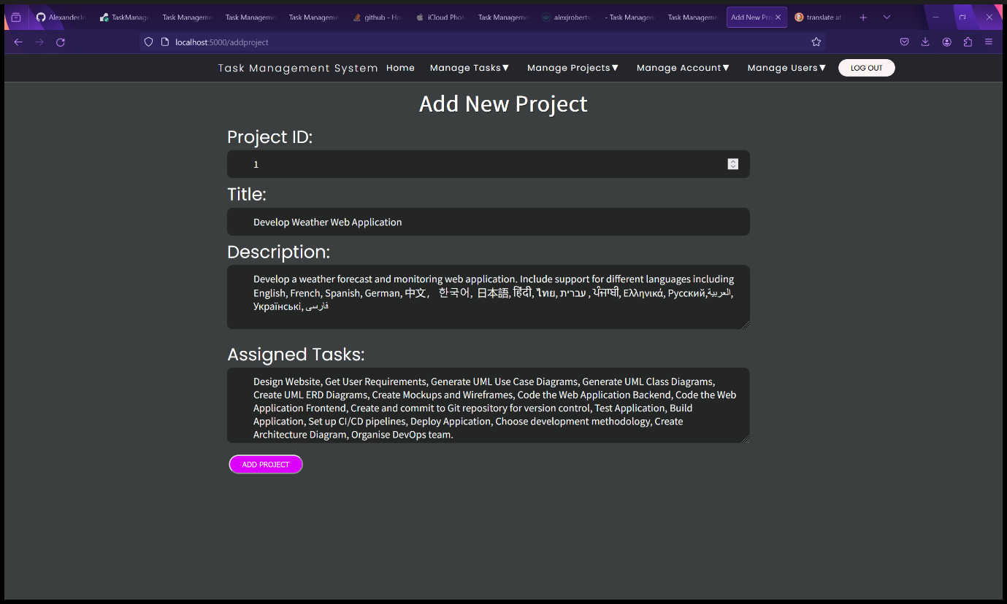

Figure 142 - Add New Project Form.

1. You will be redirected to the View Projects page where you can view the list of projects as a table.

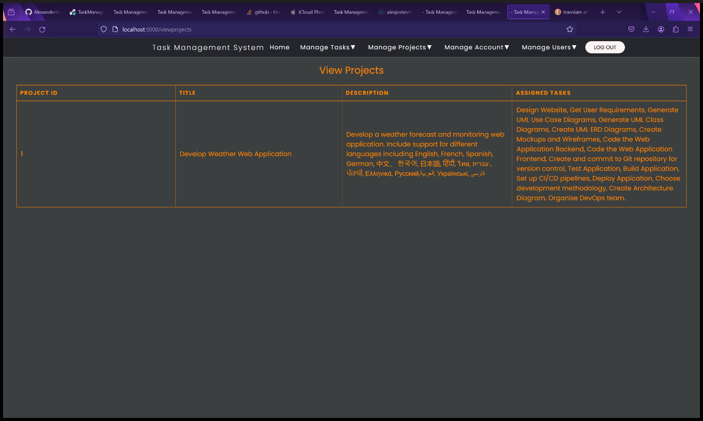

Figure 143 - Project added to View Projects Page.

### View Projects

1. You can view the list of projects as a table by clicking “View Projects” in the “Manage Projects” dropdown menu.

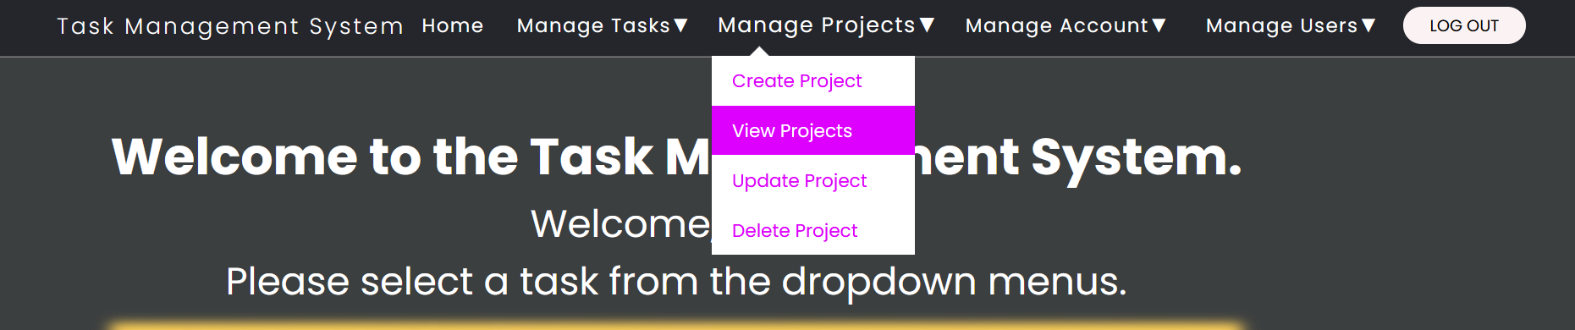

Figure 144 - Select "View Projects" from "Manage Projects" dropdown menu.

1. You will be redirected to the View Projects that displays a table of all the projects. See the two screenshots for examples.

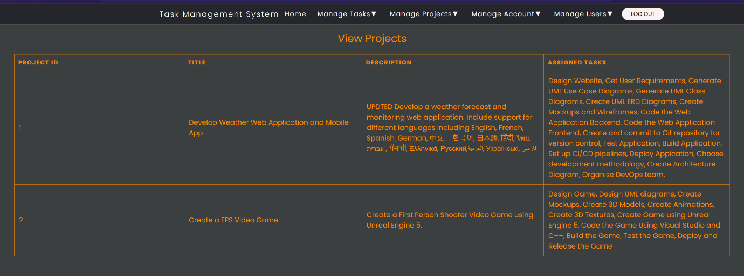

Figure 145 - View Projects page.

1. Select "Create Project" from "Manage Projects" dropdown menu.

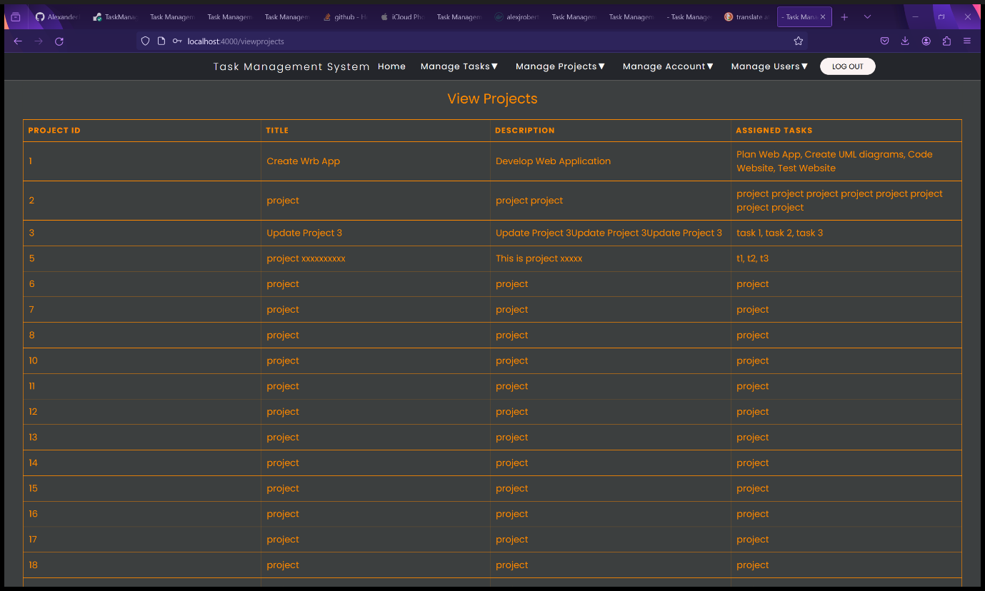

Figure 146 - View Projects page with example data.

### Update a Project – Administrators and Root User Only

1. Select “Update Project” from the “Manage Projects” dropdown menu.

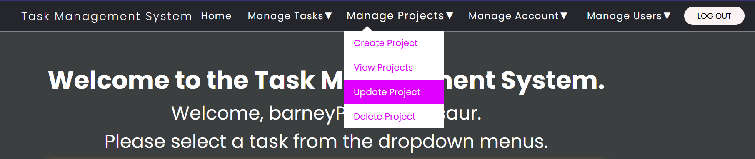

Figure 147 - Select "Update Project" from "Manage Projects" dropdown menu.

1. You will be redirected to the Update Project form.
2. Fill in the details of the new project in the Add New Project form. All fields are mandatory.
   1. The Project ID must be a whole number. All project IDs must be unique.
   2. The Title is the project title. Any character is accepted. Foreign languages are supported.
   3. The Description text field contains the project description. Any Unicode character is supported and foreign languages and writing systems are supported.
   4. The Assigned Tasks field is where you enter a list of tasks separated by a comma. Unicode characters, foreign languages and writing systems are supported.

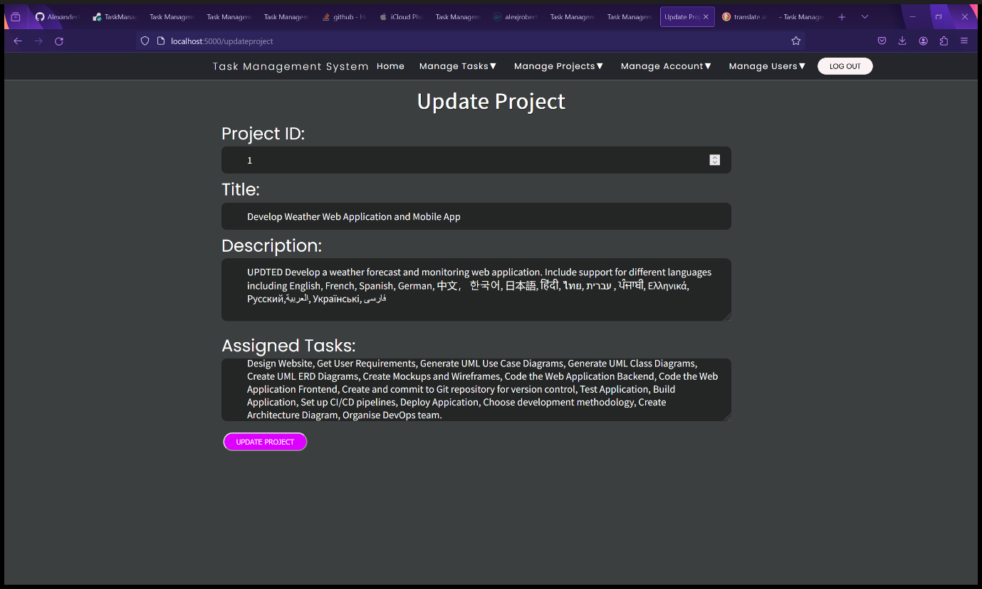

Figure 148 - Update Project form.

1. Click the “Update Project” button.
2. You will be redirected to the View Projects page where you can view the updated project.

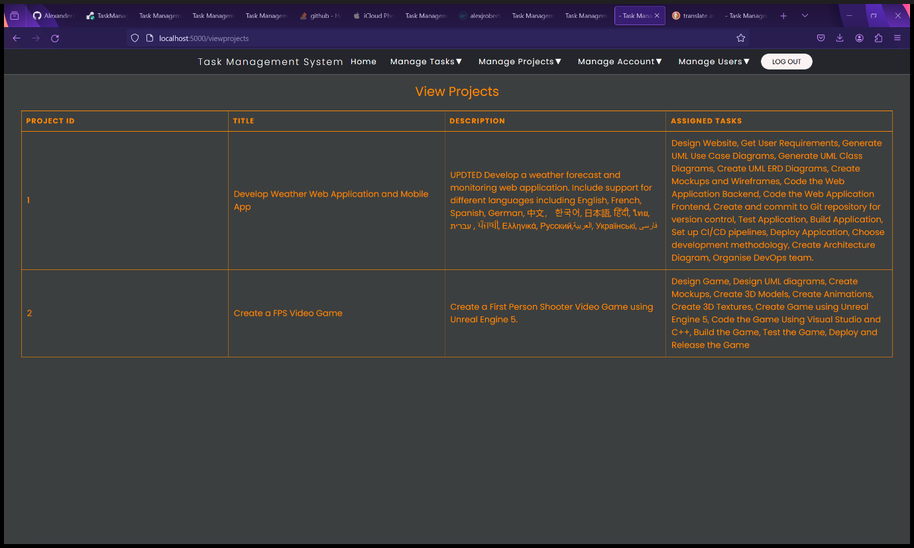

Figure 149 - View Projects page showing updated project.

### Delete a Project – Administrators and Root User Only

1. Select “Delete Project” from the “Manage Projects” dropdown menu.

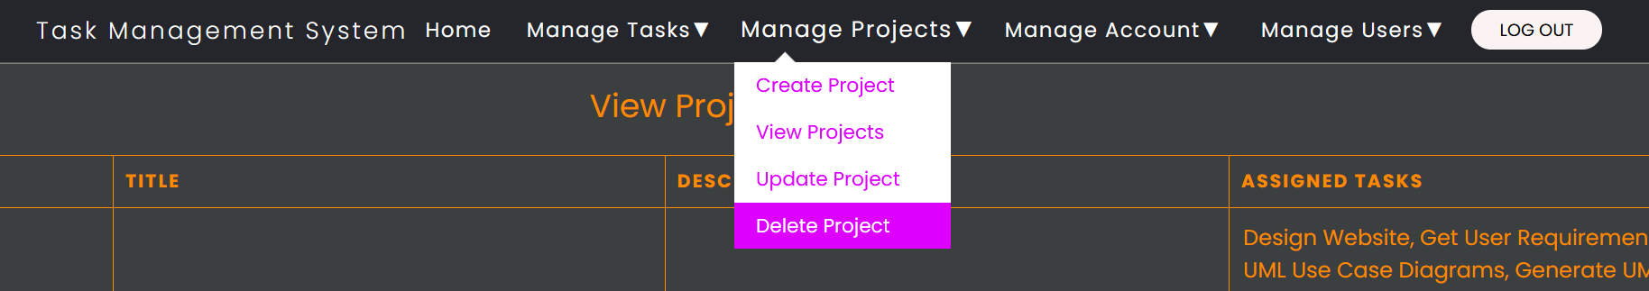

Figure 150 - Select "Delete Project" from "Manage Projects" dropdown menu.

1. You will be redirected to the Delete Project form.
2. Enter both the Project ID and Project Title into the form. The Project ID and Project Title must match to help prevent accidental deletion. In the example screenshot, Project 2 will be deleted.

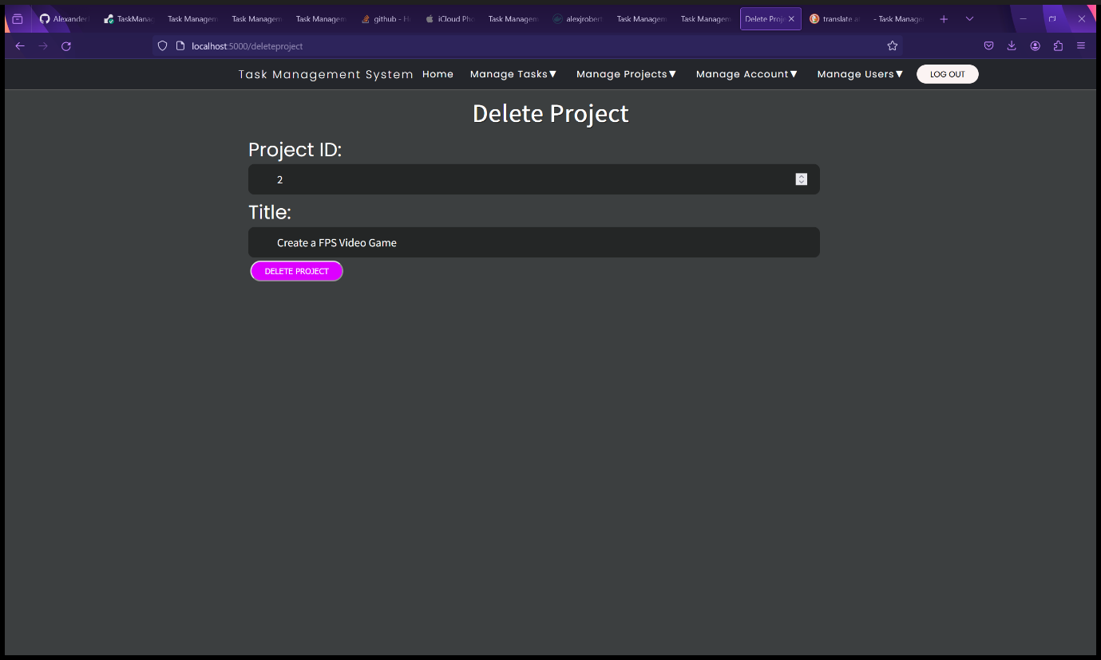

Figure 151 - Delete Project form.

* 1. Click the “Delete Project” button.
  2. You will be redirected to the View Projects page, and you will see that the project has been deleted from the database.

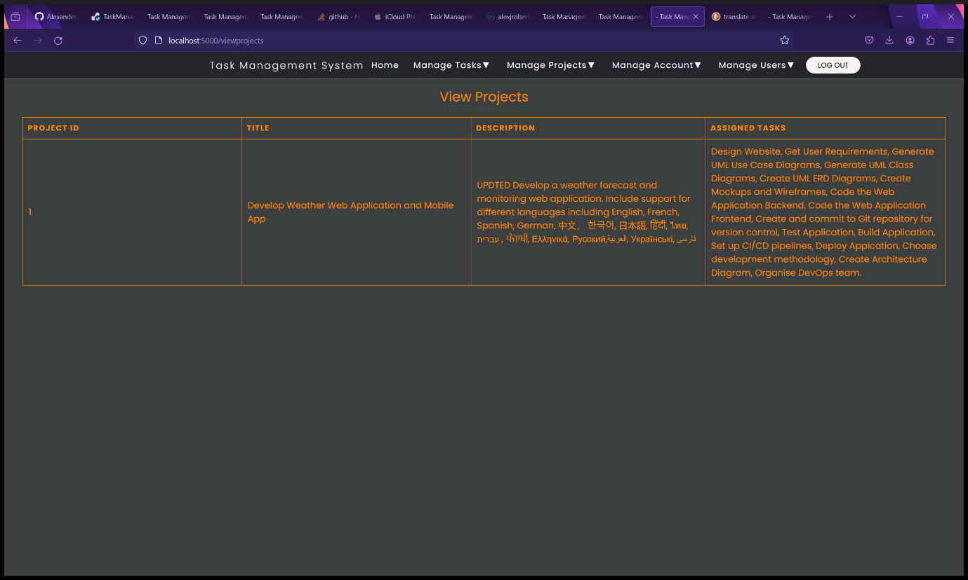

Figure 152 - Project deleted from View Projects page.

## Manage Tasks

### Create a New Task

1. Select “Create Task” from the “Manage Tasks” dropdown menu.

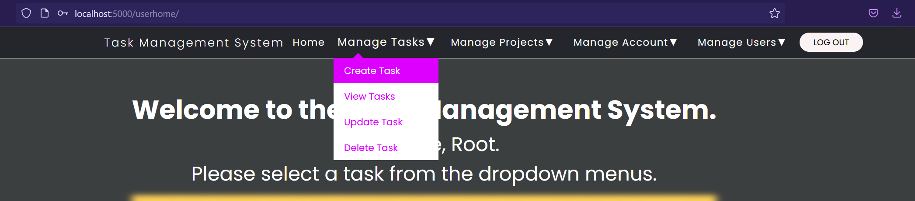

Figure 153 - Select "Create Task" from "Manage Tasks" dropdown menu.

1. You will be redirected to the Add New Task form.
2. Fill in the details of the new task in the Add New Task form. All fields are mandatory.
   1. Task ID must be a whole number and unique.
   2. Title is the title of the task. Unicode, foreign languages and writing systems are supported.
   3. Description it the description of the task. This text field is resizable and supports Unicode, foreign languages and writing systems.
   4. Due Date is the date the project is due. Must be in the format DD/MM/YYYY. Click the calendar icon in the date field for the menu to appear to select a date.

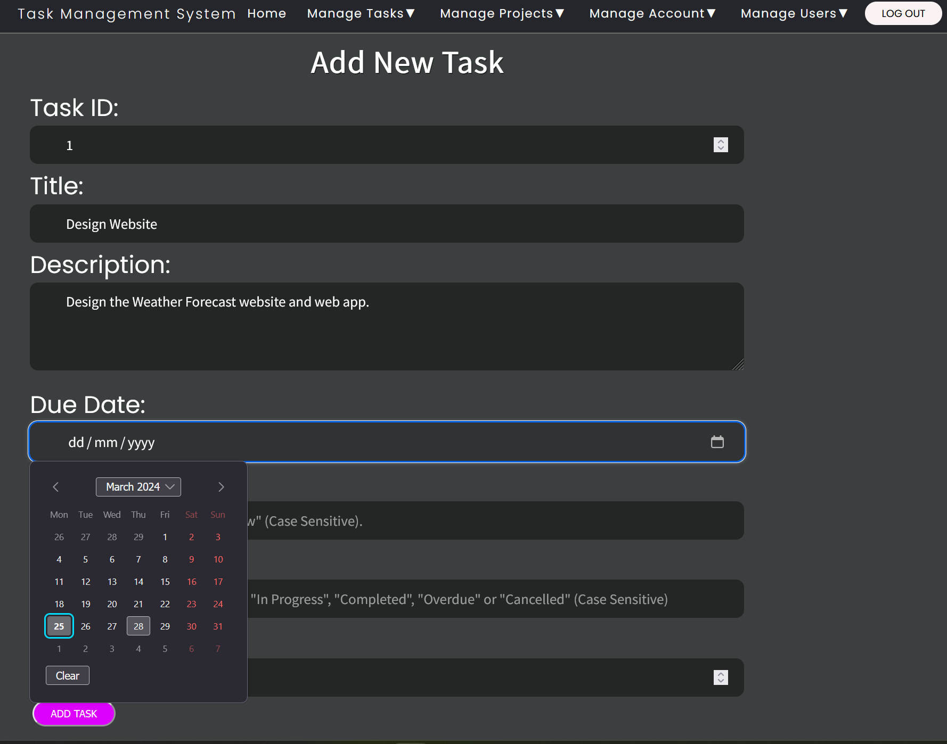

Figure 154 - Callender on Create Task form.

* 1. Priority is how urgently the task must be completed. Priority can only be “High”, “Medium” or “Low” and is case sensitive.
  2. Status is the status of the task. Status can only be “Not Started”, “Planned”, “In Progress”, “Completed”, “Overdue”, or “Cancelled” and is case sensitive.
  3. The Project ID must be a whole number and correspond to the Project ID of a project stored in the Task Management System’s database.

1. Then click the “Add Task” button.

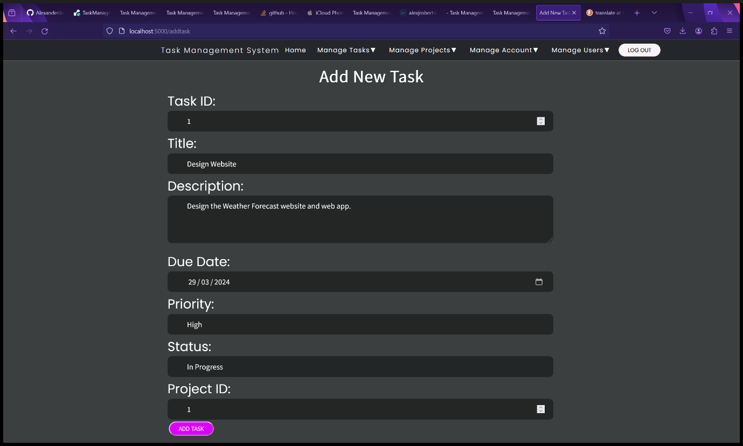

Figure 155 - Create Task form.

1. You will be redirected to the View Tasks page that displays all the tasks as a table. The task you have added will be available here.

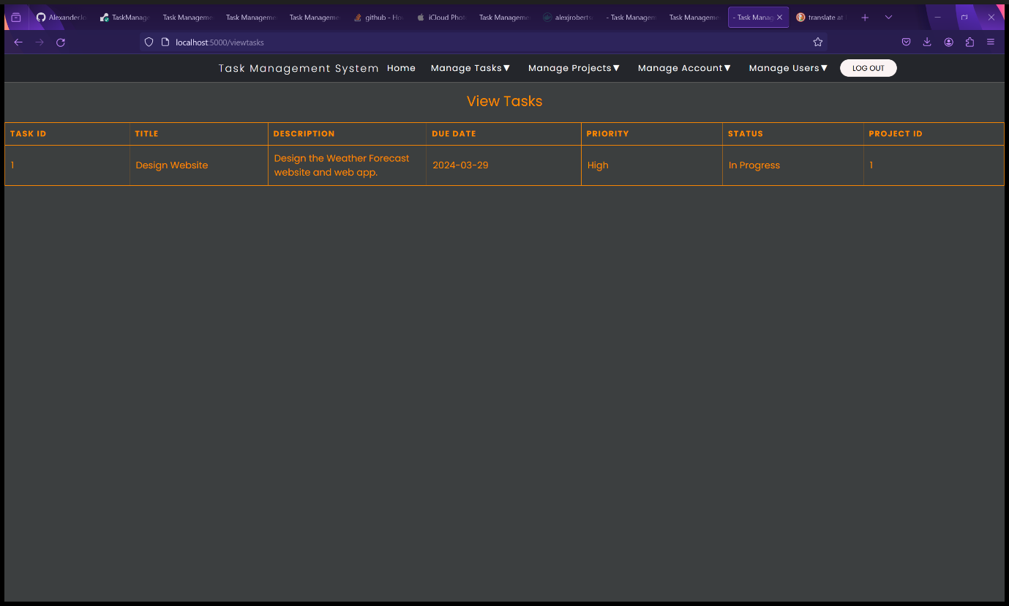

Figure 156 - New task added to View Tasks page.

### View Tasks

1. Select “View Tasks” from the “Manage Tasks” dropdown menu.

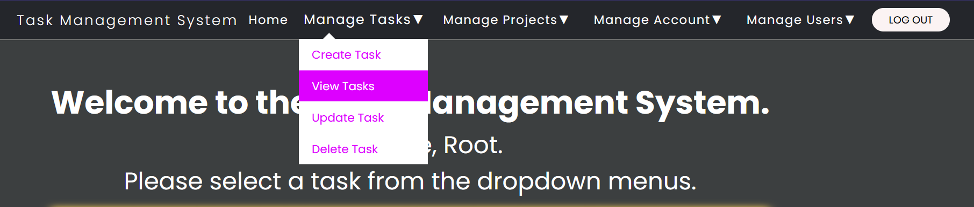

Figure 157 - Select “View Tasks" from "Manage Tasks" dropdown menu.

1. You will be redirected to the View Tasks page that displays a list of tasks and details of each task as a table.

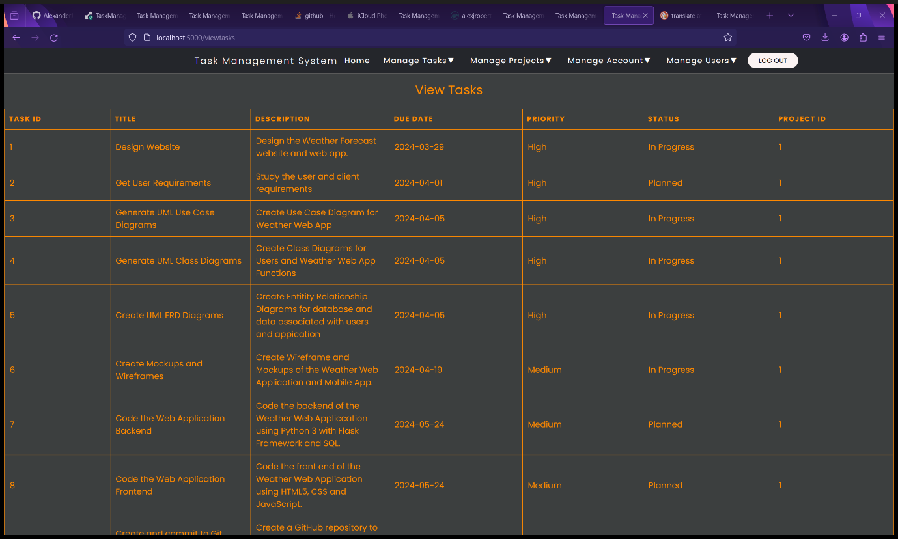

Figure 158 - View Tasks page with example tasks.

### Update Tasks – Administrators and Root User Only

1. Select “Update Task” from the “Manage Tasks” dropdown menu.

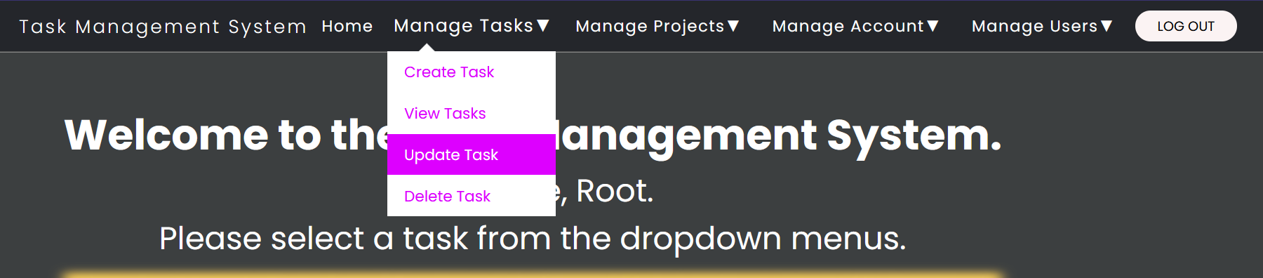

Figure 159 - Select "Update Task" from "Manage Tasks" dropdown menu.

1. Fill in the details of the new task in the Update Task form. All fields are mandatory.
   1. Task ID must be a whole number and unique.
   2. Title is the title of the task. Unicode, foreign languages and writing systems are supported.
   3. Description it the description of the task. This text field is resizable and supports Unicode, foreign languages and writing systems.
   4. Due Date is the date the project is due. Must be in the format DD/MM/YYYY. Click the calendar icon in the date field for the menu to appear to select a date.

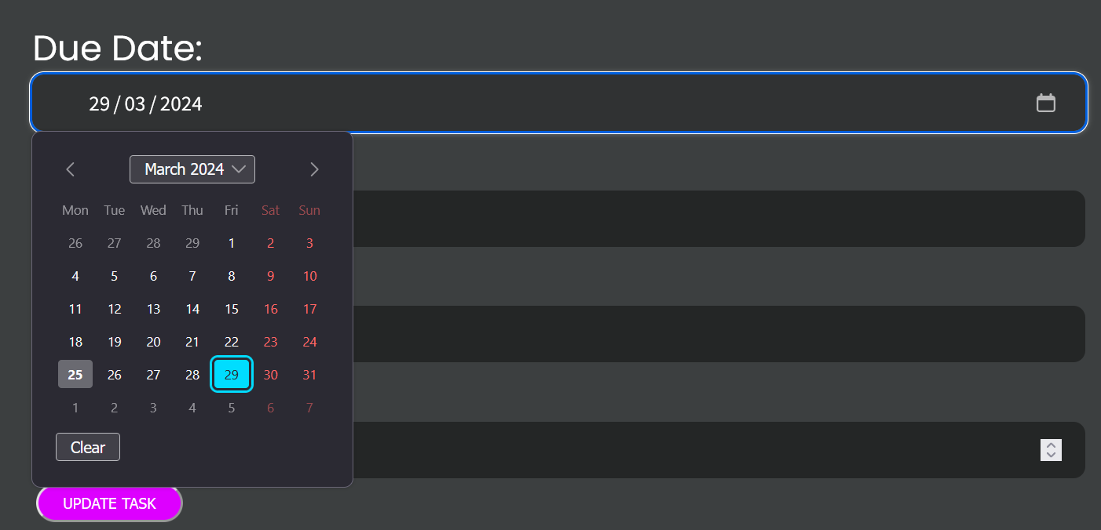

Figure 160 - Callender on Create Task form.

* 1. Priority is how urgently the task must be completed. Priority can only be “High”, “Medium” or “Low” and is case sensitive.
  2. Status is the status of the task. Status can only be “Not Started”, “Planned”, “In Progress”, “Completed”, “Overdue”, or “Cancelled” and is case sensitive.
  3. The Project ID must be a whole number and correspond to the Project ID of a project stored in the Task Management System’s database.

1. Then click the “Update Task” button.

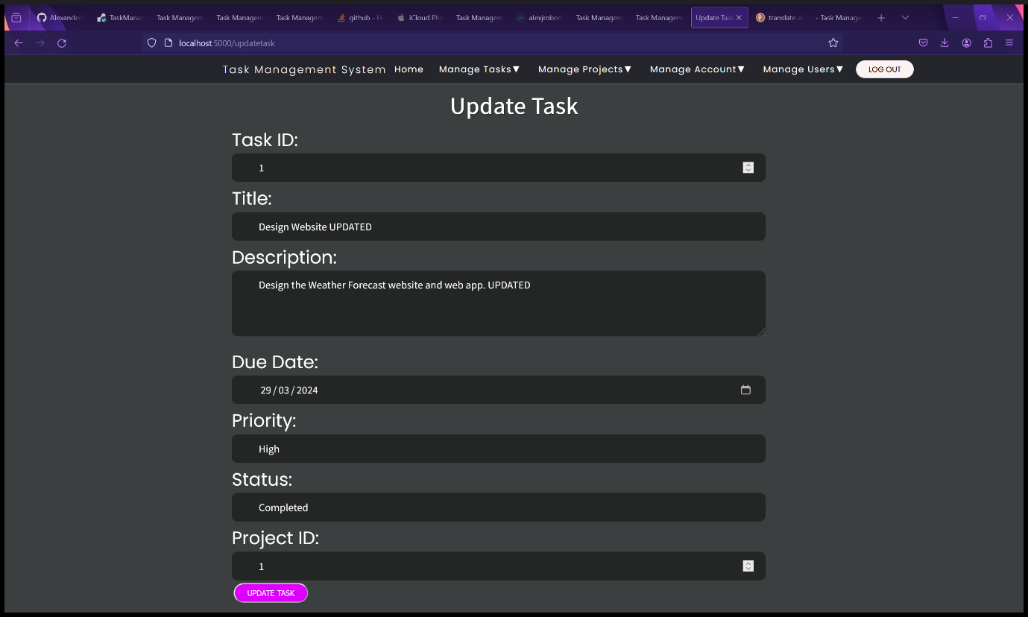

Figure 161 - Update Tasks form.

1. You will be redirected to the View Tasks page where you can view the updated task.

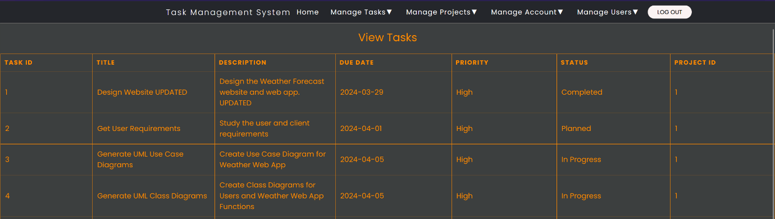

Figure 162 - View Tasks page with updated task.

### Delete Tasks – Administrators and Root users only.

1. Select “Delete Task” from the “Manage Tasks” dropdown menu.

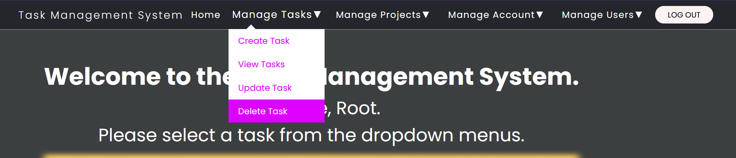

Figure 163 - Select "Delete Task" from "Manage Tasks" dropdown menu.

1. You will be redirected to the Delete Task form.
2. Enter both the Task ID and Task Title into the form. The Task ID and Task Title must match to help prevent accidental deletion. In the example screenshot, Task 4 will be deleted.

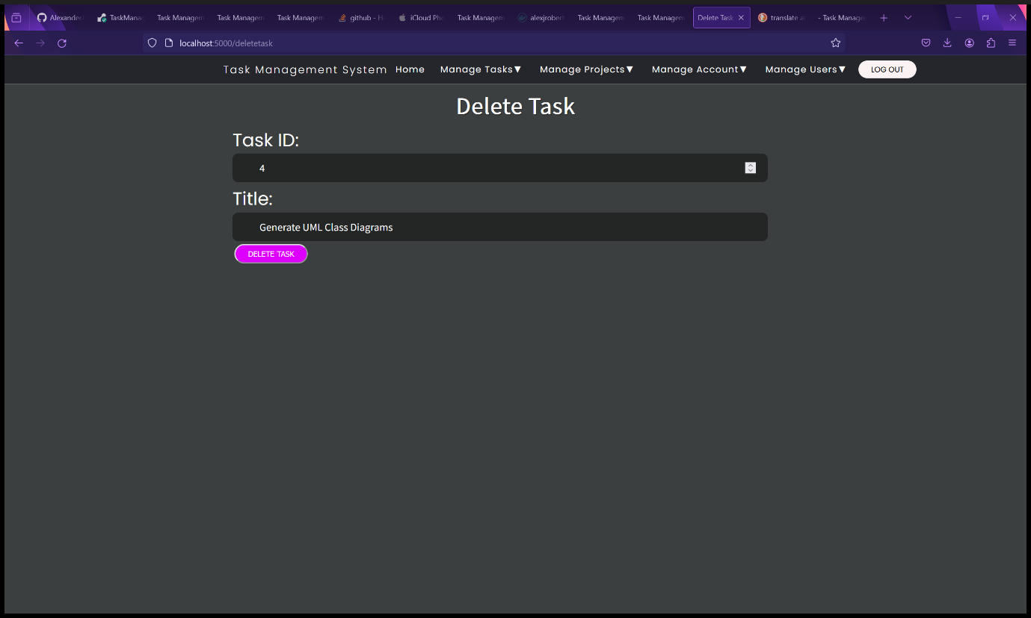

Figure 164 - Delete Task form.

1. Click the “Delete Task” button.
2. You will be redirected to the View Tasks page, and you will see that the task (Task 4 in this case) has been deleted from the database.

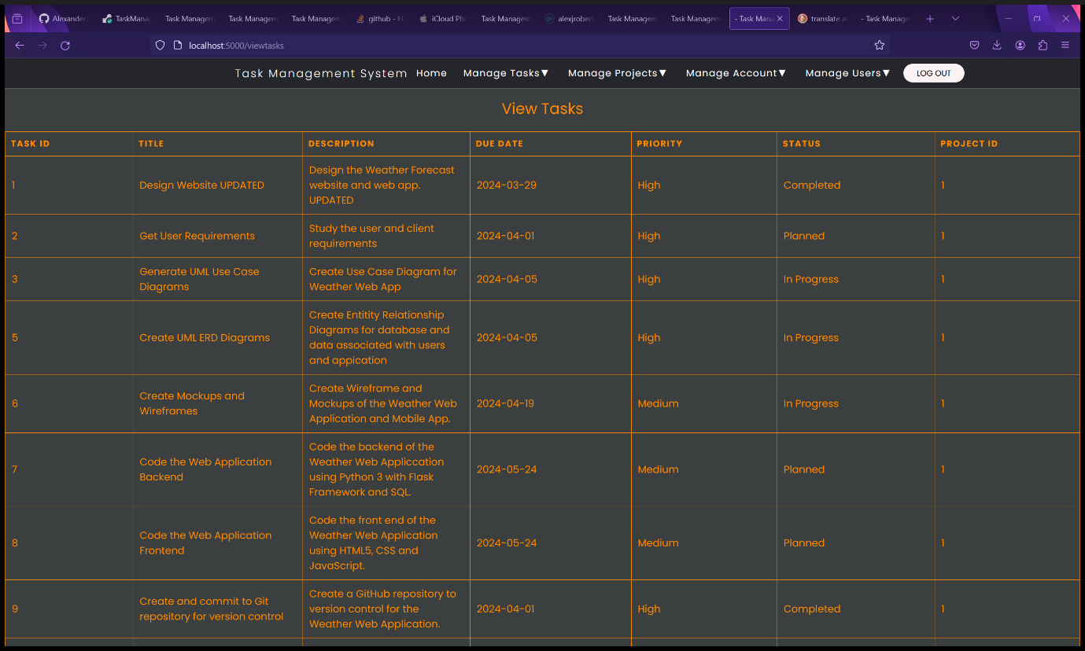

Figure 165 - View Tasks page after Task 4 has been deleted.

## Managing Your Account

### View Your Account Details

1. Select “View Account Details” from the “Manage Account” dropdown menu.

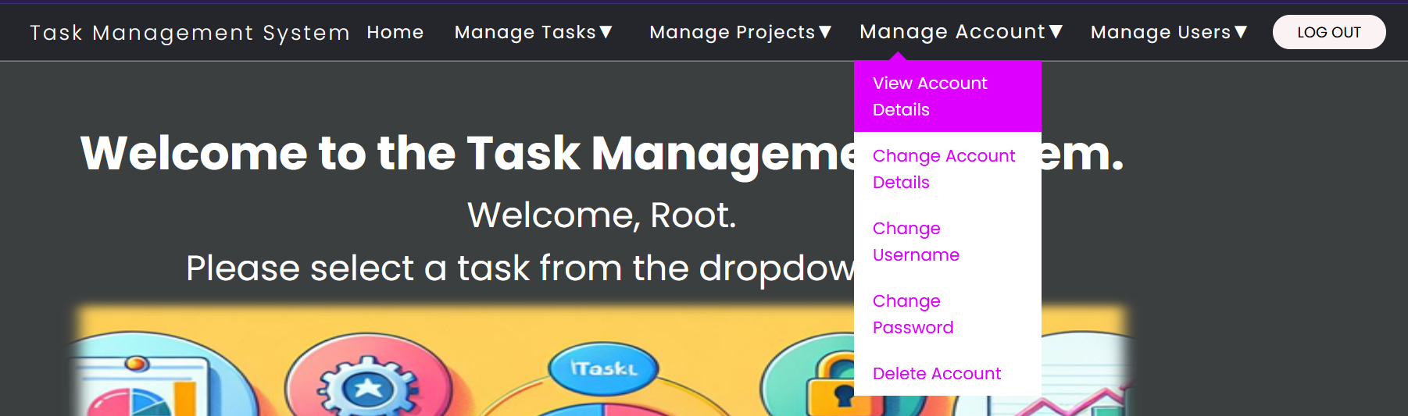

Figure 166 - Select "View Account Details" from "Manage Account" dropdown menu.

1. You will be redirected to the Your Account Details page.

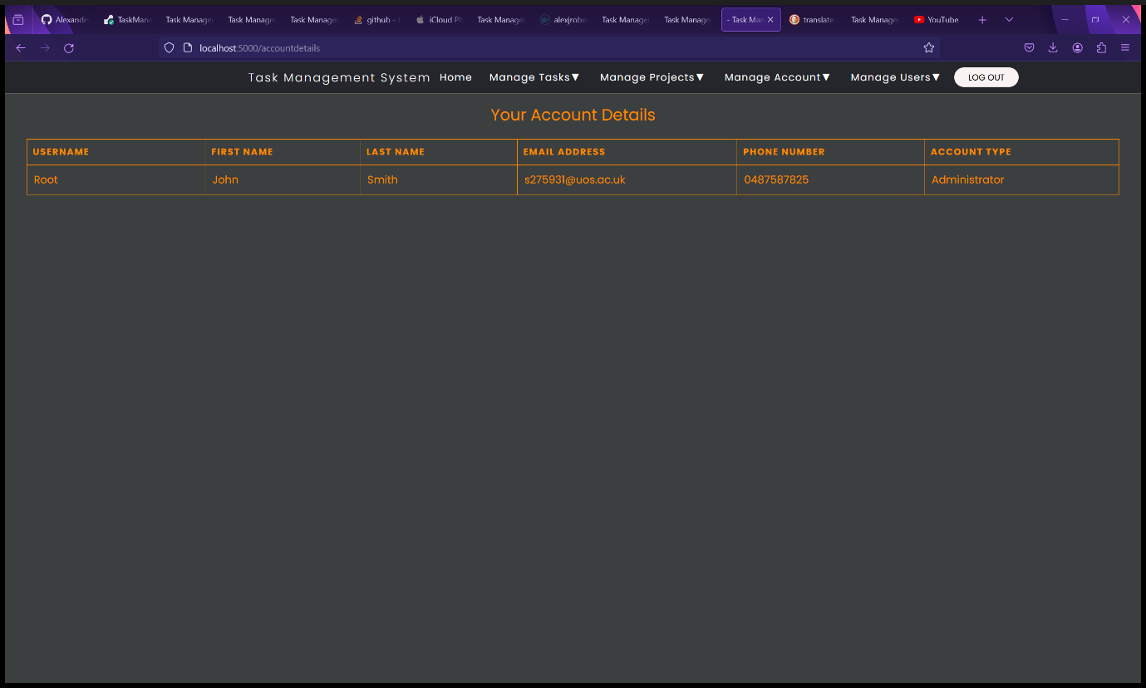

Figure 167 - Your Account Details page

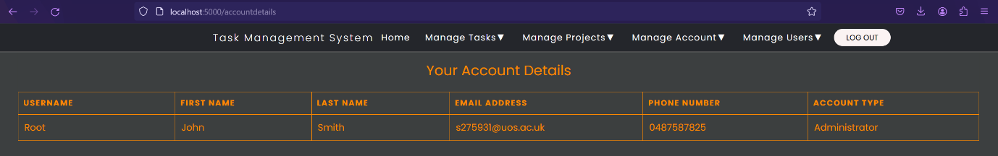

Figure 58 - Your Account Details.

### Changing your Account Details

1. Select “Change Account Details” from the “Manage Account” dropdown menu.

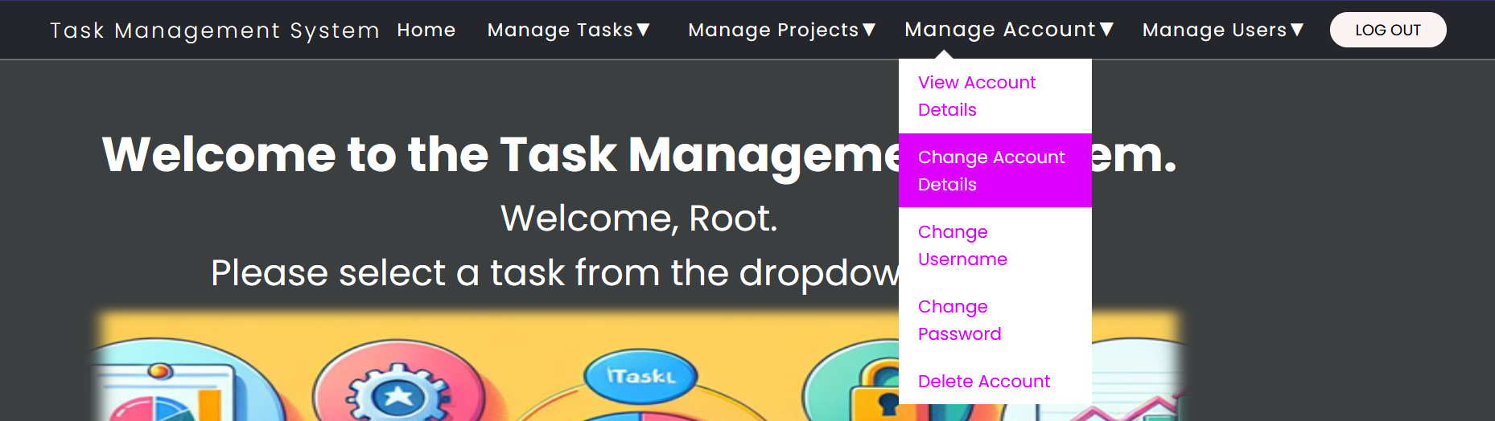

Figure 168 - Select "Change Account Details" from "Manage Account" dropdown menu.

1. You will be redirected to the Update Account Details page where you can change all your account details except your username and password which are done on a different page. You also cannot change your account type or blocked status – only an administrator or Root user can do this.

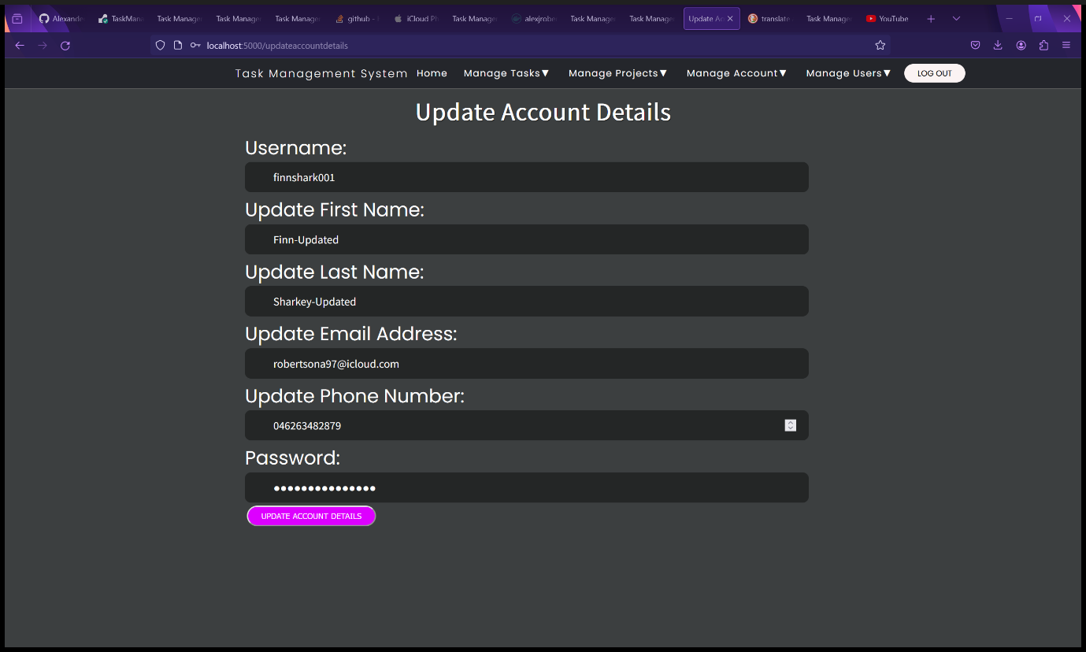

Figure 169 - Update Account Details form.

1. Fill in the Update Account Details Form and click the “Update Account Details” button.
2. You will be redirected to the User Home page with a message saying, “Account Details Updated Successfully”.

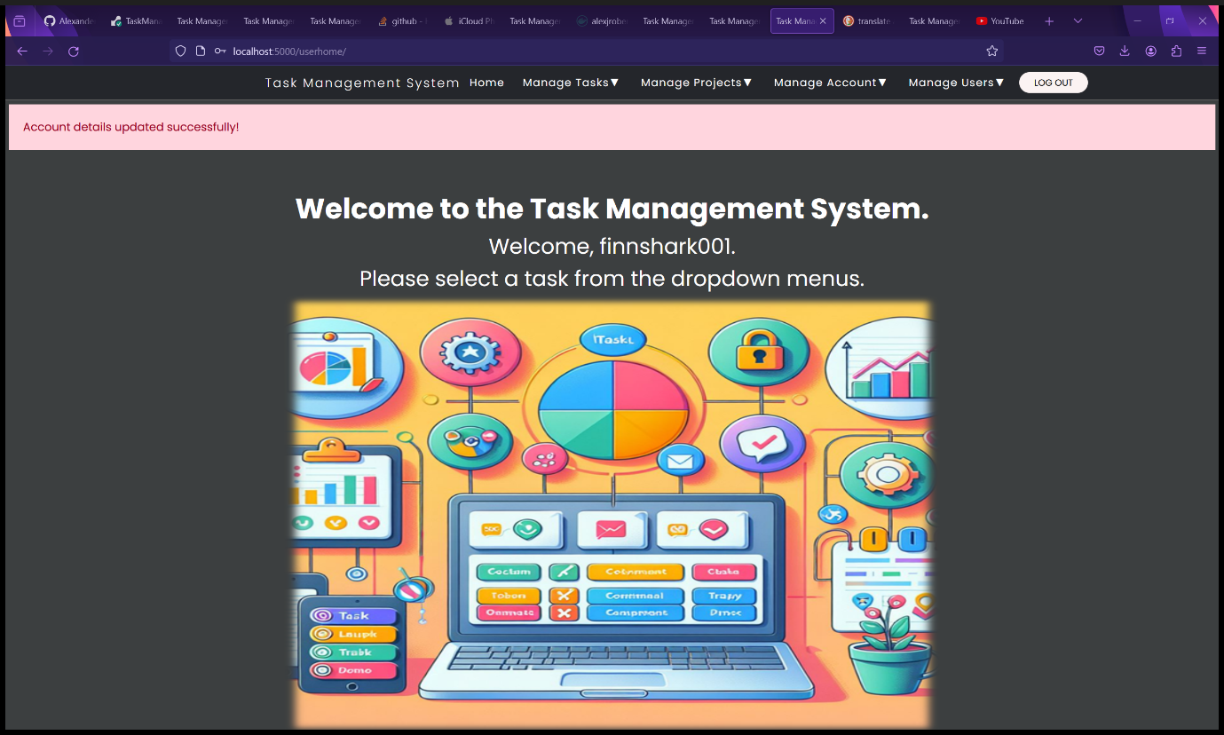

Figure 170 - User Home page after updating account details.

1. You can view your updated account details in the View Account Details page.

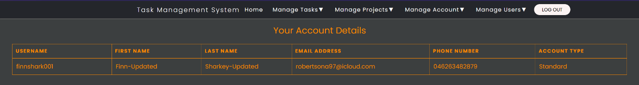

Figure 171 - Account details after being updated.

### Changing your Username

1. Select “Change Username” from the “Manage Account” dropdown menu.

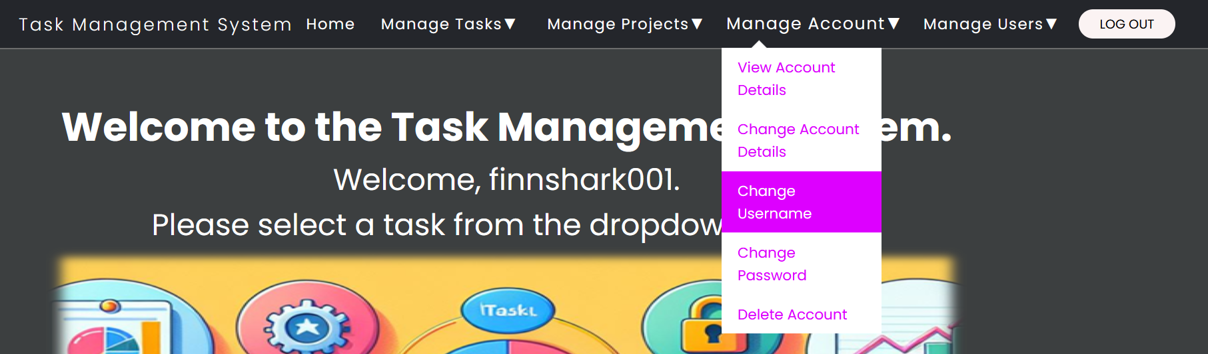

Figure 172 - Select "Change Username" from "Manage Account" dropdown menu.

1. You will be required to Change Username form page.
2. Fill in the Change Username form with:
   1. Your current username
   2. Your new username
   3. Confirm your new username so you remember it and prevent accidental changes.
   4. Enter your password to confirm your username change, for security to prevent unauthorized username changes and to prevent accidental username changes.
3. Click the “Change Username” button.

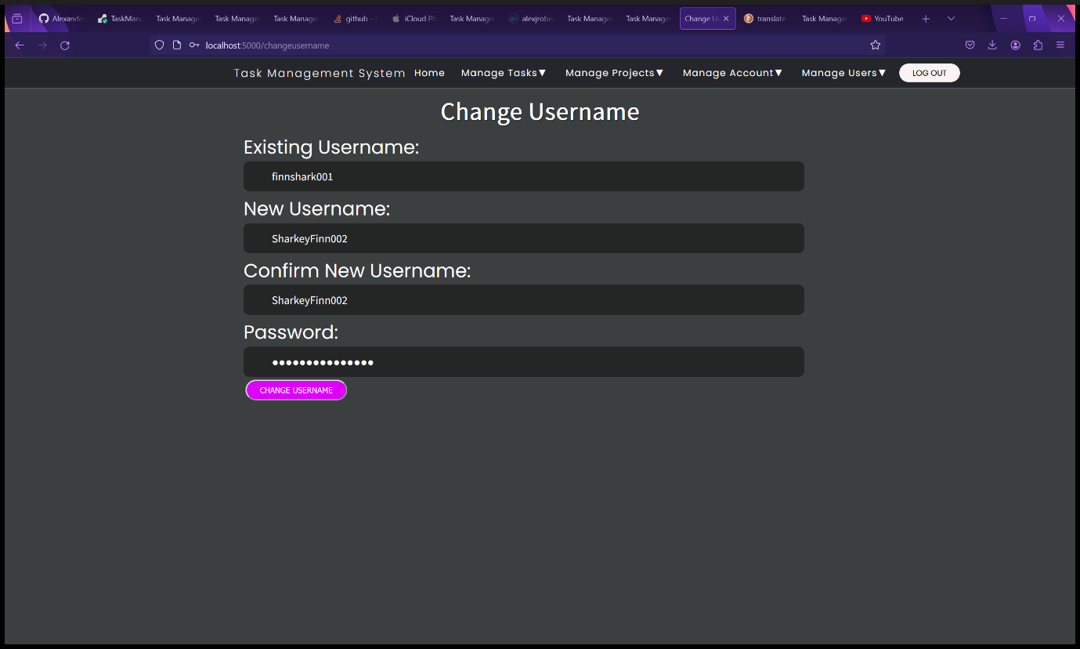

Figure 173 - Change Username form.

1. You will be redirected to the User Home Page with a message saying, “Username changes successfully!”.

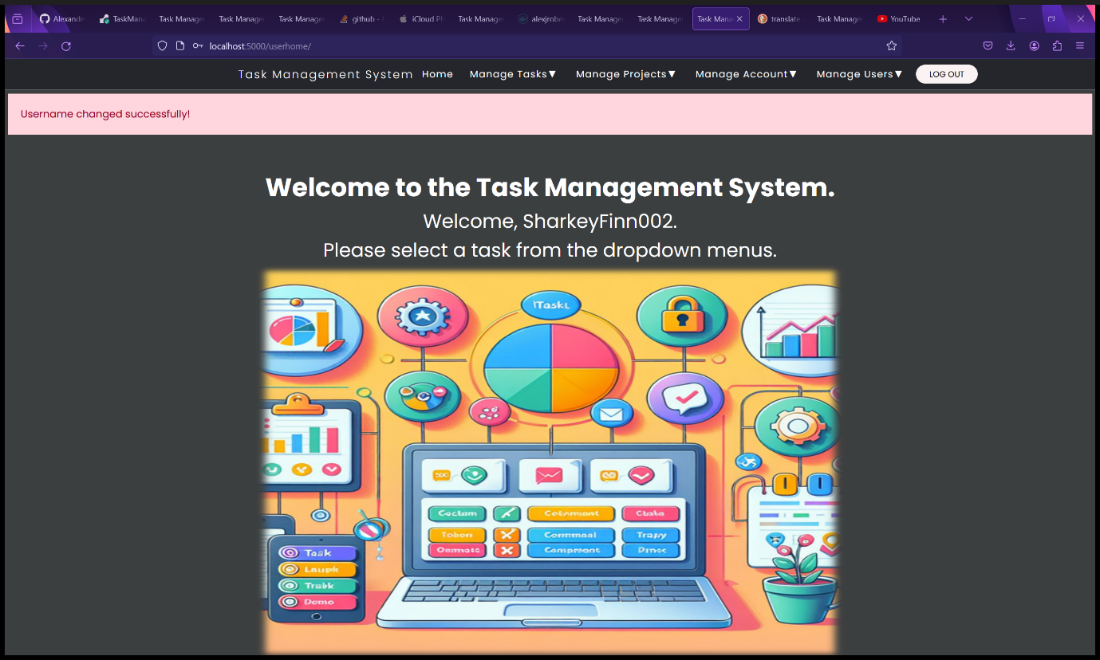

Figure 174 - User Home page after changing username.

1. You can view your username change in the View Account details page.

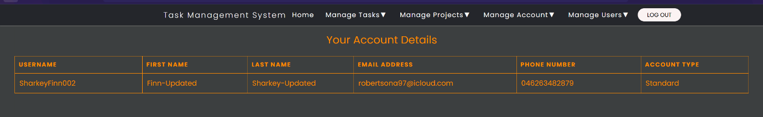

Figure 175 - Your Account Details page after changing username.

### Changing your Password

1. Select “Change Password” from the “Manage Account” dropdown menu.

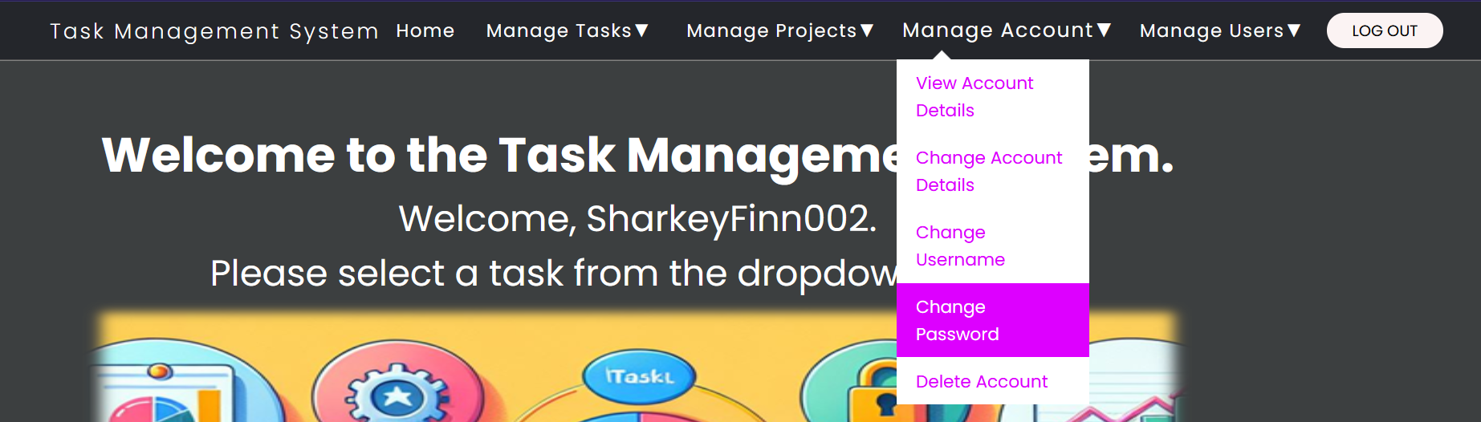

Figure 176 - Select "Change Password" from "Manage Account" dropdown menu.

1. You will be redirected to the Change Password form page.
2. Fill in the Change Password form:
   1. Username – Your current username.
   2. Existing Password – for security to prevent unauthorised and accidental password changes.
   3. New Password – must meet the following requirements: Minimum length of 10 characters, at least one capital letter, one lowercase letter, one number, one special ASCII, UTF or Unicode character and must not be a common password.
   4. Confirm new password so you are less likely to forget it.
3. Click the “Change Password” button.

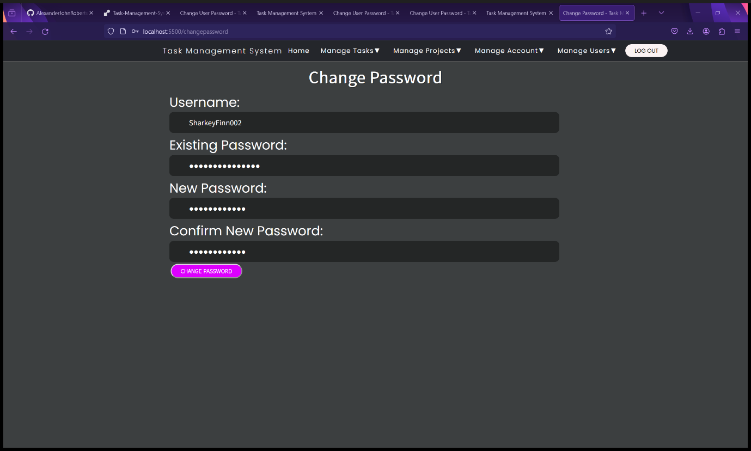

Figure 177 - Change Password form page.

* 1. You will be redirected to the User Home page showing a message saying, “Password Changed Successfully”.

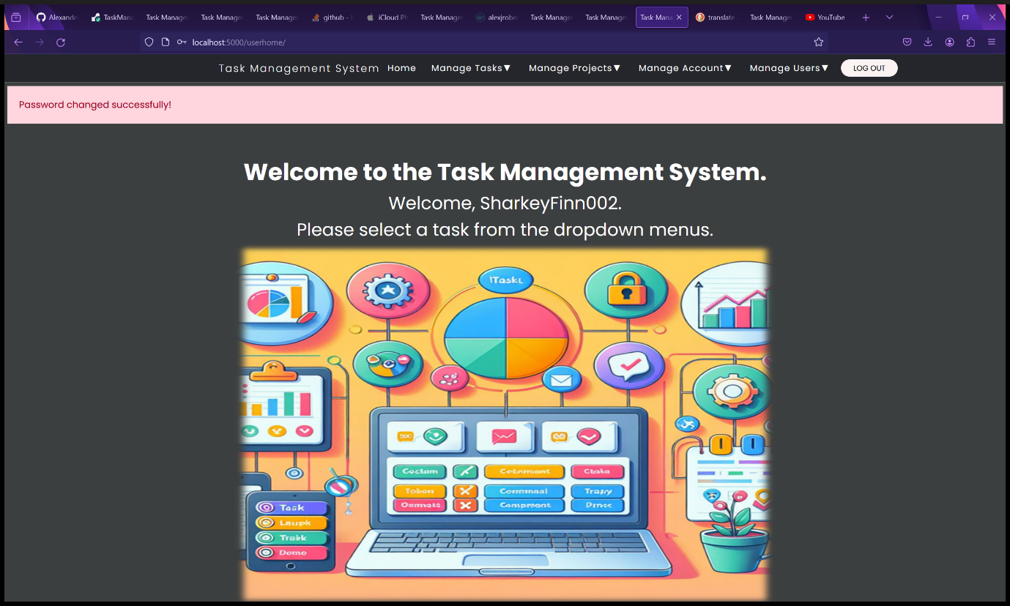

Figure 178 - User Home page after changing password.

1. You will not be able to view your password in the View Account Details page because of security and privacy reasons.

### Deleting your Account

WARNING: DELETING YOUR ACCOUNT WILL BE PERMANENT.

1. Select “Delete Account” from the “Manage Account” dropdown menu.

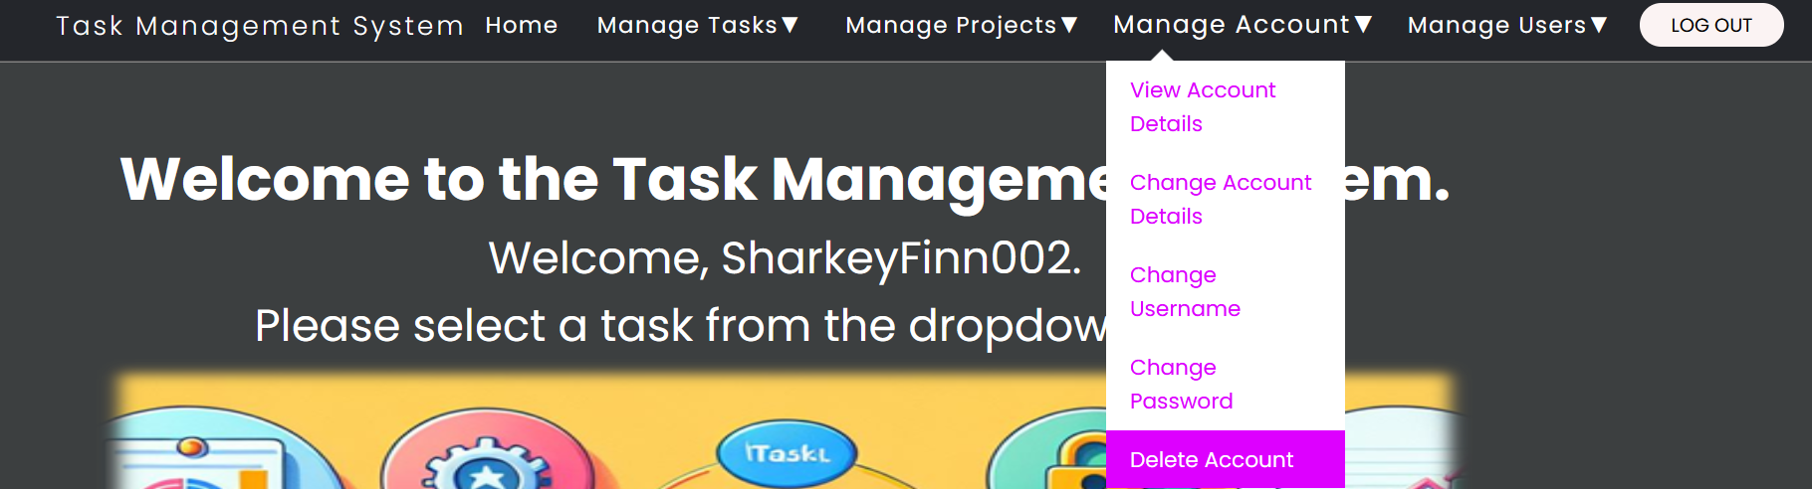

Figure 179 - Select "Delete Account" from "Manage Account" dropdown menu.

1. You will be redirected to the Delete Account form page.
2. Fill in the Delete Account form:
   1. Username
   2. Password – security to prevent unauthorized and malicious account deletion.
   3. Confirm Password – security to prevent accidental account deletion.
3. Click the “Delete Account” button.

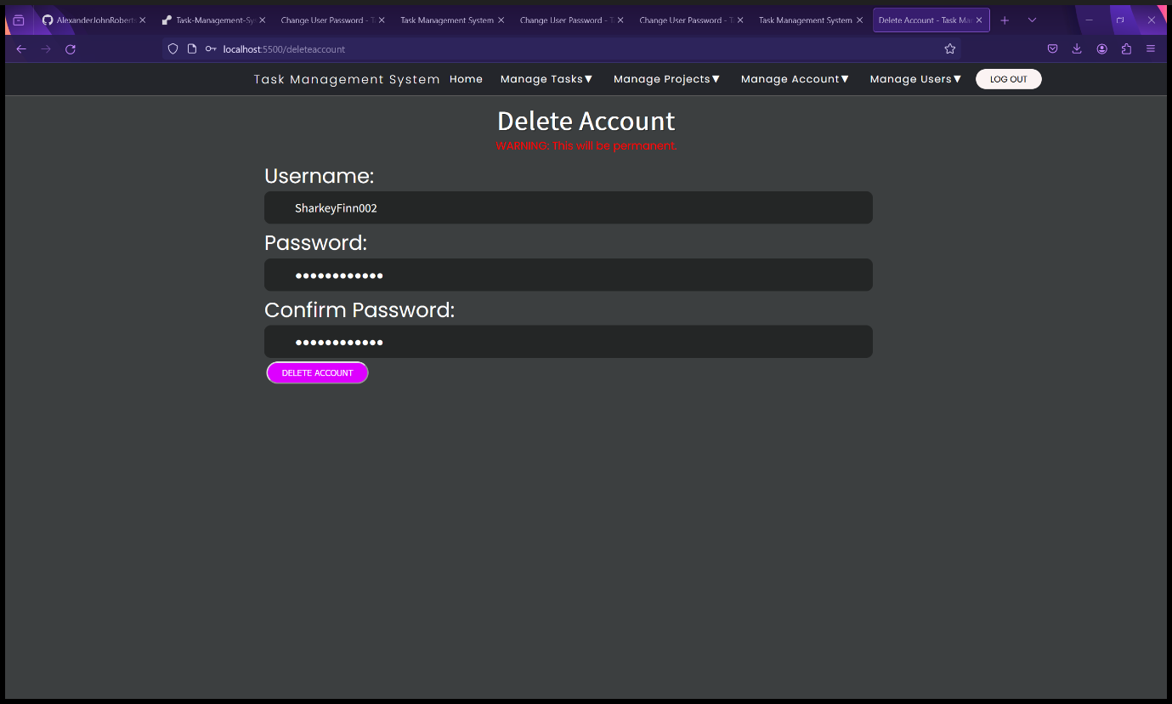

Figure 180 - Delete Account form.

1. You will be redirected to the Task Management System landing page with a message saying, “Account Deleted Successfully!”.

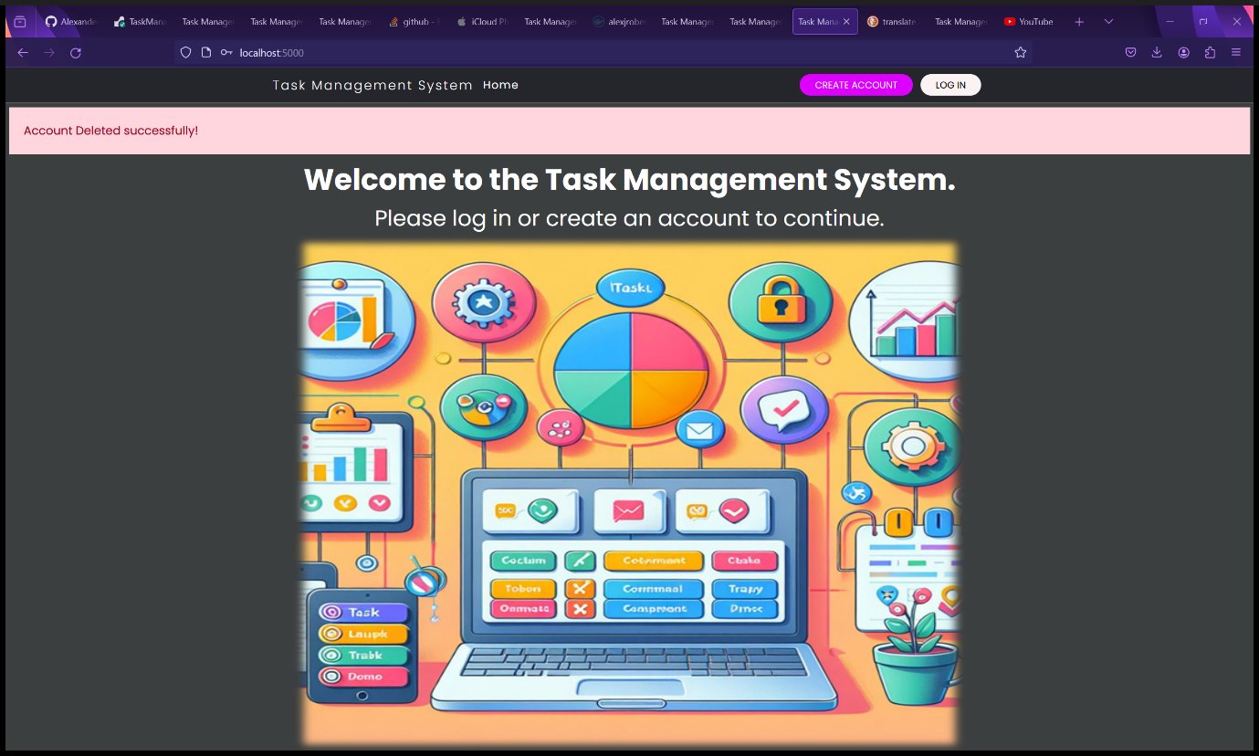

Figure 181 - Landing page after account deletion.

1. You will now be unable to log in proving that your account has been deleted. Instead, you will receive an error message saying, “Username does not exist” (See second screenshot).

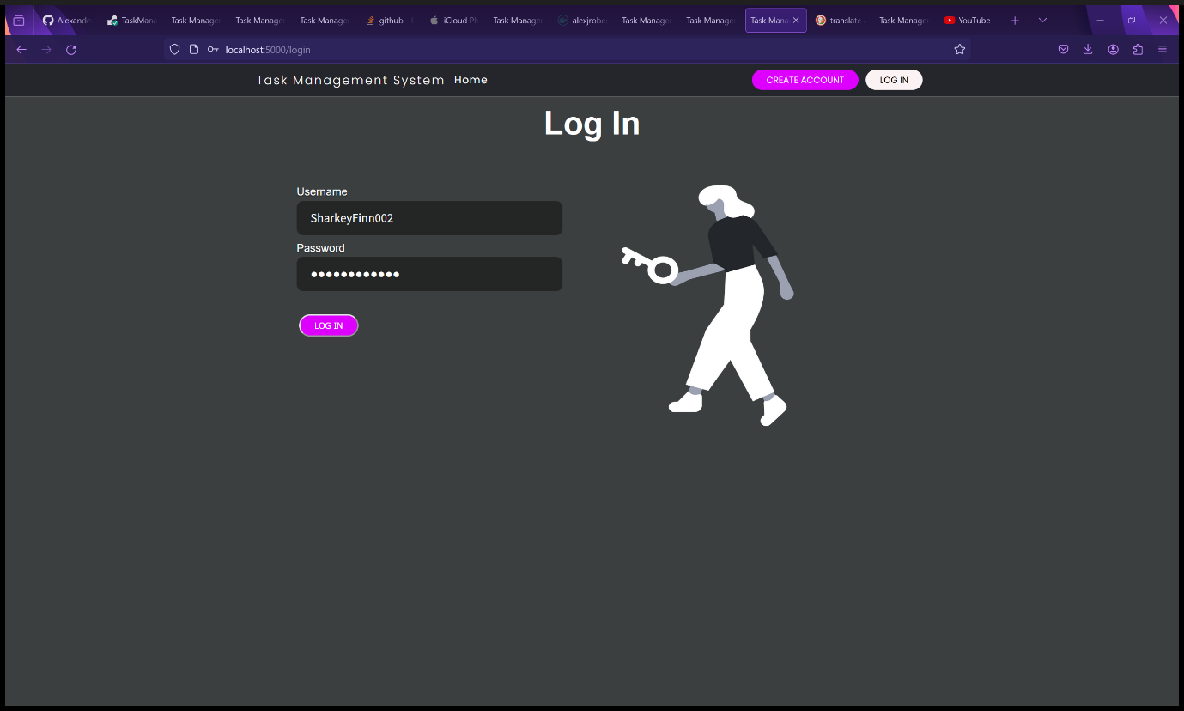

Figure 182 - Log In form.

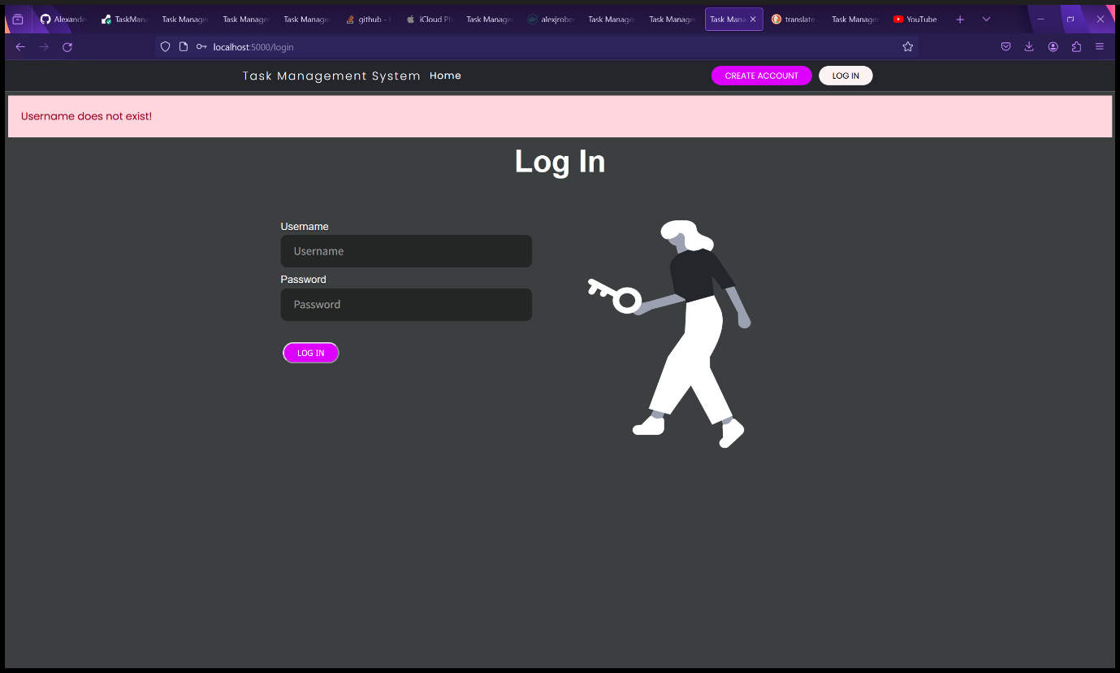

Figure 183 - The user is unable to log in because they have deleted their account.

## Managing Users and Administrative Tasks – Administrators and Root User Only

Please Note: Only administrators and Root Users have access to these features. Standard users will be denied access and will receive an Access Denied error.

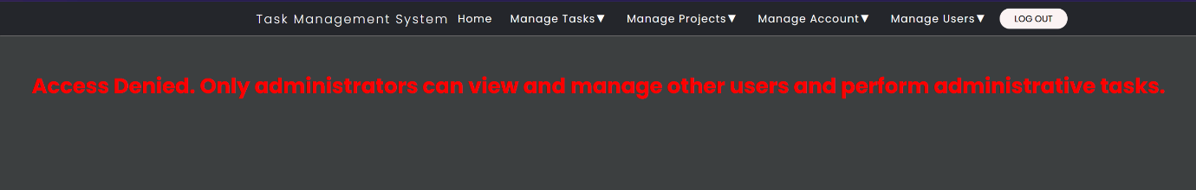

Figure 184 - Error messages that standard users get if they attempt administrative tasks or managing other users.

### View the List of Users as a Table (Administrators and Root User Only)

1. Select “View Users” from the “Manage Users” dropdown menu.

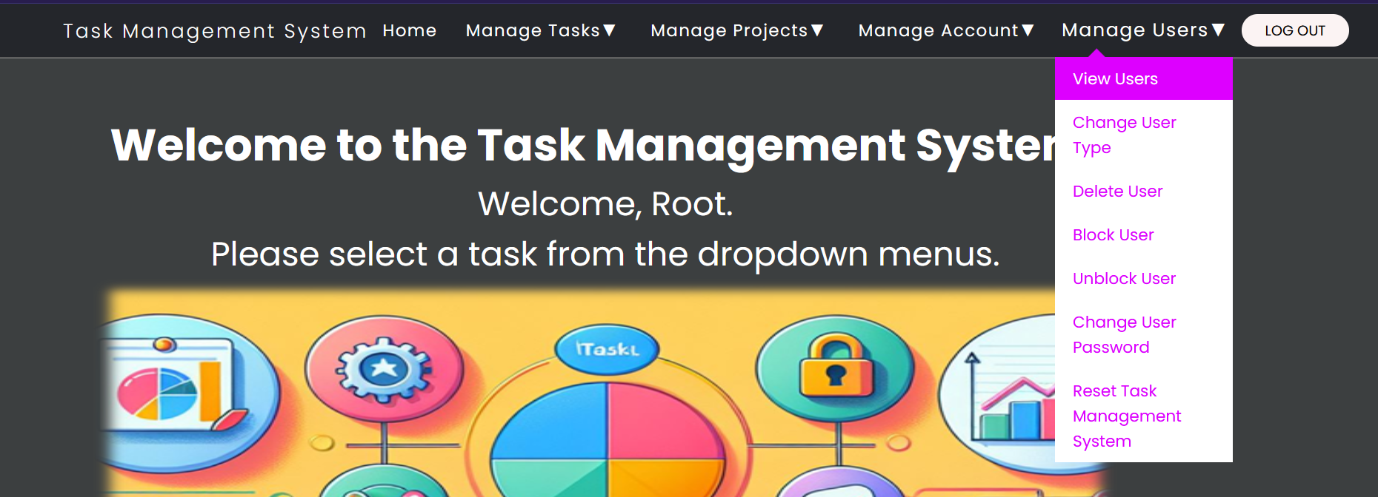

Figure 185 - Select "View Users" from "Manage Users" dropdown menu.

1. You will be redirected to the View Users page that displays a list of Users as a table with their details.

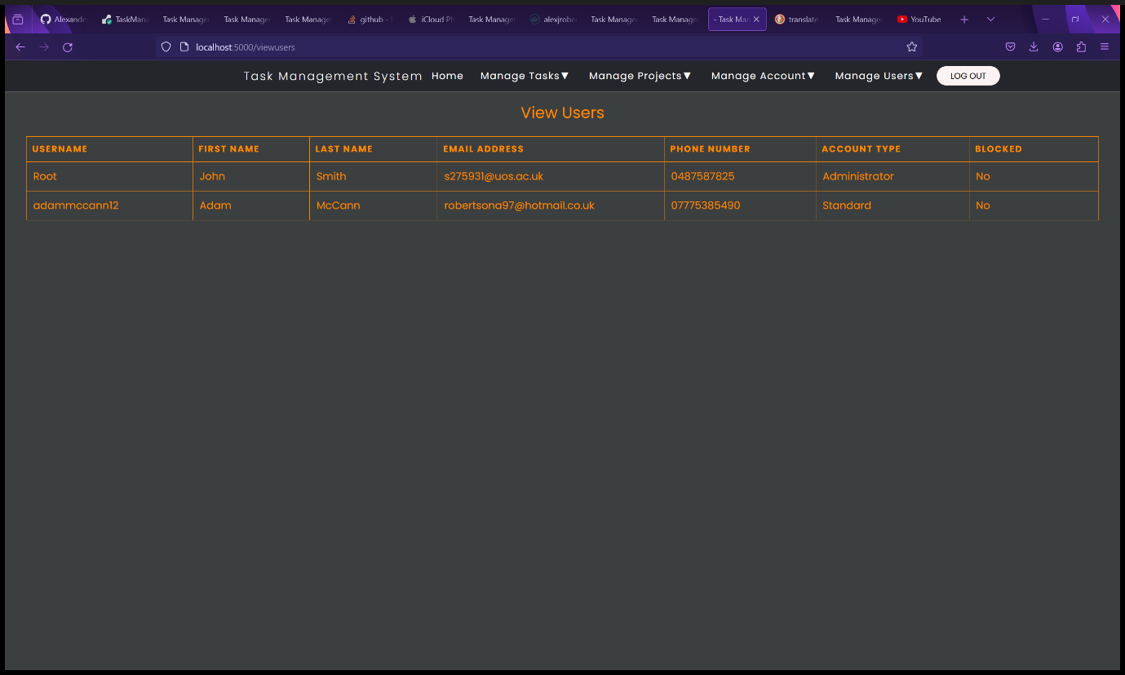

Figure 186 - View Users page with a list of users and their details.

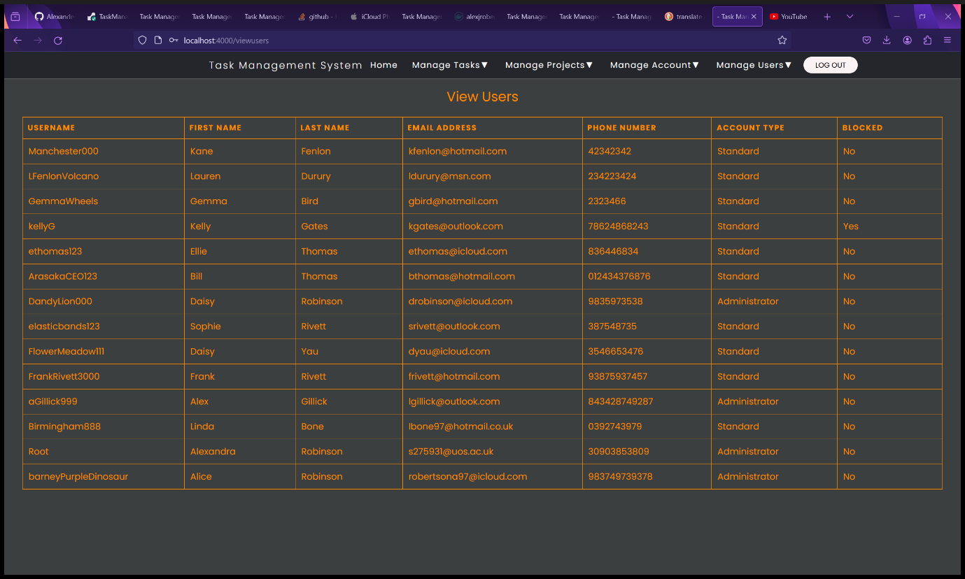

Figure 187 - View Users page with a list of users and their details (example users).

### Change User Account Type (Administrators and Root Users Only)

Instructions for changing user account types between Administrator and Standard.

1. Select “Change User Type” from the “Manage Users” dropdown menu.

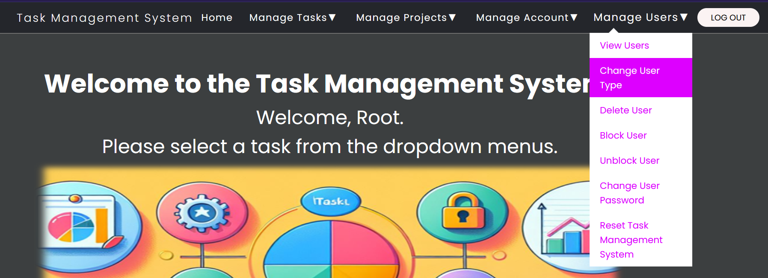

Figure 188 - Select "View Users" from "Manage Users" dropdown menu.

1. You will be redirected to the Change User Account Type form page.
2. Fill in the Change User Account Type form:
   1. Username – the username of the account to be changed.
   2. User Account Type – Type “Administrator” or “Standard” (case sensitive).
3. Click the “Change User Account Type” button.

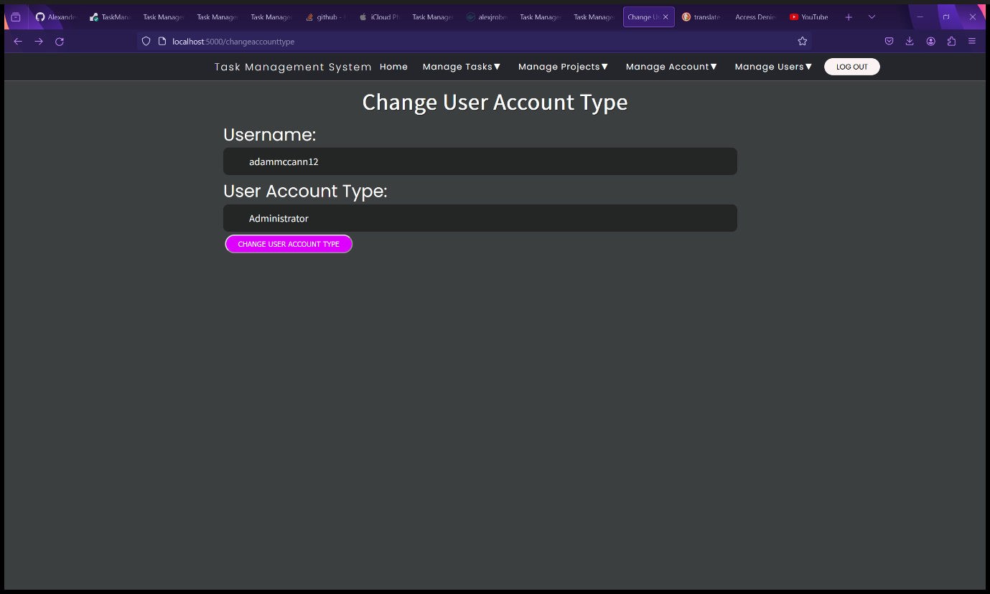

Figure 189 - Change User Account Type form.

1. You will be redirected to the View Users page showing the updated user type. A message will be displayed saying “Account type changed successfully”.

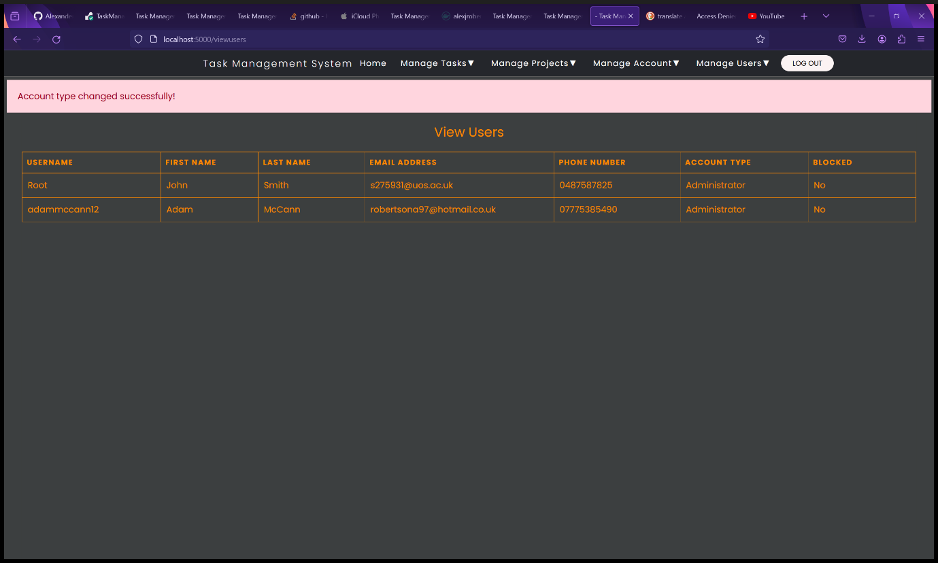

Figure 190 - View Users page after changing a user's Account Type.

### Delete a User (Administrators and Root Users Only).

**WARNING: DELETING A USER WILL BE PERMANENT.**

1. Select “Delete User” from the “Manage Users” dropdown menu.

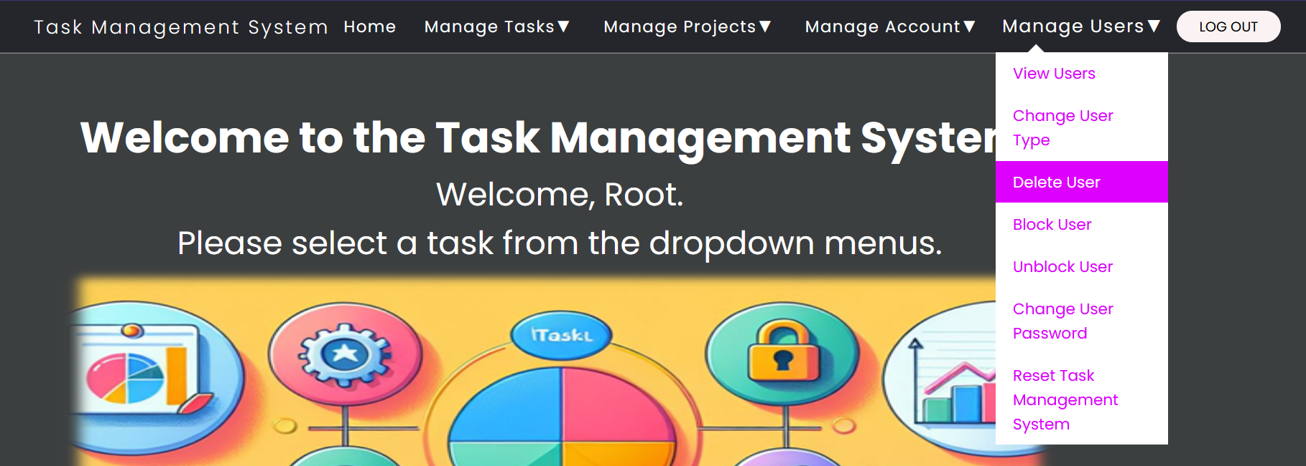

Figure 191 - Select "Delete User" from "Manage Users" dropdown menu.

1. You will be redirected to the Change User Account Type form page.
2. Fill in the Change User Account Type form:
   1. Username – the username of the account to be changed.
3. Click the “Delete User” button.

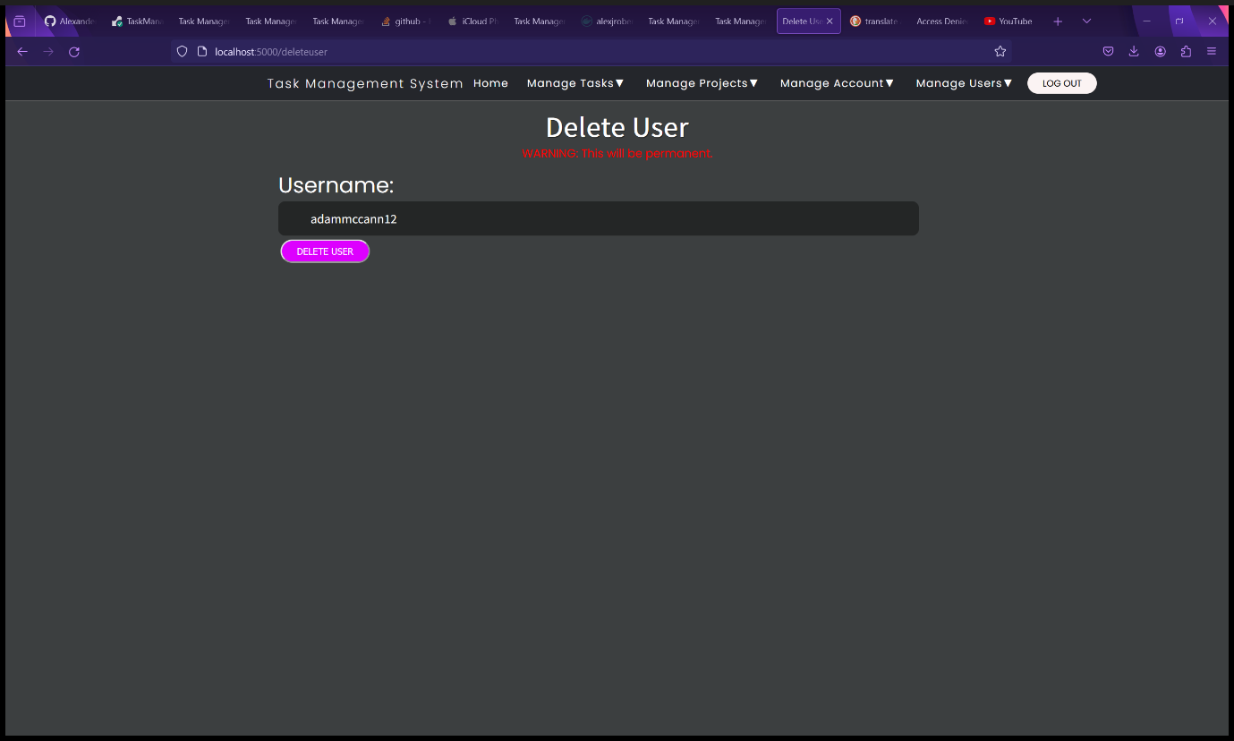

Figure 192 - Delete User form.

1. You will be redirected to the View Users page. A message will be displayed saying “User deleted successfully”.

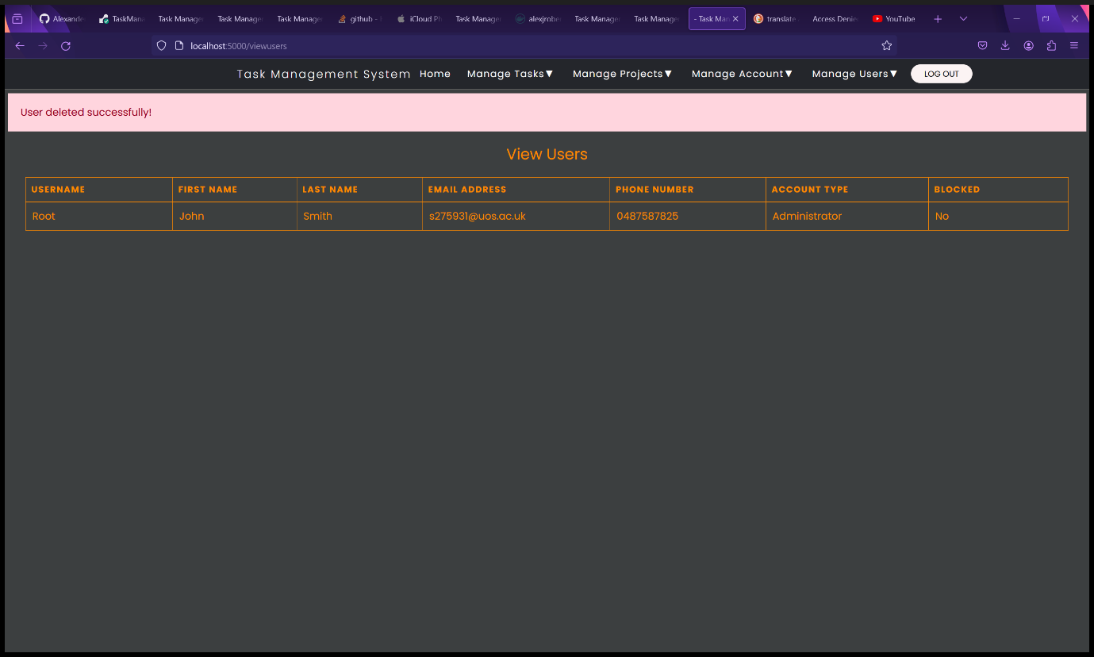

Figure 193 - View Users page after deleting a user.

### Blocking a User (Administrators and Root Users Only)

1. Select “Block User” from the “Manage Users” dropdown menu.

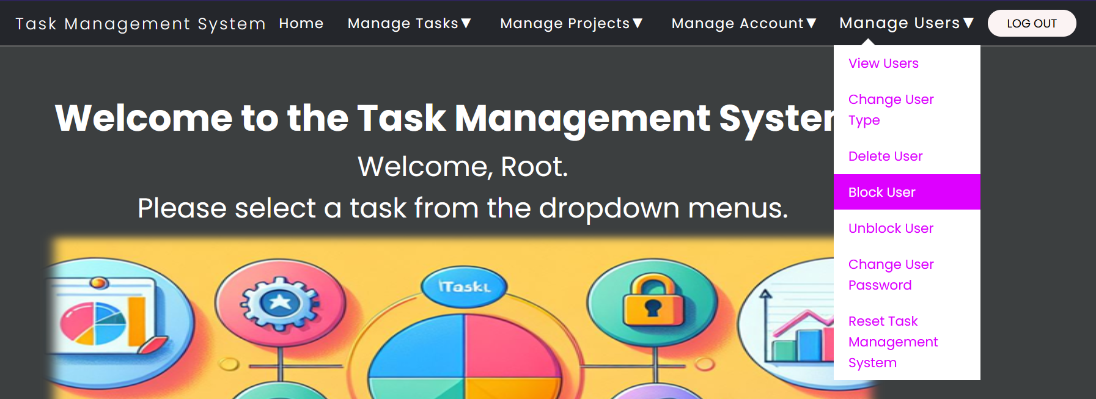

Figure 194 - Select "Block User" from "Manage Users" dropdown menu.

1. You will be redirected to the Block User form page.
2. Fill in the Block User form:
   1. Username – the username of the account to be blocked.
3. Click the “Block User” button.

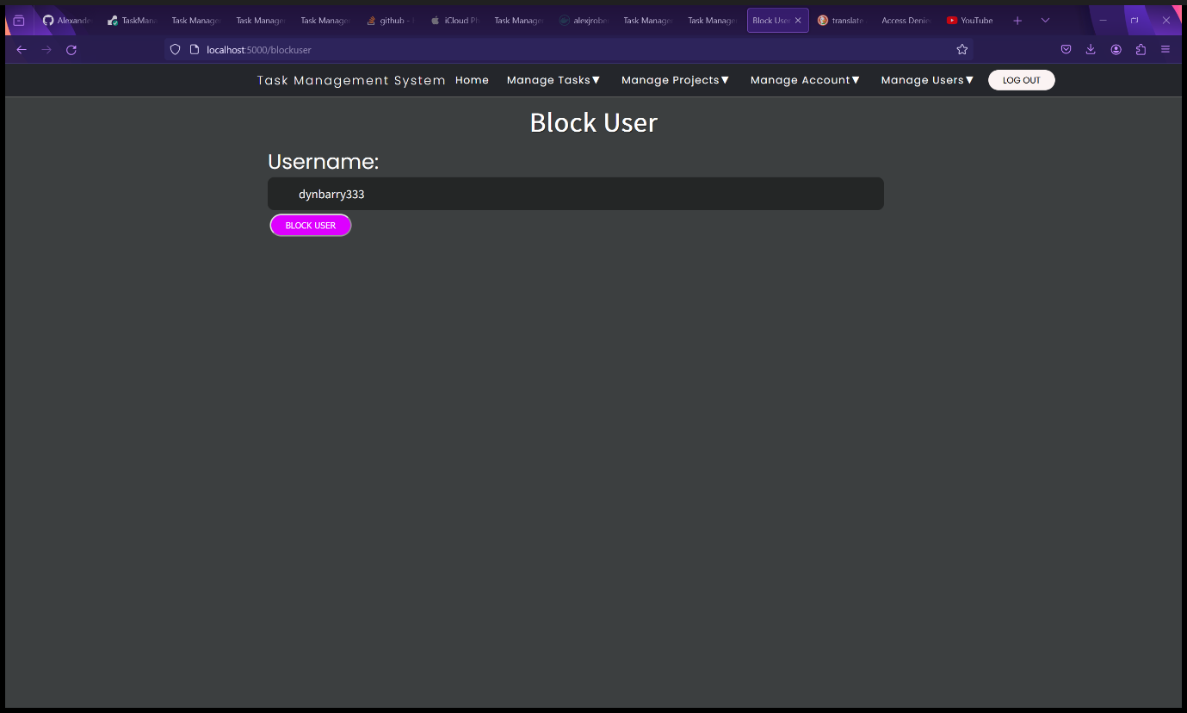

Figure 195 - Block User form.

1. You will be redirected to the View Users page. A message will be displayed saying “User blocked successfully!”. The user’s blocked status will be changed to “Yes”.

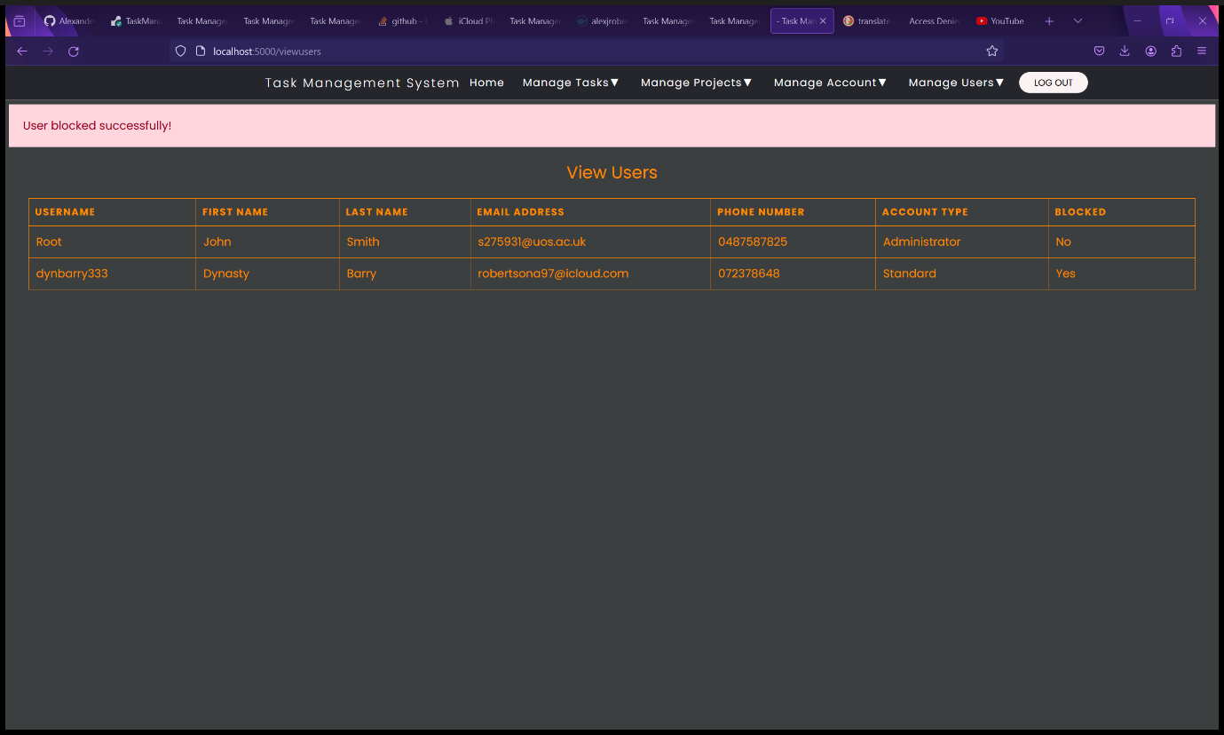

Figure 196 - View Users page after blocking a user.

1. The blocked user will now be unable to log in. Instead, they will receive an error message “You have been blocked. Please contact the administrator.”.

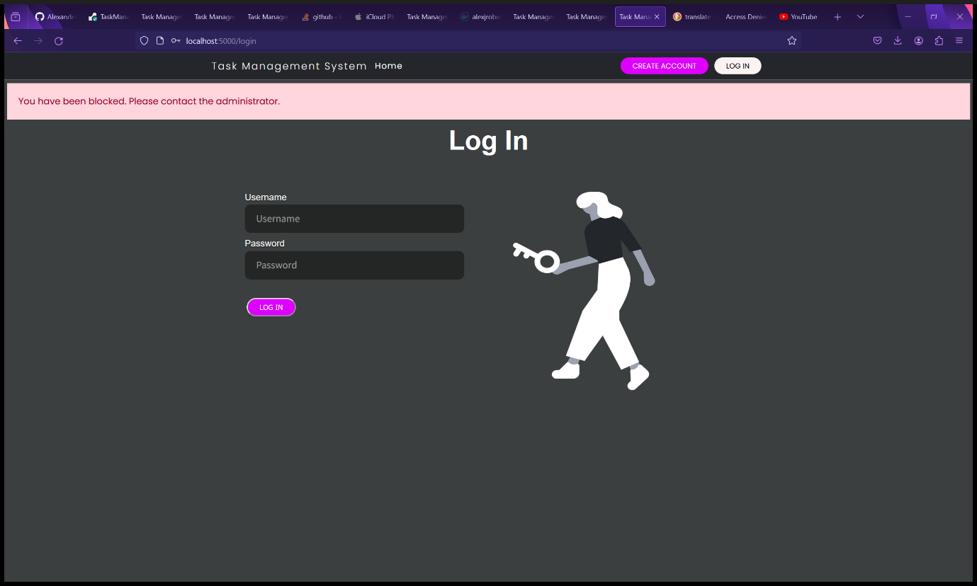

Figure 197 - The blocked user is unable to log in.

### Unblocking a User (Administrators and Root Users Only)

1. Select “Unblock User” from the “Manage Users” dropdown menu.

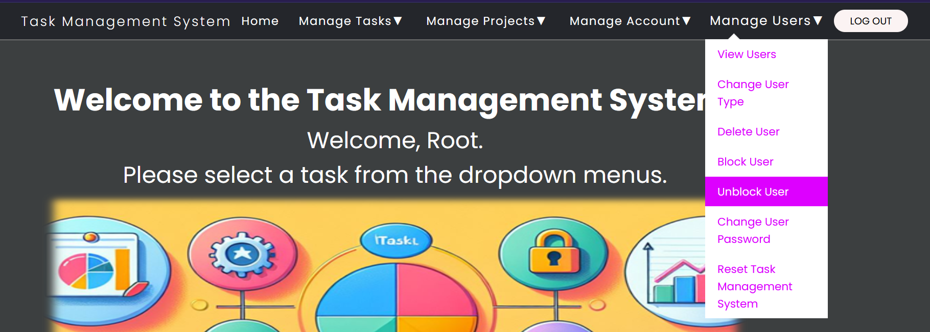

Figure 198 - Select "Unblock User" from "Manage Users" dropdown menu.

1. You will be redirected to the Unblock User form page.
2. Fill in the Unblock User form:
   1. Username – the username of the account to be unblocked. In the example, we will unblock the same user that we blocked in the previous step.
3. Click the “Unblock User” button.

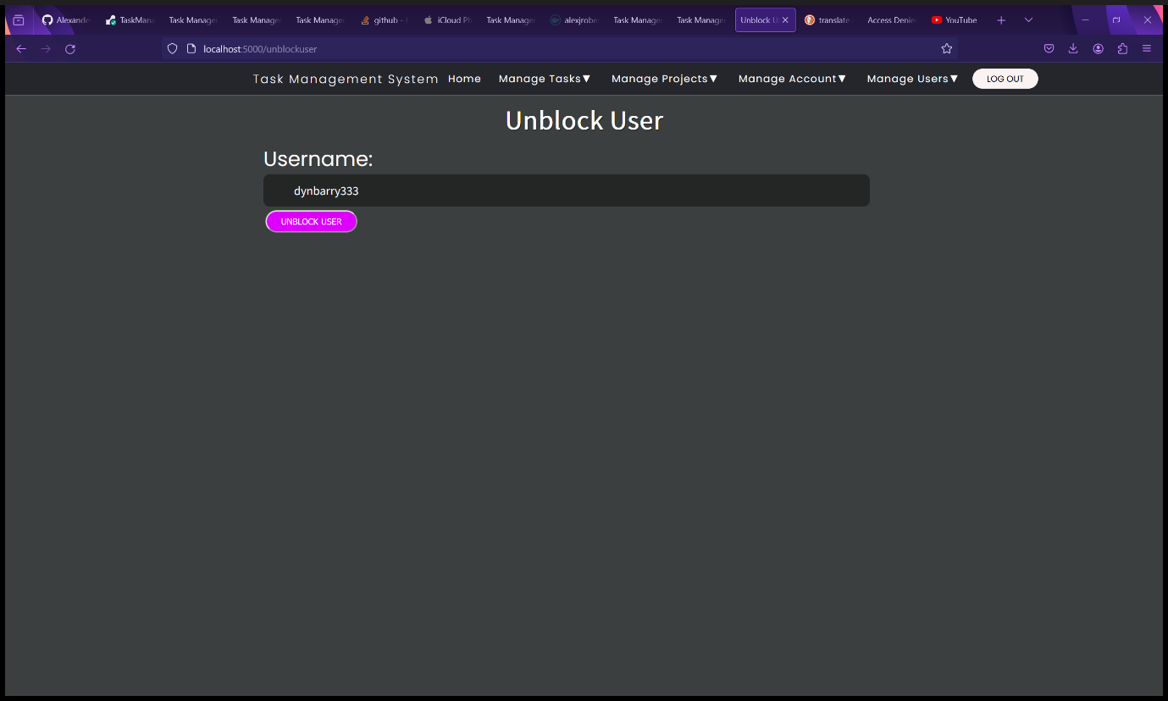

Figure 199 - Unblock User form.

1. You will be redirected to the View Users page. A message will be displayed saying “User unblocked successfully!”. The user’s blocked status will be changed to “No”.

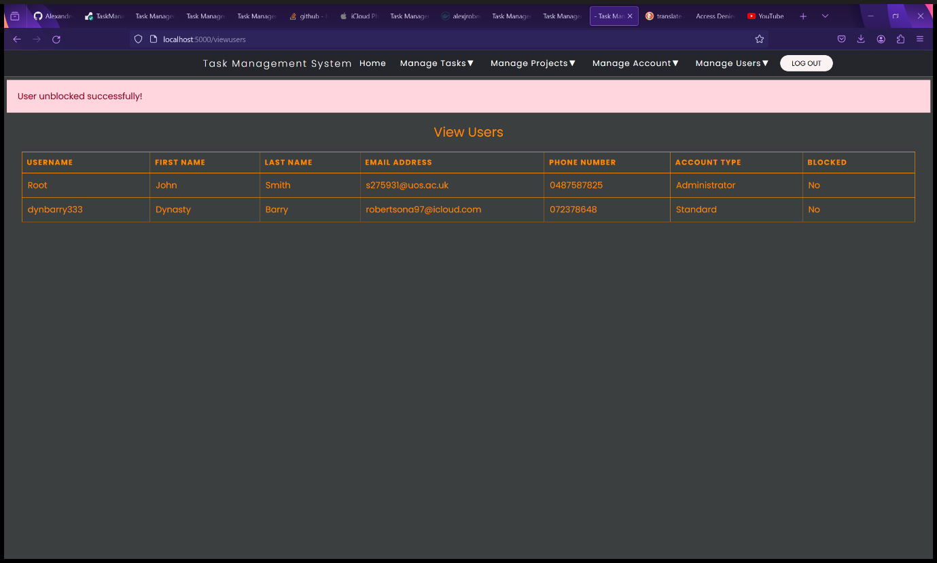

Figure 200 - View Users page after unblocking a user.

1. The unblocked user can now log in successfully.

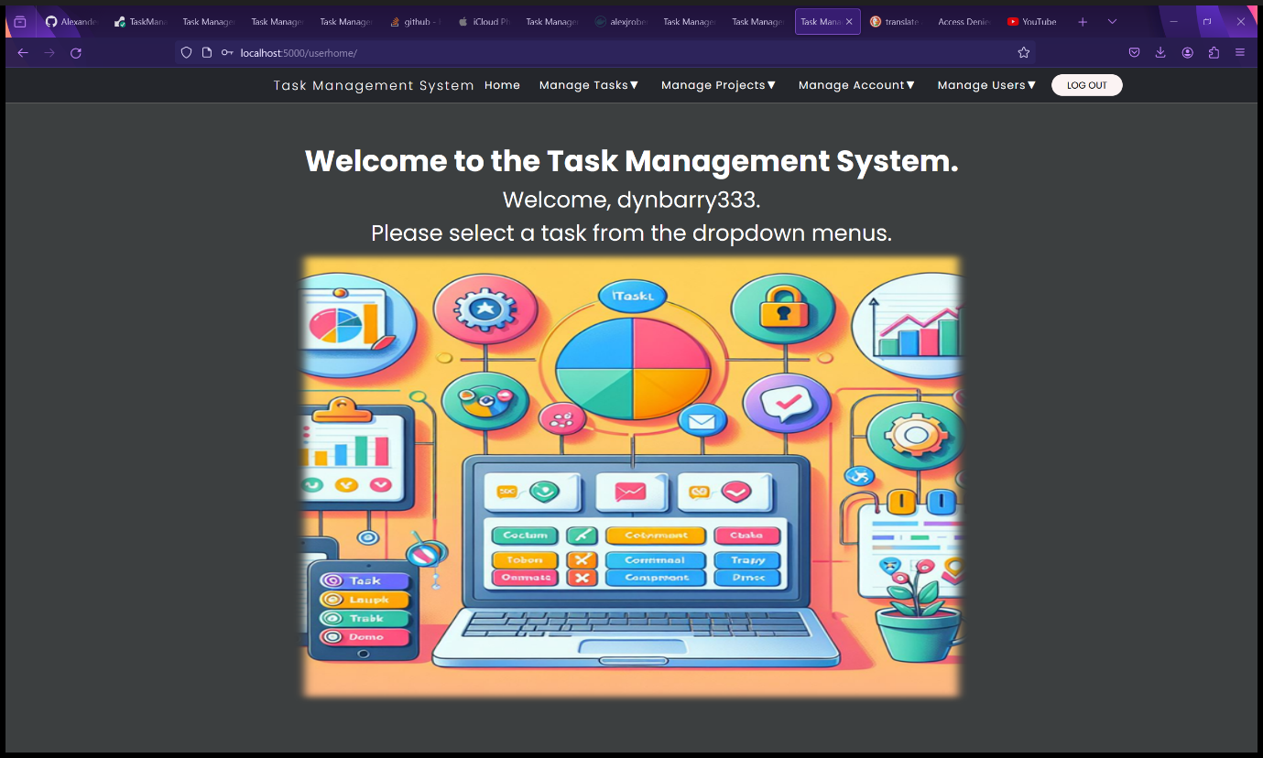

Figure 201 - The user is now able to log in again.

### Changing Another User’s Password (Administrators and Root Users Only)

1. Select “Change User Password” from the “Manage Users” dropdown menu.

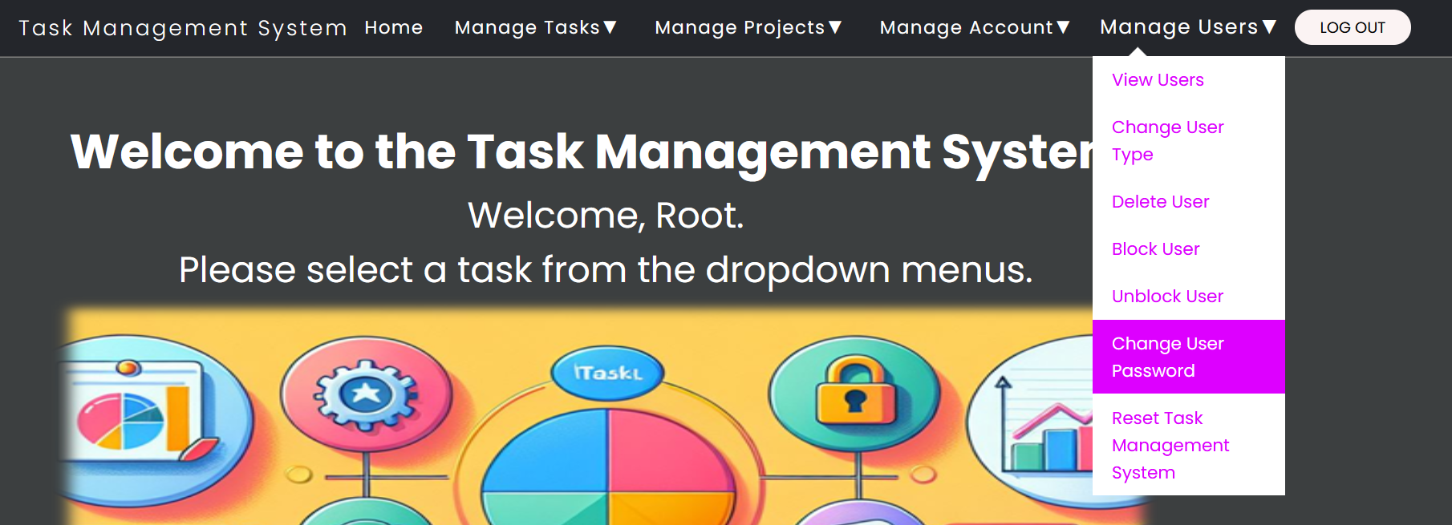

Figure 202 - Select "Change User Password" from "Manage Users" dropdown menu.

1. You will be redirected to the Change User Password form page.
2. Fill in the Change User Password form:
   1. Username – the username of the account to have their password changed.
   2. New Password – Enter the new password here. Password must meet the following requirements: Minimum length of 10 characters, at least one uppercase letter, one lowercase letter, one number and one special character. Special characters must be ASCII characters as UTF and Unicode characters are not supported in emailing the new passwords to users and will result in an error. The password must not be a common password.
3. Click the “Change User Password” button.

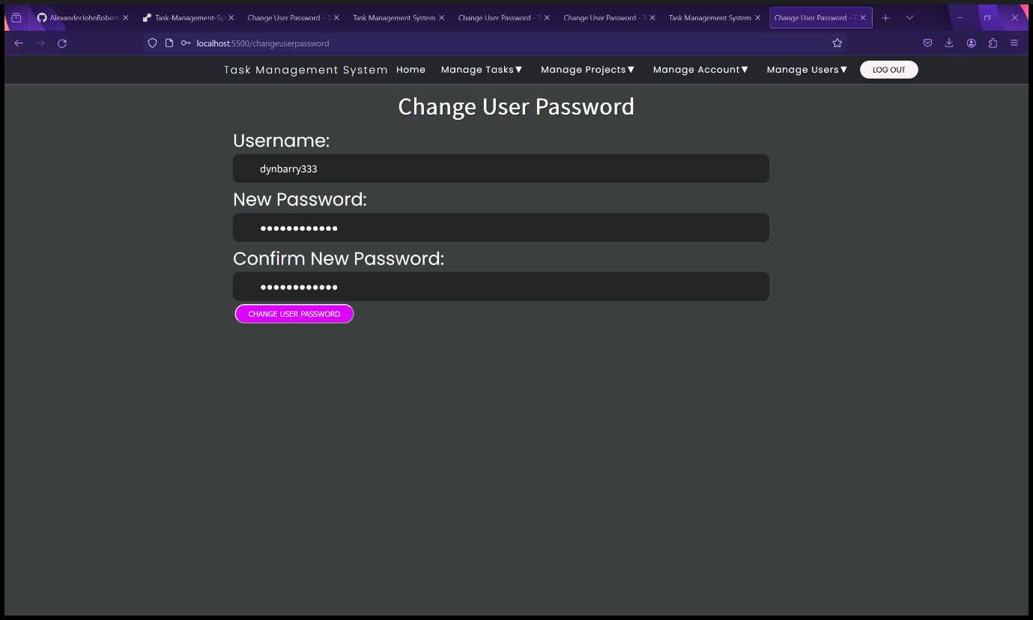

Figure 203 - Change User Password form.

1. You will be redirected to the View Users page. A message will be displayed saying “Password Changed successfully!”.
2. An email will automatically be sent to the user’s email address.

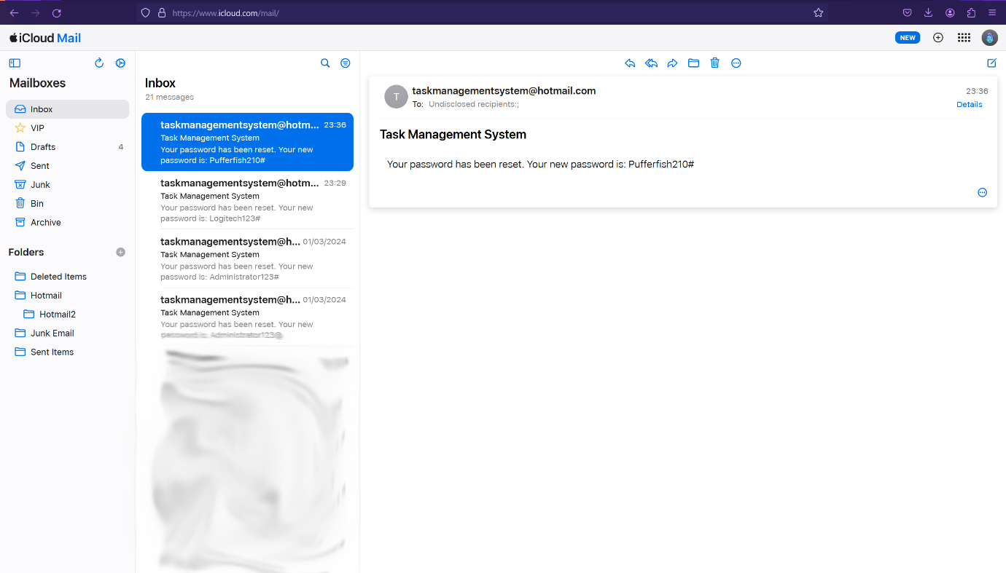

Figure 204 - Automated email sent to user of who’s password has been changed.

### Factory Resetting the Task Management System (Administrators and Root Users Only)

**WARNINING: THIS WILL BE PERMANENT. ALL DATA WILL BE LOST. IF YOU WANT TO KEEP THE DATA MAKE A BACKUP FIRST.**

1. Select “Reset Task Management System” from the “Manage Users” dropdown menu.

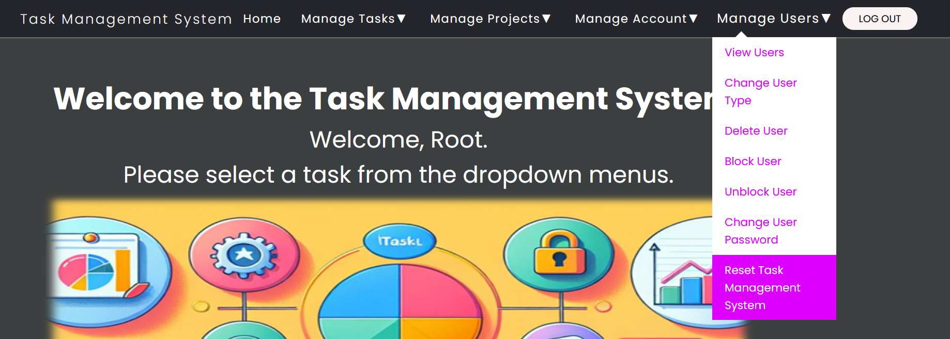

Figure 205 - Select "Reset Task Management System" from "Manage Users" dropdown menu.

1. You will be redirected to the Reset Task Management System form page.
2. Fill in the Reset Task Management System form:
   1. Administrator Password – Must be the password of your administrator or Root account – A security measure to prevent unauthorized and malicious factory resets resulting in unauthorized data loss.
   2. Confirm Password – Re-enter your password. Security measure to prevent accidental factory resets resulting in accidental data loss.
3. Click the “Reset Task Management System” button.

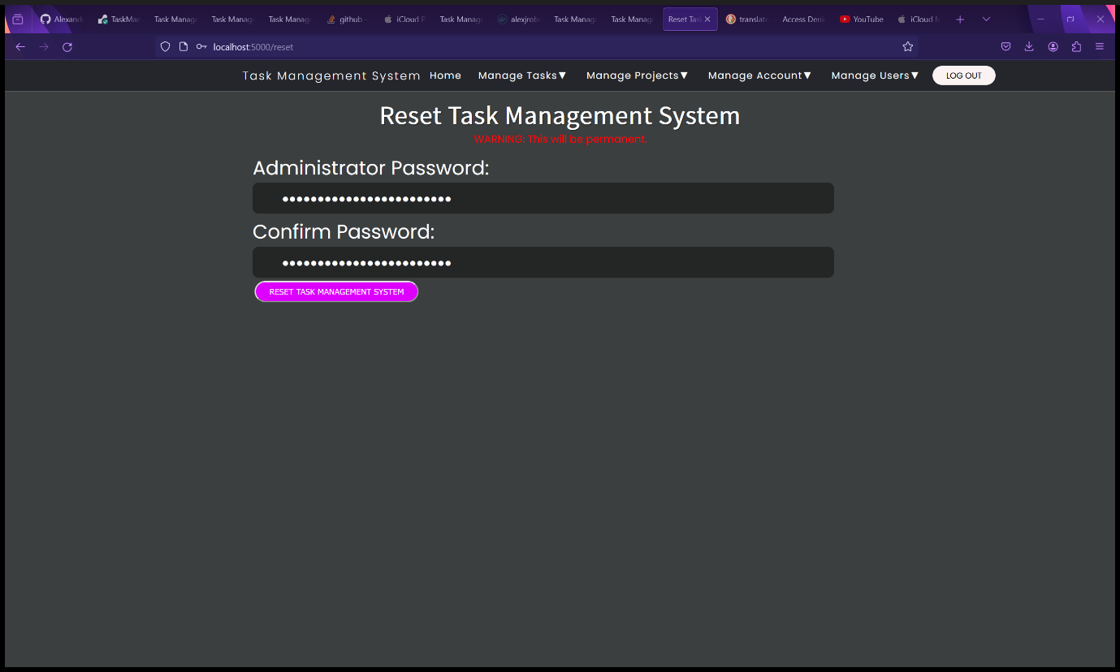

Figure 206 - Reset Task Management form.

1. The Task Management System will be factory reset and all data (projects, tasks, and users) will be wiped. You will be redirected to the Setup page. A message will appear saying “Task Management System Reset Successfully!” above the setup form.

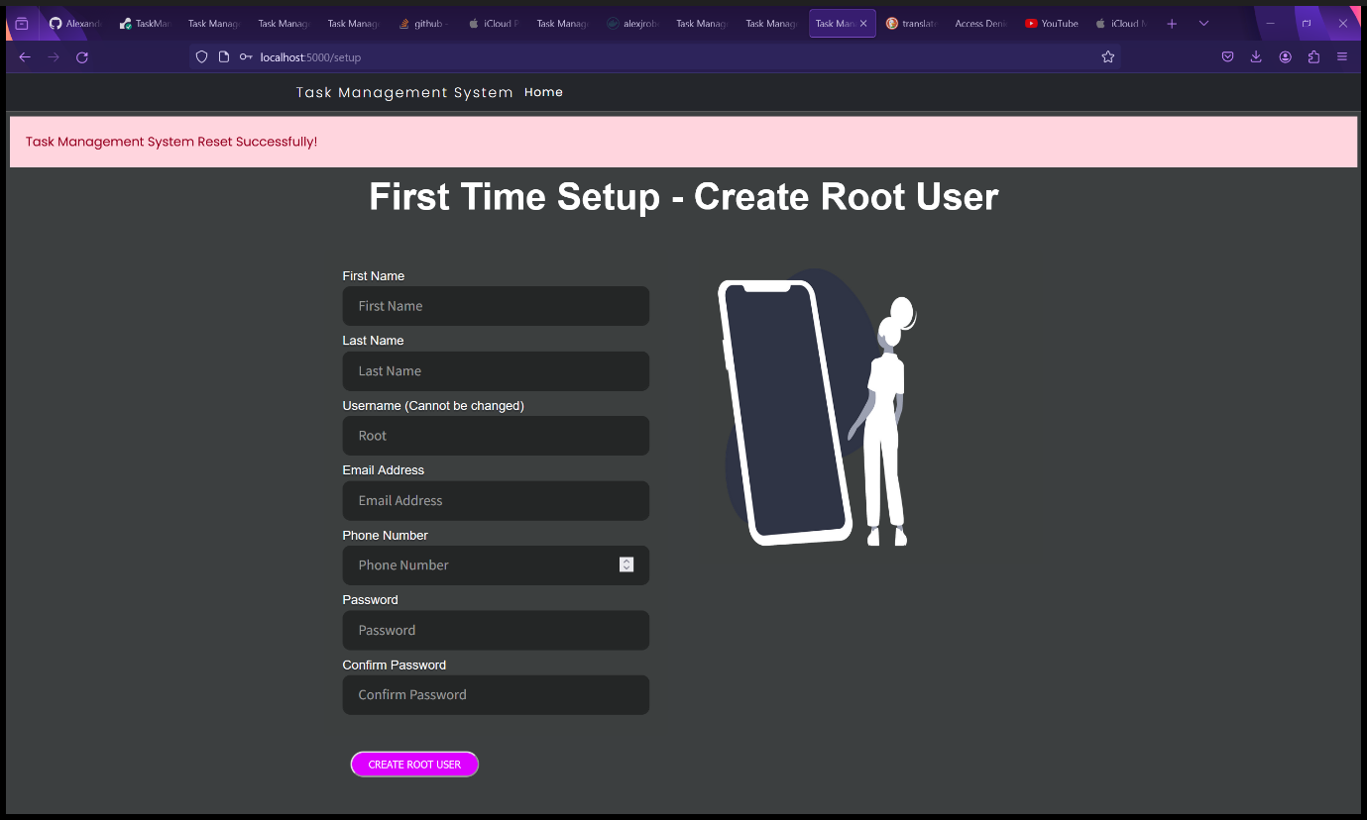

Figure 207 - Setup page after factory resetting the Task Management System.

1. Fill in the Setup form (see First Time Setup) for full instructions.



Figure 208 - Completed Setup form.

1. The Task Management System has been reset and is ready for use again.



Figure 209 - The Task Management System has been reset.

## Task Management System on Mobile Devices.

The Task Management System is a responsive web application and will therefore be displayed differently on mobile devices and displays that are too small or the resolution is too low to display the full navbar or tables. On these devices, the dropdown menus in the navbar can be accessed through a hamburger menu in the top right corner of the webpages. Each task, project and user are displayed in individual card like tables instead of the full table on mobile devices and small displays.

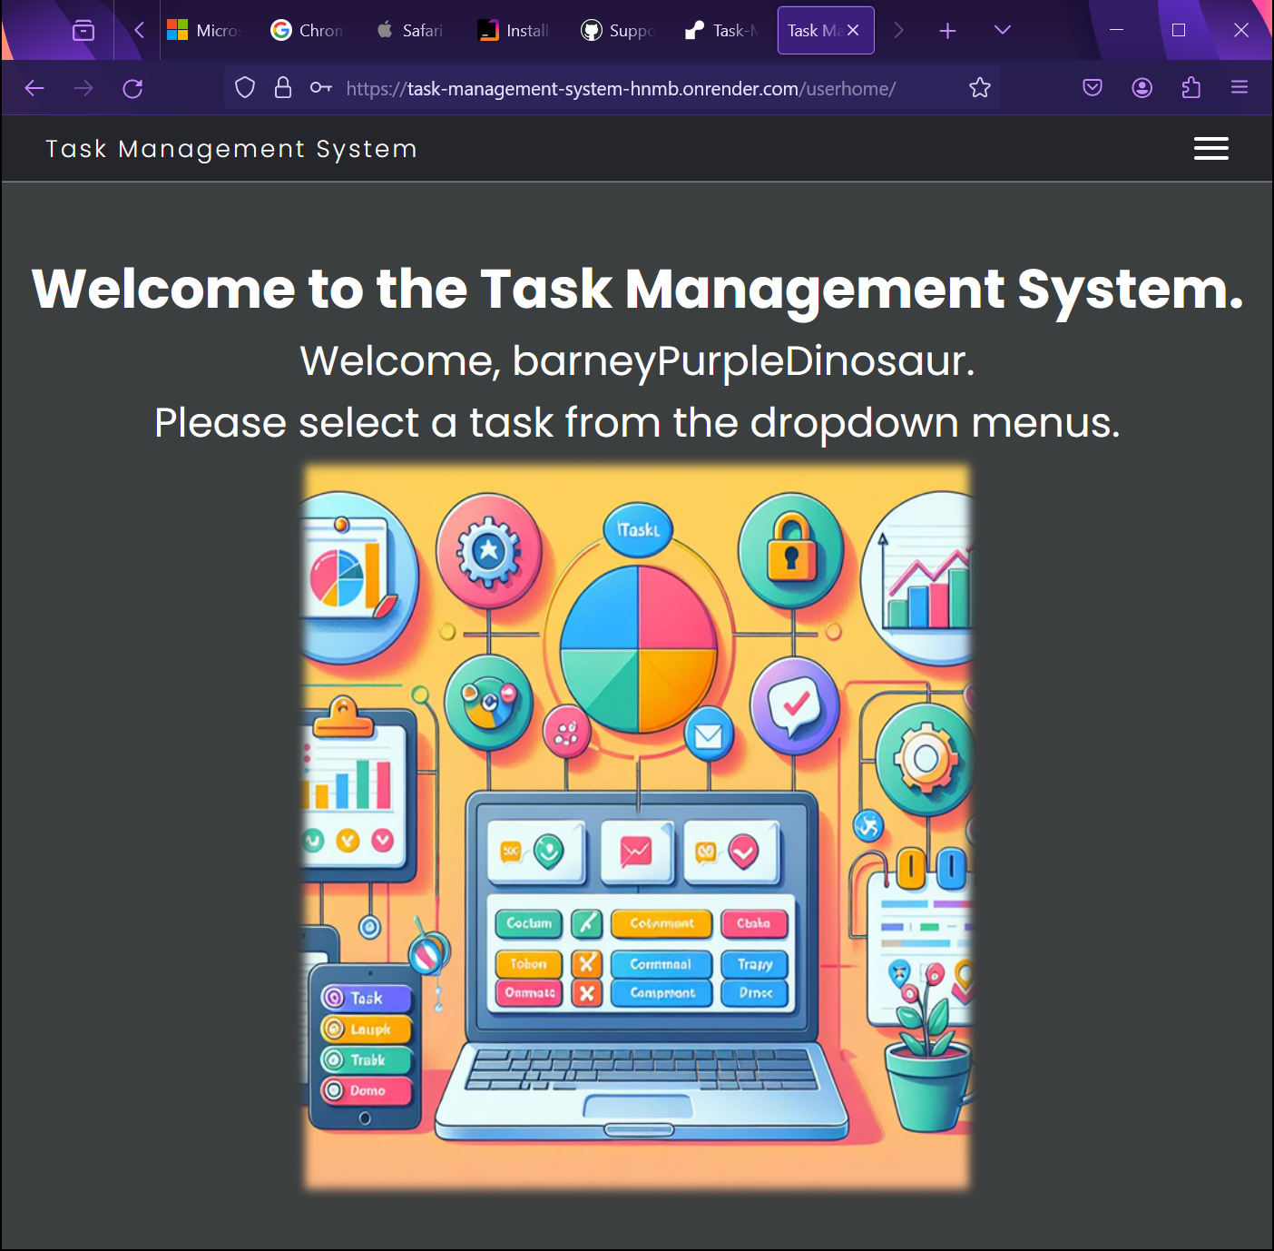

Figure 210 - Task Management System resized on Firefox.

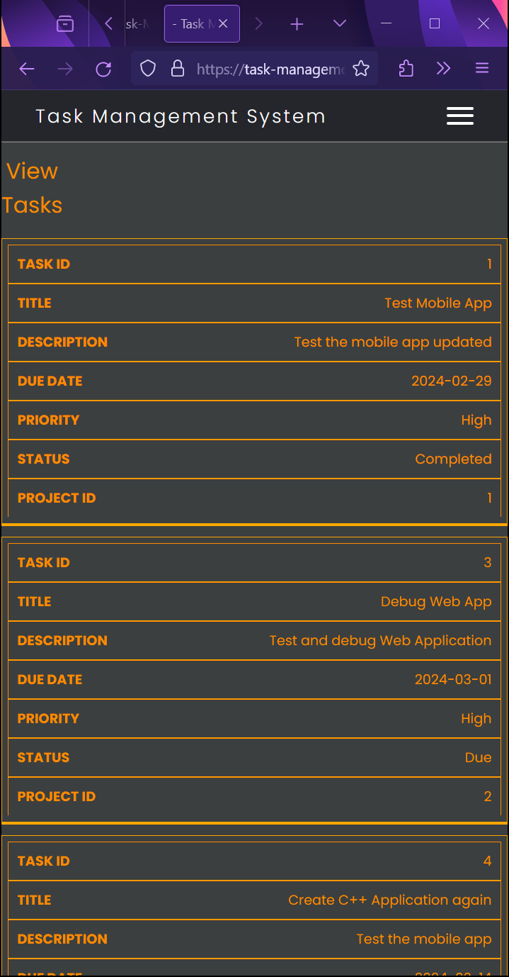

Figure 211 - Task Management System Task table on resized Firefox window.

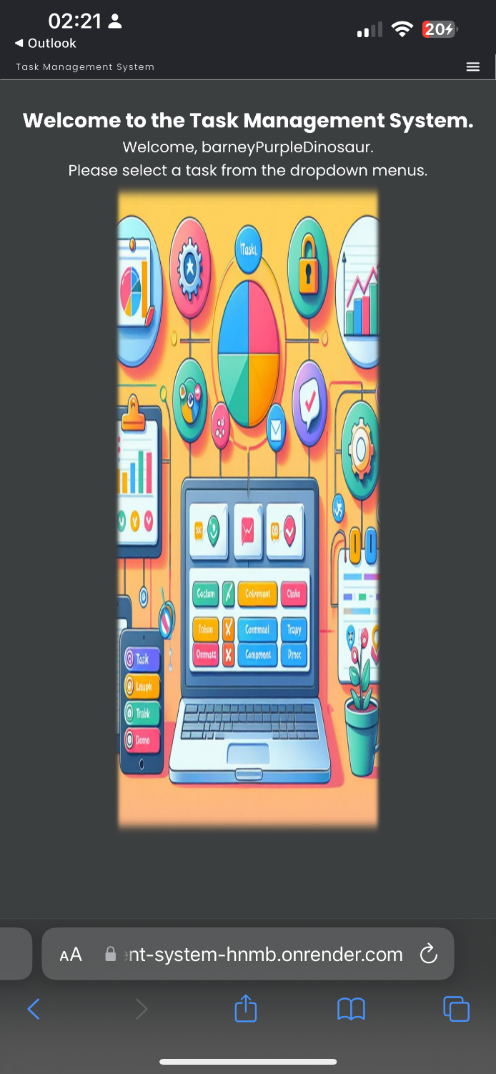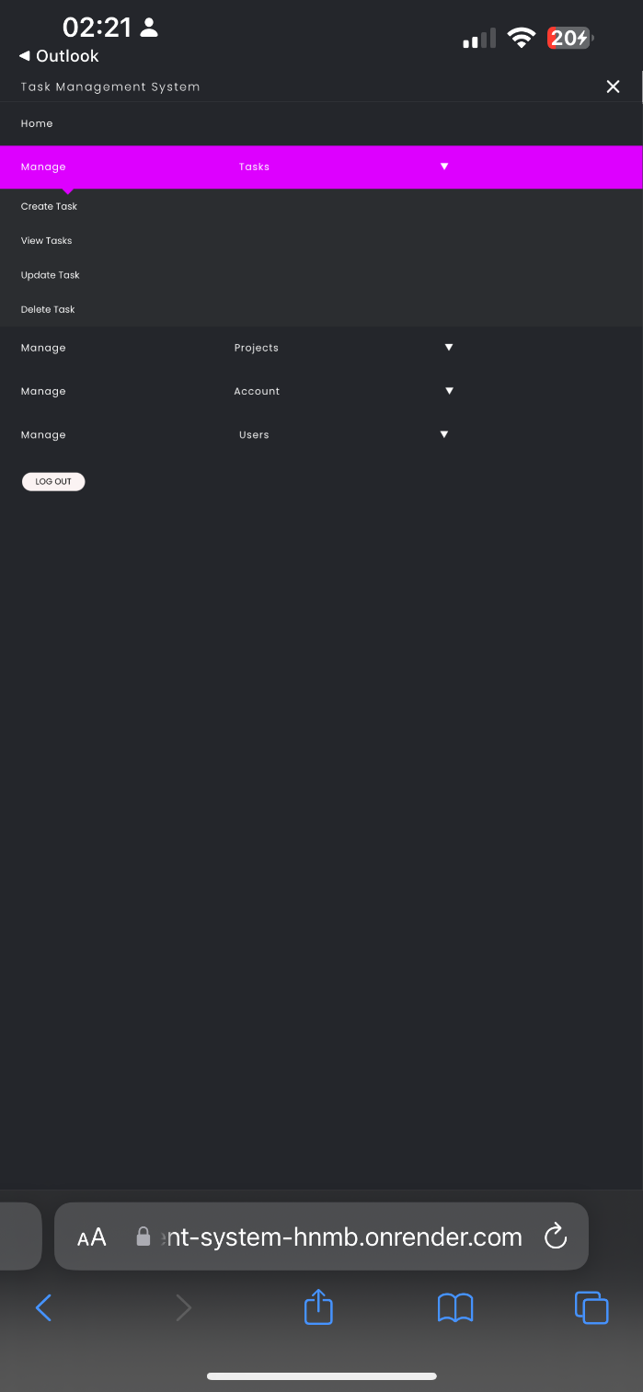

Figure 213 - Expanded Hamburger Menu with navigation (Portrait).

Figure 212 - Task Management System viewed on an

iPhone 13 Pro Max (Portrait). Hamburger Menu in the

top right corner instead of full navbar.

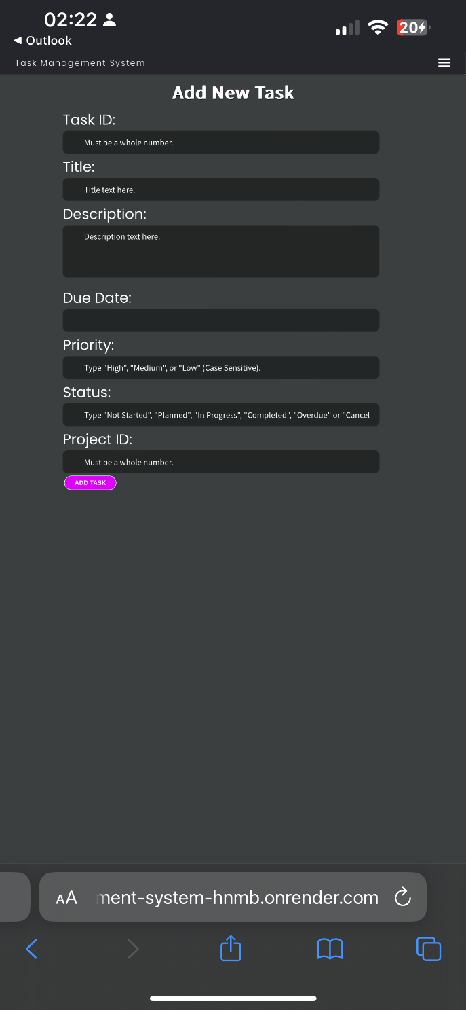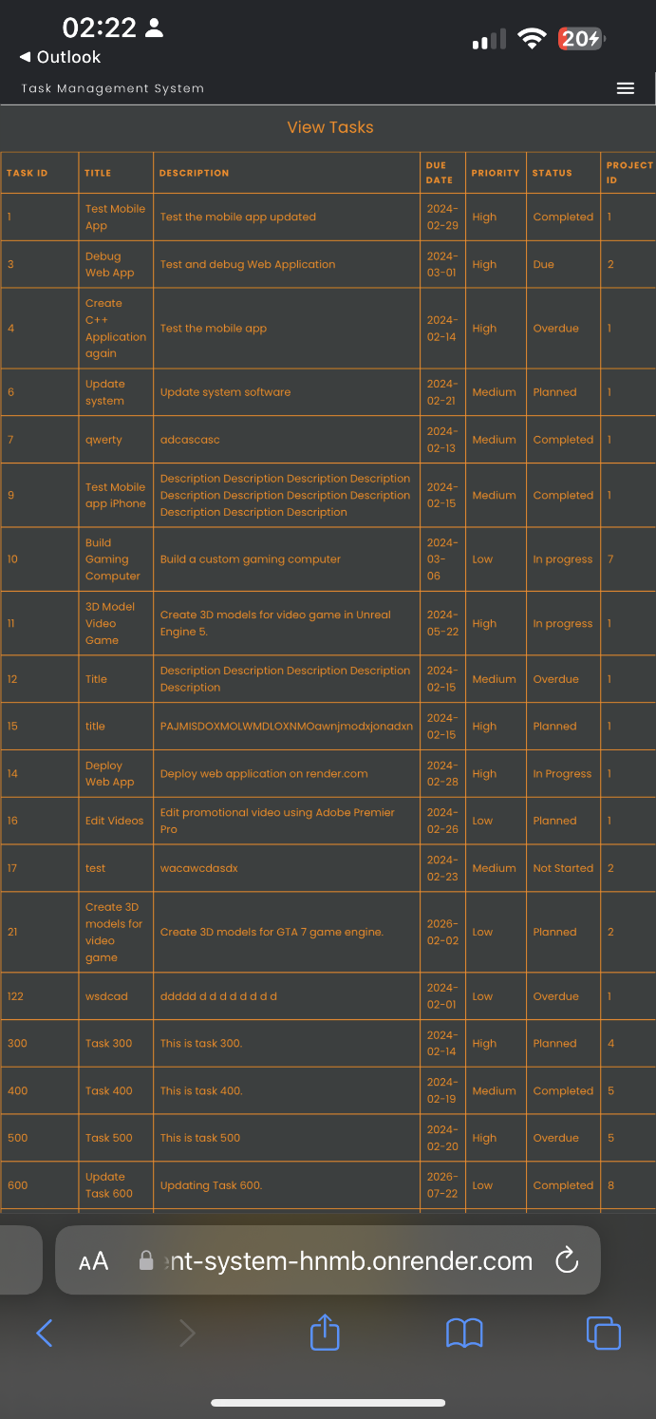

Figure 214 - Form and table viewed on iPhone 13 Pro Max (Portrait).

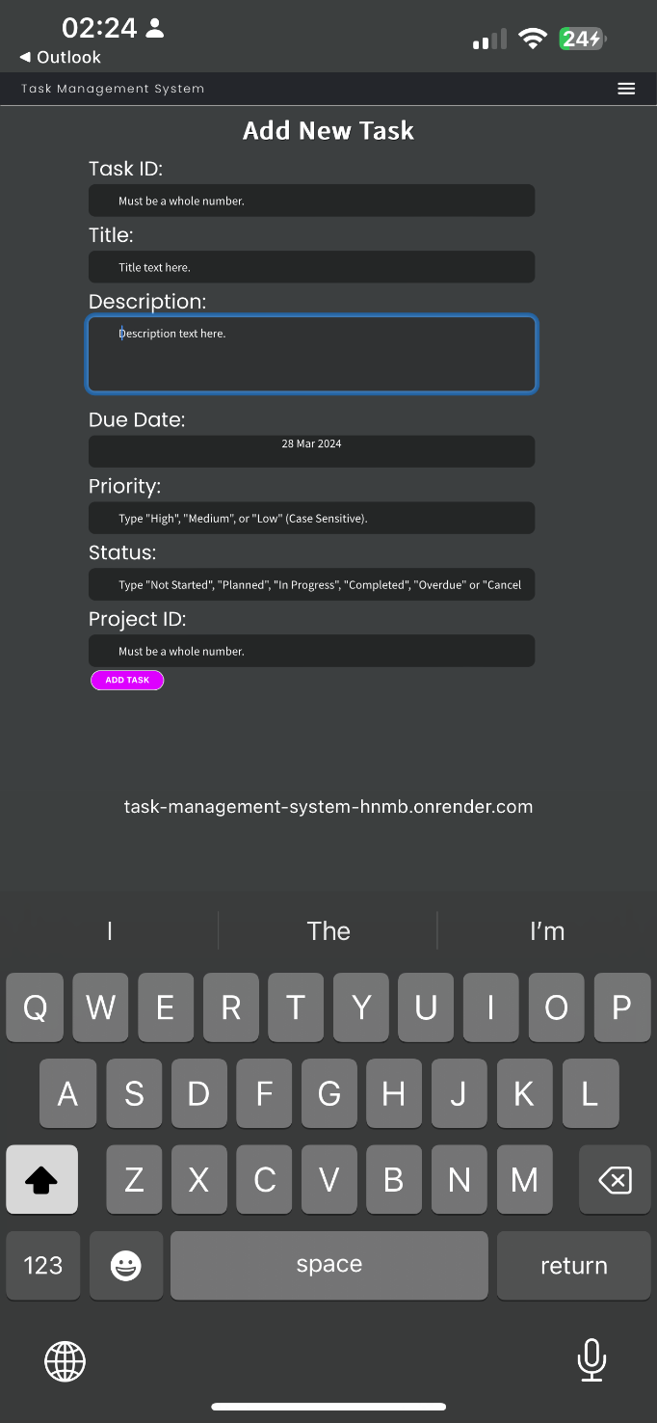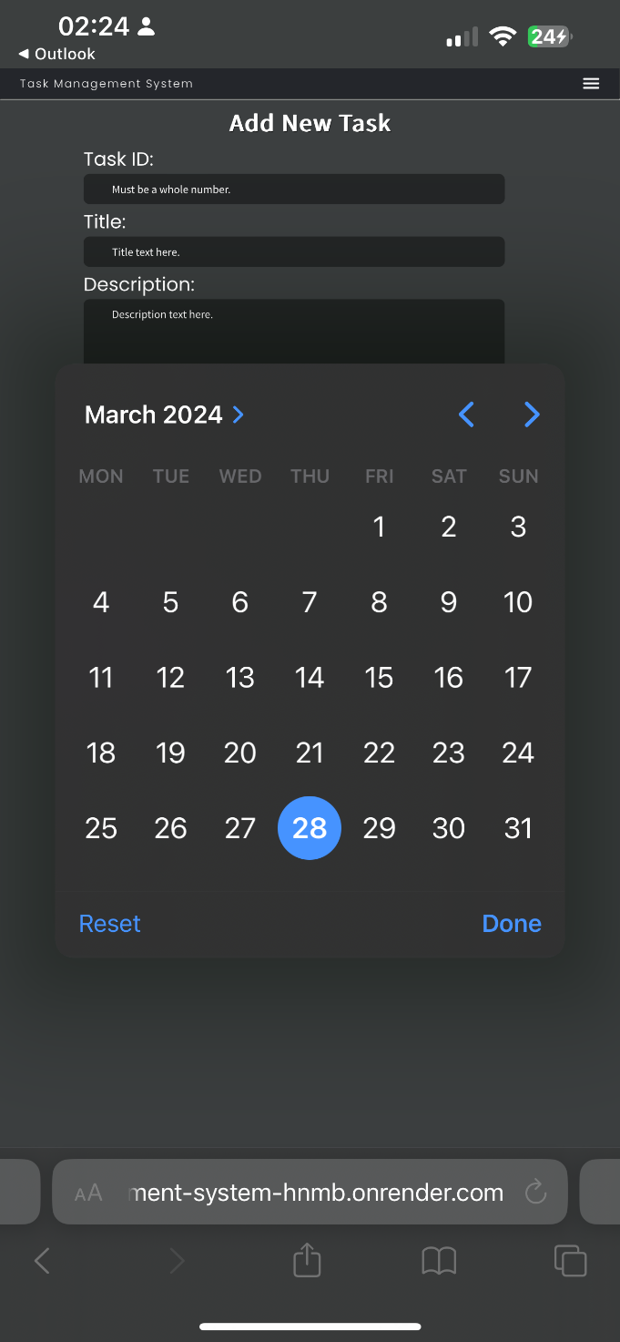

Figure 215 - On-screen keyboard and calendar for Add Task form on iPhone 13 Pro Max (Portrait).

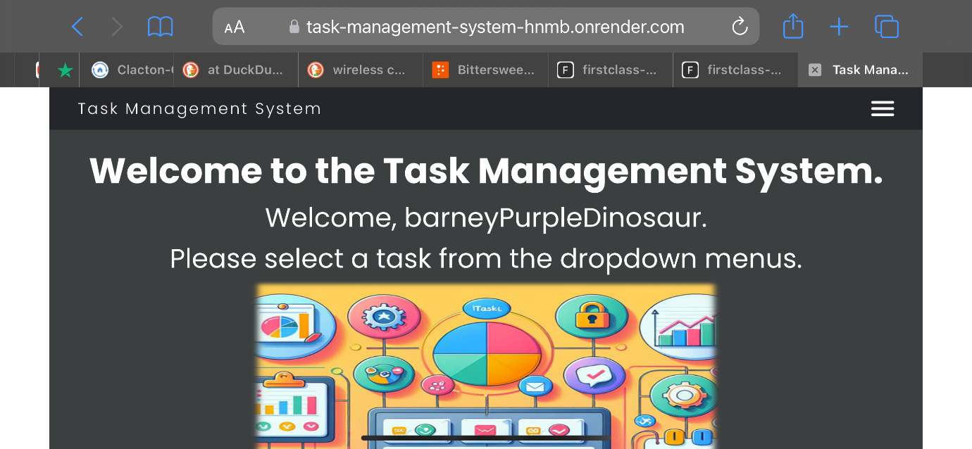

Figure 216 - Task Management System User Home page viewed on iPhone Pro Max (Landscape).

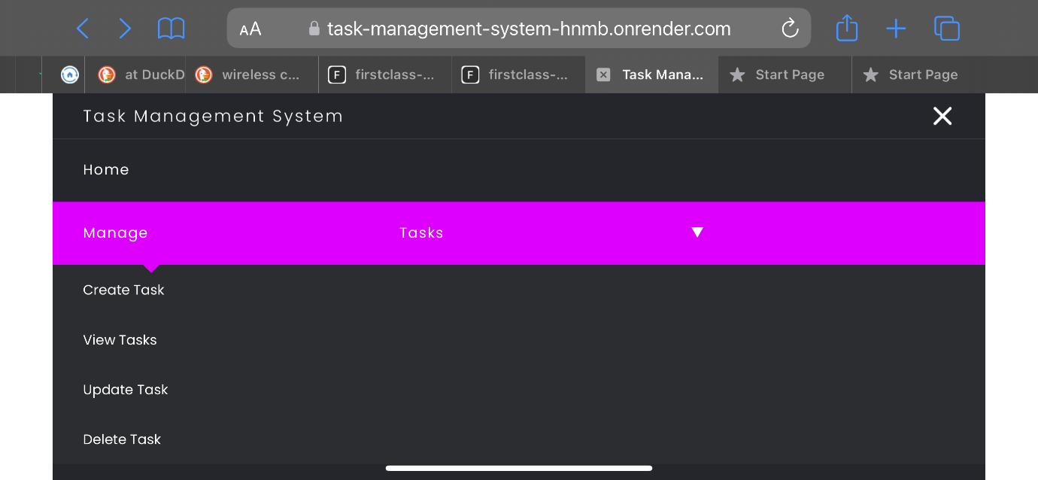

Figure 217 - Expanded Hamburger Menu with navigation (Landscape).

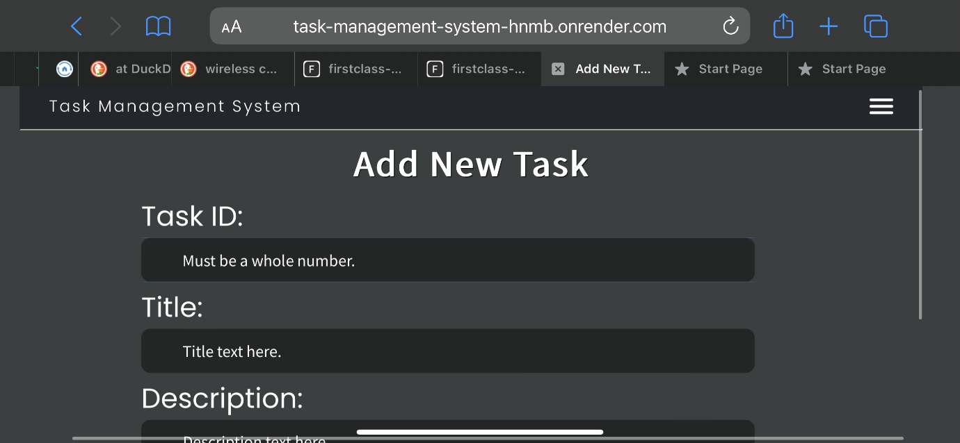

Figure 218 - Form viewed on iPhone 13 Pro Max (Landscape).

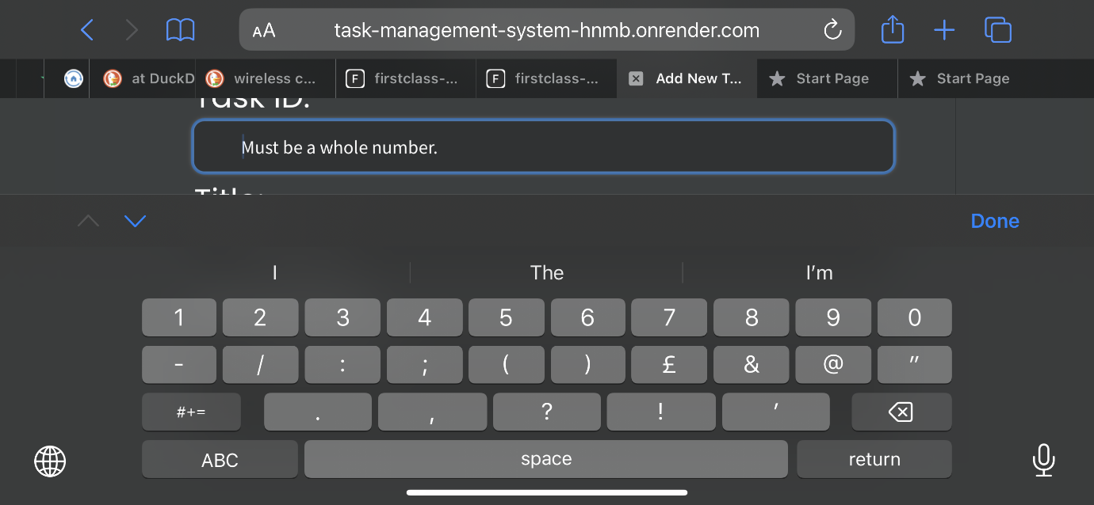

Figure 219 - Form viewed on iPhone 13 Pro Max (Landscape).

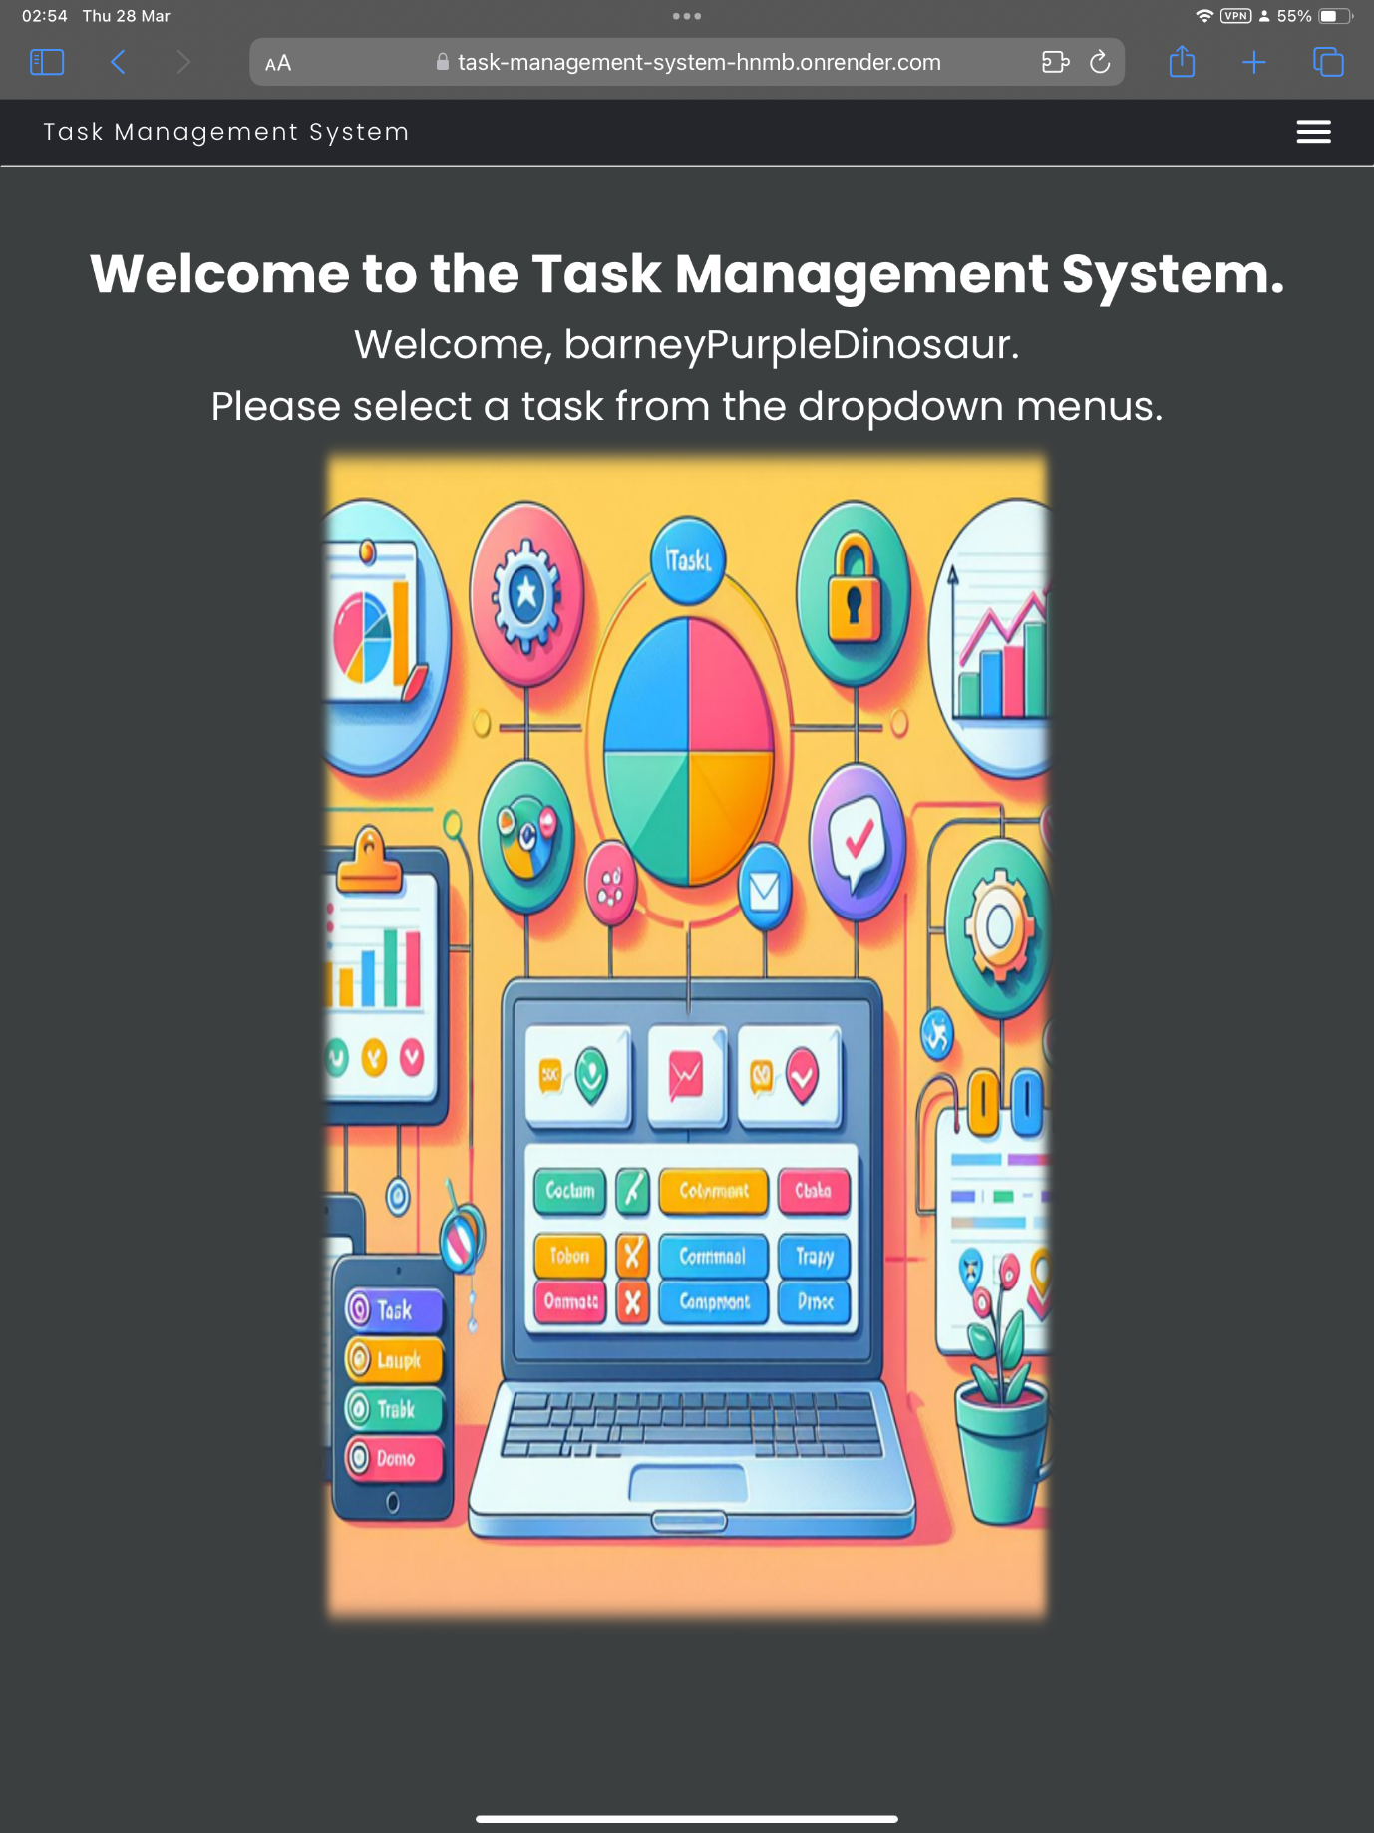

Figure 220 - Task Management System User Home Page viewed on iPad Pro (Portrait).

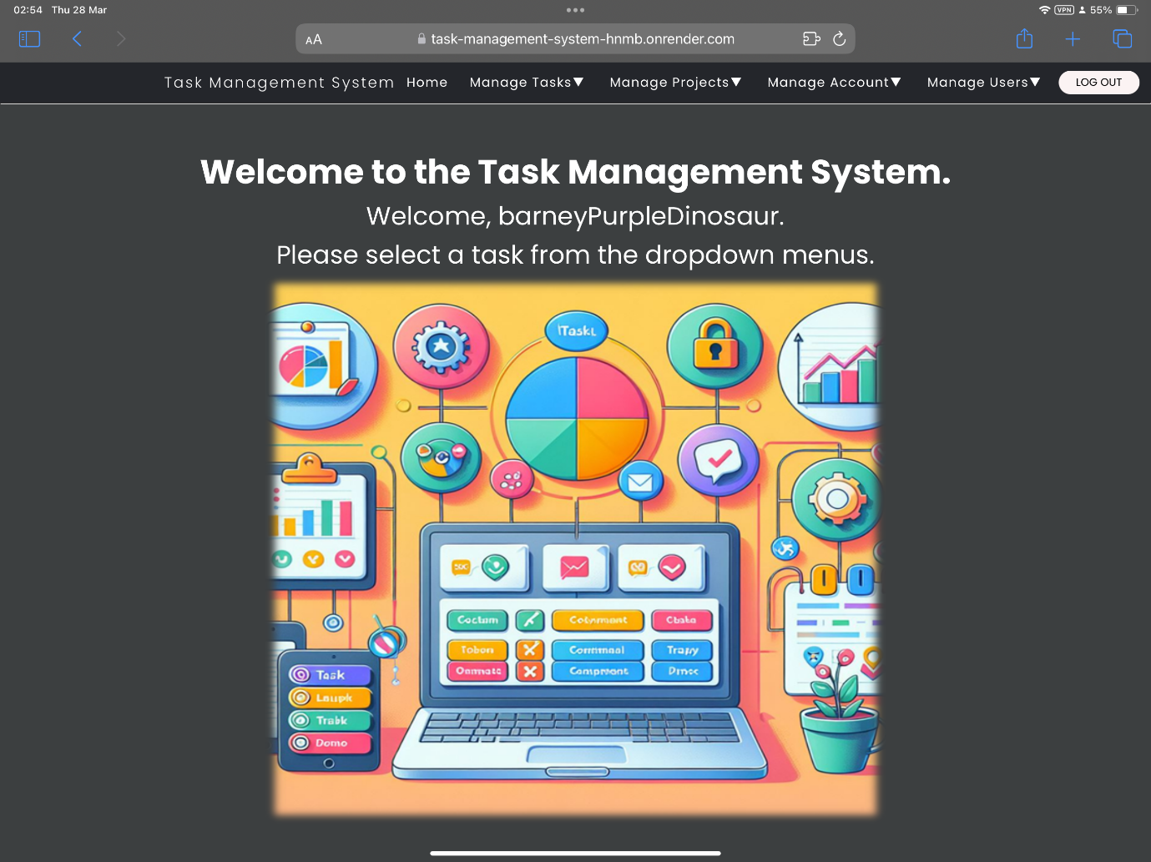

Figure 221 - Task Management System User Home Page viewed on iPad Pro (Landscape).

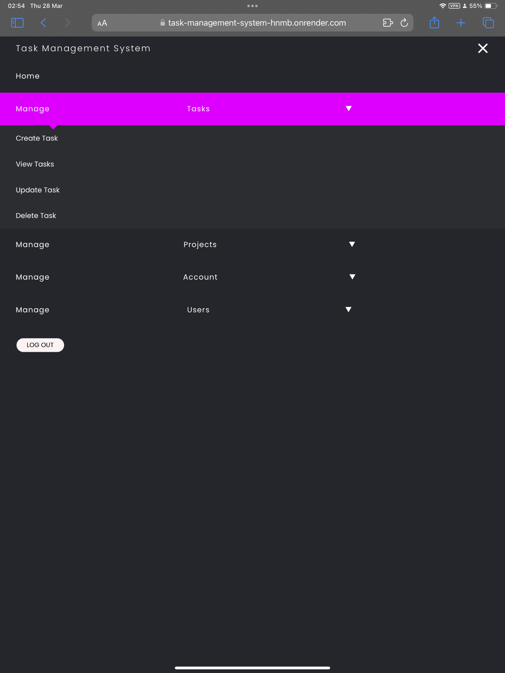

Figure 222 - Expanded Hamburger Menu instead of navbar on iPad Pro (Portrait).

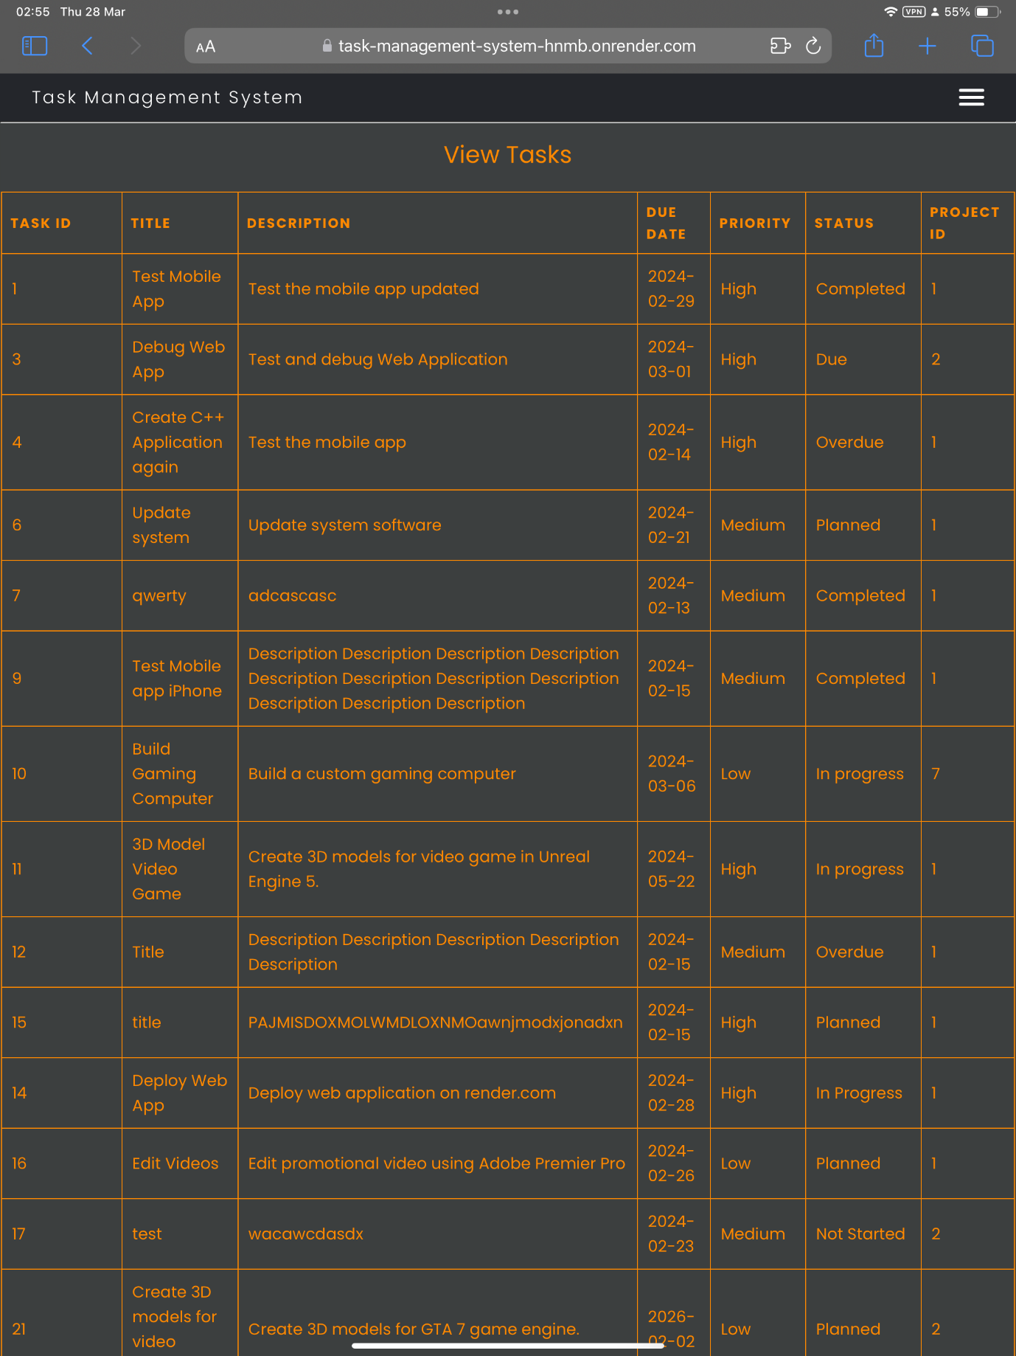

Figure 223 - Table viewed on iPad Pro (Portrait).

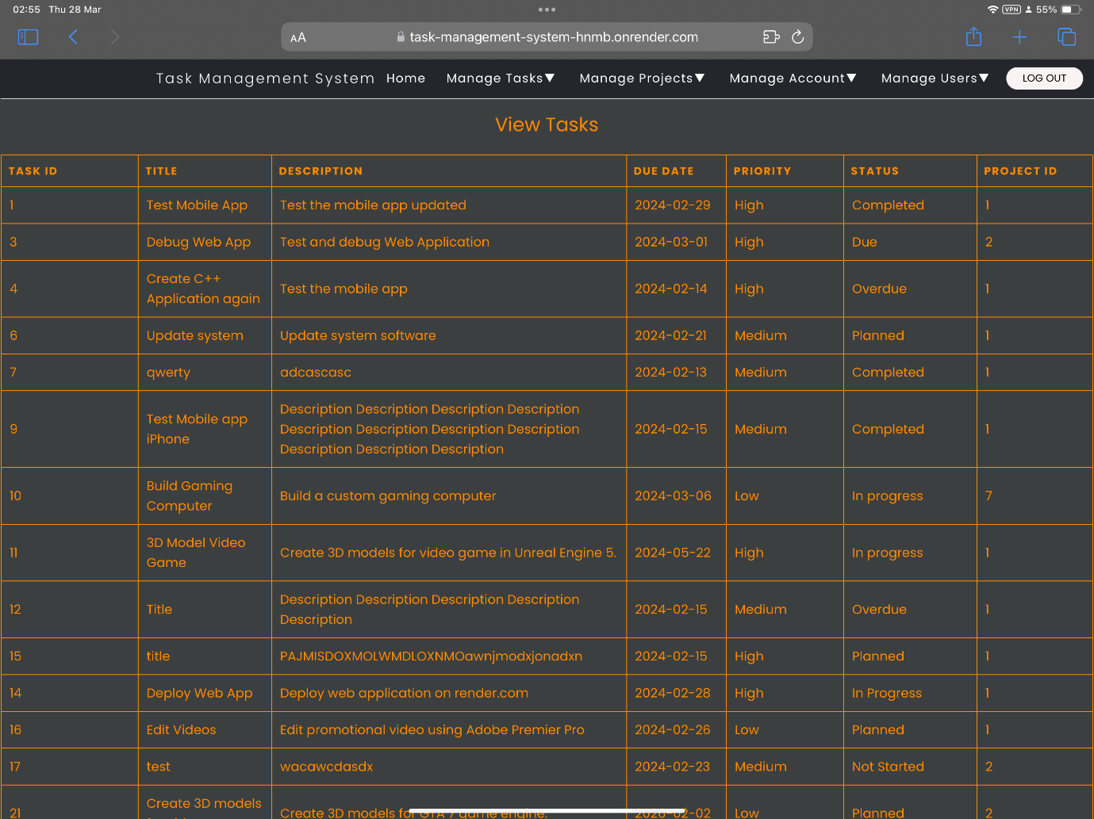

Figure 224 - Table viewed on iPad Pro (Landscape).

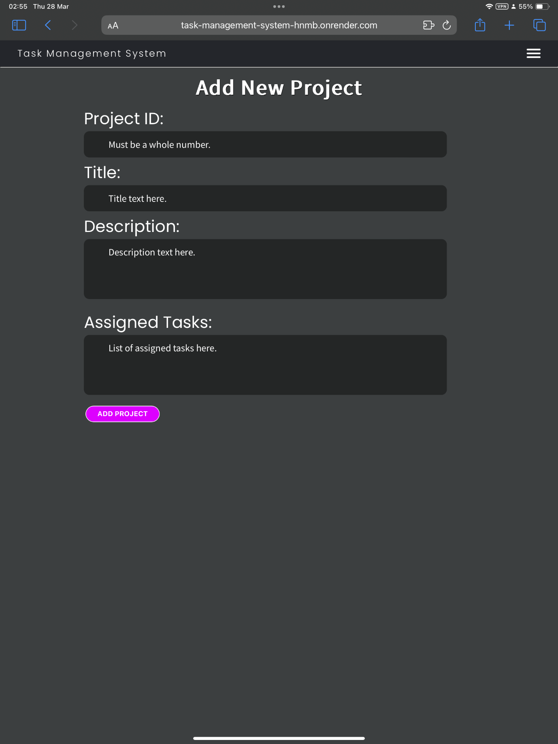

Figure 225 - Form viewed on iPad Pro (Portrait).

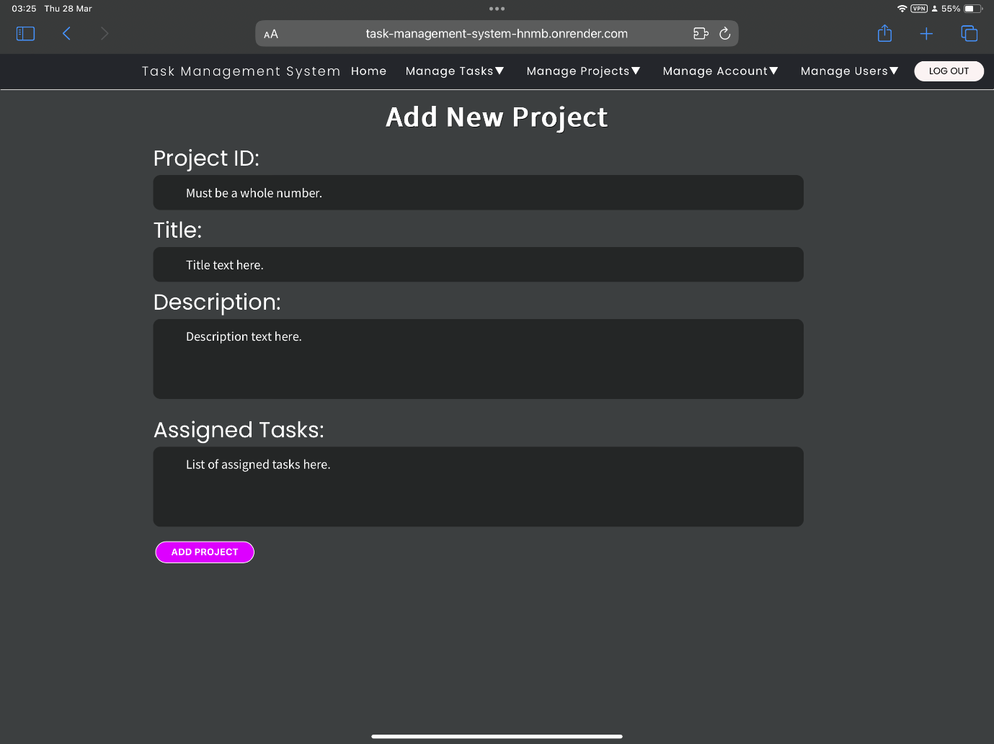

Figure 226 - Form viewed on iPad Pro (Landscape).

# Security Features

The Task Management System has several built-in security features to protect data and prevent unauthorized access, use, and misuse.

1. User Roles – There are two main user roles: Standard User and Administrator. The Root user created during setup is an administrator. Administrators have full control of the Task Management System while standard users can only add and view tasks, add and view tasks and manage their own account. Standard users cannot update or delete tasks, update, or delete projects, manage other users, or perform administrative tasks.
2. Passwords - All accounts are password protected.
3. Password Requirements – Passwords must be a minimum of 10 characters, have at least one capital letter, one lowercase letter, one number, one special character and must not be a common password. This makes it more difficult to guess and crack the passwords.
4. Password encryption – All passwords are stored securely on the database as SHA3 512-bit hashes. These hashes are rehashed several times to make it near impossible to decrypt them to obtain the password in the event the database gets hacked.
5. Maximum 3 failed login attempts – The user is automatically blocked after three failed login attempts by entering the incorrect password. This also helps prevent automated password cracking, guessing and brute force attacks. The user can only be unblocked by another administrator.
6. Authentication – Once the user logs in using the correct username and password (which is checked in the database), a cookie containing the user’s username and another cookie containing the session ID are stored in the user’s browser. The session ID is randomly generated every time the user logs into the Task Management System and is also stored in the database. The cookie containing the username must match the username in the database and the cookie containing the session ID must match the session ID in the database for the user to be authenticated and granted access to the Task Management System or else an Access Denied error message will appear instead. When the user logs out, the cookies containing the username and session ID are cleared and the session ID is cleared from the database.
7. Sanitisation – the SQL statements executed in the Python code are sanitised to prevent SQL injection attacks.

# References

Apple (2024) *Safari Support.*   
Available at: https://support.apple.com/safari  
(Accessed: 28 March 2024).

Choose an open source license (2007) *GNU Affero General Public License v3.0.*   
Available at: https://choosealicense.com/licenses/agpl-3.0/  
(Accessed: 25 04 2024).

Docker, Inc. (2024) *Docker Docs - Install Docker Desktop on Linux.*   
Available at: https://docs.docker.com/desktop/install/linux-install/  
(Accessed: 28 March 2024).

Docker, Inc. (2024) *Docker Docs - Install Docker Desktop on Mac.*   
Available at: https://docs.docker.com/desktop/install/mac-install/  
(Accessed: 28 March 2024).

Docker, Inc. (2024) *Docker Docs - Install Docker Desktop on Windows.*   
Available at: https://docs.docker.com/desktop/install/windows-install/  
(Accessed: 28 March 2023).

Docker, Inc. (2024) *Docker Hub - Develop faster. Run anywhere..*   
Available at: https://hub.docker.com/  
(Accessed: 28 March 2024).

Gibb, T. (2011) *How-To Geek.*   
Available at: https://www.howtogeek.com/73318/how-to-check-if-your-cpu-supports-second-level-address-translation-slat/  
(Accessed: 28 March 2024).

GitHub (2024) *Let’s build from here.*   
Available at: https://github.com/  
(Accessed 28 March 2024).

GitHub (2024) *Supported operating systems for GitHub Desktop.*   
Available at: https://docs.github.com/en/desktop/overview/supported-operating-systems-for-github-desktop  
(Accessed: 28 March 2024).

Google (2024) *Chrome browser system requirements.*   
Available at: https://support.google.com/chrome/a/answer/7100626?hl=en  
(Accessed: 28 March 2024).

Jetbrains (2024) *Install PyCharm.*   
Available at: https://www.jetbrains.com/help/pycharm/installation-guide.html  
(Accessed: 28 March 2024).

Jetbrains (n.d.) *Welcome to JetBrains Account.*   
Available at: https://account.jetbrains.com/login  
(Accessed: 28 March 2024).

Kinda Code (2022) *Docker Deskktop system requirements (Windows, macOS).*   
Available at: https://www.kindacode.com/article/docker-desktop-system-requirements-windows-macos/  
(Accessed: 28 March 2024).

Microsoft (2024) *Microsoft Edge supported Operating Systems.*   
Available at: https://learn.microsoft.com/en-us/deployedge/microsoft-edge-supported-operating-systems  
(Accessed: 28 March 2024).

Mozilla (2024) *Firefox System Requirements.*   
Available at: https://www.mozilla.org/en-US/firefox/124.0.1/system-requirements/  
(Accessed: 28 March 2024).

Render.com (2023) *Render - Your fastest path to production.*   
Available at: https://render.com/  
(Accessed: 28 March 2024).